Click to edit Master title style

York and Scarborough Teaching Hospitals NHS Foundation Trust
Green Plan 2023-2026

York and Scarborough Teaching Hospitals Green Plan 2023 – 2026
- CEO Forward 3
- Executive Summary 4
- Introduction 5
- Overview 6
  - About Us 6
  - Achieving Strategic Goals 7
  - Partnership Working 9
  - Sustainability Timeline 10
  - Achievements 11
  - Targets 13
  - Drivers For Change - General 14
  - Drivers For Change - Healthcare Specific 15
- Carbon Reduction Progress 16
  - CO2e Emissions 2019/20 – 2021/22 16
  - NHS and Mandatory Carbon Reporting Data Issues 17
- Delivering a Net Zero NHS 18
  - Overview 18
  - 2021/22 Carbon Footprint/Carbon Footprint Plus 19
  - Decarbonisation Progress 2019/20 – 2021/22 20
  - Historic and Forecast Data 21
  - Carbon Footprint 22
  - Carbon Footprint Plus 23
- NHS Sustainability Overview 24
  - Themes 25
- NHS Sustainability Areas of Focus
  - Workforce and System Leadership 26
  - Sustainable Models of Care 28
  - Digital Transformation 30
  - Travel and Transport 32
  - Estates and Facilities 34
  - Green Space and Biodiversity 36
  - Medicines 38
  - Supply Chain and Procurement 40
  - Food and Nutrition 42
  - Adaptation 44
- Communications and Tracking Progress 46
- Governance 47
- Reporting 48
- Risk 49
- Finance 50
Appendix 1: Glossary 51
Appendix 2: References 53

CEO Forward

“York and Scarborough Teaching Hospitals NHS Foundation Trust strives to actively encourage, promote and achieve zero carbon emissions in all that it does, through its staff, its services, its premises, its patients and visitors and its partners in line with NHS targets”
I very much welcome and support this Green Plan.
As a large, acute healthcare organisation, we are determined to deliver our contribution to national carbon reduction targets and broader sustainable development principles.
We are committed to incorporating sustainability into all that we do to ensure that our services are fit for the needs of the future without compromising on the services we provide at present.
This Green Plan sets ambitious targets and outlines the reductions in carbon emissions required to achieve our goals.
I am confident that we can face these challenges head on and emerge as a more resilient, sustainable organisation that provides quality services, continuing to put patients at the heart of everything we do.
Simon Morritt
Chief Executive Officer
Trust mission statement

Executive Summary

This 2023-2026 Green Plan has been developed to replace the 2021-2026 Green Plan, taking account of the most recent NHS guidance and targets. The introduction of numerous NHS targets in recent years, set against a backdrop of the October 2020 publication of “Delivering a Net Zero National Health Service”, has served to highlight the improvements needed to strengthen the Trust’s plan for improving our sustainability and tackling carbon reduction. Achieving the net zero carbon target which relates to the emissions that we directly control (referred to as our NHS Carbon Footprint) through reducing our energy use, our fleet and business travel, our use of anaesthetic gases and with changes to prescribing inhalers, is to be achieved by 2040 with 80% of this delivered by 2032 from our baseline year. For emissions that we can influence but can’t directly control, the net zero target is 2045 for our NHS Carbon footprint Plus. The NHS Carbon Footprint Plus includes the embodied carbon emissions from the things we buy such as medicines and medical devices and also the carbon footprint of patient and visitor travel together with the staff commute.
This plan identifies a range of recent achievements in delivering the pathway to net zero as well as achievements against some of the new targets, such as the phase out of anaesthetic gas desflurane by 2024 and the increased use of technology to allow people to receive consultations at home and also work from home; but it is clear that the speed of change to transition to lower carbon alternatives needs to accelerate.
An analysis of our NHS Carbon Footprint shows for 2021/22 that 73% of the footprint is due to our energy use with 72% of the footprint coming from our gas consumption. The second highest category in our NHS Carbon Footprint is anaesthetic gases at 12%. Fleet and business travel contributes 8% of our carbon emissions but patients and visitor travel accounts for the second largest portion (15%) of the Carbon Footprint Plus, with medicines at 25% being the highest proportion. In summarising the actions required to achieve carbon and greenhouse gas reduction, there is a strong focus on energy, through better control, improvements to building fabric, installation of renewables and building to net zero standards, and also travel, through improvements of facilities for active travel and electric vehicle charging, but also noting that this is about total reduction to net zero through emerging technology, the way that we deliver services to minimise waste and procurement decisions that capture requirements to reduce the carbon impact and lead to net zero.
Whilst the later sections of the report highlight the importance of communication, tracking progress, risks and finance, it is noted that the real cost of emitting carbon is the long-term impact of the changing climate and irreversible change. We only have a short window of opportunity to stop this happening. Much of the action needed to achieve net zero results in a cost of reducing carbon emissions and this currently has to be borne by the organisation meeting the targets. Whilst the Trust was successful in obtaining the Public Sector Decarbonisation Scheme to start the journey at its York and Bridlington sites, this is only the tip of the iceberg. It is hoped that government addresses this matter by providing funding to cover the cost burden for organisations like the Trust. Whilst work must continue to deliver the required carbon savings to achieve net zero and help to solve the current climate emergency, the Trust needs to establish the most cost-effective way to achieve this without further delay.

Introduction

Why do we need this plan?
As an NHS organisation and a spender of public funds, we must work in a way that has a positive effect on the communities we serve. Our opportunities to make a positive impact extend beyond CO₂ reduction, and we can also help to influence our local community and workforce's health as well as our local environment.
By reducing single-occupancy car journeys, encouraging uptake of active and public travel, and reducing our business mileage, we can contribute to local air pollution reductions and increase the fitness of our staff. We can also reduce our environmental impact by reducing the usage of single-use plastics where an alternative is available and ensuring that resources are used sustainably with minimal possible waste.
NHS institutions across the country are committed to the "Delivering a Net Zero NHS“ strategy by publishing their own Green Plans. Published in October 2020, these ambitious targets are outlined later in the document and form the backbone of the Trust's long-term carbon reduction strategy.
In addition to Net Zero NHS carbon reduction targets, we also must ensure that the Trust can meet sustainability-related targets within the NHS Long-Term Plan, Standard Service Contract and Operational Planning and Contracting Guidance. We are also committed to using the NHS’s new strategic sustainability framework as established in “How to Produce a Green Plan 2021” 1 which contains many work streams that are outlined later in this document. We must take a proactive stance on carbon reduction and take advantage of new technologies and methods of working to reduce our emissions as these become available.
Meeting the targets found later in this report will require holistic measures that ensure carbon reduction across the board. By collaborating with local partners and other NHS institutions, we can share best practices and ensure that we are at the vanguard of the process of becoming a Net Zero National Health Service.

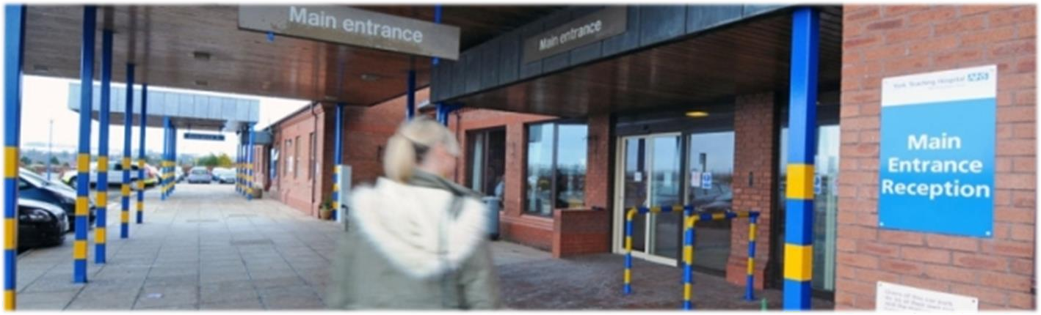
Bridlington Hospital Main Entrance

Overview
About Us
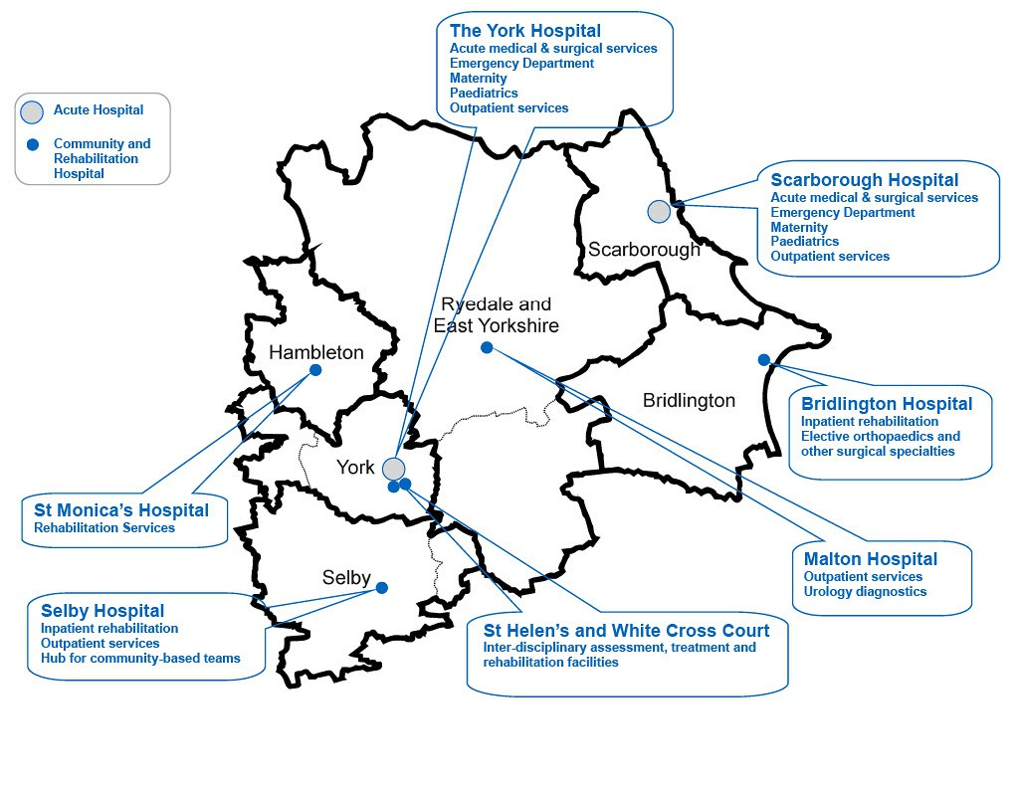
Our Hospitals
- York Hospital
- Scarborough Hospital
- Bridlington Hospital
- Malton Hospital
- The New Selby War Memorial Hospital
- St Monica’s Hospital Easingwold
- White Cross Rehabilitation Hospital
- Nelson’s Court Rehabilitation Hospital (Previously St Helen’s)
Our Activity
The Trust operates a wide range of inpatient, outpatient and community services across the region and provides emergency care through A&E units in York, Scarborough and Selby.
In 2021/22, the Trust had more than 0.95 million patient contacts across our sites, with the average number of patient occupied beds being 826.

Overview

Achieving Strategic Goals
Overview
The transition to net zero is an exciting process to be a part of, and each NHS Trust will experience its own specific challenges and opportunities in achieving this goal. It is important that both are highlighted and addressed to maximise progress.
Successes
The Trust has made good progress in reducing carbon emissions from various sources, including implementing CO₂ limits on business vehicle leases, developing a policy to remove desflurane (the high intensity greenhouse gas) from use at the Trust before the end of 2022, and incorporating electric vehicles into our fleet. Widening the scope of actions taken allows for increased integration of sustainability into everyday working practices and supports awareness from staff in all roles. More examples of recent successes can be found on page 11.

Opportunities
While the Covid-19 pandemic unquestionably impacted all sectors, resulting in unprecedented changes to how we live our lives, climate change and the environment remain high on the national agenda.
From an environmental perspective, the pandemic has presented and continues to present new challenges such as the disposal of high volumes of PPE and decreased public transport utilisation. Still, there have also been areas where the pandemic has quickened positive change and provided inspiration for the post-Covid future. The use of videoconferencing by staff has increased tenfold since the start of the pandemic primarily because of social distancing measures and an increase in home working. Since the pandemic has become more manageable, there have been residual impacts, including a reduction in business mileage due to staff now having a viable, tested alternative to travelling to other sites. The increase in home working enforced by the pandemic, and increasing the availability of video/telephone appointments for patients have reduced unnecessary inconvenience to patients and reduced local congestion, pollution, and carbon emissions.
We must take these and other positive by-products of Covid-19 into account as we make decisions in the future.

Overview

Achieving Strategic Goals

Challenges
With a growing, ageing population and one of the highest rates of obesity in Europe, the outlook is challenging for the Health Service. While the provision of a central NHS strategy to reach net zero is highly welcome, future strategies across all areas of the NHS must be consistent with meeting these commitments if targets are to be achieved.

York and Scarborough Teaching Hospitals provide healthcare for an area of 3,400 square miles - one of the largest of any Trust in the country. This geographical spread results in high levels of business travel between sites, one of the areas we have to address. Combined Heat and Power (CHP) generators, powered by natural gas, provide most of the Trust's electricity. While they used to provide the Trust with an annual carbon saving, the national grid's rapid decarbonisation has resulted in these CHPs being more carbon-intensive than drawing the necessary electricity from the grid. While on-site electricity production from gas benefits the Trust financially, we will not achieve the required carbon savings to meet future targets until we fully address this. The achievement of funding through the Public Sector Decarbonisation Scheme at Bridlington, has allowed the Trust to start this journey resulting in a switching off of the gas fired CHP, in favour of a low carbon heat pump system and largely scale solar panels to generate the majority of the site’s electricity use (see page 35 for more information).

Historic measures to reduce carbon emissions have often had a financial co-benefit that made them viable, but there will be costs associated with meeting net zero. A Climate Change Committee study determined that a 2050 net zero target is "technically feasible but highly challenging“ 2, requiring complex, costly, and time-consuming interventions. As the NHS Carbon Footprint Plus requires Net Zero emissions by 2045 and includes emissions outside the scope of the Climate Change Act, it is logical to assume that the same will apply to these targets. We must reflect on this reality and adjust our expectations accordingly to reduce emissions at the required rate.

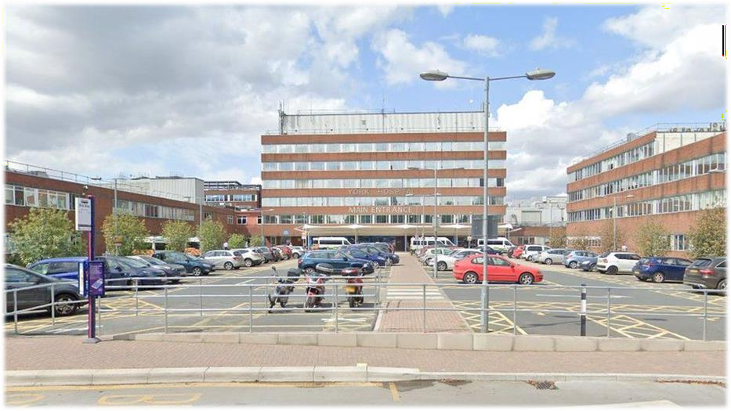
York Hospital Main Entrance: Over 700,000 patients are seen every year at the York site, representing around 60% of our clinical activity.

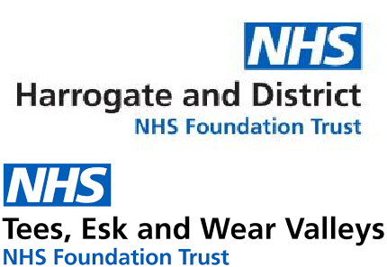
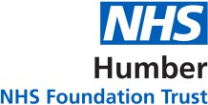

Overview

Partnership Working

Working Together
The Trust’s premises are spread across a large geographical area, spanning a multitude of local and regional councils and NHS partner organisations serving a registered population of approximately 800,000 people.
All of our partners are working to reach Net Zero by 2050 as per the Climate Change Act, some such as City of York Council, have gone further and set more ambitious targets, including a 2030 Net Zero target for scope 1 and 2 emissions. It is vital that we link with these partners to share best practices and ideas so that all groups can make progress towards these ambitious targets.
The Trust works with local councils to help achieve our aims, such as encouraging uptake of active and public transport to work and being involved in local schemes to cut air pollution. The Humber and North Yorkshire Health and Care Partnership is working towards sustainability goals across the region, and the Trust is keen to be an active partner in this endeavour.
Our Partners
- City of York Council
- North Yorkshire Council
- East Riding of Yorkshire Council
- York and North Yorkshire Local Enterprise Partnership (LEP)
- Humber and North Yorkshire Health and Care Partnership
- Humber and North Yorkshire Integrated Care Board (ICB)
- Northern Lincolnshire and Goole NHS Foundation Trust
- Hull University Teaching Hospitals NHS Trust
- Harrogate and District NHS Foundation Trust
- Humber NHS Foundation Trust
- Tees, Esk and Wear Valleys NHS Foundation Trust
- Rotherham, Doncaster and South Humber NHS Foundation Trust
- Yorkshire Ambulance Service NHS Trust

Overview

Sustainability Timeline

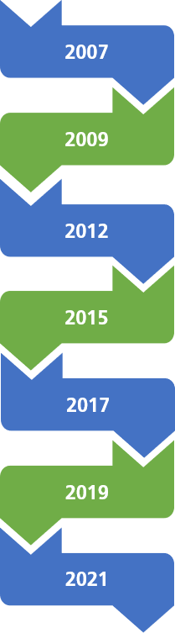
2023

Green Plan updated for 2023-2026

Green Plan published for 2021-2026
First Trust-wide Travel Plan published to
encourage greater use of active and public forms of travel

The Trust updates it’s SDMP to cover the
following three years

The Trust publishes it’s first Sustainable
Development Management Plan (SDMP)

The Trust incorporates Scarborough and Bridlington Hospitals

Sustainable Development Group (SDG) Established

The Trust commits to reducing its CO₂ emissions

Overview

Achievements

In recent years, the Trust has made good progress on sustainability across a range of areas. Some of our highlights are shown below, aligned to the NHS’s recently updated Strategic Sustainability Framework outlined in section 7.1

We believe that the scope of our achievements demonstrates our commitment to carbon reduction and decreasing our environmental impact. We aim to further widen the range of areas that we are addressing during the lifetime of this strategy and look forward to reporting back on further successes in the future.
Workforce and System Leadership
The Trust has established a Green Champions network to engage staff in sustainability and carbon reduction.
Workforce and System Leadership
The Trust operates the Sustainable Development group, with an escalation route to the Trust Board.
Sustainable Models of Care
The Trust has rapidly increased the use of teleconferencing, reducing unnecessary patient travel, air pollution and congestion.
Digital Transformation
The Trust are replacing inefficient data centre equipment with less energy consuming equipment.
Digital Transformation
Reduction of paper introducing a digital solution to capture patients notes at the bedside.
Digital Transformation
Adoption and high usage of Microsoft Teams reducing the need for travel between sites and enabling agile working across the Trust estate.
Travel and Transport
Business leases limit high emission vehicles and encourage Ultra-Low emission vehicles.
Travel and Transport
Increasing the number of electric vehicles in the transport fleet (9) and ensuring charge points have been introduced.
Travel and Transport
Free NHS staff public transport trial for those at York and Scarborough Hospitals. An E-Scooters trial is in progress at York, and we also operate car share and cycle to work schemes.

Overview

Achievements

Estates and Facilities
Sustainable Design Guide introduced reinforcing the need to integrate BREAAM Excellent standards and whole life costs for all new buildings. Estates and Facilities
Since April 2020, all the electricity we import from the national grid is on a 100%
Green Tariff.
Estates and Facilities
Over £6,000 in avoided costs and 3 tonnes of CO₂ emissions saved by use of the “Warp It” reuse portal.

Estates and Facilities
Two Public Sector Decarbonisation Grants, awarded in March 2022, resulted in the installation of heat pumps, insulation, new windows, pipework insulation at York Hospital. At Bridlington Hospital a solar farm, solar panels on roofs, high efficiency motors and air source heat pump system was installed.
Green Space and Biodiversity
Area around Scarborough Hospital Helipad sown with wildflower seeds and “bee bombs” to encourage invertebrate populations, and hedgehog boxes were installed.
Green Space and Biodiversity
£200,000 charitable funding secured for Well-being gardens, with first five having been delivered in 2021/22.
Medicines
The proportion of desflurane emissions have reduced by 97.2% (100 tCO2e), whilst the total reduction in anaesthetic gas use has been 40% (1,640 tCO2e).

Medicines
Clinical prescription of greener inhalers in local care pathway in conjunction with ICS partner organisations.

Supply Chain and Procurement
Sustainability is a mandatory consideration in all new business cases and resource use and efficiency is part of all new job descriptions (since 2017).

Food and Nutrition
Single-use plastics have been phased out of retail areas and wards, with 90% of provision covered by veg-ware and 100% ceramic cups in York.
Adaptation
Flood defences installed at Tadcaster Health Centre. Adverse weather plan updated to include data collection opportunities to inform longer term capital planning.

Overview

Targets

Ensure that car leasing schemes for staff promote zero and ultra-low emission vehicles.
Reduce fleet air pollution by using exclusively zero and ultra-low emission vehicles.

Increase the percentage of virtual outpatient consultations by decreasing the percentage of face-to-face appointments.
Phase out use of oil for primary heating at all sites by 2028.

Reduce water usage and
waste.

Support move to less carbon intensive inhalers, where clinically appropriate.

Reduce avoidable use of single- use plastics.

Reduce use of single-use plastic food and drink containers, cups, covers and lids.
Work towards ensuring that all new builds and refurbishments conform to Net Zero Standards.
Provide an annual review of adverse weather impacts and adapt premises and service delivery to mitigate risks of climate change.
Cease use of single use plastic cutlery, plates and cups on our premises.

Maximise the rate of return for walking aids.

Replace lighting with LED alternatives during routine maintenance.

Reduce carbon emissions from use of gas, oil and electricity through better controls and building fabrics and implementation of renewables and heat pump technology.

Work towards appropriate number of IT devices where appropriate reducing the number of devices and enabling us to have better utilisation of equipment.

Targets derived from the NHS Standard Contract Service Conditions 2022/20234, NHS Long Term Plan 20195 and the Greener NHS MoU requirements April 2021.

Overview

Drivers For Change - General
Legislative
- Civil Contingencies Act 2004
- Climate Change Act (CCA) 2008 (updated 2019)
- Public Services (Social Values) Act 2013
Mandatory
- Standard Form Contract requirements for Sustainable Development 2020
- HM Treasury’s Reporting Framework
- Public Health Outcomes Framework
UK guidance
- National Policy and Planning Framework 2012
- Department of Environment, Food and Rural Affairs (DEFRA) The Economics of Climate Resilience 2013
- DEFRA Government Buying Standards for Sustainable Procurement 2016
- The Stern Review; The Economics of
Climate Change 2006
- Health Protection Agency (HPA) Health Effects of Climate Change 2012
- The National Adaptation Programme; Making the country resilient to the changing Climate 2013
- DEFRA 25 Year Plan 2018
- HM Government Clean Growth Strategy 2017 (Amended 2018)
International
- International Panel on Climate Change (IPCC) AR5 2013
- United Nations (UN) Sustainable Development Goals (SDG’s) 2016
- World Health Organisation (WHO) toward environmentally sustainable health systems in Europe 2016
- WHO Health 2020; European policy for
health and wellbeing
- The Global Climate and Health Alliance; Mitigation and Co-benefits of Climate Change

  - Overview
Drivers For Change - Healthcare Specific
Drivers for Healthcare
The drivers outlined on the previous page are not specific to healthcare and the NHS. As sustainability must be considered in a range of settings, there is a wide variety of guidance, requirements, and legislation to be mindful of - this list is not exhaustive.
In addition to more general drivers, there are healthcare-specific requirements that must be incorporated into our plan, particularly the “Delivering a Net Zero NHS” strategy released in October 2020, which includes more ambitious carbon reduction targets than legislated for by the Climate Change Act (CCA). The NHS now has a target to be Net Zero by 2045, 5 years earlier than the CCA legislates.
Health Specific Requirements
- Delivering a Net Zero NHS 2020
- NHS Standard Contract 2023/24
- NHS Long Term Plan 2019
- NHS Operational and contracting guidance 2022/23
- Third Health and Care Adaptation Report 2021
- The Carter Review 2016
- National Institute for Clinical Excellence (NICE) Physical Activity; walking and cycling 2012
- Health Technical Memoranda (HTM)’s and Health Building Notes (HBN)’s
- Sustainable Transformation Partnership (STP) Plans
- NICE guideline (NG70) 2017
- The Marmot Review; Fair Society, Healthy? Lives 2010
- Health and Care Act 2022

Carbon Reduction Progress

CO₂e Emissions 2019/20 – 2021/22
Scopes of emissions
Scope 1: Emissions that come directly from our estate - examples include gas used for heating and power generation, anaesthetic gases used in surgery and the fuel used by our vehicle fleet

Scope 2: Our only emissions in this area are from the electricity we import from the grid

Scope 3: Downstream emissions such as the carbon embedded in what we buy, our grey fleet business travel and the travel of our patients and visitors

120,000

Total Trust CO₂e emissions 2019/20 to 2021/22

150

100,000

80,000 100
KgCo2e/patient Contact

60,000
tCO2e

40,000 50

20,000

- -
2019/20 2020/21 2021/22
Scope 1 Scope 2 Scope 3 CO2e/pt Contact

Figure 1:Total Trust CO₂ e emissions 2007/8-2019/20 by scope

Carbon Reduction Progress
NHS and Mandatory Carbon Reporting Data Issues
Baseline
The targets set by both the Climate Change Act and the “Delivering a Net Zero NHS” strategy are measured against a 1990 emission baseline. If these national targets are then defined against the 2019/20 emissions footprint calculated in line with the Delivering a Net Zero NHS report, the NHS guidance states that this is equivalent to:
- Reach net zero NHS Carbon Footprint by 2040, reducing emissions by at least 47% by 2028-2032;
- Reach net zero NHS Carbon Footprint Plus by 2045, reducing emissions by at least 73% by 2036-
2038.
NHS England has produced an estimate of our 2019/20 Trust contributions to national carbon emissions to support us to deliver on the commitments to Net Zero. The data provided shows NHS England’s estimate of the Trust's contribution to the NHS Carbon Footprint Plus (which includes the NHS Carbon Footprint) and we have therefore set 2019/20 as our baseline year.
Ongoing Data
We are constantly increasing the scope of both our data recording and reporting. We backdate data wherever possible, but this is not always achievable. Increases in reported emissions as sources of CO₂ are recognised and quantified or as more accurate reporting systems are developed are inevitable. As such, some historical information will not be as accurate as more recent data.
Historical data is subject to change as more information becomes available, and we will report this in the sustainability section of the Trust Annual Report each year.

Procurement
For the rest of the data processing, this Trust uses carbon factors historically provided by the national Sustainable Development Unit (SDU) to calculate the CO2 emissions embedded in what the Trust buys. These carbon factors have not been updated for several years, meaning that changes such as decarbonisation of the grid and reductions in freight emissions are not taken into account for 2008/09 onwards. The Trust does, though, apply Retail Price Index (RPI) adjustments to account for inflation. The Trust is also exploring options to quantify these emissions with a greater degree of accuracy in the future, which could lead to changes in our reported emissions in this area.

Delivering A Net Zero NHS
Overview
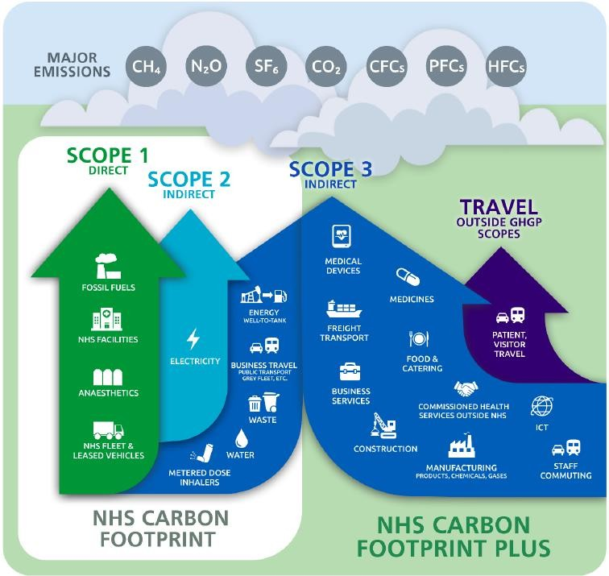
In October 2020, the NHS committed to becoming a Net Zero organisation by 2045 in the Delivering a Net Zero National Health Service3 publication. The Trust has aligned its data to work towards this strategy's targets. There are two targets, one for the "NHS Carbon Footprint," which is for an 80% reduction by 2032 and a 100% reduction by 2040. The other target is the "NHS Carbon Footprint Plus," which has an expanded scope and a target of an 80% reduction by 2039 with net-zero emissions targeted for 2045, all against a 1990 baseline (2007/8 for the Trust). The components of these two targets are shown in the diagram below as presented in the strategy. The next page provides a breakdown of our 2021/22 emissions data into NHS Carbon Footprint and Carbon Footprint Plus categories.

Delivering A Net Zero NHS

2021/22 Carbon Footprint/Carbon Footprint Plus

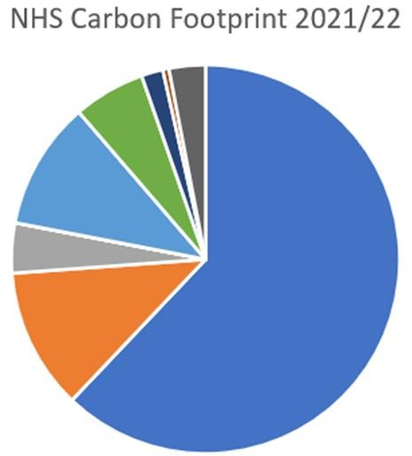
Fleet and Leased Vehicles 294 tCO2e

Business Travel (including Well to Tank) 1237 tCO2e

Energy Well to Tank 2,202 tCO2e

Water 105 tCO2e

Waste 627 tCO2e

Inhalers 861 tCO2e
Electricity
0 tCO2e

Anaesthetics
2,431 tCO2e
Gas and Oil 12,832 tCO2e

Figure 2: Trust carbon emissions for 2021/22 broken down into NHS Carbon Footprint categories
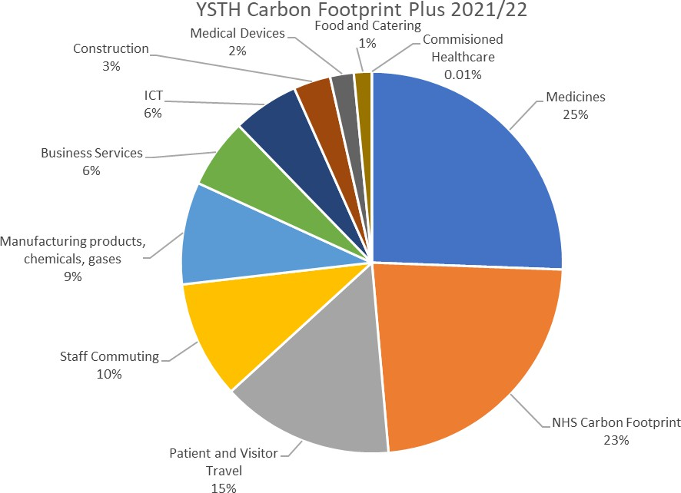

Figure 3: Trust carbon emissions for 2021/22 broken down into NHS Carbon Footprint Plus categories

Decarbonisation Progress 2019/20 –
2021/22

Our NHS Carbon Footprint for 2021/22 shows a decrease of 19.5% (5,004 tonnes CO2) since 2019/20. These calculations are based on actual measurements of use converted into carbon emissions, e.g. kWh gas using current CO2e conversion factors. The largest reductions were from swapping electricity to a green (renewables) tariff, a change in practice of the type of anaesthetic gases used and a reduction in gas consumption (used for heating). Currently 73% of this Trust’s NHS Carbon Footprint carbon emissions are from buildings energy use, 12% anaesthetic gases, fleet travel 8% Total 20.7k tonnes CO2e for our Carbon Footprint.
Our NHS Carbon Footprint Plus shows an overall decrease of 0.4% (376 tonnes CO2) between 2019/20 and 2021/22 which includes everything that the Trust procures, with an increase in 2020/21 largely due to capital investment to cope with the Covid Pandemic. As above, the method used for this calculation (relating to things that the Trust buys) is directly related to the amount spent and as more money was spent in 2020/21 this shows greater carbon emissions. Using this method, the only way to get to zero is, therefore, to spend nothing unless a new model is provided for these calculations.

Other progress the Trust has made includes:
    - Desflurane (anaesthetic gas) emissions reduced by 97.2% (100 tonnes CO2e)
    - Total reduction in anaesthetic gas use was 40% (1,640tonnes C02e)
    - Emissions from water use and treatment reduced by 68% (221 tonnes CO2e – there was a 6% reduction in use as well as a significant reduction in carbon intensity)
    - Total emissions from gas and electricity fell by 17.2% (3,110 tonnes CO2e)

Despite these successes, progress needs to be accelerated. The “Delivering a Net Zero NHS” document published in October 2020 details the targets to reduce the NHS Carbon Footprint (scope 1 and 2 emissions, business travel and upstream energy distribution) by at least 47% by 2028-2032; and the NHS Carbon Footprint Plus (all emissions) by at least 73% by 2036-2038. In order to reach these targets, year on year reductions of at least 1,100 tonnes of carbon per annum on emissions that the Trust directly control and at least 4,470 tonnes of carbon per annum on the whole NHS Carbon Footprint Plus must be achieved. Whilst progress in the last 2 years shows that this has been achieved on emissions that the Trust directly controls, there is clearly a long way to go with the things that the Trust procure. It is however clear that progress will not be at a uniform rate and the changes in procurement should lead to greater progress in later years.

Delivering A Net Zero NHS

Historic and Forecast Data

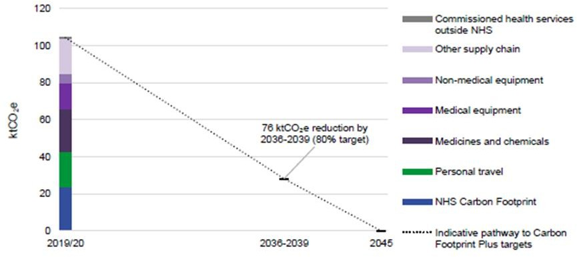

Figure 4: Historic Trust emissions aligned with the “Delivering a Net Zero NHS” strategy Carbon Footprint and projected to 2039/40.

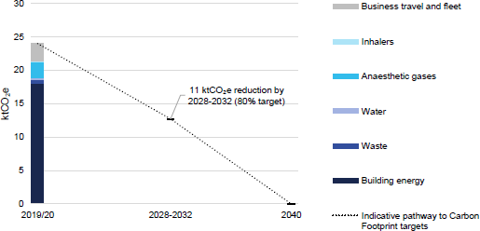

Figure 5: Historic Trust emissions aligned with the “Delivering a Net Zero NHS” strategy Carbon Footprint Plus and projected to 2044/45.

Delivering A Net Zero NHS

Carbon Footprint
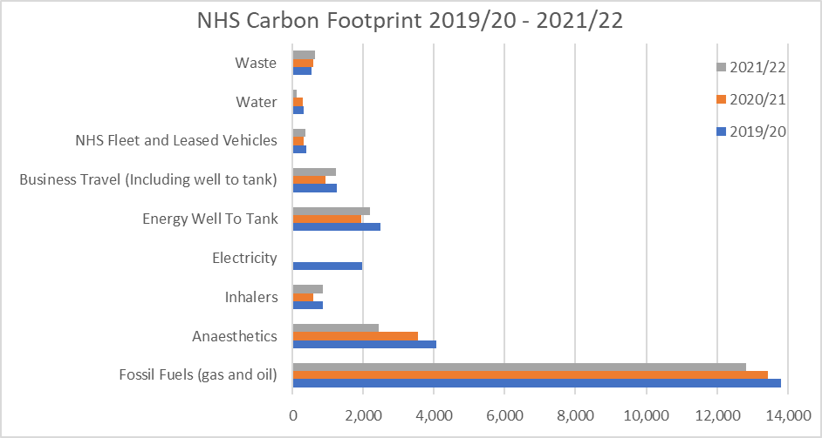

Figure 6: Carbon Footprint changes from 2019/20 to 2021/22.

Carbon Footprint overview
The NHS Carbon Footprint includes all scope 1 and 2 emissions as well as business travel, water and waste which are classified as scope 3. These are areas that we have significant influence over and are largely produced on our estate. We have already made good progress in some of these areas, such as anaesthetics and electricity, but a rapid decrease in our use of gas and oil is essential to meeting these targets as they contribute more than 60% of our Carbon Footprint.

Delivering A Net Zero NHS

Carbon Footprint Plus
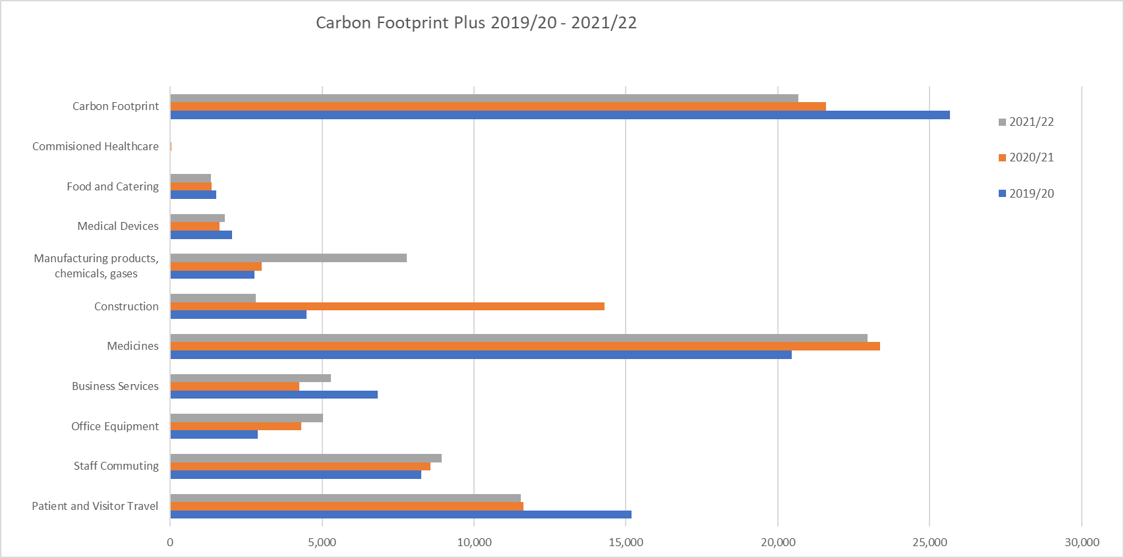

Figure 7: The emission reductions required for the Trust to meet the targets of 80% reduction by 2038/39 and 100% by 2044/45 within the scope of the NHS Carbon Footprint Plus. (Includes the NHS Carbon Footprint from Figure 6)
Footprint Plus overview
The Carbon Footprint Plus includes the full scope of emissions reported by the Trust. An interim target of an 80% reduction has been set for 2039, with a 100% reduction target set for 2045. Freight shipping is included, but this is calculated as part of our procurement emissions and is not displayed separately. Percentage breakdowns of contributions from each area for the Trust are provided in figures 2 and 3 in section 6.2.

The NHS Carbon Footprint Plus includes Scope 3 emissions, mainly from what we buy, patient and visitor travel to Trust sites, and our staff commuting. NHS Supply Chain will undertake much of the work in decarbonising supply chains centrally, but we must ensure that we integrate sustainability into procurement frameworks at a local level. Encouraging staff to use active travel and public transport will contribute towards reductions in the emissions produced from staff commuting and this will be supported by greater availability of electric vehicles in future years for both staff and the general public.

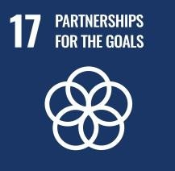

NHS Sustainability Overview

Overview
The NHS’s Sustainability Areas of Focus are used to help NHS Trusts reach their sustainability goals. The tool divides objectives into a group of workstreams, outlined on the next page. Each workstream has a responsible lead who reports back on progress to the sustainability team quarterly.
The areas of focus cover measures that can reduce CO₂ emissions and more holistic initiatives such as improving the health of our staff and visitors, increasing access to Green Space, and mitigating and adapting to the impacts of climate change.
Several NHS Long Term Plan and Standard Contract requirements are also included here within the relevant workstreams to contextualise them and demonstrate how they fit into the “bigger picture.” There is inevitably slight overlap, but this is kept to a minimum.

United Nations Sustainable Development Goals
The 2030 Agenda for Sustainability Development Goals, adopted by all United Nations Member States in 2015, provides a shared blueprint for peace and prosperity for people and the planet, now and into the future. At its heart are the 17 Sustainable Development Goals (SDGs), shown below which are an urgent call for action by all countries - developed and developing - in a global partnership. The Trust strives to improve its performance on these areas, many of which sit under the NHS Sustainability Areas of Focus.

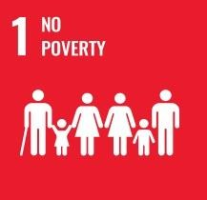
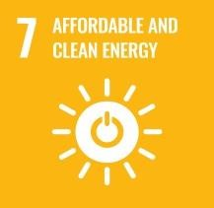
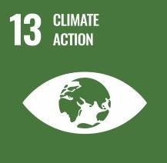
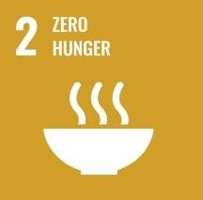
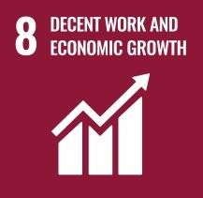
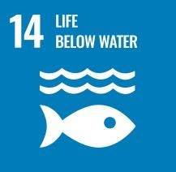
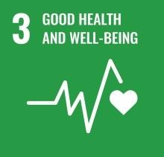
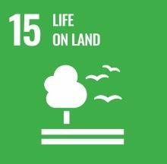
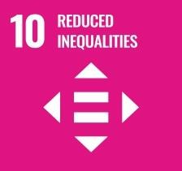
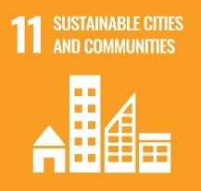
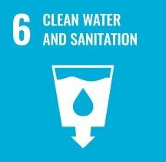
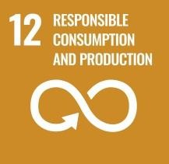

Themes

Workforce and System Leadership
Engaging and developing our workforce and system partners in defining and
delivering carbon reduction initiatives and broader sustainability goals.

Sustainable Models of Care
Embedding net zero principles across all our clinical services and considering
carbon reduction opportunities in the way care is delivered.
Digital Transformation
Harnessing existing digital technology and systems to streamline service delivery and supporting functions while improving the associated use of resources and reducing carbon emissions.
Travel and Transport
Reducing the carbon emissions arising from our travel and transport, including active travel, public transport, fleet vehicles, and logistics.
Estates and Facilities
Reducing the carbon emissions arising from our buildings and infrastructure, including energy efficiency, building design and waste reduction.
Green Space and Biodiversity
Incorporating green space and biodiversity across our estate.

Medicines
Reducing the carbon emissions related to our prescribing and use of medicines and medical products.

Supply Chain and Procurement
Using individual or collective purchasing power and decisions to reduce carbon embedded in our supply chains.

Food and Nutrition
Reducing the carbon emissions from the food made, processed or served within our organisation.
Adaptation
Plans to mitigate the risks or effects of climate change and severe weather conditions on our business and functions.

Sustainability Areas of Focus

Workforce and System Leadership

Progress

Corporate support for sustainability is embedded into the culture of the Trust by way of senior staff engagement with the green plan, policies and procedures; the Sustainable Development Group (SDG) and Sustainability Champions who deliver sustainability related information, events and activities; and the energy reduction programme board.
Ensuring staff wellbeing is also crucial for an effective and resilient workforce in a changing climate. The Trust provides resources for physical and mental wellbeing, offers NHS checks, and has introduced positive management behaviour training. We continue to improve and widen access to physical activity through our staff benefits programme, offering virtual health support and workshops. Support has also been expanded since the pandemic, with a focus on wellness and identifying individual risk factors related to Covid-19.
The Trust has appointed an Equality, Diversity and Inclusion Lead, and facilitates regular communication with employees to improve staff integration and retention. International recruitment schemes, apprenticeships and collaboration with universities support workforce growth.
Our commitment to sustainability is also demonstrated through our contracting mechanisms and strategic partnerships with local councils and organisations, most of whom are also working towards the overarching goal of Net Zero by 2050.

Sustainability Areas of Focus
Workforce and System Leadership

Strategic Objectives
- Integrate sustainability throughout the organisation;
- Improve the health and wellbeing of our workforce;
- Increase workforce retention and improve integration procedures;
- Evaluate and consider flexible working patterns where appropriate;
- Continue to build strategic partnerships with local councils and organisations.
Sustainability Actions
- Increase the distribution of sustainability information through repository development;
- Deploy the SDG to engage and motivate the workforce;
- Expand the repertoire of staff wellbeing-related benefits;
- Increase availability of sustainability-related training;
- Continue to refine and improve staff onboarding strategies and retention schemes;
- Continue to evaluate the potential for flexible and home working where appropriate;
- Appoint a Trust board-level Sustainability lead to promote sustainability initiatives across the Trust and to its partners.
Measurement & KPIs
- Sustainability surveys to be undertaken every three years;
- Quantity of Sustainability Champions across the Trust;
- Staff benefits programme availability and uptake;
- Review of sustainable areas of focus;
- Consideration of sustainability within our values, strategies, processes and procedures.

Sustainability Areas of Focus

Sustainable Models of Care

Progress
Sustainable models of care are crucial for the longevity of patient and planet health. Effective models increase resilience, performance and sustainability within the Trust.
Accelerated by the Covid-19 pandemic, the Trust has experienced a huge increase in teleconferencing, reducing unnecessary patient travel, air pollution and congestion.
Thousands of patients use the service every month, but there is active encouragement across our organisation to continue the increase of virtual appointments (where appropriate).
The Trust has also initiated a series of environmental and carbon impact calculations for specific care models, which will be expanded over the coming years.
Key partners are strategically important in the enhancement of health and promotion of resilience within individuals and communities. The Trust will continue to nurture and develop strong relationships with healthcare partners and work together to reduce environmental and carbon impacts.

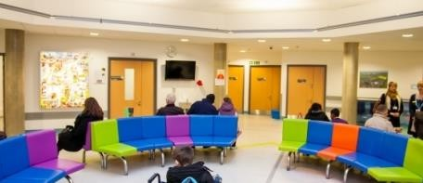

Sustainability Areas of Focus

Sustainable Models of Care

Strategic Objectives
- Reduce in-person outpatient appointments by 1/3 by 2023/24;
- Quantify the direct financial and environmental co-benefits of emerging and existing care models;
- Increase the return of walking aids to the Trust;
- Continue to build strategic relationships with key healthcare partners.
Sustainability Actions
- Continue to encourage the uptake virtual appointments across the organisation;
- Increase patient-centred pathways;
- Deploy an equipment coordinator to streamline the process of issuing and delivering equipment;
- Improve communication with local councils to obtain accurate data and enhance the return of
walking aids;
- Conduct further environmental and carbon calculations for all care models across the Trust;
- Work with partners in the healthcare system to promote resilience and awareness of sustainability.
Measurement & KPIs
- Outpatient appointment records across the Trust;
- Return rates of walking aids and other applicable equipment;
- Environmental and carbon assessments for emerging and existing care models;
- Patient feedback surveys;
- Purchasing ledgers for clinical materials.

Progress

IT infrastructure is key to the sustainability and success of the NHS because it allows for the effective management of resources, improvements in the quality of care and advanced reporting procedures.

The Trust are currently implementing a phased approach to sustainability, with the first phase already underway. This involves the streamlining and improvement of existing infrastructures. Between Jan 2022 – July 2022, just over 3300 pieces of legacy equipment were recycled. In-efficient data centre equipment is now being replaced with less energy consuming servers (an estimated completion date of July 2023), and there is the prioritisation of refurbishing existing IT equipment where possible.

The Trust has also investigated the strategic placement of computer systems within wards and offices to highlight the importance of equipment location for workflow. Alongside this, the continual monitoring of active equipment through Microsoft CCM Active Reports will help to increase the control, handling and effective distribution of IT assets in the future.

One of the most notable changes witnessed over the past 3 years is the uptake of teleconferencing, home working and virtual appointments. The Trust has implemented effective equipment distribution schemes to ensure that its workforce and patients are able to utilise this technology, and arrange flexible / home working patterns where appropriate.

Strategic Objectives
- Factor new and emerging technologies into decision-making;

- Continue to increase the uptake of teleconferencing;

- Streamline and utilise effective management software;

- Promote dialogue between departments to improve accurate data centre metering;

- Implement and improve equipment distribution through referencing and reporting systems.
Sustainability Actions
- Evaluate the potential of transfer to a cloud-based system in the next 3-5 years;

- Improve the distribution of already existing equipment by implementing a referencing and reporting system, enabling absolute control of IT assets;
- Streamline and develop the effective use of software, reducing the need for intensive hardware and paper-based processes;
- Begin to measure energy usage within data centres through accurate room metering;

- Continue to consider the potential for refurbished equipment when replacing legacy equipment;

- Increase output of educational materials and equipment distribution to promote the use of teleconferencing and virtual appointments.
Measurement & KPIs
- Outpatient appointment records across the Trust;
- Live equipment reports;
- Software assessment and evaluation reports;
- Energy consumption calculations;
- Staff surveys and reviews.

Progress

The impact of travel and transportation on the local community is significant, and the Trust recognises its responsibility to implement effective strategies for reducing air pollution at both sites.

We have already executed a travel hierarchy and plan to encourage the uptake of public and active transportation methods, built a secure 100-cycle storage facility, deployed a fleet of designated low emission pool cars and nine electric vehicles, and organised a hospital ‘Park and Ride’ facility for the site in York. The salary sacrifice scheme for bicycles has also seen good levels of uptake.

The Trust is continually expanding its promotions of healthy and active travel online and has increased accessibility to electric scooters and bicycles, with a new parking bay for patients and visitors in York. Over 4000 journeys have been made since it was launched. Our SDG encourages and promotes active participation in events like the ‘National Clean Air Day’ and the NHS Supply Chain is working to reduce the number of single supplier deliveries and consolidate the transportation of goods to each site.

The Trust has also recently announced a new incentive to encourage staff to change their single occupancy car journey to work to public transport. In late 2023, the Trust began to fund a £1 bus travel scheme for staff journeys on the First York bus network and the number 10 bus service at Scarborough. This will help to support staff journeys to work at York and Scarborough hospitals.

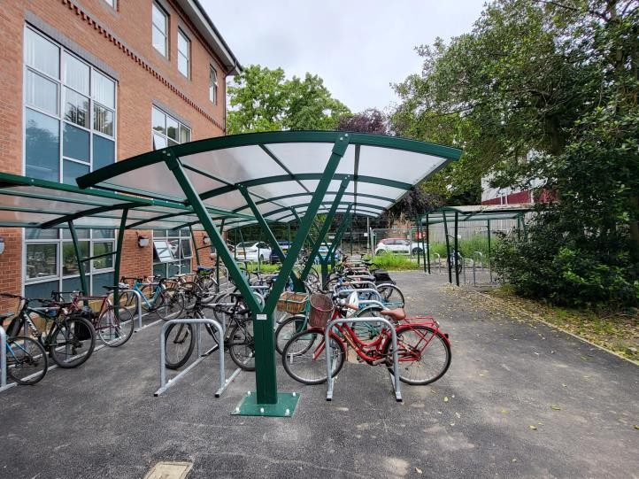

The new (2023) cycle racks near Park House at the York Hospital site.

Strategic Objectives
- Evaluate EV infrastructure and encourage active engagement from local suppliers;
- Develop a plan to reduce staff (business and commute), patient and visitor emissions;
- Reduce air pollution by transitioning fleet to use exclusively Zero and Ultra-Low Emission Vehicles including the development of plans to install electric vehicle charging infrastructure for fleet vehicles at the Provider’s Premises
- Develop a plan to reduce staff (business and commute), patient and visitor emissions.
- Ensure that all new staff lease, salary sacrifice, and pool cars purchased/leased are ULEVs or ZEVs, and work towards purchasing vans meeting these requirements;
- Reduce fleet air pollution by using exclusively zero and ultra-low emission vehicles, including the development of plans to install electric vehicle charging infrastructure for fleet vehicles at the provider’s premises;
Sustainability Actions
- Increased charging infrastructure across the Trust to support electrification;

- All new vehicles to conform to ULEV standards;

- Review and reduce business lease and fleet lease CO2 limit for all new/replacement vehicles;

- Continue to increase provision of cycle storage, showers and lockers across both sites;

- Continue to work with partners such as City of York Council to promote sustainable travel;

- Introduce a new car parking permit scheme to prioritise spaces for car sharers;

- Review the effectiveness of the £1 staff bus travel scheme with First York and the number 10 bus in Scarborough;

- Review the 2019 Travel Plan with consideration of the long term Net Zero targets of the NHS.
Measurement & KPIs
- Fleet composition and fuel use / mileage;

- Outpatient appointment records across the Trust;

- Annual staff, patient and visitor travel surveys (from late 2023 onwards);

- Take up of reduced fare (£1) staff bus travel scheme;

- Production of a new Trust Travel Plan (early 2024 that will align with the Green Plan aims and targets).

Sustainability Areas of Focus

Estates and Facilities

Progress

Developing and managing the Trust estate sustainably is crucial to its success, as it not only reduces
environmental impact, but ensures long-term financial stability and supports the well-being of staff and patients.

The NHS Net Zero Build Guide (Feb, 2023), outlines the procedures and sustainability checklists required to meet BREEAM, innovation credit and decarbonisation guidelines within sustainable new building designs and refurbishments. The Scarborough Urgent and Emergency Care development, for example, which began in 2022 was awarded BREEAM ‘excellent’ status at the pre-construction stage. A new whole-life costing approach is being implemented across all estate projects and consideration of the resilience of local biodiversity and green spaces has been of particular importance. The Trust added 2,067m2 of estate in 2021/22. We also engage local contractors and contribute to charitable initiatives within all estate projects, the principles of which were embedded into a proposed Vascular Imaging Unit development plan.

The Trust has instigated reviews of energy management procedures and since 2019/20, gas and electricity usage has seen a 6% and 8% reduction respectively. After successfully winning two Public Sector Decarbonisation Grants in 2022, extensive carbon reduction works have ensued including the installation of heat pumps, insulation, new windows, pipework, etc. to ward blocks in York and at Bridlington a solar farm, solar panels on roofs and air source heat pumps, reducing site carbon emissions by more than 60-80%.

A new waste trainer/auditor role has also been created, to provide the Trust with comprehensive audits of waste production and segregation, as well as advisory support. Between 2019-22 recycling rates increased by 3.4% to 27.6% and zero waste was sent to landfill. Water use emissions also decreased by 68% between 2019-2022, owed to the decrease in patient contacts and a national reduction in the carbon intensity of water treatment.

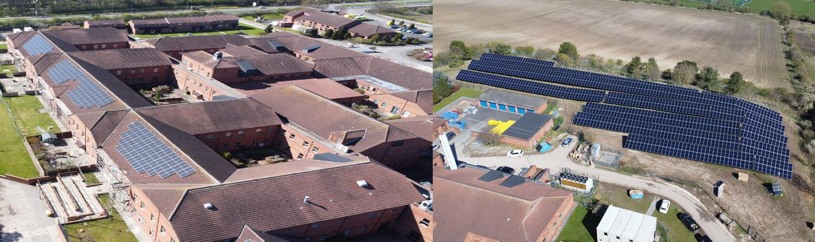
© Vital Energi
© Vital Energi
The Trust is investing a £4.75 million grant, recently won from our PSDS application, into the installation of solar panels, air source heat pumps, and energy efficient fans and insulation on our Bridlington Hospital site. The project is expected to reduce the carbon emissions associated with the building’s energy use by approximately 53%.

Sustainability Areas of Focus
Estates and Facilities

Strategic Objectives
- Projected energy and carbon performance delivered within projects;
- All new builds to conform to BREEAM, innovation credit and decarbonisation standards, as detailed in the new NHS Net Zero Building Standard;
- Renewable/low carbon technologies such as solar panels and ground/air heat pumps included in new builds;
- Increase collaboration and contracting mechanisms with local and small businesses;
- Increased recycling rates and decreased energy intensive disposal methods;
- Improved waste segregation at point of source;
Sustainability Actions
- Nominating a capital projects BREEAM lead;
- Ensuring that the BREEAM process is followed carefully to ensure ‘excellent’ category is achieved;
- Soft landings approach to the transition from construction to occupation;
- Electrical submetering in new builds to measure against projected performance;
- Sustainability and carbon reduction factored into all projects;
- Actively encourage and consider tenders from small and local contractors;
- Low carbon heating to be a tender requirement for new builds;
- Increased educational outputs regarding the waste hierarchy and importance of proper disposal, energy efficiency and
water use efficiency;
- Increased educational inputs regarding the waste hierarchy and importance of proper disposal, energy efficiency and water use efficiency to improve waste segregation, cost and carbon impact.
Measurement & KPIs
- Carbon monitoring from new builds;
- BREEAM and innovation credit assessments;
- Monitoring of renewable energy sources through ERIC data;
- Percentage waste recycled, sent to landfill, re-used (%);
- Monitoring of CO2 and financial savings from the Warp-It system;
- Workforce and contractor surveys.

Sustainability Areas of Focus

Green Space and Biodiversity

Progress

The value of nature for mental and physical wellbeing must be accounted for in the strategic implementation of net zero and sustainability initiatives. Various studies outline the importance of green space in the reduction of stress, depression and anxiety, and the improvement of physical health through space for activities. Biodiversity also plays a crucial role in the maintenance of eco-system services such as pollination and soil fertility.

Where possible, green spaces have been actively considered in the development and refurbishment of the estate. Five new wellbeing gardens have been created following a charitable donation of £200,000 from the York and Scarborough Teaching Hospital Charity. The gardens provide opportunities for rehabilitation, space for reflection and interaction and improved habitat conditions. They were developed as part of a collaborative process between teams from estates, sustainability, funding, arts, capital projects, patient experience, finance and accessibility.

Following the NHS Net Zero Building Standard, the Trust considers the potential benefits of green walls and roofs in all its estate designs, as well as the impact of construction on biodiversity, which is especially prudent given the introduction of the mandatory biodiversity net gain measure in late 2023. One notable success is the recent helipad development within close proximity of the Scarborough Urgent Emergency and Critical Care Department. 31 immature trees were redistributed for plantation in Dalby Forest and on farmland in Staintondale, the area around the pad was sown with wildflower seeds and “bee bombs” to encourage invertebrate populations, and hedgehog boxes were installed.

Sustainability Areas of Focus
Green Space and Biodiversity

Strategic Objectives
- Publish a Board approved Biodiversity Action Plan;
- Ensure more green spaces are available for staff and visitors to enjoy;
- Consider biodiversity and green space in all new build designs;
- Encourage support from the local community to engage with our green spaces;
- Implement tree planting schemes and habitat improvements to support with the carbon offsetting of developments.
Sustainability Actions
- Establish and maintain resources to develop and deliver a biodiversity action plan for the Trust;
- Applying for further funding to create and improve green spaces, working inter-
departmentally to agree best use of space;
- Ensure that Ecology/Biodiversity is considered as part of the BREEAM assessment for new builds;
- Continue to ensure that volunteers are equipped and supported in their roles;
- Continue habitat improvements for local flora and fauna e.g. owl box installations.

Measurement & KPIs
- Biodiversity Action Plan to be published within the lifetime of this strategy;
- Monitoring the area of accessible green space to ensure space is being utilised;
- BREEAM assessment Ecology/Biodiversity points scored on new builds;
- Numbers of volunteers working on green spaces;
- Funding secured for development or improvement of green paces.

Sustainability Areas of Focus

Medicines

Progress
Pharmaceuticals are critical in the delivery of healthcare to patients, and YSTH, a significant consumer and key player in this industry, has a responsibility to minimise the environmental impact of its medicinal repertoire.

Changes are being implemented across the Trust’s clinical landscape including stopping the use of desflurane and reducing metered dose inhalers, of which carbon emissions are already being tracked. Already, the Trust has collaborated with healthcare partners to reduce the use of desflurane (an anaesthetic gas with a high carbon footprint) in surgery by 97% in 2021/22 and to cease its use altogether in November 2022. The use of metered dose inhalers has also been significantly reduced, with less carbon intensive dry powder inhalers implemented as alternatives.

There are further investigations of clinical replacements to nitrous oxide and entonox, and of practices that reduce leakage and waste.

The Trust is currently investigating various recycling routes for insulin pens and inhalers, as well as product life-time extending schemes for single-use products including insulin pens and HRT pre-vaginal tablet applicators. Our pharmacy also currently operates a fully paper-less system for ordering, invoicing and prescribing. The Trust also actively recycles medicine boxes and other recyclable goods, contributing to wider waste reduction goals.

There is active engagement with clinical groups, especially the integrated care system, enabling a patient prescription service experience in line with current guidance. Within this framework, there can be accurate patient medication reviews and reductions in overprescribing which is essential both for waste reduction and cost saving goals.

Sustainability Areas of Focus
Medicines

Strategic Objectives
- Maintain this Trust’s desflurane free policy (adopted Nov 2022);
- Minimise use of metered dose inhalers via replacement with dry powder inhalers;
- Investigate alternatives to single use products;
- Reduce nitrous oxide manifolds across the Trust;
- Foster better communication between waste and clinical departments;
- Increase sustainability educational outputs specific to clinicians.
Sustainability Actions
- Continue with the preferential use of and monitor dry powder inhalers and less carbon-intensive anaesthetic gases across the Trust;
- Investigate new and emerging medicines / technologies that reduce the need for single-use products.
- Construct educational workshops and content for quality forums, explaining the importance and implications of the Green Plan and Net Zero strategies for clinicians;
- Initiate better connections between waste and clinical departments to encourage better waste management, especially with respect to recycling (e.g. blister pack guidance);
- Promote the Green Plan and Net Zero strategies to clinicians and push for an increase of ‘Sustainability Champions’ within the clinical landscape;
- Investigate and implement the decommissioning of nitrous oxide on wards.
- Evaluate nitrous oxide use and illustrate where reductions can be achieved;
Measurement & KPIs
- Staff and patient surveys;
- Monitor prescriptions and carbon outputs of carbon intensive products e.g. MDIs vs DPIs;
- Purchasing ledgers for clinical materials;
- Percentage clinical waste recycled (%)
- Prescription rates for DPIs vs MDIs.

Sustainability Areas of Focus

Supply Chain and Procurement

Progress

Procurement equates to approximately 60% of the NHS’s carbon footprint. A sustainable NHS Supply Chain will therefore substantially decrease greenhouse gas outputs, improve patient outcomes and support the local economy. As a national framework, it is essential that the NHS advocates for environmentally-conscious purchasing behaviours, with much already being done to demonstrate this.

The implementation of the Trust’s reuse portal Warp-It has been notably successful. The system has enabled a cost saving of £4,800, nearly 3000kg of CO2e emissions, and 800kg of waste in the first 3 months. In 2021/22 there were further savings of £3616 along with 1650kg of CO2e emissions and 5057kg of waste saved from disposal.

There have also been vast improvements in the procurement of fabrics across the Trust, with uniform and furniture overhauls of recycled fabrics and ‘better cotton’ in the pipeline.

NHS Supply Chain has also begun to develop a tier of scoring for suppliers and products based on their sustainability credentials, allowing for more informed decision-making in respect to overall product impact. Within this remit, the trust has asked all NHS large suppliers to conduct a full carbon audit.

Over the past 12 months, the Trust also begun to procure and utilise remanufactured surgical devices, where previously devices would be discarded. All wooden furniture is FSC certified; and a large portion of suppliers are accredited to ISO standards.

Sustainability Areas of Focus
Supply Chain and Procurement

Strategic Objectives
•
•
•
•
Decrease the proportion of virgin material in the supply chain;
Implement ‘sustainability scoring systems’ for NHS suppliers;
Implement and refine Warp-It initiative;
Foster better communication pathways between departments to encourage re-use and recycling schemes;
•
•
Engage with local and small suppliers to support the local economy;
Increase educational outputs to encourage environmentally conscious procurement.
Sustainability Actions
- Evaluate potential waste reduction strategies for PPE and other largely single-use equipment by harnessing new technologies and innovations;
- Increase the online repository of sustainability related training within the procurement industry;
- Implement changes to fabric use to include recycled fibres and renewable materials for chair coverings and uniforms e.g. 100% recycled chair fabric for operators chair and Better Cotton Initiative cotton by using the NHS uniform contract from 2024;
- Continue to increase engagement with small and local suppliers;
- Enhance energy efficiency analysis in procurement decisions on energy-intensive equipment to reduce energy demands;
- Maximise the use of the Trust Warp-It portal to reduce waste and unnecessary procurement;
- Ensure that energy use and carbon emissions are appropriately weighted in tender documents.
Measurement & KPIs
- CO2 and financial savings from the Warp-It system;
- Product energy-efficiency measures;
- Staff and supplier surveys.

Sustainability Areas of Focus

Food and Nutrition

Progress

The Trust has implemented various initiatives to achieve improved sustainability through its food and nutrition pathways.

Single-use plastics have been phased out of retail areas and wards, with 90% of provision covered by veg-ware and 100% ceramic cups in York, and local discount schemes have been implemented to encourage use of veg-ware products at specific coffee vendors.

The Trust operates a centralised production system where all staff are trained to monitor and evaluate the efficiency of their food production system, which gives way for better reporting of underused equipment and assurance that operating procedures are streamlined.

There has also been a tremendous push to digitise the ordering system through the Great Food, Great Health Programme. This way, food waste and patient-centred care can be monitored effectively, especially in terms of portion size control.

The catering department has also seen huge investment into equipment efficiency, with asset conversation from gas to electric and increased application of goods vehicles with larger capacities for frozen/chilled food storage.

One of the most notable sustainability successes is the integration of KPIs for newly on- boarded food suppliers, which take into account various factors including seasonality and locality.

All kitchen food waste from York is sent for composting and further investigations are
taking place to assess feasibility to orchestrate this methodology across other sites.

Sustainability Areas of Focus
Food and Nutrition

Strategic Objectives
- Continue to reduce food waste both at the point of source and at post-consumer levels;
- Increase the provision of healthy food options and implement effective portion controls;
- Diversification of the menu to include vegetarian, vegan and alternative dietary requirements;
- Continue to assess new waste processing technologies and innovations;
- Upskill and enhance workforce capabilities within the catering department.
Sustainability Actions
- Further increase provision of health eating options and provide nutritional information;
- Obtain a baseline of ward food waste levels and implement a strategy to reduce this;
- Deploy a catering specific dietician who can provide detailed advice and greater input into the menu structure;
- Finalise the menu restructure analysis, evaluating full plant-based menus, full seasonal menus, etc.
- Implement staff restructure and training to uplift all chefs to band 3, senior supervisors to be appointed and apprenticeship scheme start.
- Create a sustainable catering policy for patients, staff and visitors;
- Implement a catering and nutritional steering group for waste management.
- Invest into new food technologies, modernising practices;
- Review and monitor food and drink strategy, utilising data to assess effectiveness.
Measurement & KPIs
- Quarterly staff surveys;
- Progress reports;
- Food waste baseline report;
- Patient surverys;
- Percentage waste composted (%)
- Total percentage food waste (%)

Sustainability Areas of Focus

Adaptation

Progress

As the climate changes and likelihood of extreme weather events increases, the Trust must take action to protect staff and service users from the adverse impacts of climate change. Consideration of extreme weather and Trust resilience is essential if services are to be maintained.

The Trust has deployed an ‘Emergency Planning Steering Group’ (EPSG) to maintain a risk register which evaluates the potential impacts of severe weather events including flooding, heatwaves and cold snaps, brought on by current and future climatic risk. Formal action plans and procedures are also in place, which consider various scenarios of impacted service delivery.

The Adverse Weather Plan (AWP) (2021) was developed to inform estate maintenance programmes and to pave the way for longer term capital planning, risk identification and mitigation, including recommendations for automated temperature monitoring. Automated temperature monitoring was introduced in 2023 to the inpatient areas of York and Scarborough hospitals, to allow detailed reporting of the internal ward temperatures in heat wave conditions. The AWP requires the collation of an annual report on findings and lessons learnt which is submitted to Trust Executive Committee and the Head of Sustainability.

The EPSG rigorously and regularly reviews the AWP and other strategies, including the incident response plan to ensure that the Trust’s plans to adapt are based on relevant information.

Sustainability Areas of Focus
Adaptation

Strategic Objectives
- Trust premises adapted to mitigate risks associated with climate change;
•
Be able to demonstrate that our buildings and services are fit for purpose in the
a changing climate;
context of
- Further steps taken to ensure business continuity maintained during extreme weather events such as floods and heatwaves;
- Provide an annual review of adverse weather impacts and adapt premises and service delivery to mitigate risks of climate change.
Sustainability Actions
- Increased temperature monitoring across the Trust to identify areas where overheating may be an issue;
- Detailed heatwave plans incorporating monitoring information;
- Work with major suppliers to understand their resilience and contingency strategies;
- Ensuring that new buildings are built to BREEAM excellent/Net Zero standards;
- Retrofitting existing buildings where possible;
- Risk Assessments based on previous climate impacts/adverse weather monitoring;
- Utilise the data collected from the single-ward temperature control trial to formulate a business case for automated temperature monitoring in all inpatient areas.
Measurement & KPIs
- Temperature monitoring of key areas;
- Number of overheating events relative to overheating days;
- All new builds to be certified as BREEAM Excellent/Net Zero with extensions certified as BREEAM Very Good;
- Pilot scheme assessment report;
- Routine testing of business continuity plans.

Communications and Tracking Progress

Communications

As an essential part of driving change throughout our organisation, we take a considered approach to sustainability communications. By communicating what we are doing both within and outside the organisation, we can engage staff with key priorities and ensure sustainability is part of the conversation.

We communicate sustainability information regularly through various channels, including our weekly and monthly staff communications and a group of Green and Sustainability Champions.

We aim to provide a resource of accessible sustainability information for staff on our Trust Intranet site, complete with a waste guide and advice on reducing utility consumption/carbon emissions.
Tracking Progress
We will be measuring the progress of this strategy using a range of qualitative and quantitative methods including:

- Our annual NHS Sustainability Areas of Focus Scores – We are aiming for an overall percentage of 75%+ by 2026
- Consumption of Utilities - We aim to improve our reporting ability, access to real time data and invest in sub-metering throughout the lifetime of this plan.
- Travel data
- Waste Volumes
- Anaesthetic gas use
- Organisational carbon footprint as measured and reported annually in line with sector guidance

Governance

Governance
The Trust has operated a Sustainable Development Group (SDG) since 2009. The Group, which meets every quarter, includes key staff from various departments and facilitates interdepartmental work on sustainability projects. The Travel and Transport Group and Energy Reduction Programme Board were established to provide more specific workstreams and feed into the SDG.

The SDG feeds items into individual meeting work programmes for Executive Committee, Resources Committee, and the YTHFM LLP Management Group, who in turn can bring items to the attention of the Board of Directors.

Executive
Committee
Energy Reduction Programme Board
Travel and Transport Group
Sustainable Development Group
Health, Safety and Non-Clinical Risk Group
YTHFM LLP
Management Group
Resources
Committee

Board of Directors

Reporting

Reporting
The reporting of the Trust’s sustainability performance is provided through multiple systems at an operational, organisational and national level. As a responsible organisation we adopt an open and transparent approach to the information collected, making it available to all and have a duty to provide information that is accurate and is recorded within the systems below;

Monthly

  - Data collection from utilities, waste and transport used to identify levels and trends.
  - Reports and monthly figures reviewed at the Energy Reduction Working Group (ERWG).

Quarterly

  - Internal reports produced by the Sustainability Group, Travel and Transport Group, Premises Assurance Model process and Board Sustainability Lead. These are summarised and presented to the Resources Committee who escalate key issues to the Trust Board of Directors.

Annual

  - Internal report produced on Carbon and Cost Reduction programme.
  - ERIC (Estates Return Information Collection)
  - Complete assessment on NHS Sustainability Areas of Focus to identify sustainability development work, measuring progress and enabling the Trust to make plans for the future from the previous year’s actions.
  - Complete SDU Sustainability Reporting Portal which informs the sustainability section of the Trust’s Annual Report and calculates the Trust’s carbon emissions (Scope 1, 2 and 3).
  - Sustainability report identifying progress against the Green Plan and highlighting the main activities delivered throughout the year.

Risk

Risk
Risks to the delivery of our Green plan are identified through a series of committees and groups illustrated within our Governance structure. Escalation of risks is conducted through the Sustainability Development Group and placed onto the York Teaching Hospital Facilities Management Risk Register where, depending on severity of the risk, is progressed up to the Digital Performance and Financial Assurance Committee (DPFAC) and then on to Trust Board.

The register reviewed by the Sustainable Development Group on a quarterly basis include the following key risks:

- Risks of changing climate – increasing costs and impact of adverse weather and climate change which includes heat waves and overheating buildings increasing deaths from air pollution, increasing likelihood of flooding events, disruption to services and communities and longer-term changing disease patterns.

- Specific risk of overheating putting patients and vulnerable groups of visitors and staff.

- Risk of failure to reduce air pollution and failure to meet requirements of NHS standard contract 2023/24 which requires Trusts to have a plan to transition fleet to Zero and Ultra Low Emission Vehicles, install EV charging for fleet and establish policies which exclude high emission vehicle use and promote sustainable travel choices.

- Risk of failure to reduce the carbon impacts from the use, or atmospheric release, of environmentally damaging fluorinated gases used as anaesthetic agents and as propellants in inhalers, including phasing out desflurane by 2024, through clinically appropriate prescribing of lower greenhouse gas emitting anaesthetic gases and inhalers, and the appropriate disposal of inhalers.

Finance

Finance
Sustainable development schemes and activities will provide multiple benefits for the Trust over the coming years. As patient numbers, utilities and transport costs rise there will be a focused approach towards reducing costs and improving services, through changing working practices and identifying beneficial cost reduction schemes.

Financial constraints within the Trust require sustainability improvements to either find external funding, partnership working or go through the Trusts business cases (BC) process, indicating the benefits of the improvement, costs, return on investment and effects on the environment, which is viewed by the BC panel. The Trusts charitable funds are available if the improvement fits in with the criteria for accessing the funds.

The Sustainability team seek to minimise and reduce financial burdens whilst at the same time, seeking to achieve a balance between carbon and cost savings. It is increasingly difficult to achieve financial pay backs of five years or less, and greater levels of investment are now needed to achieve carbon reduction in line with Net Zero NHS targets. The Trust works with local, regional and national organisations to seek technical and financial support.

Utilities are procured through a tendering process to deliver the best value for money, provide energy from renewable sources and capture data that monitors and records information to identify high usage areas. This allows the Trust to identify areas where improvements can be made and alternative options for delivery considered.

Refurbishment to our estate provides an opportunity to invest in equipment and buildings that incorporate whole life cycle materials, heating and ventilation that can cope with the predicted changes in climate change and reduce our carbon impact on the environment.

Funding had previously been secured for submetering and telemetry for the York Hospital site. More recently, the Trust was successful with our PSDS application, allowing further decarbonisation works to be undertaken. Further work is planned to develop a capital investment programme to contribute to the achievement of carbon reduction targets.

The predicted global impacts of an increase of greater than two degrees Celsius have been widely modelled and documented. Only a short window of time is available to reduce emissions to a level that can prevent potentially irreversible changes to the climate.

There will likely be grants and government schemes to help support the financial aspect of the transition to net zero, but the organisation meeting the targets will also have to bear some of the costs themselves. The Trust must establish the most cost-effective way to deliver the required works to meet net-zero and contribute to the global effort to solve the climate emergency.

Appendix 1: Glossary

Air Pollution: Levels of pollutants in the air such as Particulate Matter, Nitrogen Dioxide (NO₂) and Sulphur Dioxide (SO₂). This is measured on the Air Quality Index, which has a scale of 1-
10. Air pollution can negatively impact health outcomes for local communities

BREEAM (Building Research Establishment Environmental Assessment Method): A method of assessing, rating and certifying the environmental, social and economic sustainability of buildings

Carbon Footprint: The total amount of greenhouse gases produced to directly and indirectly support human activities, usually expressed in equivalent tonnes of carbon dioxide (CO₂e)

Climate change: A long term shift in weather patterns and average temperatures, caused by the emission of Carbon Dioxide and other Greenhouse gases into the atmosphere

Climate change adaptation: Changes made to allow for future weather patterns. Examples include storm drains to help cope with increased flooding and improved quality road surfaces to withstand higher temperatures

CO₂e – Carbon Dioxide Equivalent: Whilst CO₂ is the most common greenhouse gas, other gases contribute to climate change, often at much higher levels per tonne. One tonne of methane has the global warming potential of 25 tonnes of CO₂. Whilst one tonne of desflurane (A potent anaesthetic gas) is equivalent to over 2000 tonnes of CO₂. The CO₂e figure allows us to factor in the impact of these other gases within our overall carbon footprint

Combined Heat and Power (CHP): The generation of electricity (usually through consumption of natural gas) with the heat utilised as a by-product

Electric Vehicle (EV’s): Vehicles driven by an electric motor. EV’s have zero tailpipe emissions (CO₂/air pollutants) and do not contribute to local air pollution

Estates Return Information Collection (ERIC): A central reporting portal where NHS
organisations report key information (such as waste and utilities usage)

Greenhouse Gases (GHGs): Gases that reduce the amount of infrared radiation that can escape through the atmosphere, thereby contributing to Global Warming. Examples include CO₂, Methane and (in the healthcare sector), anaesthetic gases

Appendix 1: Glossary

Hybrid Vehicle: A vehicle that uses conventional fuels, assisted by electric motors KPI: Key performance indicator
Low Emission Vehicle (LEV): Vehicles that meet current ‘Euro Standards’. Euro 3 for motorcycles, mopeds, motorised tricycles and quadricycles; Euro 4 for petrol cars, vans, minibuses and other specialist vehicles; Euro 6 for diesel cars, vans and minibuses and other specialist vehicles; Euro VI for lorries, buses and coaches and other specialist heavy vehicles (Correct as of July 2020)

Net Zero: The point where total CO₂e emissions minus offset emissions is less than or equal to zero

Patient Contacts: The number of patients that visit the Trust in a given time

Payback Period: The length of time required for the cost of an investment to be recovered

Sustainable Development Assessment Tool (SDAT): The SDU’s Sustainable Development Assessment Tool (SDAT) was designed to help Health and Social Care organisations assess progress in sustainable development and identify how local action is contributing to the UN Sustainable Development Goals. The tool is now superseded by the NHS Sustainability Areas of Focus.

Travel Plan: A package of actions put in place by an employer to encourage staff to use alternatives to travelling alone in their cars, both for environmental and health benefits

Ultra-low emission vehicle (ULEV): Vehicles that emit tailpipe emissions of less than 50g CO₂/km. Electric vehicles (including battery electric, plug-in hybrid electric or hydrogen fuel cell) all meet these criteria

Warp It: A material reuse portal, which assists the Trust in redistributing assets such as furniture

Whole-life Costing: Sometimes called ‘life-cycle cost’, this approach assesses the absolute cost of a product or service over the course of its lifetime, from its conception through to its end of life, taking into account purchase, maintenance and repair, training, utilities and disposal

Zero emissions vehicle (ZEVs) Fully electric vehicles that produce zero tailpipe emissions

Appendix 2: References

- How to Produce a Green Plan https://www.england.nhs.uk/greenernhs/wp- content/uploads/sites/51/2021/06/B0507-how-to-produce-a-green- plan-three-year-strategy-towards-net-zero-june-2021.pdf
- Committee on Climate Change, Net Zero: The UK’s contribution to stopping global warming, 2 May 2019 www.theccc.org.uk/publication/net-zero-the-uks-contribution-to- stopping-global-warming/
- Delivering a Net Zero National Health service https://www.england.nhs.uk/greenernhs/wp- content/uploads/sites/51/2020/10/delivering-a-net-zero-national- health-service.pdf
- NHS Standard Contract Service Conditions 2023/24 https://www.england.nhs.uk/wp-content/uploads/2023/04/03-nhs- standard-contract-fl-scs-2324.pdf

- NHS Long Term Plan 2019 https://www.longtermplan.nhs.uk/publication/nhs-long-term-plan/

- NHS Operational and contracting guidance 2022/23 https://www.england.nhs.uk/wp-content/uploads/2022/02/20211223- B1160-2022-23-priorities-and-operational-planning-guidance-v3.2.pdf

