

**Item 11.2**

|  |  |
| --- | --- |
| **Report to:** | Board of Directors |
| **Date of Meeting:** | 31 January 2023 |
| **Subject:** | CQC Section 31 Update |
| **Director Sponsor:** | Dawn Parkes - Interim Chief Nurse |
| **Author:** | Sascha Wells-Munro, Director of Midwifery |

|  |
| --- |
| **Status of the Report** (please click on the appropriate box)  Approve  Discuss  Assurance  Information  A Regulatory Requirement |

|  |  |
| --- | --- |
| **Trust Priorities**  Our People  Quality and Safety  Elective Recovery  Acute Flow | **Board Assurance Framework**  Quality Standards  Workforce  Safety Standards  Financial  Performance Targets  DIS Service Standards  Integrated Care System |

|  |
| --- |
| **Summary of Report and Key Points to highlight:**  On the 25 November 2022, the CQC, under Section 31 (S31) of the Health and Social Care Act 2008 imposed conditions on the Trust registration in respect of maternity and midwifery services. This Trust updates the CQC monthly on the 23rd of the month with progress against the S31 notice.  **Recommendation:**   * To approve the January 2024 monthly submission to the CQC which provides assurance on progress and impact on outcomes in November 2023. |

**CQC Section 31 Progress Update**

Maternity Services at York and Scarborough NHS Foundation Trust have embarked on a programme of service and quality improvements.

This report provides assurance on the progress to date in delivering against the improvement plan for the purpose of the monthly submission to CQC following the Section 31 notice.

**A.2 Fetal Monitoring**

**A.2.2 Fetal Monitoring Training**

Current Fetal Monitoring compliance figures, by site, at the end of November 2023 are outlined below. All staff groups in maternity are above 85% compliance.

|  |  |  |
| --- | --- | --- |
| Staff Group | York | Scarborough |
| Midwives | 95% | 90% |
| Consultants | 100% | 100% |
| Obstetric medical staff | 94% | 88% |

A training plan for 2024 has been devised by the Practice Development Midwife and new Obstetric Clinical Education Lead. All staff have been rostered to attend training before they become non-compliant with their training compliance. The plan encompasses the entire maternity workforce (midwifery, medical and obstetrics) and has been mapped against the NHS England Core Competency Framework v2.

**A.2.3 Fresh Eyes Audit**

The Fetal Monitoring Lead Midwife and Transformation Midwife undertook an audit against the Saving Babies Lives Care Bundle v3 (SBLv3), Element 4, compliance with intrapartum risk assessments and ‘fresh eyes’ hourly peer review.

Saving Babies Lives V3 states *“A buddy system should be used to help provide an objective holistic review for example ‘Fresh Eyes’ – this should be undertaken at least hourly when CTG monitoring is used and at least four hourly when IA is utilised, unless there is a trigger to provide a holistic review earlier.”*

Seventy five cases over a three month period were randomly selected, as recommended by SBLv3. For a fair representation of cross site activity, 24 Scarborough cases and 51 York cases were chosen (due to relative birth rates).

Badgernet has CTG review tool which can be used by a single practitioner “review” or as a Fresh Eyes tool “peer review”. For the audit, the timing of the completion of reviews on the “peer review” tool as well as looking at the clinical narrative for context was assessed. A case was classed as compliant if a “Fresh Eyes” has been performed by two registered staff at least every 1 hour (with a 15 minutes late tolerance as per local guidance). If there were any late or missed “Fresh Eyes” the case has been classed as non-compliant and themes have been identified.

Of the 75 cases reviewed, 20 (27%) were fully compliant with the fresh eyes requirement.

Of the 55 non-compliant cases:

* 16 had one fresh eyes check missing
* 8 had one fresh eyes check completed outside 1 hour 15 minutes

However, a total of 510 Fresh Eyes were required across the 75 cases that were audited. Of these, 388 were completed on time. This would give an overall compliance figure of 76% if the data is analysed in this way which is much closer to the 80% threshold the trust is hoping to achieve.

An action plan has been developed to address non-compliance; this will be presented to the Clinical Governance meeting in February 2024.

**A.3 Risk Assessments**

The CQC found evidence in patient records which showed incomplete assessments of risk and plans of care to mitigate such risks. All antenatal risk assessments are recorded on BadgerNet.

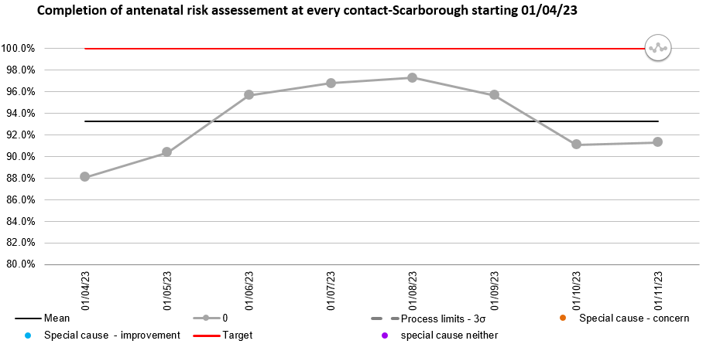

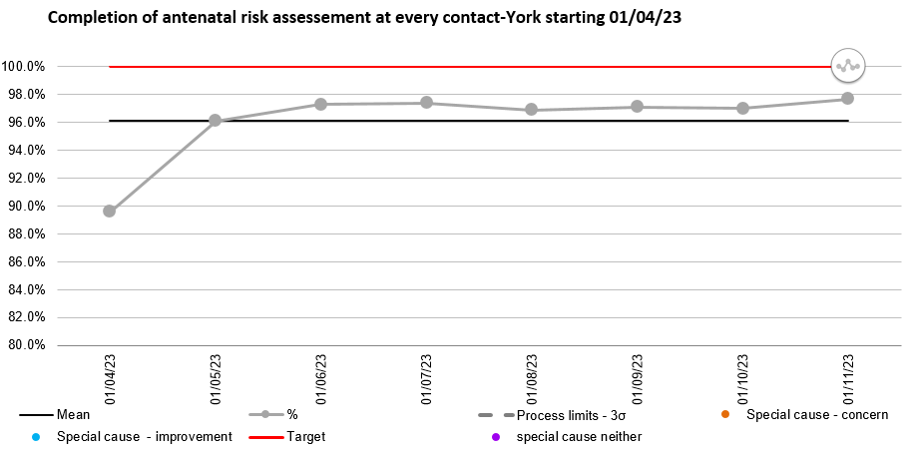

The completion of the antenatal risk assessment is a mandatory field on BadgerNet, the digital Midwives are working with CleverMed to understand why the software reports in this way.

**A.4 Assessment and Triage**

On the 12 May 2023, the Birmingham Symptom Specific Obstetric Triage System (BSOTS) Triage system went live at York Hospital and partially from 3 July 2023 at Scarborough. The triage system is part of the Badgernet software, the system facilitates the prioritisation of women based on needs.

Following a BadgerNet system wide update, data is now available for live collection of triage data. The team leaders and our digital midwife are currently assessing the data quality to ensure recording is accurate.

An internal audit review has been commissioned to gain assurance on the triage process. This commenced in September 2023. The audit is now complete and will be shared with the senior team this week. Upon review, an action plan based on the recommendations will be shared in this report.

The introduction of BSOTS in January 2023 is demonstrating a steady reduction in the number of red flags reported which are outlined in the NICE safe midwifery staffing for maternity settings (2015). These will continue to be monitored as a key safety metric for our service in demonstrating safe staffing. This is observed through the compliance figures.

Due to the estate and staffing at the Scarborough site, triage is currently situated in the labour ward. Capital investment request for the adaptation to create a dedicated triage space has recently been approved by the Capital Planning and Equipment Group and tender now secured. Works to the space will commence in February 2024. Until then, adaptations have been made to provide the space for triage to commence in Scarborough.

Recruitment has not been as successful as anticipated, however with agency, triage should be launched in its dedicated space in the coming weeks. The HCA/MSW vacancy has been filled and we anticipate our new team members will join us in February.

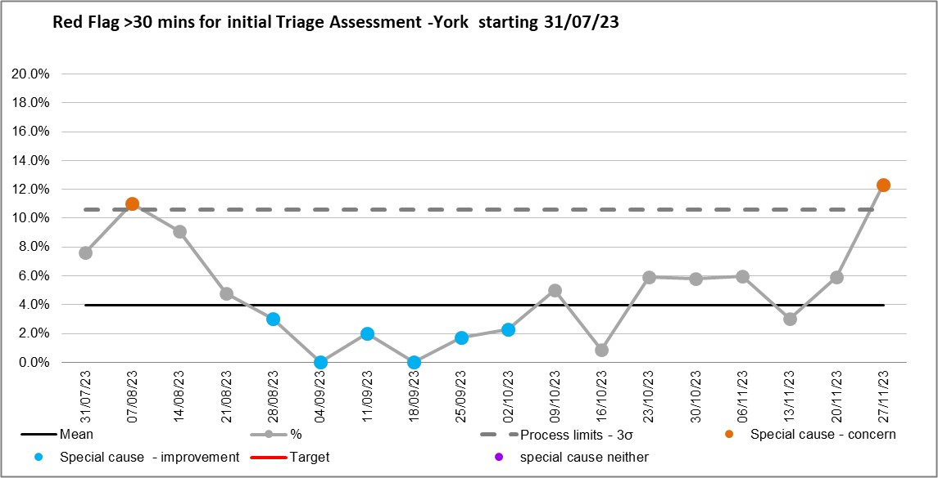

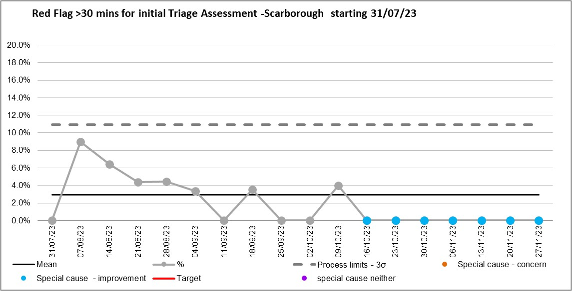

1. Governance and Oversight of Maternity Services

**B.1 Post-Partum Haemorrhage**

**PPH over 1.5 litres**

PPH is included as one of the key priority areas in the Trust Patient Safety Incident Review Plan launched in December 2023.

|  |  |
| --- | --- |
| Blood Loss | Number in November 2023 |
| 1.5l – 1.9l | 17 (range 1.5l – 1.9l) |
| 2l – 2.4l | 3 (range 2l – 2.3l) |
| > 2.5l | 3 (range 2.9l – 3.5l) |

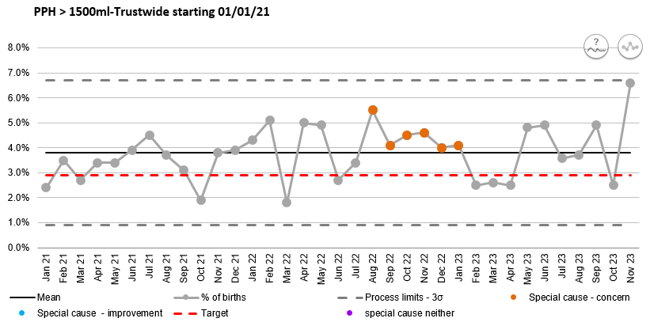

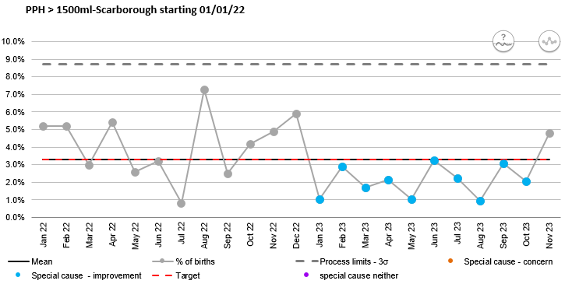

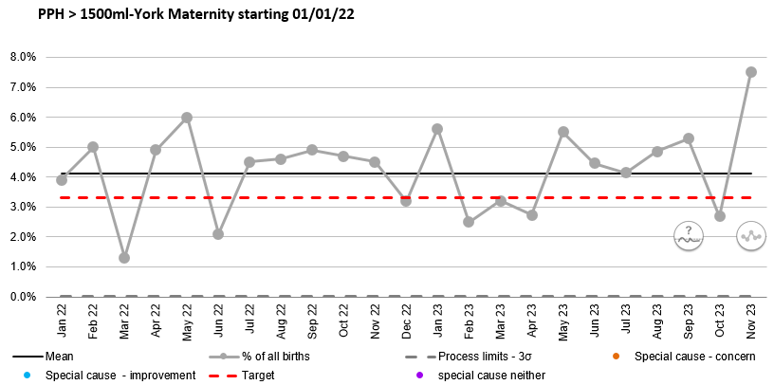

**PPH between 1000ml – 1499ml**

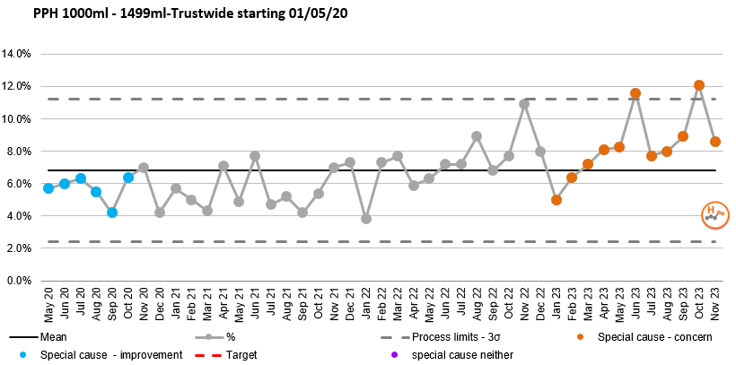

The rate of PPH between 1000ml and 1499ml continues to show special cause variation concern however has decreased in November 2023. The PPH Group is being established and refocused with support from the Trust Quality Improvement team to look at how we address this increase to improve care.

**B.2 Incident Reporting**

There were nine moderate harm incidents reported in November 2023.

|  |  |  |  |
| --- | --- | --- | --- |
| **Datix Number** | **Incident Category** | **Outcome/Learning/Actions** | **Outcome** |
| 7197 | PPH 2925ml | For review using the PPH review tool and feed into the improvement group | PSIR completed awaiting review |
| 7366 | Low cord gases | CTG interpretation and classification | PSIR presented to Q&S. For local learning |
| 8541 | Unexpected admission to SCBU | For review by ATAIN meeting | Feed into the ATAIN improvement work |
| 7207 | 3a Perineal Tear | To be included in the perineal tear cluster review | Review in progress |
| 7682 | Antenatal stillbirth 32+6 weeks gestation | Reviewed in case review meeting, support offer to staff involved | Reported to MBRRACE-UK for review using the PMRT |
| 7922 | Incorrect equipment on the wards | Review of care, no harm caused, equipment removed from the wards | Trust wide patient safety brief issued |
| 8118 | PPH 3900ml (high risk pregnancy) | Awaiting Obstetric review | To be reviewed using the PPH review tool and feed into the improvement group |
| 8530 | Unexpected admission to SCBU | Reviewed at the ATAIN meeting | Escalation to paediatricians |
| 8264 | Delay in category 3 section due to theatre capacity | Reviewed as a cluster due to staffing challenges on this shift | To feed into the theatre demand and capacity workstream |

**B.4 Management of Risks**

**B.4.1.1 Project Updates York**

The security update is complete in York with ongoing training on the use of the system.

**B.4.1.2 Project Updates Scarborough**

The infrastructure is in place at Scarborough for the implementation of x-tags. The use of Hugs tags continues to be effective at Scarborough. Video intercoms have been updated and installed at the ward entrances.

**B.4.2 Scrub and Recovery Roles**

The recruitment of scrub and recovery roles for maternity theatres continues.