

**Equality Objectives April 2024-March 2028**





Photographs taken from the Celebration of Achievement Awards 2023:

Excellence in Diversity & Inclusion

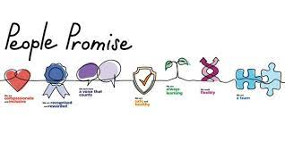

**Contents**

Glossary of Terms 3

Introduction 4

The Equality Act 2010 and the Public Sector Equality Duty (PSED) 5

The NHS Equality Delivery System (EDS 2022) 6

Our Commitment to Equality, Diversity and Inclusion (EDI) 8

Equality, Diversity and Inclusion objectives April 2024 – March 2028 9

Workforce and Patient Equality Monitoring Information 13

Appendix 1 15

## Glossary of Terms

Accessible Information Standard AIS

Black and Minority Ethnic BME

Electronic Staff Record ESR

Equality Delivery System EDS 2022/EDS

Equality, Diversity and Inclusion EDI

Gender Pay Gap GPG

Lesbian, Gay, Bisexual, Transgender, Questioning and other identities LGBTQ+

National Health Service NHS

National Health Service England NHSE

Public Sector Equality Duty PSED

Workforce Disability Equality Standard WDES

Workforce Race Equality Standard WRES

York Teaching Hospital Facilities Management YTHFM

## Introduction

York and Scarborough Teaching Hospitals NHS Foundation Trust provides a comprehensive range of acute hospital, community and specialist healthcare services for approximately 800,000 people living in and around York, North Yorkshire, North East Yorkshire and Ryedale - an area covering 3,400 square miles.

We manage 8 hospital sites and have a workforce of around 12,000 staff, inclusive of bank, substantive and fixed-term staff working across our hospitals within the community and York Teaching Hospitals Facilities Management (YTHFM).

**Our hospitals**

* [York Hospital](https://www.yorkhospitals.nhs.uk/our-hospitals/-the-york-hospital/)
* [Scarborough Hospital](https://www.yorkhospitals.nhs.uk/our-hospitals/scarborough-hospital/)
* [Bridlington Hospital](https://www.yorkhospitals.nhs.uk/our-hospitals/bridlington-hospital/)
* [Malton Hospital](https://www.yorkhospitals.nhs.uk/our-hospitals/malton-community-hospital/)
* [The New Selby War Memorial Hospital](https://www.yorkhospitals.nhs.uk/our-hospitals/the-new-selby-war-memorial-hospital/)
* [St Monica's Hospital Easingwold](https://www.yorkhospitals.nhs.uk/our-hospitals/st-monicas-easingwold/)
* [White Cross Rehabilitation Hospital](https://www.yorkhospitals.nhs.uk/our-hospitals/whitecross-court/)
* [Nelsons Court Inpatients Unit](https://www.yorkhospitals.nhs.uk/our-hospitals/nelsons-court/)

York and Scarborough Teaching Hospitals NHS Foundation Trust is a diverse employer and provider of care. Our aim is to create a culture of inclusion where everyone feels valued and respected for who they are and what they bring to our organisation. We understand that it is pivotal for our colleagues to have the best experience as this affects patient experience, safety and outcomes.

The Workforce and Service Equality Objectives, which cover the Trust are inclusive of YTHFM, have been reviewed and focus on Access, Experience and Outcomes. Action plans are in place for the Workforce Race Equality Standard (WRES), Workforce Disability Equality Standard (WDES) and the Staff Survey. The appropriate teams are involved in identifying interventions to reduce the Trust’s Gender Pay Gap (GPG) and the NHS England (NHSE) Equality, Diversity and Inclusion (EDI), six High Impact Actions are incorporated into the EDI Agenda.

## The Equality Act 2010 and the Public Sector Equality Duty (PSED)

The Equality Act 2010 introduced a general equality duty requiring organisations to have due regard in the exercising of their functions.

**These are to:**

1. Eliminate discrimination, harassment, and victimisation.
2. Advance equality of opportunity between people who share a protected characteristic and people who do not.
3. Foster good relations between people who share a protected characteristic and those who do not.

**We are required to do this by:**

1. Removing or minimising disadvantages suffered by people due to their protected characteristic.
2. Taking steps to meet the needs of people from protected groups where these are different from the needs of other people.
3. Encouraging people from protected groups to participate in public life or in other activities where their participation is disproportionately low.
4. Taking the steps needed in meeting the needs of disabled persons that are different from the needs of persons who are not disabled; and include steps to take account of disabled person’s disabilities.
5. Having due regard towards the need to foster good relations between persons who share a relevant protected characteristic and persons who do not share it, to tackle prejudice and promote understanding.

**The Protected Characteristics covered by the Equality Act 2010 are**:

* Age
* Disability
* Gender Reassignment
* Marriage and Civil partnership
* Pregnancy and Maternity
* Race
* Religion or Belief
* Sex
* Sexual Orientation

**The PSED places additional specific duties on public authorities, including NHS Trusts, these are to:**

* Publish sufficient information to demonstrate compliance with the general duty by 31 January 2012 and thereafter annually, and
* Prepare and publish 1 or more equality objectives by 6 April 2012 and no more than 4 years thereafter.

## The NHS Equality Delivery System (EDS 2022)

Implementation of the EDS 2022 is a requirement on both NHS commissioners and NHS providers.

The EDS is an improvement tool for patients, staff and leaders of the NHS. It supports NHS organisations in England - in active conversations with patients, public, staff, staff networks, community groups and trade unions - to review and develop their approach in addressing inequalities in health access, experiences, impact and outcomes through three domains: Services, Workforce Health and Wellbeing and Inclusive Leadership. It is driven by data, evidence, engagement and insight and has been amended to be brought in line with the NHS Long Term Plan, and in response to COVID-19.

Organisations must work with partners and stakeholders across the Domains. Each Outcome is to be scored based on the evidence provided. Once each Outcome has been scored an improvement plan is developed and implemented.

The Trust will continue to meet the requirements of the EDS 2022 as we recognise that this will support us in improving our delivery of care, staff experience and inclusive leadership practices.

**EDS Domain 1 - Commissioned or provided services**

**Outcome 1A**: Patients (service users) have required levels of access to the service.

**Outcome 1B**: Individual patients (service users) health needs are met.

**Outcome 1C**: When patients (service users) use the service, they are free from harm.

**Outcome 1D**: Patients (service users) report positive experiences of the service.

**EDS Domain 2** - **Workforce health and well-being**

**Outcome 2A**: When at work, staff are provided with support to manage obesity,

diabetes, asthma, COPD and mental health conditions.

**Outcome 2B**: When at work, staff are free from abuse, harassment, bullying and

physical violence from any source.

**Outcome 2C**: Staff have access to independent support and advice when suffering from

stress, abuse, bullying, harassment and physical violence from any source.

**Outcome 2D**: Staff recommend the organisation as a place to work and receive treatment.

**EDS Domain 3 - Inclusive leadership**

**Outcome 3A**: Board members, system leaders (Band 9 and VSM) and those with line

management responsibilities routinely demonstrate their understanding of,

and commitment to, equality and health inequalities.

**Outcome 3B**: Board/Committee papers (including minutes) identify equality and health

inequalities related impacts and risks and how they will be mitigated and

managed.

**Outcome 3C**: Board members, system and senior leaders (Band 9 and VSM) ensure levers

are in place to manage performance and monitor progress with staff and

patients.

## Our Commitment to Equality, Diversity and Inclusion (EDI)

York and Scarborough Teaching Hospitals NHS Foundation Trust is dedicated to

encouraging a supportive and inclusive culture where all our patients can receive high quality, person-centred healthcare which meets their needs. It is within our best interest to promote diversity and eliminate discrimination amongst our workforce in the development of services and our hospital environments. We are working hard to engage and listen to our colleagues to ensure that we continuously support the development of an inclusive culture in line with our Trust Value.

We are committed to taking our responsibilities seriously in providing equity and fairness to all our staff, ensuring we provide no less favourable treatment on the grounds of the 9 protected characteristics.

The aim of this report is to meet the requirements of the Equality Act 2010 and to move beyond compliance by creating a culture of inclusion.

**York and Scarborough Teaching Hospitals NHS Foundation Trust commits to**:

* Being an organisation that is welcoming and accessible to all.
* Ensuring that there are no barriers to accessing jobs, training or promotion.
* Engaging with patients, communities and colleagues, whilst working collaboratively with our partners and stakeholders.
* Not tolerating any forms of discrimination and will challenge it safely wherever we see it, ensuring that Equality, Diversity and Inclusion (EDI) is everybody’s business – continuing to embed our values and behavioural expectations; a ‘Just Culture’ and learning environment for all.
* Acting on staff feedback.
* Developing interventions which help our staff to understand and support one another for the benefit of each other and patients in our care.

The Trust has made good progress by providing dedicated focus on our EDI agenda. 2024 sees the Trust in a very different position to where it was previously. We acknowledge that we are still on a journey but embedding inclusive practices is of great focus for us.

Simon Morritt

Chief Executive

## Equality, Diversity and Inclusion objectives April 2024 – March 2028

Our new Equality Objectives for the period April 2024 - March 2028 are based on areas that we would like to continue to improve and those we know require some development.

The Trust’s Inclusion Forum has oversight of the progress we are making with our objectives. The Resources and Patient Experience sub-committees also review progress then the Trust’s Board of Directors provide final approval. Inclusion is integral to our strategies, policies and procedures. Our Trust engages with our staff networks to improve employment practices, supported by their Executive Director Sponsors and the Head of EDI, and are involved in the Trust’s decision-making process.

The EDI agenda is embedded into multiple teams’ schemes of work and our EDI Workstream has operational responsibility for identifying local actions and solutions.

The Trust will continue to engage with our partners, stakeholders, communities and those in regions further afield to ensure that we listen, involve, learn and act on information, advice and best practice.

|  |  |  |
| --- | --- | --- |
| **Aim** | **Objective** | **Measurable Outcome** |
| Our services are accessible to all, our workforce has equitable access, experience and outcomes. | Ensure all areas of EDI compliance are met and action plans are implemented to improve experience. NHSE EDI Improvement Plan  EDS 2022, Workforce Race and Disability Standards, Accessible Information Standard, Sexual Orientation Monitoring Standard, Gender Pay Gap. | Improvement measures/targets set by the Trust or nationally in relation to the WRES and WDES are met. (Several actions within the 2023-2025 WRES action plan include statistical targets, the one WDES target for this period has been met.) Effectiveness of all improvement interventions is to be analysed through the standards in 2025.  *Bank WRES Indicator 1 – 0.6% by 2025  WRES Indicator 2 – achieve a relative likelihood of 1  WRES Indicator 5 – 30.8%, by 2025  WRES Indicator 8 - 2.5%, by 2025  EDS Domain improvement plans are implemented, reassessed and Domain scores improved. Year on year improvement in the Gender Pay Gap.  Year on year reduction in patient experience complaints. |
| To improve the employment experiences of our ethnically diverse, Disabled and neurodiverse staff. | Implement an Anti-racism strategy, Workplace Adjustment policy and guidance on supporting neurodiverse staff. | An improvement in experiences will be measured through the WRES and WDES data within the Staff Survey.  *WRES Indicator 5 – annual decrease of 1%  WRES Indicator 6 – annual decrease of 2%  WRES Indicator 8 – annual decrease of 1.5%  WDES Indicator 8 – annual increase of 1% (in response to the 2023 Staff Survey)  Compassionate and Inclusive engagement scores – annual increase of 1% |
| To improve in the equality monitoring of people who use our services and the demographics of our communities. | Ensure the Trust’s systems can capture equality monitoring information in order to provide insight to improve access, experience and outcomes of our patients. | Data is available and accessible to inform the patient EDI agenda.  Evidence of improvement to be measured through an internal audit by Patient Access of patient records to ensure all fields have been completed. Engagement with Patient Access team Q1. Improvement trajectories for each system to be agreed Q2. |
| Foster a healthcare environment that prioritises equity, inclusivity, and improved health outcomes for all individuals, considering socio-economic, demographic, or other determinants. | Develop a plan that encompasses the overall Trust Inequality Strategy to address and mitigate health disparities within the Trust's catchment area. Implement the plan through Task and Finish groups. | Evidence-based intervention strategies to reduce health inequalities will be in place across the services identified in the Trust’s health inequalities plan, endorsed at the Patient Experience Sub-Committee in Q1.  Undertake an internal baseline audit of the Accessible Information Standards in Q3.  Accessible Information Working Group to develop an improvement plan with clear trajectories in Q4 – monitoring of the plan and actions through the Health Inequalities and Population Health Steering Group.  Evidence of improvement to be measured through the reduction in the number of complaints and concerns about accessible information – target metrics to be established in Q4.  Evidence of improvement to be measured through the reduction of complaints and concerns related to discrimination will decline – target metrics to be established in Q4. |
| Ensure the Trust complies with the Inclusive and Accessible Build Environment Strategy. | The Trust’s annual access audit schedule is progressed, the action plan maintained and workplan implemented. | Access guides are up to date, disability awareness training and the access programme is delivered and the Trust’s access plan implemented. |

**\***

**Bank WRES** - Indicator 1 Percentage of active workers by ethnic group and gender across key grades and staff groups.

**WRES -** Indicator 2 - Relative likelihood of White staff being appointed from shortlisting compared to that of BME staff being appointed from shortlisting across all posts. Indicator 5 - Percentage of staff experiencing harassment, bullying, or abuse from patients, relatives or the public in the last 12 months. Indicator 8 - In the last 12 months have you personally experienced discrimination at work from any of the following: Manager/team leaders or colleagues? **WDES** - Indicator 8 - Percentage of Disabled staff saying that their employer has made adequate adjustment(s) to enable them to carry out their work.

## Workforce and Patient Equality Monitoring Information

**Workforce**

This section focuses on internal demographics regarding staff employed by York and Scarborough Teaching Hospitals and YTHFM and has been extracted from the Electronic Service Record (ESR) on a snapshot date of 30 November 2023.

In relation to gender, our workforce is heavily made up of females which is reflective of the NHS profile. The national ESR system does not yet enable organisations to collect data on other gender identities.

There is a proportion of staff that chose not to share whether they have a religious affiliation or not and this is their right. The Trust promotes the benefits of sharing personal diversity information and will continue to do so.

Our age demographics show that there is an even spread of staff from ages 26-60, but less staff are employed below and above this. This will influence our work on apprenticeships, retirement and workforce planning.

Our sexual orientation profile shows that many staff have not disclosed their orientation and there will be different reasons for this. This will influence our EDI work on engagement, culture, psychological safety, training and equality monitoring. The LGBTQ+ Staff Network are incorporating this into their annual objectives.

The staff ethnic profile of the Trust, whilst states BME (Black and Minority Ethnic) in the pie chart is broken down further. This is important, to show the different ethnicities, but also to acknowledge and recognise that different ethnic groups have a variety of different needs and therefore should not be treated as one homogeneous group. There is only a small proportion of staff that have not shared their ethnicity. The WRES annual report goes into detail about their experiences.

The ethnic groups that are more represented than others are White, Black or Black British African, and the Asian or Asian British categories. This is likely to be reflective of our localities with the some BME groups being in situ due to international recruitment and representation in certain professions.

There has been an increase in staff sharing their disability identity, it is important to continue to support staff so this is incorporated in our equality monitoring work and WDES action plan.

Our marital status and civil partnership data shows that a high percentage of staff either identify as married or single. This will continue to influence the development of policies.

The Trust’s workforce equality monitoring data can be found in Appendix 1.

**Patient**

The Trust acknowledges that its systems need to improve in capturing patient equality monitoring information and correlate it with information about the communities we serve. This will be included in in future PSED reports once available. However, a link to the following app [Microsoft Power BI](https://app.powerbi.com/view?r=eyJrIjoiODZmNGQ0YzItZDAwZi00MzFiLWE4NzAtMzVmNTUwMThmMTVlIiwidCI6ImVlNGUxNDk5LTRhMzUtNGIyZS1hZDQ3LTVmM2NmOWRlODY2NiIsImMiOjh9) provides information on the Trust’s catchment populations and segregates the data in terms of age, gender and ethnicity.

## Appendix 1

**Public Sector Equality Duty, Workforce Equality Monitoring Information**

**Workforce Equality Monitoring Information**

The below data covers York & Scarborough Teaching Hospitals, York Teaching Hospital Facilities Management (YTHFM) LLP and Bank workers.

* **Staff in post headcount = 12,281**

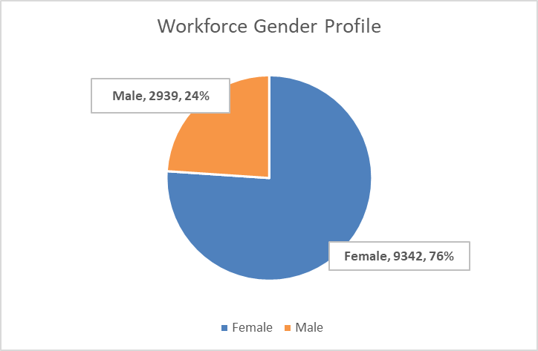

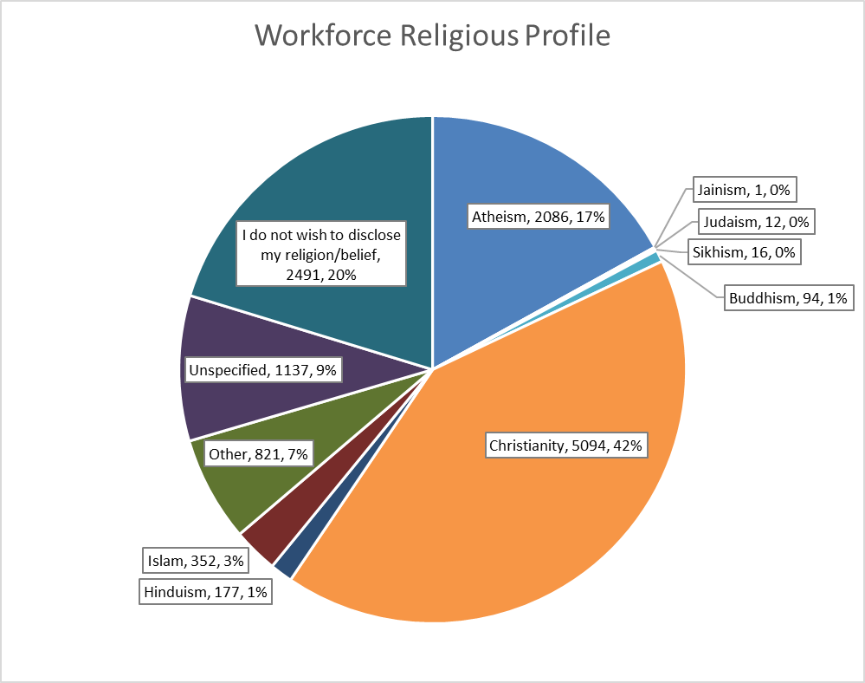

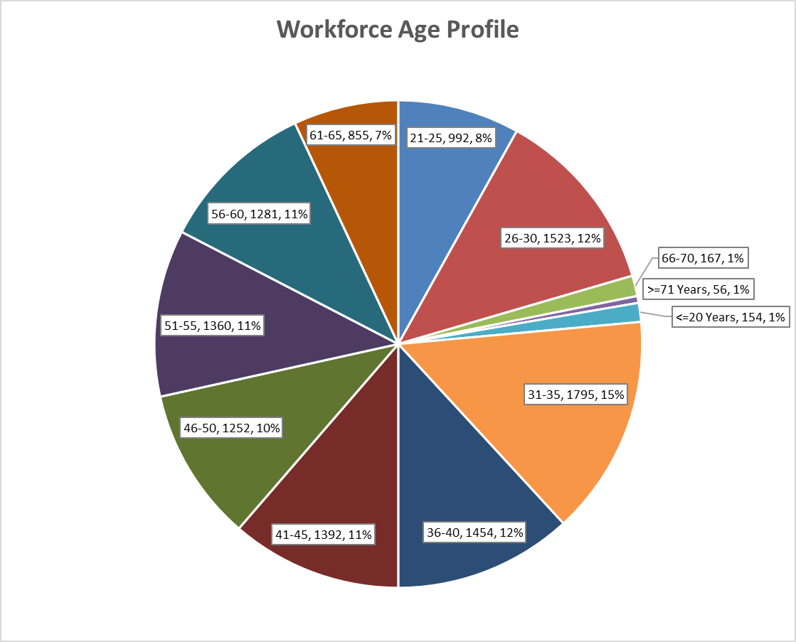

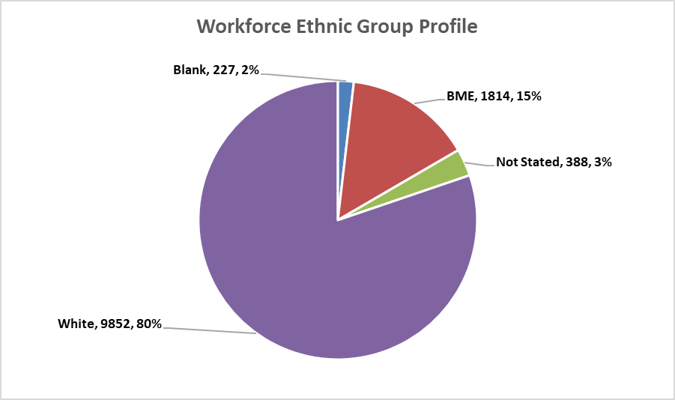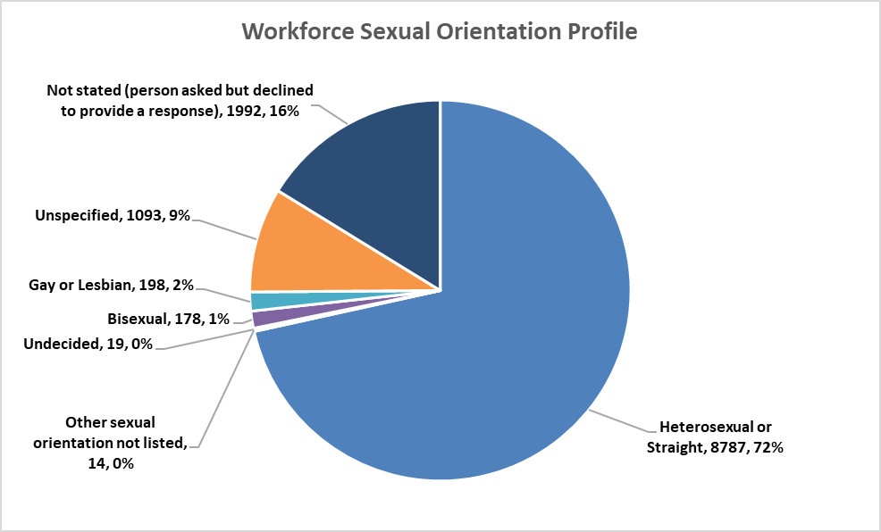

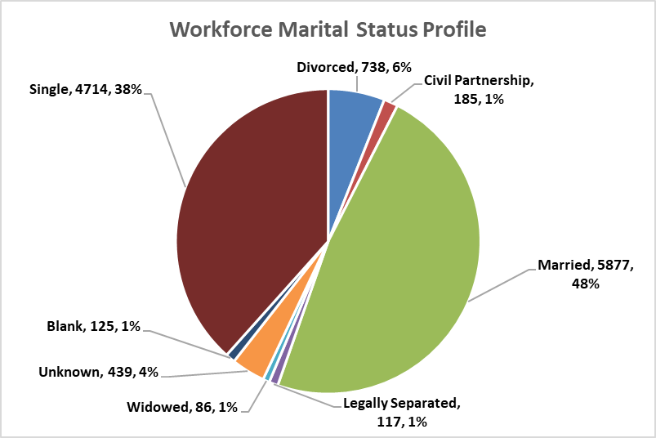

|  |  |  |
| --- | --- | --- |
| **Ethnic Origin** | **Headcount** | **Origin vs Total (%)** |
| Any Other Ethnic Group | 170 | 1.38% |
| Asian British | 9 | 0.07% |
| Asian Mixed | 3 | 0.02% |
| Asian or Asian British - Any other Asian background | 266 | 2.17% |
| Asian or Asian British - Bangladeshi | 23 | 0.19% |
| Asian or Asian British - Indian | 448 | 3.65% |
| Asian or Asian British - Pakistani | 63 | 0.51% |
| Asian Sinhalese | 2 | 0.02% |
| Asian Sri Lankan | 2 | 0.02% |
| Asian Unspecified | 3 | 0.02% |
| Black British | 3 | 0.02% |
| Black Mixed | 1 | 0.01% |
| Black Nigerian | 14 | 0.11% |
| Black or Black British - African | 466 | 3.79% |
| Black or Black British - Any other Black background | 22 | 0.18% |
| Black or Black British - Caribbean | 29 | 0.24% |
| Black Unspecified | 1 | 0.01% |
| Chinese | 64 | 0.52% |
| Filipino | 50 | 0.41% |
| Malaysian | 2 | 0.02% |
| Mixed - Any other mixed background | 22 | 0.18% |
| Mixed - Asian & Chinese | 2 | 0.02% |
| Mixed - Black & White | 1 | 0.01% |
| Mixed - Other/Unspecified | 20 | 0.16% |
| Mixed - White & Asian | 51 | 0.42% |
| Mixed - White & Black African | 53 | 0.43% |
| Mixed - White & Black Caribbean | 20 | 0.16% |
| Not Stated | 388 | 3.16% |
| Other Specified | 4 | 0.03% |
| Unspecified | 227 | 1.85% |
| White - Any other White background | 359 | 2.92% |
| White - British | 8718 | 70.99% |
| White - Irish | 68 | 0.55% |
| White Cypriot (non specific) | 1 | 0.01% |
| White English | 366 | 2.98% |
| White Greek | 5 | 0.04% |
| White Italian | 2 | 0.02% |
| White Mixed | 3 | 0.02% |
| White Northern Irish | 8 | 0.07% |
| White Other European | 73 | 0.59% |
| White Other Ex-Yugoslav | 2 | 0.02% |
| White Polish | 67 | 0.55% |
| White Scottish | 15 | 0.12% |
| White Serbian | 2 | 0.02% |
| White Turkish | 3 | 0.02% |
| White Unspecified | 157 | 1.28% |
| White Welsh | 3 | 0.02% |
| **Grand Total** | **12281** | **100.00%** |

|  |  |  |
| --- | --- | --- |
| **Care Group Area vs Employee Gender** | **Headcount of Gender** | **Percentage of Gender** |
| **419 CG Cancer Specialist & Clinical Support Services Group** | **2244** | **18.27%** |
| Female | 1742 | 14.18% |
| Male | 502 | 4.09% |
| **419 CG Chairman & Chief Executives Office Group** | **58** | **0.47%** |
| Female | 49 | 0.40% |
| Male | 9 | 0.07% |
| **419 CG Chief Nurse Team** | **121** | **0.99%** |
| Female | 87 | 0.71% |
| Male | 34 | 0.28% |
| **419 CG Corporate Services** | **32** | **0.26%** |
| Female | 24 | 0.20% |
| Male | 8 | 0.07% |
| **419 CG Digital Information Services Group** | **253** | **2.06%** |
| Female | 132 | 1.07% |
| Male | 121 | 0.99% |
| **419 CG Family Health Care Group** | **954** | **7.77%** |
| Female | 898 | 7.31% |
| Male | 56 | 0.46% |
| **419 CG Finance Group** | **224** | **1.82%** |
| Female | 137 | 1.12% |
| Male | 87 | 0.71% |
| **419 CG Medical Governance Group** | **62** | **0.50%** |
| Female | 46 | 0.37% |
| Male | 16 | 0.13% |
| **419 CG Medicine** | **3068** | **24.98%** |
| Female | 2478 | 20.18% |
| Male | 590 | 4.80% |
| **419 CG Operations Management Group** | **237** | **1.93%** |
| Female | 211 | 1.72% |
| Male | 26 | 0.21% |
| **419 CG Surgery** | **1936** | **15.76%** |
| Female | 1457 | 11.86% |
| Male | 479 | 3.90% |
| **419 CG Workforce and Organisational Development group** | **1776** | **14.46%** |
| Female | 1340 | 10.91% |
| Male | 436 | 3.55% |
| **419 LLP CG Estates & Facilities** | **1316** | **10.72%** |
| Female | 741 | 6.03% |
| Male | 575 | 4.68% |
| **Grand Total** | **12281** | **100.00%** |

|  |  |  |
| --- | --- | --- |
| **Care Group Area vs Religion** | **Headcount of  Religious Belief** | **Percentage of  Religious Belief** |
| **419 CG Cancer Specialist & Clinical Support Services Group** | **2244** | **18.27%** |
| Atheism | 436 | 3.55% |
| Buddhism | 14 | 0.11% |
| Christianity | 896 | 7.30% |
| Hinduism | 24 | 0.20% |
| I do not wish to disclose my religion/belief | 393 | 3.20% |
| Islam | 55 | 0.45% |
| Judaism | 4 | 0.03% |
| Other | 159 | 1.29% |
| Sikhism | 4 | 0.03% |
| Unspecified | 259 | 2.11% |
| **419 CG Chairman & Chief Executives Office Group** | **58** | **0.47%** |
| Atheism | 14 | 0.11% |
| Buddhism | 1 | 0.01% |
| Christianity | 25 | 0.20% |
| I do not wish to disclose my religion/belief | 11 | 0.09% |
| Other | 3 | 0.02% |
| Unspecified | 4 | 0.03% |
| **419 CG Chief Nurse Team** | **121** | **0.99%** |
| Atheism | 19 | 0.15% |
| Buddhism | 1 | 0.01% |
| Christianity | 66 | 0.54% |
| Hinduism | 1 | 0.01% |
| I do not wish to disclose my religion/belief | 23 | 0.19% |
| Other | 7 | 0.06% |
| Unspecified | 4 | 0.03% |
| **419 CG Corporate Services** | **32** | **0.26%** |
| Atheism | 4 | 0.03% |
| Christianity | 14 | 0.11% |
| I do not wish to disclose my religion/belief | 6 | 0.05% |
| Other | 1 | 0.01% |
| Unspecified | 7 | 0.06% |
| **419 CG Digital Information Services Group** | **253** | **2.06%** |
| Atheism | 61 | 0.50% |
| Buddhism | 1 | 0.01% |
| Christianity | 94 | 0.77% |
| Hinduism | 1 | 0.01% |
| I do not wish to disclose my religion/belief | 33 | 0.27% |
| Islam | 1 | 0.01% |
| Judaism | 1 | 0.01% |
| Other | 12 | 0.10% |
| Unspecified | 49 | 0.40% |
| **419 CG Family Health Care Group** | **954** | **7.77%** |
| Atheism | 196 | 1.60% |
| Buddhism | 4 | 0.03% |
| Christianity | 390 | 3.18% |
| Hinduism | 9 | 0.07% |
| I do not wish to disclose my religion/belief | 161 | 1.31% |
| Islam | 23 | 0.19% |
| Other | 71 | 0.58% |
| Sikhism | 2 | 0.02% |
| Unspecified | 98 | 0.80% |
| **419 CG Finance Group** | **224** | **1.82%** |
| Atheism | 45 | 0.37% |
| Christianity | 92 | 0.75% |
| I do not wish to disclose my religion/belief | 36 | 0.29% |
| Islam | 8 | 0.07% |
| Other | 15 | 0.12% |
| Sikhism | 1 | 0.01% |
| Unspecified | 27 | 0.22% |
| **419 CG Medical Governance Group** | **62** | **0.50%** |
| Atheism | 14 | 0.11% |
| Buddhism | 2 | 0.02% |
| Christianity | 26 | 0.21% |
| I do not wish to disclose my religion/belief | 11 | 0.09% |
| Islam | 3 | 0.02% |
| Other | 2 | 0.02% |
| Unspecified | 4 | 0.03% |
| **419 CG Medicine** | **3068** | **24.98%** |
| Atheism | 441 | 3.59% |
| Buddhism | 38 | 0.31% |
| Christianity | 1425 | 11.60% |
| Hinduism | 69 | 0.56% |
| I do not wish to disclose my religion/belief | 539 | 4.39% |
| Islam | 113 | 0.92% |
| Judaism | 4 | 0.03% |
| Other | 192 | 1.56% |
| Sikhism | 3 | 0.02% |
| Unspecified | 244 | 1.99% |
| **419 CG Operations Management Group** | **237** | **1.93%** |
| Atheism | 43 | 0.35% |
| Buddhism | 1 | 0.01% |
| Christianity | 107 | 0.87% |
| I do not wish to disclose my religion/belief | 48 | 0.39% |
| Other | 21 | 0.17% |
| Unspecified | 17 | 0.14% |
| **419 CG Surgery** | **1936** | **15.76%** |
| Atheism | 331 | 2.70% |
| Buddhism | 9 | 0.07% |
| Christianity | 781 | 6.36% |
| Hinduism | 43 | 0.35% |
| I do not wish to disclose my religion/belief | 369 | 3.00% |
| Islam | 66 | 0.54% |
| Other | 107 | 0.87% |
| Sikhism | 2 | 0.02% |
| Unspecified | 228 | 1.86% |
| **419 CG Workforce and Organisational Development group** | **1776** | **14.46%** |
| Atheism | 318 | 2.59% |
| Buddhism | 20 | 0.16% |
| Christianity | 636 | 5.18% |
| Hinduism | 24 | 0.20% |
| I do not wish to disclose my religion/belief | 384 | 3.13% |
| Islam | 69 | 0.56% |
| Jainism | 1 | 0.01% |
| Judaism | 3 | 0.02% |
| Other | 141 | 1.15% |
| Sikhism | 4 | 0.03% |
| Unspecified | 176 | 1.43% |
| **419 LLP CG Estates & Facilities** | **1316** | **10.72%** |
| Atheism | 164 | 1.34% |
| Buddhism | 3 | 0.02% |
| Christianity | 542 | 4.41% |
| Hinduism | 6 | 0.05% |
| I do not wish to disclose my religion/belief | 477 | 3.88% |
| Islam | 14 | 0.11% |
| Other | 90 | 0.73% |
| Unspecified | 20 | 0.16% |
| **Grand Total** | **12281** | **100.00%** |

|  |  |  |
| --- | --- | --- |
| **Care Group Area vs Age** | **Headcount  of Age** | **Percentage  of Age** |
| **419 CG Cancer Specialist & Clinical Support Services Group** | **2244** | **18.27%** |
| <=20 Years | 12 | 0.10% |
| >=71 Years | 10 | 0.08% |
| 21-25 | 147 | 1.20% |
| 26-30 | 237 | 1.93% |
| 31-35 | 289 | 2.35% |
| 36-40 | 309 | 2.52% |
| 41-45 | 298 | 2.43% |
| 46-50 | 248 | 2.02% |
| 51-55 | 270 | 2.20% |
| 56-60 | 242 | 1.97% |
| 61-65 | 161 | 1.31% |
| 66-70 | 21 | 0.17% |
| **419 CG Chairman & Chief Executives Office Group** | **58** | **0.47%** |
| 26-30 | 7 | 0.06% |
| 31-35 | 3 | 0.02% |
| 36-40 | 9 | 0.07% |
| 41-45 | 12 | 0.10% |
| 46-50 | 6 | 0.05% |
| 51-55 | 5 | 0.04% |
| 56-60 | 10 | 0.08% |
| 61-65 | 3 | 0.02% |
| 66-70 | 3 | 0.02% |
| **419 CG Chief Nurse Team** | **121** | **0.99%** |
| >=71 Years | 2 | 0.02% |
| 21-25 | 1 | 0.01% |
| 26-30 | 5 | 0.04% |
| 31-35 | 12 | 0.10% |
| 36-40 | 11 | 0.09% |
| 41-45 | 15 | 0.12% |
| 46-50 | 19 | 0.15% |
| 51-55 | 23 | 0.19% |
| 56-60 | 21 | 0.17% |
| 61-65 | 11 | 0.09% |
| 66-70 | 1 | 0.01% |
| **419 CG Corporate Services** | **32** | **0.26%** |
| 26-30 | 2 | 0.02% |
| 31-35 | 4 | 0.03% |
| 36-40 | 3 | 0.02% |
| 41-45 | 4 | 0.03% |
| 46-50 | 4 | 0.03% |
| 51-55 | 6 | 0.05% |
| 56-60 | 8 | 0.07% |
| 61-65 | 1 | 0.01% |
| **419 CG Digital Information Services Group** | **253** | **2.06%** |
| >=71 Years | 1 | 0.01% |
| 21-25 | 8 | 0.07% |
| 26-30 | 24 | 0.20% |
| 31-35 | 35 | 0.28% |
| 36-40 | 30 | 0.24% |
| 41-45 | 28 | 0.23% |
| 46-50 | 29 | 0.24% |
| 51-55 | 42 | 0.34% |
| 56-60 | 29 | 0.24% |
| 61-65 | 25 | 0.20% |
| 66-70 | 2 | 0.02% |
| **419 CG Family Health Care Group** | **954** | **7.77%** |
| <=20 Years | 2 | 0.02% |
| 21-25 | 86 | 0.70% |
| 26-30 | 119 | 0.97% |
| 31-35 | 148 | 1.21% |
| 36-40 | 148 | 1.21% |
| 41-45 | 128 | 1.04% |
| 46-50 | 91 | 0.74% |
| 51-55 | 92 | 0.75% |
| 56-60 | 90 | 0.73% |
| 61-65 | 43 | 0.35% |
| 66-70 | 7 | 0.06% |
| **419 CG Finance Group** | **224** | **1.82%** |
| 21-25 | 11 | 0.09% |
| 26-30 | 12 | 0.10% |
| 31-35 | 31 | 0.25% |
| 36-40 | 19 | 0.15% |
| 41-45 | 27 | 0.22% |
| 46-50 | 26 | 0.21% |
| 51-55 | 41 | 0.33% |
| 56-60 | 35 | 0.28% |
| 61-65 | 20 | 0.16% |
| 66-70 | 2 | 0.02% |
| **419 CG Medical Governance Group** | **62** | **0.50%** |
| 21-25 | 10 | 0.08% |
| 26-30 | 18 | 0.15% |
| 31-35 | 8 | 0.07% |
| 36-40 | 7 | 0.06% |
| 41-45 | 2 | 0.02% |
| 46-50 | 8 | 0.07% |
| 51-55 | 5 | 0.04% |
| 56-60 | 3 | 0.02% |
| 61-65 | 1 | 0.01% |
| **419 CG Medicine** | **3068** | **24.98%** |
| <=20 Years | 35 | 0.28% |
| >=71 Years | 11 | 0.09% |
| 21-25 | 297 | 2.42% |
| 26-30 | 440 | 3.58% |
| 31-35 | 503 | 4.10% |
| 36-40 | 347 | 2.83% |
| 41-45 | 336 | 2.74% |
| 46-50 | 335 | 2.73% |
| 51-55 | 320 | 2.61% |
| 56-60 | 250 | 2.04% |
| 61-65 | 164 | 1.34% |
| 66-70 | 30 | 0.24% |
| **419 CG Operations Management Group** | **237** | **1.93%** |
| <=20 Years | 1 | 0.01% |
| >=71 Years | 1 | 0.01% |
| 21-25 | 9 | 0.07% |
| 26-30 | 21 | 0.17% |
| 31-35 | 29 | 0.24% |
| 36-40 | 26 | 0.21% |
| 41-45 | 21 | 0.17% |
| 46-50 | 23 | 0.19% |
| 51-55 | 39 | 0.32% |
| 56-60 | 45 | 0.37% |
| 61-65 | 21 | 0.17% |
| 66-70 | 1 | 0.01% |
| **419 CG Surgery** | **1936** | **15.76%** |
| <=20 Years | 19 | 0.15% |
| >=71 Years | 5 | 0.04% |
| 21-25 | 164 | 1.34% |
| 26-30 | 255 | 2.08% |
| 31-35 | 285 | 2.32% |
| 36-40 | 207 | 1.69% |
| 41-45 | 223 | 1.82% |
| 46-50 | 214 | 1.74% |
| 51-55 | 219 | 1.78% |
| 56-60 | 200 | 1.63% |
| 61-65 | 125 | 1.02% |
| 66-70 | 20 | 0.16% |
| **419 CG Workforce and Organisational Development group** | **1776** | **14.46%** |
| <=20 Years | 58 | 0.47% |
| >=71 Years | 12 | 0.10% |
| 21-25 | 191 | 1.56% |
| 26-30 | 297 | 2.42% |
| 31-35 | 330 | 2.69% |
| 36-40 | 191 | 1.56% |
| 41-45 | 154 | 1.25% |
| 46-50 | 121 | 0.99% |
| 51-55 | 132 | 1.07% |
| 56-60 | 132 | 1.07% |
| 61-65 | 119 | 0.97% |
| 66-70 | 39 | 0.32% |
| **419 LLP CG Estates & Facilities** | **1316** | **10.72%** |
| <=20 Years | 27 | 0.22% |
| >=71 Years | 14 | 0.11% |
| 21-25 | 68 | 0.55% |
| 26-30 | 86 | 0.70% |
| 31-35 | 118 | 0.96% |
| 36-40 | 147 | 1.20% |
| 41-45 | 144 | 1.17% |
| 46-50 | 128 | 1.04% |
| 51-55 | 166 | 1.35% |
| 56-60 | 216 | 1.76% |
| 61-65 | 161 | 1.31% |
| 66-70 | 41 | 0.33% |
| **Grand Total** | **12281** | **100.00%** |

|  |  |  |
| --- | --- | --- |
| **Care Group Area vs Sexual Orientation** | **Headcount of  Sexual Orientation** | **Percentage of  Sexual Orientation** |
| **419 CG Cancer Specialist & Clinical Support Services Group** | **2244** | **18.27%** |
| Bisexual | 35 | 0.28% |
| Gay or Lesbian | 49 | 0.40% |
| Heterosexual or Straight | 1585 | 12.91% |
| Not stated (person asked but declined to provide a response) | 315 | 2.56% |
| Other sexual orientation not listed | 3 | 0.02% |
| Undecided | 7 | 0.06% |
| Unspecified | 250 | 2.04% |
| **419 CG Chairman & Chief Executives Office Group** | **58** | **0.47%** |
| Bisexual | 2 | 0.02% |
| Gay or Lesbian | 2 | 0.02% |
| Heterosexual or Straight | 45 | 0.37% |
| Not stated (person asked but declined to provide a response) | 5 | 0.04% |
| Unspecified | 4 | 0.03% |
| **419 CG Chief Nurse Team** | **121** | **0.99%** |
| Gay or Lesbian | 5 | 0.04% |
| Heterosexual or Straight | 100 | 0.81% |
| Not stated (person asked but declined to provide a response) | 12 | 0.10% |
| Unspecified | 4 | 0.03% |
| **419 CG Corporate Services** | **32** | **0.26%** |
| Heterosexual or Straight | 21 | 0.17% |
| Not stated (person asked but declined to provide a response) | 4 | 0.03% |
| Unspecified | 7 | 0.06% |
| **419 CG Digital Information Services Group** | **253** | **2.06%** |
| Bisexual | 6 | 0.05% |
| Gay or Lesbian | 7 | 0.06% |
| Heterosexual or Straight | 173 | 1.41% |
| Not stated (person asked but declined to provide a response) | 19 | 0.15% |
| Unspecified | 48 | 0.39% |
| **419 CG Family Health Care Group** | **954** | **7.77%** |
| Bisexual | 13 | 0.11% |
| Gay or Lesbian | 10 | 0.08% |
| Heterosexual or Straight | 702 | 5.72% |
| Not stated (person asked but declined to provide a response) | 132 | 1.07% |
| Undecided | 1 | 0.01% |
| Unspecified | 96 | 0.78% |
| **419 CG Finance Group** | **224** | **1.82%** |
| Bisexual | 2 | 0.02% |
| Gay or Lesbian | 3 | 0.02% |
| Heterosexual or Straight | 166 | 1.35% |
| Not stated (person asked but declined to provide a response) | 24 | 0.20% |
| Other sexual orientation not listed | 2 | 0.02% |
| Unspecified | 27 | 0.22% |
| **419 CG Medical Governance Group** | **62** | **0.50%** |
| Bisexual | 4 | 0.03% |
| Gay or Lesbian | 2 | 0.02% |
| Heterosexual or Straight | 45 | 0.37% |
| Not stated (person asked but declined to provide a response) | 8 | 0.07% |
| Unspecified | 3 | 0.02% |
| **419 CG Medicine** | **3068** | **24.98%** |
| Bisexual | 42 | 0.34% |
| Gay or Lesbian | 48 | 0.39% |
| Heterosexual or Straight | 2310 | 18.81% |
| Not stated (person asked but declined to provide a response) | 433 | 3.53% |
| Other sexual orientation not listed | 3 | 0.02% |
| Undecided | 4 | 0.03% |
| Unspecified | 228 | 1.86% |
| **419 CG Operations Management Group** | **237** | **1.93%** |
| Bisexual | 2 | 0.02% |
| Gay or Lesbian | 5 | 0.04% |
| Heterosexual or Straight | 184 | 1.50% |
| Not stated (person asked but declined to provide a response) | 30 | 0.24% |
| Unspecified | 16 | 0.13% |
| **419 CG Surgery** | **1936** | **15.76%** |
| Bisexual | 16 | 0.13% |
| Gay or Lesbian | 22 | 0.18% |
| Heterosexual or Straight | 1328 | 10.81% |
| Not stated (person asked but declined to provide a response) | 344 | 2.80% |
| Other sexual orientation not listed | 1 | 0.01% |
| Undecided | 3 | 0.02% |
| Unspecified | 222 | 1.81% |
| **419 CG Workforce and Organisational Development group** | **1776** | **14.46%** |
| Bisexual | 45 | 0.37% |
| Gay or Lesbian | 28 | 0.23% |
| Heterosexual or Straight | 1244 | 10.13% |
| Not stated (person asked but declined to provide a response) | 282 | 2.30% |
| Other sexual orientation not listed | 4 | 0.03% |
| Undecided | 2 | 0.02% |
| Unspecified | 171 | 1.39% |
| **419 LLP CG Estates & Facilities** | **1316** | **10.72%** |
| Bisexual | 11 | 0.09% |
| Gay or Lesbian | 17 | 0.14% |
| Heterosexual or Straight | 884 | 7.20% |
| Not stated (person asked but declined to provide a response) | 384 | 3.13% |
| Other sexual orientation not listed | 1 | 0.01% |
| Undecided | 2 | 0.02% |
| Unspecified | 17 | 0.14% |
| **Grand Total** | **12281** | **100.00%** |

|  |  |  |
| --- | --- | --- |
| **Care Group Area vs Disability** | **Headcount  of Disability** | **Percentage  of Disability** |
| **419 CG Cancer Specialist & Clinical Support Services Group** | **2244** | **18.27%** |
| No | 1693 | 13.79% |
| Not Declared | 99 | 0.81% |
| Unspecified | 366 | 2.98% |
| Yes | 86 | 0.70% |
| **419 CG Chairman & Chief Executives Office Group** | **58** | **0.47%** |
| No | 49 | 0.40% |
| Unspecified | 6 | 0.05% |
| Yes | 3 | 0.02% |
| **419 CG Chief Nurse Team** | **121** | **0.99%** |
| No | 100 | 0.81% |
| Not Declared | 2 | 0.02% |
| Unspecified | 10 | 0.08% |
| Yes | 9 | 0.07% |
| **419 CG Corporate Services** | **32** | **0.26%** |
| No | 22 | 0.18% |
| Unspecified | 9 | 0.07% |
| Yes | 1 | 0.01% |
| **419 CG Digital Information Services Group** | **253** | **2.06%** |
| No | 175 | 1.42% |
| Not Declared | 3 | 0.02% |
| Unspecified | 57 | 0.46% |
| Yes | 18 | 0.15% |
| **419 CG Family Health Care Group** | **954** | **7.77%** |
| No | 753 | 6.13% |
| Not Declared | 15 | 0.12% |
| Unspecified | 143 | 1.16% |
| Yes | 43 | 0.35% |
| **419 CG Finance Group** | **224** | **1.82%** |
| No | 170 | 1.38% |
| Unspecified | 42 | 0.34% |
| Yes | 12 | 0.10% |
| **419 CG Medical Governance Group** | **62** | **0.50%** |
| No | 52 | 0.42% |
| Not Declared | 3 | 0.02% |
| Unspecified | 6 | 0.05% |
| Yes | 1 | 0.01% |
| **419 CG Medicine** | **3068** | **24.98%** |
| No | 2503 | 20.38% |
| Not Declared | 91 | 0.74% |
| Prefer Not To Answer | 1 | 0.01% |
| Unspecified | 371 | 3.02% |
| Yes | 102 | 0.83% |
| **419 CG Operations Management Group** | **237** | **1.93%** |
| No | 194 | 1.58% |
| Not Declared | 7 | 0.06% |
| Prefer Not To Answer | 1 | 0.01% |
| Unspecified | 28 | 0.23% |
| Yes | 7 | 0.06% |
| **419 CG Surgery** | **1936** | **15.76%** |
| No | 1521 | 12.38% |
| Not Declared | 36 | 0.29% |
| Prefer Not To Answer | 2 | 0.02% |
| Unspecified | 313 | 2.55% |
| Yes | 64 | 0.52% |
| **419 CG Workforce and Organisational Development group** | **1776** | **14.46%** |
| No | 1435 | 11.68% |
| Not Declared | 30 | 0.24% |
| Prefer Not To Answer | 2 | 0.02% |
| Unspecified | 233 | 1.90% |
| Yes | 76 | 0.62% |
| **419 LLP CG Estates & Facilities** | **1316** | **10.72%** |
| No | 1203 | 9.80% |
| Not Declared | 36 | 0.29% |
| Prefer Not To Answer | 2 | 0.02% |
| Unspecified | 29 | 0.24% |
| Yes | 46 | 0.37% |
| **Grand Total** | **12281** | **100.00%** |

|  |  |  |
| --- | --- | --- |
| **Care Group Area vs Ethnic Group** | **Headcount of  Ethnic Group** | **Percentage of  Ethnic Group** |
| **419 CG Cancer Specialist & Clinical Support Services Group** | **2244** | **18.27%** |
| Blank | 31 | 0.25% |
| BME | 243 | 1.98% |
| Not Stated | 56 | 0.46% |
| White | 1914 | 15.59% |
| **419 CG Chairman & Chief Executives Office Group** | **58** | **0.47%** |
| Blank | 2 | 0.02% |
| BME | 3 | 0.02% |
| Not Stated | 1 | 0.01% |
| White | 52 | 0.42% |
| **419 CG Chief Nurse Team** | **121** | **0.99%** |
| BME | 6 | 0.05% |
| Not Stated | 2 | 0.02% |
| White | 113 | 0.92% |
| **419 CG Corporate Services** | **32** | **0.26%** |
| BME | 1 | 0.01% |
| Not Stated | 1 | 0.01% |
| White | 30 | 0.24% |
| **419 CG Digital Information Services Group** | **253** | **2.06%** |
| Blank | 1 | 0.01% |
| BME | 14 | 0.11% |
| Not Stated | 4 | 0.03% |
| White | 234 | 1.91% |
| **419 CG Family Health Care Group** | **954** | **7.77%** |
| Blank | 7 | 0.06% |
| BME | 84 | 0.68% |
| Not Stated | 13 | 0.11% |
| White | 850 | 6.92% |
| **419 CG Finance Group** | **224** | **1.82%** |
| BME | 14 | 0.11% |
| Not Stated | 3 | 0.02% |
| White | 207 | 1.69% |
| **419 CG Medical Governance Group** | **62** | **0.50%** |
| Blank | 2 | 0.02% |
| BME | 10 | 0.08% |
| Not Stated | 2 | 0.02% |
| White | 48 | 0.39% |
| **419 CG Medicine** | **3068** | **24.98%** |
| Blank | 64 | 0.52% |
| BME | 712 | 5.80% |
| Not Stated | 82 | 0.67% |
| White | 2210 | 18.00% |
| **419 CG Operations Management Group** | **237** | **1.93%** |
| Blank | 1 | 0.01% |
| BME | 4 | 0.03% |
| Not Stated | 3 | 0.02% |
| White | 229 | 1.86% |
| **419 CG Surgery** | **1936** | **15.76%** |
| Blank | 26 | 0.21% |
| BME | 356 | 2.90% |
| Not Stated | 96 | 0.78% |
| White | 1458 | 11.87% |
| **419 CG Workforce and Organisational Development group** | **1776** | **14.46%** |
| Blank | 69 | 0.56% |
| BME | 291 | 2.37% |
| Not Stated | 79 | 0.64% |
| White | 1337 | 10.89% |
| **419 LLP CG Estates & Facilities** | **1316** | **10.72%** |
| Blank | 24 | 0.20% |
| BME | 76 | 0.62% |
| Not Stated | 46 | 0.37% |
| White | 1170 | 9.53% |
| **Grand Total** | **12281** | **100.00%** |

|  |  |  |
| --- | --- | --- |
| **Care Group Area vs Marital Status** | **Headcount of  Marital Status** | **Percentage of  Marital Status** |
| **419 CG Cancer Specialist & Clinical Support Services Group** | **2244** | **18.27%** |
| Civil Partnership | 32 | 0.26% |
| Divorced | 128 | 1.04% |
| Legally Separated | 20 | 0.16% |
| Married | 1124 | 9.15% |
| Single | 835 | 6.80% |
| Unknown | 77 | 0.63% |
| Widowed | 16 | 0.13% |
| Blank | 12 | 0.10% |
| **419 CG Chairman & Chief Executives Office Group** | **58** | **0.47%** |
| Divorced | 3 | 0.02% |
| Married | 42 | 0.34% |
| Single | 13 | 0.11% |
| **419 CG Chief Nurse Team** | **121** | **0.99%** |
| Civil Partnership | 1 | 0.01% |
| Divorced | 9 | 0.07% |
| Legally Separated | 2 | 0.02% |
| Married | 80 | 0.65% |
| Single | 24 | 0.20% |
| Unknown | 4 | 0.03% |
| Widowed | 1 | 0.01% |
| **419 CG Corporate Services** | **32** | **0.26%** |
| Divorced | 3 | 0.02% |
| Married | 20 | 0.16% |
| Single | 7 | 0.06% |
| Unknown | 2 | 0.02% |
| **419 CG Digital Information Services Group** | **253** | **2.06%** |
| Civil Partnership | 2 | 0.02% |
| Divorced | 12 | 0.10% |
| Legally Separated | 3 | 0.02% |
| Married | 135 | 1.10% |
| Single | 95 | 0.77% |
| Unknown | 4 | 0.03% |
| Widowed | 1 | 0.01% |
| Blank | 1 | 0.01% |
| **419 CG Family Health Care Group** | **954** | **7.77%** |
| Civil Partnership | 12 | 0.10% |
| Divorced | 54 | 0.44% |
| Legally Separated | 5 | 0.04% |
| Married | 498 | 4.06% |
| Single | 352 | 2.87% |
| Unknown | 26 | 0.21% |
| Widowed | 3 | 0.02% |
| Blank | 4 | 0.03% |
| **419 CG Finance Group** | **224** | **1.82%** |
| Divorced | 22 | 0.18% |
| Legally Separated | 2 | 0.02% |
| Married | 117 | 0.95% |
| Single | 74 | 0.60% |
| Unknown | 6 | 0.05% |
| Widowed | 3 | 0.02% |
| **419 CG Medical Governance Group** | **62** | **0.50%** |
| Civil Partnership | 1 | 0.01% |
| Divorced | 1 | 0.01% |
| Married | 21 | 0.17% |
| Single | 35 | 0.28% |
| Unknown | 2 | 0.02% |
| Blank | 2 | 0.02% |
| **419 CG Medicine** | **3068** | **24.98%** |
| Civil Partnership | 40 | 0.33% |
| Divorced | 185 | 1.51% |
| Legally Separated | 23 | 0.19% |
| Married | 1499 | 12.21% |
| Single | 1185 | 9.65% |
| Unknown | 88 | 0.72% |
| Widowed | 21 | 0.17% |
| Blank | 27 | 0.22% |
| **419 CG Operations Management Group** | **237** | **1.93%** |
| Civil Partnership | 4 | 0.03% |
| Divorced | 27 | 0.22% |
| Legally Separated | 4 | 0.03% |
| Married | 121 | 0.99% |
| Single | 66 | 0.54% |
| Unknown | 13 | 0.11% |
| Widowed | 2 | 0.02% |
| **419 CG Surgery** | **1936** | **15.76%** |
| Civil Partnership | 15 | 0.12% |
| Divorced | 93 | 0.76% |
| Legally Separated | 18 | 0.15% |
| Married | 983 | 8.00% |
| Single | 719 | 5.85% |
| Unknown | 80 | 0.65% |
| Widowed | 7 | 0.06% |
| Blank | 21 | 0.17% |
| **419 CG Workforce and Organisational Development group** | **1776** | **14.46%** |
| Civil Partnership | 23 | 0.19% |
| Divorced | 102 | 0.83% |
| Legally Separated | 15 | 0.12% |
| Married | 699 | 5.69% |
| Single | 823 | 6.70% |
| Unknown | 71 | 0.58% |
| Widowed | 15 | 0.12% |
| Blank | 28 | 0.23% |
| **419 LLP CG Estates & Facilities** | **1316** | **10.72%** |
| Civil Partnership | 55 | 0.45% |
| Divorced | 99 | 0.81% |
| Legally Separated | 25 | 0.20% |
| Married | 538 | 4.38% |
| Single | 486 | 3.96% |
| Unknown | 66 | 0.54% |
| Widowed | 17 | 0.14% |
| Blank | 30 | 0.24% |
| **Grand Total** | **12281** | **100.00%** |