[Logo (colour)](http://staffroom.ydh.yha.com/corporate-branding-and-identity/logo-colour-1/image_view_fullscreen)

**LIVEX 2018**

FINAL REPORT AND RECOMMENDATIONS



|  |  |
| --- | --- |
| **LIVEX 2018 Final Report** | |
| **Author(s):** | Mark Hindmarsh – Joint Head of Strategy & Lead for Emergency Planning  Dr Phil Dickinson – Consultant Anaesthetist, Clinical Lead North Yorks & Humber Major Trauma Network  Lt Col Richard Chadwick – Chief Instructor, Army Medical Services Training Centre, 2nd Medical Brigade |
| **Contributors:** | Sarah Tomlinson – Head of EPRR, NHS England (Yorks & Humber)  Lt Col Jayne Cumming – Senior Nursing Officer, Army Medical Services Training Centre, 2nd Medical Brigade |
| **Owner:** | Wendy Scott – Chief Operating Officer and Accountable Emergency Officer |
| **Senior Responsible Officer:** | Wendy Scott – Chief Operating Officer |
| **Date of issue:** | September 2018 |
| **Version:** | v1.0 |
| **Review date:** | Recommendations should be reviewed quarterly from the date of approval |
| **Responsibility for review, distribution and testing:** | Emergency Planning Steering Group |
| **Consultation:** | LIVEX Participants  LIVEX Casualty Volunteers  LIVEX Enabling staff (York Trust & Army Medical Services Training Centre, 2nd Medical Brigade) |
| **Target audience:** | Trust Board  Trust Executive Board  Directorate Leadership Teams |
| **Publishing and distribution:** | This document is available to staff via the staff intranet.  The document also has a Government Security Classification of OFFICIAL |

**Contents**

1. Foreword 4

2. Executive Summary 5

3. Introduction 6

3.1. The Incident Response Plan (IRP) & NHS England Guidance 6

3.2. Aims and objectives of LIVEX 7

3.3. Scope of LIVEX 7

3.4. The Army Medical Services Training Centre (AMSTC) 8

3.5. Planning LIVEX – Adapting Army Methodology into the NHS 8

3.6. The LIVEX Exercise and Scenario 10

3.7. The Content and Structure of this Report 10

3.8. Governance and Assurance 11

4. Trustwide Issues from LIVEX 13

4.1. Command, Control and Communication (C3) 13

4.2. Post Incident Enquiry and Forensics 13

4.3. Information and Core Patient Database (CPD) 13

4.4. Strategic Deployment of Staff and Resources during an Incident 14

4.5. Staff Call-In Process 14

4.6. Clinical Skills Training - Trauma 14

4.7. Trustwide Recommendations 15

5. York Hospital Exercise 16

5.1. Gold Command 16

5.2. Silver Command 18

5.3. Bronze Commands 19

5.4. ED Bronze - Resus, Minors, Majors & Triage 22

5.5. Conclusions - York Hospital 24

6. Scarborough Hospital Exercise 25

6.1. Gold Command 25

6.2. Silver Command 27

6.3. Bronze Commands 28

6.4. ED Bronze - Resus, Minors, Majors & Triage 30

6.5. Casualty Feedback 32

6.6. Conclusions - Scarborough Hospital 33

7. Media Coverage and Communications 34

7.1. Social Media 34

7.2. Television coverage 36

7.3. Newspapers, Radio and Other Media Coverage 37

7.4. VIP & VVIP Visitors Days 37

7.5. Communications Conclusions 37

8. Building on LIVEX 39

8.1. The Relationship with the Military in York 39

8.2. Future Exercises & Training 39

8.3. Sharing Learning Within the NHS 40

9. Conclusions 41

10. Collated List of Recommendations 44

11. Appendix 50

11.1. Links to EPRR policy documents 50

11.2. List of delegates for the VIP day 50

11.3. Acknowledgments 52

# Foreword

Unfortunately, we live in times where the likelihood of another terrorist attack remains highly likely. There were no fewer than four separate incidents in the UK in 2017, and the Police continue to foil plots and arrest would-be attackers on a continuous basis. The attacks on Manchester Arena on 22nd May 2017 were the most deadly since the London bombings of 2005 – 22 people died, hundreds were injured and many of them continue to receive physical, mental and emotional support to this day. What we’ve been able to achieve at LIVEX is dedicated to and inspired by the families who lost loved ones in 2017.

We are not immune from this threat in York and North Yorkshire. York is one of the most popular cities in the UK for tourists (6 million in 2015), and throughout the year Scarborough hosts concerts and other events attracting tens of thousands of people. There are many other major events in our region throughout the year, all of which, sadly, could become targets for those who want to cause harm.

In July 2018 York Teaching Hospital NHS FT and 2nd Medical Brigade embarked on a unique series of training exercises to help prepare NHS staff to respond to a major incident. 2nd Medical Brigade are internationally recognised for the quality of their training and ability to prepare staff for challenging situations, and for the NHS, working with them in this way represented a fantastic opportunity.

The running of LIVEX18 was the culmination not just of a years’ worth of planning and preparatory work, but a decade or more of partnership working between our two organisations. The purpose of the exercises was simple – to help train and prepare our staff to respond to a mass casualty major incident, whereby the Trust’s hospitals had to manage a large influx of seriously injured people in a short space of time.

The approach taken at LIVEX was unique. Unlike the Military, the NHS does not regularly conduct large scale, multi-department, multi-organisation collective training exercises. The individual skills and knowledge of our NHS clinicians are well honed, but what is not routinely tested is how clinical and non-clinical teams come together, and how the response to an incident is led and co-ordinated. LIVEX aimed to correct this.

The opportunity to run LIVEX not only tested our plans, but also had unintended consequences, not originally considered during the preparatory phase. These included the boost to the morale and confidence of those taking part and the level of external interest in what we were doing. We have laid the foundations to support training and emergency preparedness across the NHS and we intend to share our learning and experience with others to support them in the future.

We are very proud of what was achieved at LIVEX and look forward to working closely together in the future.





Brigadier Toby Rowlands Wendy Scott

**Commander**  **Chief Operating Officer & Accountable**

**2nd Medical Brigade** **Emergency Officer**

**York Teaching Hospital NHS FT**

# Executive Summary

During the week of the 2nd July 2018 York Teaching Hospital NHS Foundation Trust in partnership with the 2nd Medical Brigade, ran two live mass casualty simulation exercises – one for York Hospital and one for Scarborough Hospital. The exercises were held at the Army Medical Services Training Centre (AMSTC) in York and were known as “LIVEX”.

As part of its legal requirements under the Civil Contingencies Act, the Trust is required to have an up to date Incident Response Plan (IRP), detailing how the Trust would respond in the event of a Major Incident occurring. The IRP was recently updated to incorporate new national guidance that was released following the Manchester Arena Attack – but the plan itself hadn’t been rigorously tested. NHS England also require the Trust to run a live training exercise at least once every three years to test the IRP.

The principal purpose of LIVEX was to test the IRP and train staff in this uniquely challenging environment.

A scenario was devised that was essentially the same for both the York and Scarborough exercises, and involved the detonation of an Improvised Explosive Device (IED), plus some gunfire taking place in close proximity to the hospital. This scenario then generated a large number casualties that presented to the hospital over the course of the seven hour exercise.

Around 100 frontline NHS staff were involved in each of the main exercises, and they were supported by around another 100 individuals (NHS and Army) who helped to facilitate the exercise or participated as a casualty actor.

Having completed the exercise, the IRPs for both hospital sites were deemed “fit for purpose.” However, there were a number of issues that arose from LIVEX that require attention, the most pressing of which require a Trustwide response. They are:

* **Command, Control & Communications** – staff in leadership roles would benefit from improved training in this area, and new equipment is needed to facilitate this.
* **Forensics & Post Incident Enquiry** – Arrangements in this area are currently absent from the IRP. Work is required with The Police & Coroner to confirm arrangements.
* **Information & IT –** There are three separate elements to this issue:
  + It should be quicker to register patients in ED during an incident.
  + A common way is needed to register and track unidentifiable patients.
  + There should be a way to count patients presenting in the currency of P1, P2, P3 to facilitate situation reporting and liaison with the Ambulance Service.
* **Deployment of Staff –** Consideration should be given to how, in the event of a Major Incident, staff should be deployed to the site most in need of support.
* **Call-in Process –** The Trust needs a robust method of calling staff into its hospitals (especially out of hours) that isn’t dependent on switchboard in the event of an incident
* **Trauma Training –** Frontline clinical staff should receive additional training around the management of trauma cases that rarely present at their hospital.

The media campaign around LIVEX was very successful, with LIVEX featuring on both BBC and ITV local news programmes and the “#LIVEX18” being seen over 91,000 on Twitter.

Overall responsibility for implementation of LIVEX recommendations sits with the Chief Operating Officer, but will be overseen by the Emergency Planning Steering Group. A table top version of LIVEX (called “LIVEX in a Box”) is being developed in conjunction with The Army which it will be possible to share with other NHS Organisations to support their learning and preparedness.

# Introduction

Between the 2nd and 6th July 2017 York Teaching Hospital NHS FT, in partnership with the 2nd Medical Brigade, ran two live mass casualty simulation exercises – one for each of the Trust’s two main acute hospital sites in York and Scarborough (depicted below). The exercises were held at the Army Medical Services Training Centre (AMSTC) in Strensall, just outside York.

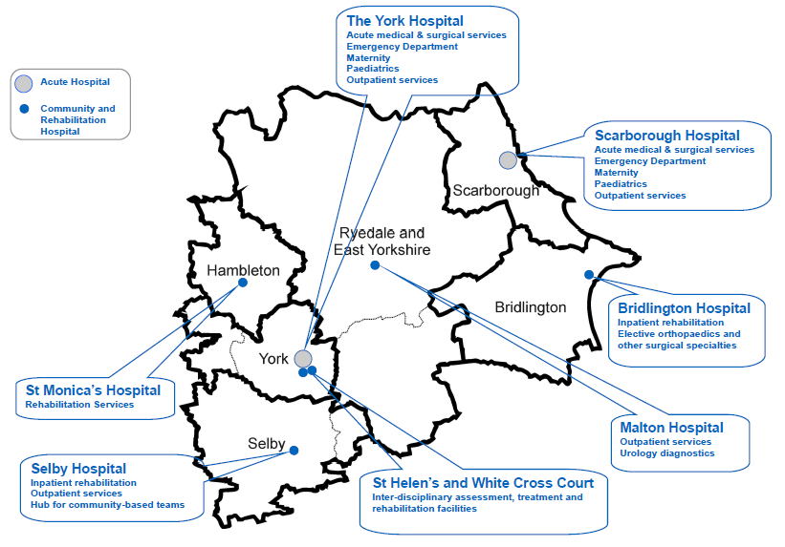

The Trust’s two main acute sites are 42 miles apart – at least an hours journey. Furthermore, Scarborough Hospital is particularly challenged, as it is over an hour away from any other major hospitals, resulting in its participation in several national initiatives to support the sustainability of acute hospitals in remote locations. These geographical and organisational challenges pose the organisation unique challenges in relation to how the sites would interact in the event of an incident, and how patients and resources might be deployed appropriately and effectively.



## The Incident Response Plan (IRP) & NHS England Guidance

As part of the Trust’s legal responsibilities under the Civil Contingency Act 2004, it is required to have a plan in place that sets out how it would declare and subsequently respond to an incident taking place in the vicinity of the organisation. NHS England require that plan, known as the Incident Response Plan (IRP), to be exercised at least once every three years.

The key features of the Trust IRP include:

* A description of how to assess any incident in the vicinity, and the process for making a decision around whether to declare a formal incident status.
* In the event of an incident being declared, a description of how the Trust would establish a formal Command and Control structure (i.e. establish Gold, Silver and Bronze commands).
* More than 50 Action Cards, setting out the tasks that individuals in a command role should undertake in the event of an incident declaration.
* How to record decisions, interact with external agencies and communicate effectively during an incident.
* How to establish a Recovery Working Group and de-brief following an incident.

**NHS England – Concept of Operations for Managing Mass Casualties**

The NHS England document “Concept of Operations for Managing Mass Casualties” was published in November 2017, in the aftermath of the Manchester Arena terrorist attack. The document required every region of England to have a pre-agreed plan as to how, in the event of a mass casualty incident occurring, casualties would be spread across the region’s acute hospitals.

All acute hospitals were asked to state, in the first two hours, following an incident how many of each casualty “type” (i.e. Priority 1, 2 and 3) they would be able to accept. The hospitals in our Trust submitted the following numbers:

**Table 1. Numbers of Priority 1, 2 and 3 Casulaties that York and Scarborough Hospitals could Accept in the Event of Mass Casualty Incident in this Region**

|  |  |  |  |
| --- | --- | --- | --- |
|  | **Priority 1 (P1) Casualties** | **Priority 2 (P2) Casualties** | **Priority 3 (P3) Casualties** |
| **York Hospital** | 6 | 6 | 30 |
| **Scarborough Hospital** | 4 | 4 | 30 |

These figures are then combined with the equivalent data from the other hospitals in the region. Yorkshire Ambulance Service refer to this as the “Casualty Distribution Framework”.

The Concept of Operations for Managing Mass Casualties document also set out a number of other requirements that Acute Trusts need to be able to enact in the event of a Mass Casualty incident occurring. This includes:

* The ability to double critical care capacity for 96 hours following an incident.
* Ability to free up other acute inpatient beds.
* Manage major trauma patients normally transferred to other units for treatment.

The LIVEX exercise aimed to test not just the Trust IRP, but elements of this important NHS England document too.

## Aims and objectives of LIVEX

The main aims of LIVEX were:

* To evaluate the Trust IRP, including all action cards at gold, silver and bronze levels, in order to make improvements and amendments as required.
* Exercise staff in ED and in Trauma teams, to develop their skills and give them some experience of functioning in a mass casualty scenario.
* Provide all participating staff with an environment to give them some experience of working in a formal command and control structure.
* To visually capture actions and procedures in order to contribute to future YTH training opportunities thereby disseminating the Major Incident plan across YTH.

## Scope of LIVEX

The principal purpose of LIVEX was to test the Trust Incident Response Plan and its associated Action Cards in as realistic a way as possible. As part of that test, there were specific elements of the IRP that had a particular focus on them, namely;

* Whether or not each site would be able to cope with the number of P1, P2 and P3 casualties that had been designated to that site on the Yorkshire Casualty Distribution Framework.
* Whether or not each site would be able to double its ICU capacity in response to a mass casualty incident.
* Whether the full complement of Action Cards for both EDs worked as envisaged.
* Whether Gold and Silver Command teams would be able to manage the range of issues that arise as a result of having declared a Major Incident.
* How YAS would interact with the hospital site was included in scope.

There were several areas that were definitively out of scope at LIVEX. These included:

* LIVEX was a test of the Trust IRP, it was not a test of individuals and this was made clear to participants at every briefing session.
* There were several external agencies that were not involved as full participants at LIVEX, but would be involved in the response to a real mass casualty incident, they included:
* The local CCGs, NHS England, NHS Improvement or Public Health England.
* Local authorities.
* Other category 1 responders, including Police and Fire Services.
* LIVEX was not a test of the entire Yorkshire Casualty Distribution Framework – it was only a test of the numbers of casualties assigned to either York or Scarborough Hospital.
* Although discussed during the exercise, LIVEX was not intended to test the transfer arrangements of patients around Yorkshire between hospital sites.

## The Army Medical Services Training Centre (AMSTC)

The Army Medical Services Training Centre (AMSTC) was formed in 1989 and in 1999 it occupied what had been a vehicle workshop which had been converted into a Hospital Trainer. It is part of The 2nd Medical Brigade which delivers Deployed Hospital Care, including Battle Casualty Replacements and Individual Augmentees, for current and future operations.

The normal role of AMSTC is validate and assure Deployed Hospital Care capabilities that are about to deploy on operations, or are about to be held at very short notice readiness to deploy anywhere in the world to provide medical care. The exercises use collective immersive simulation to re-create the hospital into which the teams will eventually deploy, and create the environmental conditions that the hospital will encounter on deployment.

Casualty actors are inserted into the hospital and the free play exercise allows objective evidence and data to be gathered against the military performance standards required of that unit.  This methodology has been used to assess and validate hospitals that have successfully deployed to Iraq, Afghanistan, Sierra Leone and South Sudan.  AMSTC is recognised by NATO partners as a world leader in collective macro simulation, and has been featured on national news programmes to demonstrate this world leading innovative facility.

## Planning LIVEX – Adapting Army Methodology into the NHS

**Working upto LIVEX – July 2017 to June 2018**

LIVEX was not simply two live exercises. The successful delivery of the exercises was the culmination of over 12 months of work, to document, test and train staff against the refreshed Trust IRP. The timeline is depicted below.

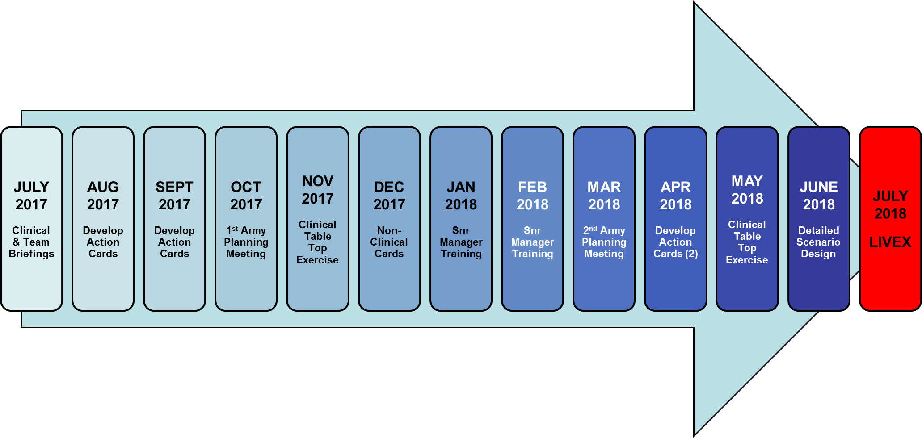

The LIVEX development plan, which was founded in the Army “Crawl-Walk-Run” training methodology, used briefings, table top exercises, and small group training to build ownership and awareness of the refreshed Trust IRP. The actual LIVEX exercises themselves served therefore as an important motivator and end-point for staff involved in the development work.

**The Structure of the LIVEX Fortnight**

The set-up, preparation and actual running of the LIVEX exercises took place over a ten day period at the end of June and start of July 2018. This is depicted below:

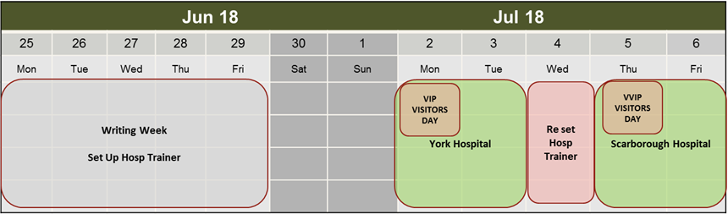

At the end of June the physical build of the York Emergency Department was finalised, and the IT and other relevant infrastructure was installed. Finishing touches were made to the exercise scenario and patient storyboards.

The following week, was divided into three parts as below:

* **Part 1 - 2nd & 3rd July –** This encompassed the York Hospital staff training day on the 2nd July and the exercise day on the 3rd July. There was a VIP visitors day also held on the 2nd July.
* **Part 2 – 4th July –** The York Hospital layout was taken down, and the Scarborough Hospital ED was built. Infrastructure testing also took place.
* **Part 3 – 5th & 6th July –** Scarborough Hospital staff were trained on the 5th July and then took part in their exercise on the 6th July. VVIPs visited the site on the 5th July.

## The LIVEX Exercise and Scenario

**Running LIVEX**

The exercise was a blend of a real-time casualty simulation and table-top decision-making. The focus for the full immersive training were the main Emergency Departments (EDs), whose facilities and floor layout were accurately reproduced at AMSTC. A full “day shift” of ED staff took over the ED and received live “actor” casualties whose simulated injuries were created in line with clinical “stories” designed by the LIVEX planning staff. The ED staff assessed each casualty, just as they would in real life; made decisions on treatment and which hospital departments and services needed to be involved in their subsequent care.

Those supporting departments were represented in BRONZE Command, which was physically located next to the ED. They executed their part in the patient treatment pathway through a mixture of a conceptual “table top” exercise and being called forward to the ED to see and assess some of the casualty actors.

NHS and Military enabling staff accompanied casualty actors along the patient pathway to provide clinical information to Trust staff involved in care and decision making. They also served to observe the actions of all Command areas to provide feedback through pre-prepared Key Performance Indicator (KPI) data sheets.

**The Scenario**

The basic scenario was the same for both the York and Scarborough exercises, with the only real change being the location of the incident. The incidents were both terrorist in nature, and related to the detonation of an IED along with gunfire and took place in very close proximity to each hospital. The fictitious incident in York took place at York City Football Ground and in Scarborough the incident took place at the Cricket Ground. These locations were deliberately chosen to ensure that casualties presented quickly at the hospital following the incident to test the response to casualties arriving both on foot and by ambulance.

The number of casualties resulting from the incident, was deliberately designed so that both hospitals received slightly more patients than they had stated they would be able to manage on the Casualty Distribution Framework.

## The Content and Structure of this Report

**Scope of this Report**

This report is not intended to be a blow by blow account of what happened during the week of LIVEX exercises. It is intended to be a report setting out the recommendations and actions emerging from the exercise, plus feedback from participants and observers about what we might do to improve the IRP and associated departmental Action Cards. Discussion around how LIVEX was run and how the exercise itself, including the training day could be improved is not contained within this report.

**Designing and Gathering Feedback and Intelligence for this Report**

There are three principal sources of information that were used to inform the recommendations in this report. They are:

* Observer Recommendations, based on their Key Performance Indicators (KPIs).
* Participant Feedback form both questionnaires and comments received following LIVEX (see appendix).
* Content from Hot-Debrief meetings held with exercise participants immediately following the conclusion of the exercise.

Draft versions of this report have also been shared with Trust Executives, department leads and LIVEX participants to gather further feedback and ensure that the recommended actions contained within this report are accurate.

**Development of Observer Key Performance Indicators**

Prior to LIVEX a joint team of NHS and Army staff worked together to create a series of Key Performance Indicators (KPIs) for each of the areas/departments that were participating in LIVEX. The KPIs were arrived at using a number of sources of information, including; the Trust Incident Response Plan (IRP), NHS England guidance and other nationally recognised Emergency Planning standards.

These KPIs were then used by observers at LIVEX to help ensure that their feedback was structured and focused around the areas that mattered most. There were ten domains against which observers gathered their observations (although not all ten domains were relevant to all areas). These domains were:

* Incident awareness and declaration • Incident Response – ED
* Command, Control & Communication • Incident Response – Theatres
* Incident Response – Other Bronze Areas • Incident Response – Critical Care
* Incident Response – Media Management • Recovery from Incident
* Post Incident Enquiry (inc. Forensics) • Psychosocial Response & Recovery

In the detailed report that follows, in the sections relating to “Observer Recommendations and RAG”, there is a Red-Amber-Green (RAG) rating against each of these ten areas (or fewer if there were some not relevant to a particular area). Some narrative explanation then follows justifying the RAG rating. The table below explains what is meant by each of these colours:

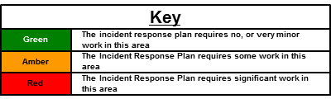

The RAG rating is not an indication as to the performance of individuals at LIVEX, rather an indicator as to the amount of work required on the IRP or Action Cards to address the issues identified as part of LIVEX.

## Governance and Assurance

**Role of the Accountable Emergency Officer**

As per NHS England guidance, all Acute Trusts should nominate an Accountable Emergency Officer (AEO). This individual should be a Trust Executive Director, and is responsible for all Emergency Preparedness, Resilience and Response issues. The Chief Operating Officer acts at the AEO for this Trust, and so is ultimately responsible for the delivery of the recommendations arising from this report to the Trust Board of Directors.

**Role of the Emergency Planning Steering Group (EPSG)**

Where possible, actions arising from this report have been delegated to departmental heads and senior managers – and many of them have been involved in the writing of this report. Given the nature of some of the recommendations in this report, the membership of the group will be reviewed and it may be necessary to establish some short term task and finish groups to work up the detail of some of the recommendations.

Overall, the implementation of all LIVEX actions will be overseen by the EPSG, which meets quarterly and reports to the AEO.

**Sharing the Learning**

A version of this report will be placed on the Trust Website and intranet pages and will become a public document. It will also be shared with all local NHS and other relevant partner organisations through the “Local Health Resilience Forum”, which is supported by the NHS England regional team.

# Trustwide Issues from LIVEX

The purpose of this section is to set out issues that were observed at both the York and Scarborough exercises and are therefore Trust-wide in nature and the most significant issues to address as priorities. Recommendations in this section are common therefore to both sites and the IRP as a whole. As they are organisation-wide issues, they also carry the most significant risk to the Trust and a priority to be resolved.



## Command, Control and Communication (C3)

Across all command cells, Gold, Silver and Bronze it was apparent that staff would benefit from further training in how the command and control structures should function and how to communicate effectively within them. It was also clear that the Trust should invest in some materials to help command cells function optimally. Areas for improvement include:

* Establishing an appropriate “battle rhythm” during an incident.
* Structuring of meetings and briefings with clear agendas, specific outputs and the monitoring of actions.
* The Trust should invest in some visual aids (be it hard copy or electronic) to help maintain situational awareness and deadlines.
* Use of tools such as METHANE to disseminate and receive information.
* Confirming locations of command teams and equipping them appropriately.

## Post Incident Enquiry and Forensics

The Kerslake Review into the Manchester Arena attack recommended that all NHS organisations should be aware of their role in the collection and preservation of forensic evidence[1]. Players and observers at both LIVEX exercises recognised that recognition of forensics related issues and post-incident requirements was poor and requires action to remedy.

It is to the credit of staff participating in LIVEX that some of them did pick this issue up and began acting upon it later on during the exercise itself, as there is no reference to this issue at all in the Trust IRP or Action Cards. This is therefore a significant gap in Trust plans.

The sorts of actions that should be included in the IRP include:

* A recognition of the Trusts requirement to maintain requisite documentation for any subsequent public enquiry.
* The establishment of a formal police casualty bureau that would ensure any casualties discharged from the incident were required to liaise with the police prior to leaving site.
* Clinician training around the need for forensic preservation of evidence, including the availability of the correct plastic evidence collection bags.
* Guidance around what needs to be done if the suspected perpetrator of any attack arrives at hospital requiring treatment.

## Information and Core Patient Database (CPD)

CPD is the hospital patient administration system (or PAS system). It holds a version of the patient record and is the system used at the Trust to register patients upon admission and track their subsequent movements through the hospital.

There were three distinct issues identified relating to information and CPD that were observed at both exercises at LIVEX. These are addressed in turn below:

**Registering Patients at the ED Reception**

In the event of a major incident, CPD does not allow the timely booking in of patients at the ED reception desk resulting in a delay to treatment. This issue does not relate to the operating speed of CPD, rather the number and complexity of the mandatory data fields that have to be completed for every patient attending the department. The delay in the registration process resulted in delays to the commencement of treatment, a heightened sense of anxiety from those waiting to book in and pressure on ED reception staff.

**Common Patient Identifier for “Unknown” Patients**

There is no common process, across the Trust for the registration of “unknown” patients (e.g. a patient presenting at the hospital who is unconscious or isn’t able to identify themselves for any reason). This led to confusion around how patients were being identified and could have, for example, easily led to the wrong diagnostic result being attributed to the wrong patient. A simple, consistent process is required, that works across all departments at both sites.

**Tracking of P1/P2/P3 Patients**

CPD does not provide a way of tracking casualties using the “currency” of P1/P2/P3. This resulted in the loss of situational awareness across commands, inaccuracies in reports and returns leaving the Trust and the distraction of key staff away from primary duties to attempt to gather this information using paper.

## Strategic Deployment of Staff and Resources during an Incident

If an incident, on the scale of the scenario in LIVEX, occurred in our locality the Trust would need to consider how best to deploy staff and other resources across its sites to enable it to respond optimally. This issue would be particularly pertinent if the location of the incident was in the close vicinity of one of the main sites, resulting in a much greater number of casualties presenting at that site compared to the other.

NHS England guidance is clear that sites are required to be able to maintain their major incident response for at least 96 hours following the initial declaration of a major incident, and this too has implications for how staff will need to be deployed. There is a need therefore to set out in the IRP how resources might be used differently across sites in the event of a major incident.

## Staff Call-In Process

Upon declaration of a Major Incident, the current process documented in the IRP for calling in staff is reliant on switchboard, plus individual departments and specialties getting in contact with colleagues independently.

Although not explicitly tested at LIVEX, many LIVEX participants expressed their concerns around this process, especially if an incident were to occur out of hours. There is a need to have a clear, agreed Trustwide process for calling in staff in the event of an incident that is not dependent on switchboard or individuals who would be better placed leading and responding to the incident itself. This requirement should include the process around calling in junior staff, those not officially “on-call” and loggists.

## Clinical Skills Training - Trauma

LIVEX participants from both exercises that were involved in managing casualties reported they would value further clinical skills training, relating to the management of some trauma cases that they rarely see. Feedback showed that this was particularly around the management of penetrating trauma and casualties presenting with blast injuries.

## Trustwide Recommendations

|  |  |  |  |  |
| --- | --- | --- | --- | --- |
| **No.** | **Site** | **Area/ Dept** | **Action Required** | **Proposed Owner** |
| 1 | Trustwide | Trustwide | Develop training package for those in command roles to improve their command, control and communications capability, knowledge and skills. | Chair EPSG |
| 2 | Trustwide | Trustwide | Work with the Police, CPS and Coroner to review requirements for ensuring Trust is able to contribute to any post-incident inquiry. This includes the establishment of a casualty bureau and that evidence is retained for future possible forensics work. | Chair EPSG |
| 3 | Trustwide | Trustwide | Develop a CPD solution for the timely booking in of patients during a major incident. | Chair EPSG & Head of IT Development |
| 4 | Trustwide | Trustwide | Develop and roll out a consistent process across all hospital departments for the registration of “unknown” patients on CPD. This process must meet the needs of ED, all diagnostic areas and all other possible destinations for patients. Consideration should be given to how this process functions at the regional Major Trauma Centres. | Chair EPSG & Head of IT Development |
| 5 | Trustwide | Trustwide | Review and modify CPD to identify appropriate processes for the tracking of casualties in the currency of (P1/2/3) across the patient pathway | Chair EPSG & Head of IT Development |
| 6 | Trustwide | Trustwide | The IRP should be updated setting out how staff should be strategically deployed across sites to enable an effective response to an incident, especially if the incident occurs closer to one site. | Chair EPSG |
| 7 | Trustwide | Trustwide | The process for calling in staff in the event of a major incident should be reviewed, a new process agreed and the IRP and training should be updated accordingly. | Chair EPSG |
| 8 | Trustwide | Trustwide | Participant feedback relating to future trauma training requirements should be reviewed and a new training package established to address this | Clinical Leads for Trauma and ED on both sites |

# York Hospital Exercise

The York Hospital teams were trained on the 2nd July and undertook their exercise on the 3rd July. In all, 99 staff from York Hospital participated in the exercise. They came from a range of clinical and non-clinical areas including ED, Nursing, Therapies, Security and Portering to name but a few. Additionally, there were 41 different casualty actors and 7 members of staff from Yorkshire Ambulance who were directly involved in the scenario that played out.



## Gold Command

**Observer Recommendations**

**Table 2. Observer RAG Ratings for York Hospital Gold Command**

|  |  |  |  |  |  |
| --- | --- | --- | --- | --- | --- |
| **Domain** | | **RAG** | **Domain** | | **RAG** |
| **1** | Incident awareness and declaration | **A** | **2** | Incident Response – ED | **G** |
| **3** | Command, Control & Communication | **A** | **4** | Incident Response – Theatres | **A** |
| **5** | Incident Response – Other Bronze Areas | **G** | **6** | Incident Response – Critical Care | **G** |
| **7** | Incident Response – Media Management | **G** | **8** | Recovery from Incident | **G** |
| **9** | Post Incident Enquiry (inc. Forensics) | **R** | **10** | Psychosocial Response & Recovery | **A** |

|  |  |  |
| --- | --- | --- |
| **Key** | | |
| The IRP/Department Plan requires significant work | The IRP/Department Plan requires some work | The IRP/Department Plan requires no, or very minor work |

Observer feedback for Gold Command in York was collected against the KPI framework and resulted in the RAG rating as set out above. At the end of each bullet point below, numbers in brackets below indicate the domain reference number that the observation point relates to. Some of the areas highlighted for improvement included:

* There was some initial confusion around whether gold or silver command had declared an incident status and what that status was (1).
* A good “battle rhythm” was set by the gold team who had a good oversight of the incident (3).
* The awareness of the site Lockdown policy wasn’t fully understood and could have left the site vulnerable (1).
* The requirement to work with outside agencies was well understood, but contact detail and lists of those agencies are not documented in the IRP or Action Cards (3).
* Very clearly understood by Gold that the incident required careful media management (7).
* Given the limited Communications personnel available, there was a gap between Gold and Silver around what media/communications issues should be communicated up to Gold (3).
* Short term staff and casualty welfare was considered routinely, but there was limited discussion on the longer term psychosocial impact of the incident (10).
* The need to establish a Recovery team was identified early, but resources were not available at LIVEX to put it into operation and get it functioning properly (8).
* The need to work with the Police and be mindful of forensics issues was not recognised early enough and is completely absent from the IRP (9).

**Participant Feedback Questionnaires**

Only two members of the Gold Command team submitted feedback forms. Of those that responded they reported that they had attended training prior to LIVEX and reported that as a result, they knew where the Incident Response Plan (IRP) was and had been briefed on it. Following LIVEX all of the respondents felt “well prepared” to respond to an incident.

**Hot Debrief Feedback**

In their hot-debrief session the team highlighted the importance of the Loggist role, and how well they had interacted with the Silver Command team and how important the interactions between those teams had been in getting a good situational awareness.

The team also felt that the Communications Team specialist would be better placed in the Gold rather than Silver Command team (a change that was subsequently tested in the Scarborough Exercise later in the week).

**Conclusions and recommendations for this area**

|  |  |  |  |  |
| --- | --- | --- | --- | --- |
| **No.** | **Site** | **Area/ Dept** | **Action Required** | **Proposed Owner** |
| 9 | Trustwide | Gold & Silver | Action Card/IRP to be amended setting out the process more clearly around incident declaration and dissemination. | Chair EPSG |
| 10 | Trustwide | Gold | In addition to the Gold Action Card, a list of the top 5 to 10 issues for the Gold team to consider should be set out, split by incident type (i.e terrorist, fire, CBRN or Cyber Attack). This would include issues such as; Public Health Issues, Media Plan, 96 hr plan etc | Chair EPSG |
| 11 | Trustwide | Gold & Silver | Additional training to be given around the site Lockdown policies and processes. The Lockdown process should also be tested and exercised annually. | Head of Security |
| 12 | Trustwide | Gold | Lists of relevant external agencies, including social care organisations, Air Ambulance and Public Health England (PHE) should be accessible to Gold Command | Chair EPSG |
| 13 | Trustwide | Gold | The location of the senior Communications expertise should be in Gold Command. | Communications Lead |
| 14 | Trustwide | Gold | A review of the emotional and pastoral support available for staff responding to an incident should be undertaken. This should include the role of the Trust Chaplain. | Chair EPSG |
| 15 | Trustwide | Gold | Training should include explanation of the function and make up of an Incident Recovery Team | Chair EPSG |
| 16 | Trustwide | Gold & Silver | Ensure all in a command and leadership role are trained and clear on how best to use the loggist role | Chair EPSG |
| 17 | Trustwide | Gold | The Gold Action Card should be updated stating that two loggists are required for the team | Chair EPSG |
| 18 | Trustwide | Gold | IRP should include information on the process around the administration of Hep B/Post Exposure Prophylaxis. This should then be incorporated into training. | Clinical Lead for Microbiology |

## Silver Command

**Observer Recommendations & RAG**

**Table 3. Observer RAG Ratings for York Hospital Silver Command**

|  |  |  |  |  |  |
| --- | --- | --- | --- | --- | --- |
| **Domain** | | **RAG** | **Domain** | | **RAG** |
| **1** | Incident awareness and declaration | **G** | **2** | Incident Response – ED | **G** |
| **3** | Command, Control & Communication | **A** | **4** | Incident Response – Theatres | **G** |
| **5** | Incident Response – Other Bronze Areas | **G** | **6** | Incident Response – Critical Care | **G** |
| **7** | Incident Response – Media Management | **G** | **8** | Recovery from Incident | **G** |
| **9** | Post Incident Enquiry (inc. Forensics) | **R** | **10** | Psychosocial Response & Recovery | **A** |

|  |  |  |
| --- | --- | --- |
| **Key** | | |
| The IRP/Department Plan requires significant work | The IRP/Department Plan requires some work | The IRP/Department Plan requires no, or very minor work |

Observer feedback for Silver Command in York was collected against the KPI framework and resulted in the RAG rating as set out above. At the end of each bullet point below, numbers in brackets below indicate the domain reference number that the observation point relates to Some of the areas highlighted for improvement included:

* There wasn’t any formal use of the METHANE framework to convey information to staff and share situational awareness (3).
* The team would benefit from training on how best to use the loggist in their team and better understand which decisions and issues need to be logged (3).
* Early awareness of the need to track casualties through the hospital and issue was worked through by the team, but hampered by functionality in the systems available (1).
* Clear understanding of the need to create capacity, but more consideration in the plan needs to be given to the potential to receive casualties from other sites too (5 + 1).

**Participant Feedback Questionnaires**

Only three questionnaires from the Silver Team were received. However, they all reported that prior to LIVEX they had “limited” confidence in their role in a major incident and in the preparedness to play their part. Following LIVEX the team reported 100% of them were either prepared or well prepared to respond to a major incident.

The team also commented that LIVEX helped them to see how other departments operated and how their decisions could have a knock on effect on other areas. They also commented that Lockdown and security considerations needed further briefing and training.

**Hot Debrief Feedback**

The Silver team reported that the constant reassessment of the situation helped their understanding of the situation and that the senior medical and nursing roles in Silver gave real clarity and high quality information.

The team reported a number of issues that require further action and attention:

* A different location in York Hospital needs to be identified and resourced appropriately to house Silver Command. The current location (next to Operations Centre, 2nd Floor, Jct 5) is too small, isn’t equipped properly and is not located close enough to the front of the hospital.
* There was a little confusion as to what the Yorkshire Ambulance Service (YAS) Hospital Advice and Liaison Office (HALO) role could be tasked with and which YAS related issues should be discussed with YAS remotely.
* Inclusion of the most recent Yorkshire Casualty Distribution Matrix in the IRP would be helpful.
* Further aids on how to manage some communications issues, such as twitter, would be useful.

**Conclusions and recommendations for this area**

|  |  |  |  |  |
| --- | --- | --- | --- | --- |
| **No.** | **Site** | **Area/ Dept** | **Action Required** | **Proposed Owner** |
| 19 | York | Silver | A new location, convenient to most is required at York Hospital to house Silver Command. This should include positioning of aids and equipment to support Silver, including signage that can by deployed in the Hospital so others can find Silver Command. | Chair EPSG |
| 20 | Trustwide | Silver | The role of Medical Lead in Silver Command should be taken only by individuals who have received specific training for this role (i.e. it should not default be a Deputy Medical or Clinical Director). It is likely this list will be made up of Medical Physicians. | Chair EPSG |
| 21 | Trustwide | Silver | A new Action Card for the Medical and Nursing Leads in Silver Command should not be developed. However, “hints, tips and questions to ask” should be added to the Silver Commander Action Card to help guide their work. | Chair EPSG |
| 22 | Trustwide | Silver | The YAS Hospital Advice and Liaison Officer (HALO) role should have an action card developed to clarify its function. | YAS Head of EPRR |
| 23 | Trustwide | Silver & Gold | Given YAS are an external organisation, clarity is needed as to who should liaise with the YAS Silver Command/incident based team. | YAS Head of EPRR |
| 24 | Trustwide | Silver | Further training and aids should be included in the IRP to support Silver Command in dealing with Communications (inc. Social Media) issues. | Trust Communications Lead |
| 25 | Trustwide | Silver | The IRP should have a copy of the site Action Cards structure, and Yorkshire Casualty Distribution Framework included in it. This should also be included in the incident box held in Silver Command | Chair EPSG |

## Bronze Commands

In play at LIVEX, in addition to the ED, there were at least 16 other departments or hospital functions in play. Their role at LIVEX varied – some effectively ran a “table top” exercise, some were called forward and had to involve themselves with individual casualties in the ED, some ran a diagnostic or support service and others provided support and advice to other areas, for example around staffing issues. This section covers the significant observer feedback and resulting notable actions for some of these areas.

**Observer Recommendations – Notable Practice**

The placing of a consultant surgeon in both ED and main theatres (supported by an Anaesthetist) worked extremely well over the exercise – communication was excellent and patients were moved through the system without undue delay, prioritised in the correct clinical order.

The same was noted for the joint working of several other areas, including Acute Medicine, Elderly Medicine and Matron teams, Community teams with the Therapies services and Theatres and Critical Care.

The NHS England requirement to double Critical Care capacity was observed at LIVEX, and this is a significant achievement – however, it was not tested whether it could be sustained for 96 hours.

**Observer Recommendations – Areas to Improve**

None of the departmental action cards require the commander to establish how much follow up work is likely to result from the initial influx of patients, and what a departmental recovery plan might look like. This is key to understand to begin thinking about future staffing requirements.

There were issues in a number of areas, particularly in diagnostics and transfusion around not having a common unique patient identifier (see Trustwide issues).

In Pharmacy, there is no evidence that the volume of medication required to respond to an incident of this nature (e.g. Anaesthetics etc.) was considered by either the Theatres team or Pharmacy team – and this isn’t an explicit action on their card. This also needs to be considered in the light of two acute receiving sites – so it might not be possible to shift medications from one site to bolster the other.

**Participant Feedback Questionnaires**

47% of participants who operated in Bronze Command roles hadn’t received any training prior to LIVEX on the IRP or their role within it – however 89% said this didn’t impact on their performance. This is reassuring as it means Action Cards were clear and briefings given on the day allowed staff to perform well.

Some of the comments included:

*“Clear chain of command – good gold leadership”*

*“A&E, Resus, and deploying staff to ED seemed to work well patients moved through swiftly and there was good spirit from everyone helping out”*

**Chart 4. Confidence and preparedness of Bronze Command Staff to participate in a Major Incident Before and After LIVEX**

3 months prior to LIVEX 70% of those operating in Bronze Command stated that they had no or limited confidence to play their part in a major incident. Following LIVEX 100% of respondents said they were prepared, well prepared or extremely well prepared for a major incident.

**Hot Debrief Feedback**

The teams highlighted the need to have resources in place prior to an incident being declared. This would include:

* Having Major Incident Packs in all relevant places across the Trust. These would include coloured tabards for those in command roles and versions of the most up to date IRP and Action Cards.
* Additional paper documentation specific for a major incident should be pre-prepared.

The teams also noted the importance for those not at LIVEX in understanding how departments/services other than their own would organise themselves in a major incident. One of the examples cited was around how well the transfusion service functioned, but that key to them being able to work well was all other areas understanding how to access them, the process for ordering and where they were going to be based.

**Conclusions and recommendations for this area**

|  |  |  |  |  |
| --- | --- | --- | --- | --- |
| **No.** | **Site** | **Area/ Dept** | **Action Required** | **Proposed Owner** |
| 26 | Trustwide | All Bronze | All Bronze level action cards should make reference to planning for the 96 hours following the incident, including planning for what activity is likely to be needed and the staffing resource to deliver that. | Chair EPSG |
| 27 | Trustwide | All Bronze | All other Bronze Commanders entering the ED should report to the EPIC upon arrival. This should be added to all Action Cards. | Chair EPSG |
| 28 | York | Pharmacy Bronze | The Pharmacy Command card should include reference to reviewing the relevant stocks at both sites soon after incident declaration. This should include Antibiotics, Control Drugs and Anti-virals. | Chief Pharmacist |
| 29 | Trustwide | All Areas | Each department should have a major incident box available, which includes all plans, tabards and some specialist equipment. | Chair EPSG |
| 30 | Trustwide | All Areas | A review should be undertaken of how to improve communication between all in Command roles. This should include consideration of radios, deck phones, use of wifi etc. | Chair EPSG |
| 31 | York | All Bronze | Future training for all departments should include an explanation of how other areas would function and organise themselves in a major incident. | Chair EPSG |
| 32 | Trustwide | Critical Care | The Critical Care Bronze Action Card should make more explicit the process around how capacity should be doubled, including location, staffing and how it will be maintained for 96 hours. | Clinical Lead for Critical Care |
| 33 | Trustwide | Surgery & Anaesthesia | Bronze Command Action Cards for Surgery and Anaesthesia should be updated to state that once directed, Directorate Management teams should be responsible for coordinating any cancellation of elective surgery (not the Bronze Commander themselves). | Clinical Directors for Surgery & Anaesthesia |
| 34 | Trustwide | Surgery & Anaesthesia | Contact details for the organisation that supplies External Fixators for patients who have undergone surgery to stabilise bone and soft tissue should be included in the Action Cards | Clinical Directors for Surgery & Anaesthesia |

## ED Bronze - Resus, Minors, Majors & Triage

The feedback in this section includes both the ED staff plus other staff, from various other specialty backgrounds that were called forward and based themselves in ED for the majority of LIVEX – e.g. those that worked in trauma teams.

**Observer Recommendations & RAG**

**Table 5. Observer RAG Ratings for York Hospital ED**

|  |  |  |  |  |  |
| --- | --- | --- | --- | --- | --- |
| **Domain** | | **RAG** | **Domain** | | **RAG** |
| **1** | Incident awareness and declaration | **G** | **2** | Incident Response – ED | **G** |
| **3** | Command, Control & Communication | **G** | **4** | Incident Response – Theatres |  |
| **5** | Incident Response – Other Bronze Areas |  | **6** | Incident Response – Critical Care |  |
| **7** | Incident Response – Media Management | **G** | **8** | Recovery from Incident | **G** |
| **9** | Post Incident Enquiry (inc. Forensics) | **R** | **10** | Psychosocial Response & Recovery | **A** |

|  |  |  |
| --- | --- | --- |
| **Key** | | |
| The IRP/Department Plan requires significant work | The IRP/Department Plan requires some work | The IRP/Department Plan requires no, or very minor work |

At LIVEX ED were not allocated a dedicated loggist to record actions or decisions - ED Action Cards should be updated to include this requirement. The department would have benefitted from having a clear, visual way of identifying other sector commanders, i.e. in Resus, Majors, Triage etc and there should be regular team huddles and tabards should be used to ensure the department remains coordinated.

The lack of functionality in CPD to track casualties in the currency was a re-current issue, pulling staff in clinical and leadership roles away from their core duties. This was resolved (partially) once the ED Bronze Command had a senior manager allocated to them to attend briefings and take a lead role on establishing what had been through the department thus far and this role should be formally established on an Action Cards for ED.

**Participant Feedback Questionnaires**

As has already been recognised, some updates to CPD may help the ED response in the future. However, despite this the manning and re-organisation of the team on the front reception desk is also important, and staff thought that a practice run through of the front desk response plan would have been good preparation prior to the exercise.

Feedback indicated that staff would benefit from further training around the clinical management of trauma, and this is addressed in the Trustwide recommendations section.

*“Needed more experience with trauma patients”*

Other feedback from this cohort highlighted the importance of updating the Trust call-in plan. While the scenario was in-hours, staff reported concern about how this would function out of hours. This is also addressed in the Trustwide recommendations section. Comments included:

*“Update call-in systems”*

*“Need a better plan for cancelling elective work…and a better staff call in plan.”*

**Table 6. York Hospital ED Staff confidence and preparedness pre and post LIVEX**

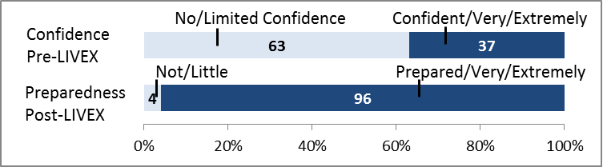

3 months prior to LIVEX 63% of staff reported that had limited or no confidence in their knowledge and understanding of their role during a major incident. Following LIVEX, 96% said they were prepared, well prepared or extremely well prepared to respond.

**Hot Debrief Feedback**

Participants reported that communication was good, that Action Cards helped and that teamwork was excellent. There were several comments relating the how the front of house was organised. They included:

* A liaison role should be developed and based in the waiting room.
* The booking in processes both for YAS and walk-in patients could be improved, and resourced differently.

**Conclusions and recommendations**

|  |  |  |  |  |
| --- | --- | --- | --- | --- |
| **No.** | **Site** | **Area/ Dept** | **Action Required** | **Proposed Owner** |
| 35 | York | ED | The ED Bronze Commander should have a liaison officer to shadow them, to attend briefings and gather information on behalf of the ED Bronze. An action card should be developed (in line with the Scarborough one) for this. | Directorate Manager – Acute Medicine/ED |
| 36 | York | ED | The front reception desk plan for a major incident should be explicitly document and exercised with front line staff. This should include where extra staff could be sourced from. | Directorate Manager – Acute Medicine/ED |
| 37 | York | ED | Consideration should be given to having a single point of entry and triage for ambulances and walk-in patients during a major incident (as per Scarborough) and all Ambulances should book in, as per normal upon arrival at ED. | Clinical Director for Emergency Medicine |
| 38 | Trustwide | ED | The department should have pre-prepared major incident packs ready to use. These should contain; trauma booklet, blood forms, bottles, labels, consent forms, transfusion forms ID bracelets etc | Directorate Manager – Acute Medicine/ED |
| 39 | Trustwide | ED | Personal Protective Equipment (i.e. gloves, masks and aprons) were not routinely worn when managing patients. This should be addressed in future trauma training. | Clinical Leads for Trauma – York & Scarborough |

## Conclusions - York Hospital

The IRP is generally fit for purpose for the York Hospital site. The main Trustwide issues (see section 4) clearly impacted on the ability of the team to respond to the incident as effectively as they would have liked. However, due to the significant work undertaken by staff in the last 14 months, only relatively minor updates and amendments are required to further refine the hospital response to an incident.

One of the issues to be addressed in all areas, including in Silver and Gold Commands is the establishment of an Incident Recovery Team and consideration of how the hospital will continue to effectively respond to the incident in the 96 hours following the incident. At the core of this is the development of a picture of the clinical work that needs to be completed and then the staff needed to support this. This is especially important in areas such as surgery, critical care and theatres.

The location in York Hospital of the Silver Command team, and possible Police presence (to establish a casualty bureau) was something that came up repeatedly in feedback. Confirming this new location and ensuring it is equipped appropriately is a priority action for the York site.

When the feedback for the participants in the York exercise is collated, it demonstrates more than a 60% increase in how confident participants felt about being able to respond to an incident. This is depicted in the chart below.

**Chart 7. Collated feedback from all participants at the York Hospital exercise, showing confidence and preparedness pre and post LIVEX**

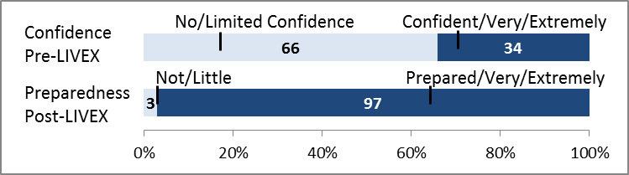

The staff of York Hospital understandably approached LIVEX with a degree of apprehension. They quickly overcame their concerns, worked incredibly hard and produced an excellent collective response to a challenging situation. Their desire to learn and interact with external agencies was particularly impressive and a credit to the Trust.

# Scarborough Hospital Exercise

The Scarborough Hospital teams arrived and were trained on the 5th July and did their exercise on the 6th July. In all 89 members of staff participated in the exercise itself, from surgery to radiology, from therapies to communications. There were also a further 8 members of staff from YAS who participated and over 35 casualty actors throughout the day.

In reviewing the feedback from the Scarborough exercise, there were several issues identified that were common to both York and Scarborough sites. For brevity’s sake, these have not been repeated, but will be reported on the final action logs as needing to be addressed at both sites.



## Gold Command

At the Scarborough Hospital exercise a notable change from the York exercise was that the Gold Command cell was physically located in a building separate from the main Hospital Trainer that hosted the exercise. This was to simulate that in the event of an incident occurring around Scarborough, it is likely that those that the Gold Command team would be based in York.

**Observer Recommendations & RAG**

**Table 8. Observer RAG Ratings for Scarborough Hospital Gold Command**

|  |  |  |  |  |  |
| --- | --- | --- | --- | --- | --- |
| **Domain** | | **RAG** | **Domain** | | **RAG** |
| **1** | Incident awareness and declaration | **G** | **2** | Incident Response – ED | **G** |
| **3** | Command, Control & Communication | **R** | **4** | Incident Response – Theatres | **A** |
| **5** | Incident Response – Other Bronze Areas | **A** | **6** | Incident Response – Critical Care | **A** |
| **7** | Incident Response – Media Management | **A** | **8** | Recovery from Incident | **A** |
| **9** | Post Incident Enquiry (inc. Forensics) | **R** | **10** | Psychosocial Response & Recovery | **G** |

|  |  |  |
| --- | --- | --- |
| **Key** | | |
| The IRP/Department Plan requires significant work | The IRP/Department Plan requires some work | The IRP/Department Plan requires no, or very minor work |

Some areas of notable good practice included:

* The declaration of the incident was timely as was communication to other parts of the hospital (1).
* Early recognition of the need to consider staff psychological welfare and requirement to work with NHS partners to deliver this (10).

The remote location of the Gold Command team demonstrated several areas in which the Trust IRP needs to be amended and updated. These included:

* Robust communications (phone, data and video conferencing) between the Gold and Silver teams is essential for Command, Control and Communication (C3) to function efficiently (3).
* Consideration should be given to the establishment of a Gold “forward” team. This is, a team based on the site nearest the incident that shadow the roles of the Gold Team and report directly back to them for decisions (3).
* A communications lead both in the Gold team and based within the Silver team nearest the site of the incident would also aid C3 (3).
* The Gold Action Cards should require the establishment of a Recovery Working Group early (9).
* The embedding of Joint Emergency Services Interoperability Principles (JESIP) and joint decision making principles more generally should be incorporated into Gold Command team training (1).

The coordination with two Silver Command cells was not properly tested at LIVEX, and so this could be subject to further training in future for Gold Command teams. This needs to include plans for rapid discharge and transportation of staff, equipment and patients.

At the Scarborough exercise, a decision was made to locate the Lead for Communications in the Gold team. Observers reported that this seemed to work better than locating it in the Silver Team (as had been done for the York exercise). However, there was not a good understanding from the participants in the exercise that the Gold team need to be made aware of incidents that were likely to be of media interest.

**Participant Feedback Questionnaires**

Participants in the Gold team recognised the need to improve communications and the connectivity between sites in the event of an incident, and also reported that resources such as pre-populated charts and papers should be available to the Gold team to aid their management and oversight of the incident.

All respondents were aware of the location of the IRP and had read it.

**Hot Debrief Feedback**

The Gold team felt that Silver was responsive to their requests and there was the right level of experience and knowledge based within the Gold team. There was also suggestion that access to TV news in Gold command would have been helpful to keep abreast of unfolding events.

The teams also suggested that media training be given to a wider pool of people, who could find themselves in a Gold Command position and that video conferencing facilities should be installed in the base for Silver Command.

**Conclusions and recommendations**

|  |  |  |  |  |
| --- | --- | --- | --- | --- |
| **No.** | **Site** | **Area/ Dept** | **Action Required** | **Proposed Owner** |
| 40 | Trustwide | Gold & Silver | The locations of all Command cells on all sites should be confirmed. All locations should have video conferencing, access to TV news and at least two phone lines available. These locations should be equipped with a major incident box, containing all relevant information and visual aids. | Chair EPSG |
| 41 | Scarborough | Gold | Consideration should be given to how a Gold “forward” team might function. This may include a liaison officer role. | Chair EPSG |
| 42 | Trustwide | Gold | The Gold Card should make explicit the requirement to establish a Recovery Working Group early on in the incident | Chair EPSG |
| 43 | Trustwide | Gold | Training around JESIP principals should be incorporated into future Gold Command training | Chair EPSG |
| 44 | Trustwide | Gold & Silver | Media training should be given to a wider pool of individuals who may be needed to speak to media outlets. Emergency lines to take (holding statements) should be included in the IRP. | Trust Communications Lead |
| 45 | Trustwide | Gold & Silver | The format of the Trust loggist book should be confirmed and communicated to all loggists. | Chair EPSG |
| 46 | Trustwide | Gold & Silver | In addition to loggists, a pool of individuals willing to act as “runners” should be developed. | Chair EPSG |

## Silver Command

**Observer Recommendations & RAG**

**Table 9. Observer RAG Ratings for Scarborough Hospital Silver Command**

|  |  |  |  |  |  |
| --- | --- | --- | --- | --- | --- |
| **Domain** | | **RAG** | **Domain** | | **RAG** |
| **1** | Incident awareness and declaration | **G** | **2** | Incident Response – ED | **G** |
| **3** | Command, Control & Communication | **A** | **4** | Incident Response – Theatres | **G** |
| **5** | Incident Response – Other Bronze Areas | **G** | **6** | Incident Response – Critical Care | **G** |
| **7** | Incident Response – Media Management | **G** | **8** | Recovery from Incident | **A** |
| **9** | Post Incident Enquiry (inc. Forensics) | **R** | **10** | Psychosocial Response & Recovery | **G** |

|  |  |  |
| --- | --- | --- |
| **Key** | | |
| The IRP/Department Plan requires significant work | The IRP/Department Plan requires some work | The IRP/Department Plan requires no, or very minor work |

Good practice included:

* A clear understanding of the need to create capacity across the site, and organise Bronze Command teams to enact that (1).
* Initial briefings, following incident declaration were promptly brought together which aided the understanding of the incident across the organisation (3).

Areas that were identified for improvements included:

* There was no formal use of the Joint Decision Making model or the METHANE structure of reporting to aid reporting or situational awareness. This should be incorporated into future training (3).
* The agreement from Silver Command to stop new cases going to theatre was not taken as early as it could have been meaning that a number of cases had started at the time of the incident (4+6).

**Participant Feedback Questionnaires**

Three months before LIVEX 72% of respondents in the Silver team reported no or limited confidence in their understanding of their role in a Major Incident. Following LIVEX, 86% of respondents reported being prepared, well prepared or extremely well prepared to respond to a Major Incident.

The role of the loggist was highlighted as being essential to the team, but although the loggist had been trained, the Silver team hadn’t been trained on how to best interact with them, including understanding which issues should be logged.

Some of the roles in Security and Estates & Facilities that were based in the Silver Team didn’t have pre-authored Action Cards, and this should be addressed.

**Hot Debrief Feedback**

The team felt that the team worked well and that they were quick to understand the situation. Working with the security team seemed to work well, but they were aware that in a real incident they would need to link with the main office in York.

The Silver team also reported that a 2nd loggist would have been welcome in the team and more clarity on what the role and function of NHS England in a Major Incident might be

**Conclusions and recommendations**

|  |  |  |  |  |
| --- | --- | --- | --- | --- |
| **No.** | **Site** | **Area/ Dept** | **Action Required** | **Proposed Owner** |
| 47 | Trustwide | Silver | Use of the METHANE structure of reporting incidents should be built into training. | Chair EPSG |
| 48 | Trustwide | Silver | Silver Action Card should be updated to state that Silver should work with medical and nursing leads in Silver, ED and Critical Care to establish what the remaining capacity is for P1 and P2 patients for sitrep reports. | Chair EPSG |
| 49 | Trustwide | Silver | Silver Command should have a list of extra posts that need to be filled across the site in the event of a major incident being declared, e.g. booking in clerks, runners, loggists etc. | Chair EPSG |
| 50 | Trustwide | Silver | A laminated A1 poster should be included in the designated Silver Command room that allows the Silver Command to record who is in each of the bronze command roles and what their contact details are. | Chair EPSG |
| 51 | Scarborough | Silver | Action Cards for those in Silver Command representing Estates & Facilities and Security should be developed. | Chair EPSG |

## Bronze Commands

**Observer Recommendations – Notable Practice**

Critical care team noticed early on that they needed a loggist and that they should be recording their decisions and actions. There is a definite requirement to have a loggist alongside anyone in a command role.

The surgical, anaesthetics and theatres teams worked slickly through the incident. Patients were prioritised and sent from ED without significant delay. Given the volume of surgical work presenting in ED, there was one suggestion to base an additional senior surgeon in ED.

**Observer Recommendations – Areas to Improve**

The plan to double critical care capacity was enacted, however these actions were not logged (see above) and no consideration was given to maintaining this increase for 96 hours.

Overall the Scarborough Theatres team responded well, but they would benefit from having reference in their Action Card to the need to check for availability and stock levels of blood products and access to the One Hour Damage Limitation Surgical Guidance.

The Radiology team highlighted that a number of patient notes, including the patient trauma booklet were left in the ED when the patient had been sent for a CT. This needs to be resolved in future ED training.

**Participant Feedback Questionnaires**

The teams highlighted the need to focus on more pastoral care for staff and also on support for relatives of those that had been involved in the incident itself. Some of the staff also felt that they weren’t properly briefed on the bed and critical care capacity, that may had hindered some of their decision making.

It was also highlighted that as the provider of Community Healthcare services in Scarborough is now provided by Humber NHS FT our Action Cards need to link to theirs – particularly from Medicine, Elderly and Therapies areas.

**Chart 10. Participants in Bronze Command Roles for Scarborough Hospital. Confidence and preparedness pre and post LIVEX**

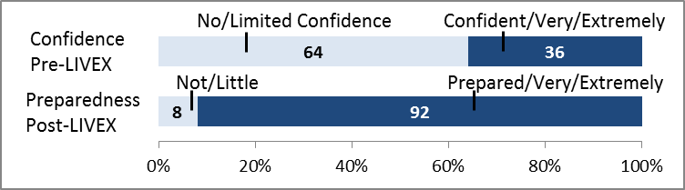

Following LIVEX 92% of this staff group reported themselves being prepared, well prepared or extremely well prepared to manage in a major incident scenario. This contrasts with only 64% of staff, in the 3 months before LIVEX having no or limited confidence in their ability to respond to an incident.

**Hot Debrief Feedback**

Staff in Bronze Command roles reported that roles were well defined and that there was an effective command structure. They reported that the communication around the declaration of the major incident status could have been clearer, as could clarity on the lockdown arrangements.

There was only minimal consideration given to the issue of secondary transfers to other providers, which is an issue that wasn’t addressed at LIVEX. Some concern was also expressed about the call-in process for off duty staff.

**Conclusions and recommendations**

|  |  |  |  |  |
| --- | --- | --- | --- | --- |
| **No.** | **Site** | **Area/ Dept** | **Action Required** | **Proposed Owner** |
| 52 | Trustwide | Bronze | All Bronze Command roles should also be accompanied by a loggist and this should be documented on their Action Card. | Chair EPSG |
| 53 | Trustwide | All Command Roles | Given the difficulty of obtaining loggists for all in command roles, consideration should be given to obtaining Dictaphones and video recording equipment for all in command roles to record decisions on. | Chair EPSG |
| 54 | Scarborough | Bronze | The ability at Scarborough to maintain a doubling of Critical Care capacity for 96 hours should be reviewed. | Clinical Lead for ICU at Scarborough |
| 55 | Trustwide | Bronze | The theatres Action Cards should have two actions added to them: 1) Review Blood Product Stocks & 2) Reference to Damage Limitation Surgical Guidance. | Clinical Director – Theatres & Anaesthetics |
| 56 | Trustwide | Bronze Theatres | A simple form should be developed to allow Theatres staff to track patients waiting for, going into and out from Theatres. | Lead Nurse for Theatres |
| 57 | Trustwide | Bronze Theatres & Critical Care | As Theatre recovery is going to be used as the space to expand ICU into, an agreed set of working principals and arrangements are needed. | Clinical Director – Theatres & Anaesthetics |
| 58 | Scarborough | Bronze | Scarborough Action Cards need to link to Action Cards in the Community Healthcare provider (Humber NHS FT). | Chair EPSG |
| 59 | Trustwide | Bronze | All Action Cards should have an action added to ensure that all members of the team are taking breaks and refreshments. Estates & facilities cards should detail how to obtain food and drink out of hours. | Chair EPSG |
| 60 | Scarborough | Bronze | The exact transfer route for patients from the helipad to the hospital should be confirmed. | Chair EPSG |

## ED Bronze - Resus, Minors, Majors & Triage

**Observer Recommendations & RAG**

**Table 11. Observer RAG Ratings for ED at Scarborough Hospital**

|  |  |  |  |
| --- | --- | --- | --- |
| **Domain** | **RAG** | **Domain** | **RAG** |
| Incident awareness and declaration | **G** | Incident Response – ED | **G** |
| Command, Control & Communication | **A** | Incident Response – Theatres |  |
| Incident Response – Other Bronze Areas |  | Incident Response – Critical Care |  |
| Incident Response – Media Management | **G** | Recovery from Incident | **G** |
| Post Incident Enquiry (inc. Forensics) | **R** | Psychosocial Response & Recovery | **A** |

|  |  |  |
| --- | --- | --- |
| **Key** | | |
| The IRP/Department Plan requires significant work | The IRP/Department Plan requires some work | The IRP/Department Plan requires no, or very minor work |

Very visible leadership from the ED Bronze Command, who constantly moved around the department to maintain situational awareness. He also had a supportive and encouraging style with all staff working in the ED. Having clearly identified section leaders (i.e. one person in each of Resus, Majors, Minors and Triage) should help the departmental response further.

The ED plan of locking down the main entrance to the department so that all ambulance and walk-in patients presented at the same door worked extremely well. Flow was maintained, triaging was completed in a timely way and all staff understood where patients were in the system.

Immediate staff welfare was regularly considered (including a Matron who was sent to ED to support the teams). Consideration of longer term support of staff also needs to be incorporated into the Action Cards.

Even with an ED Bronze Command Liaison Officer role in place, the department struggled to track how many of each of the P1/P2/P3 patients had been through the department. While an IT solution is sought and developed to this issue, this should be a responsibility of the Liaison Officer role.

**Participant Feedback Questionnaires**

The teams based in ED felt they would benefit from further training to support their knowledge in the field of trauma care – this issue has been addressed in the Trustwide issues section. To emphasize this point, one of the free text comments simply read:

*“More training needed on burns and mass bleeds”*

**Chart 12. Scarborough Hospital ED Participants confidence and preparedness pre and post completion of LIVEX**

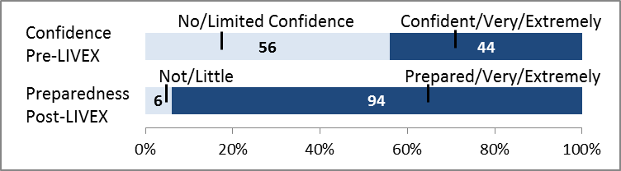

When asked, how they felt about their role in relation to a major incident 3 months before LIVEX 56% of the ED respondents stated that had no or limited confidence in their understanding of their role. Following LIVEX, 94% of respondents stated they were prepared, well prepared or extremely well prepared to manage during a major incident.

**Hot Debrief Feedback**

The teams stated that the communication and team working within the department and with others had worked well. This had contributed to the smooth flow of patients out of the department to other areas. They also referenced how having a single entrance to the department had helped the triage process.

Further comments included that there weren’t the log books or personnel in the department to support incident logging, and that staff working on the ground hadn’t always understood what had happened in the main incident.

**Conclusions and recommendations**

|  |  |  |  |  |
| --- | --- | --- | --- | --- |
| **No.** | **Site** | **Area/ Dept** | **Action Required** | **Proposed Owner** |
| 61 | Scarborough | ED | Each section of the ED should have a clearly identified leader, with a pre-authored Action Card that is handed to them. That individual should wear a tabard. | Directorate Manager – Acute Medicine/ED |
| 62 | Trustwide | ED | While IT issues relating to the tracking of P1/P2/P3 patients is resolved, the tracking of these patients should be the responsibility of the Liaison Officer (or triage officer if not present) – Action Card to be amended. | Directorate Manager – Acute Medicine/ED |
| 63 | Trustwide | ED | The department should be equipped with sufficient log books and a loggist to support record keeping. | Directorate Manager – Acute Medicine/ED |
| 64 | Trustwide | ED | Trust Antibiotic guidelines and management of Blood Borne Virus guidance should be included in the ED major incident box. | Clinical Lead for Microbiology |

## Casualty Feedback

At the Scarborough Hospital exercise, 56 of the casualty volunteers completed the standard Trust “Friends & Family Test” feedback cards. This was not completed during the York Hospital exercise as it was only recognised during the course of LIVEX week that this could be achieved.

The “Word Cloud” below was generated using an online tool from all of the written free text that was contained within the feedback cards collected. The larger the word the more prominent it was in the feedback.

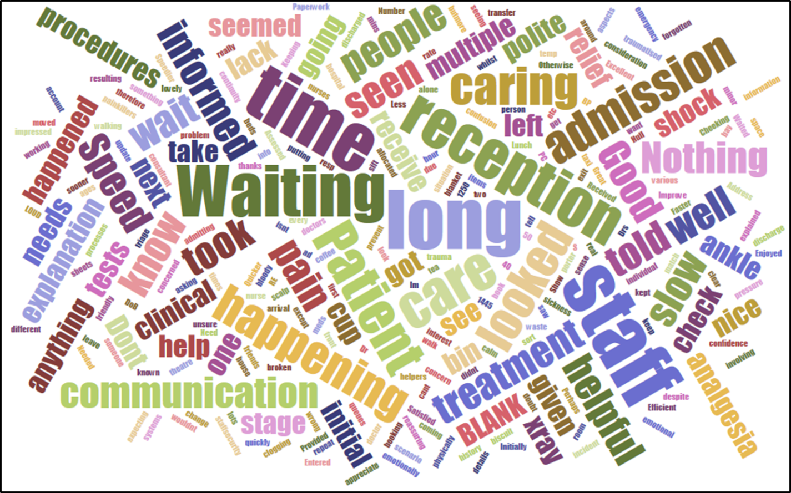

Displaying the feedback in this way shows clearly the feedback from the casualty actors –they felt they were left waiting for too long in the reception area. In a mass casualty incident patients with minor injuries will inevitably have to wait for a longer time periods, but communicating with them about what was happening could have helped lessen anxious patients and supported those that have just been through a traumatic event. This is equally true for patient relatives who could also have gathered in the ED waiting area to await news on their loved ones.

It should also be noted that words such as “polite”, “caring” and “helpful” are also very prominent in the cloud. Additionally, 77% of respondents said that they would be likely or extremely likely to recommend the ED to a friend or family member if they required similar treatment.

**Recommendations**

|  |  |  |  |  |
| --- | --- | --- | --- | --- |
| **No.** | **Site** | **Area/ Dept** | **Action Required** | **Proposed Owner** |
| 65 | Scarborough | ED | A role based within the ED waiting area to communicate with those waiting to be seen (P3’s) would be beneficial. | Directorate Manager – Acute Medicine/ED |

## Conclusions - Scarborough Hospital

The IRP and associated Action Cards for Scarborough Hospital are generally fit for purpose. Aside from the main Trustwide issues (see section 4) the only other significant risk for Scarborough is the remote location of Gold Command if the incident is in Scarborough and Gold Command is in York. Consideration should be given of the factors that would give rise to the movement of Gold Command to Scarborough from York or the establishment of a “forward” Gold team.

The Scarborough Hospital team also considered the incident to be a Scarborough Hospital issue. While this may be an “exercise-ism” and didn’t impact on the team’s ability to respond at LIVEX, further consideration should be given to how people, equipment and other resources could be moved from other sites to support an incident response in Scarborough and this is also detailed in the Trustwide issues section.

The use of a single entrance for all patients presenting from the incident in the ED worked incredibly well. Coherent triage was achieved, which supported situational awareness and patient flow. The team in York ED should also consider this approach in their departmental plans.

**Chart 13. Collated feedback from all participants at the Scarborough Hospital exercise, showing confidence and preparedness pre and post LIVEX**

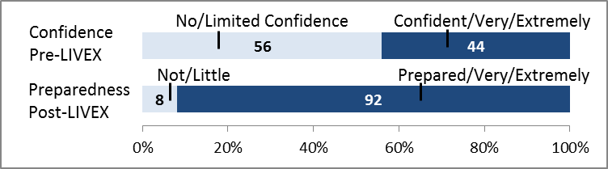

When collated together the staff feedback responses from the Scarborough exercise, there was almost a 50% increase in how confident participants felt about being able to respond to an incident. This is depicted in the chart below.

Scarborough Hospital staff are a tight knit and highly motivated group who work well together and delivered an impressive response to the major incident. They are to be congratulated on the significant preparatory work undertaken and their professional approach to the immersive simulation.

# Media Coverage and Communications



## Social Media

LIVEX coverage on social media was predominantly through Facebook and Twitter. The Social Media Campaign was supported by the Trust Corporate Communications Team, individuals organising the exercises, LIVEX participants and visitors.

**York Hospital Trust Facebook Account**

Over the course of LIVEX week, the Trust posted on its page two times about LIVEX. As of the 31st July 2018, the total number of people reached with these two posts (i.e. the number of people that saw the posts) was **18,681.** This quantity of views outperformed the average amount of activity on the Trust Facebook page in a number of ways, as set out below.

**Chart 14. Average number of views of LIVEX and non-LIVEX Facebook posts on the Trust Facebook page in July 2018**

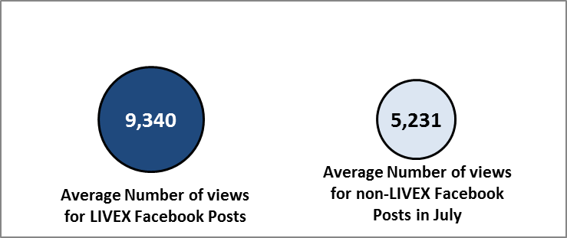

**Chart 15. Number of reactions of top LIVEX and non-LIVEX Facebook posts on the Trust Facebook page in July 2018**

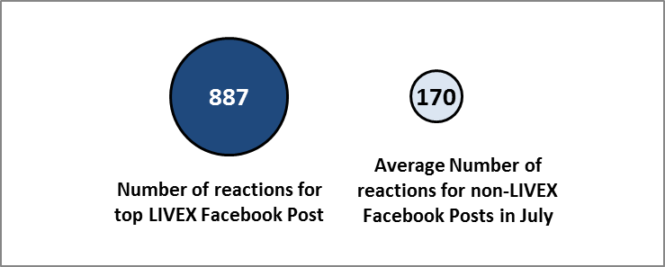

The post referenced in the chart above, was one of the top three posts so far in 2018 in terms of the number of reactions.

**Chart 16. Number of times the top LIVEX post was shared compared to the average number of times that a Facebook post from the Trust page is shared**

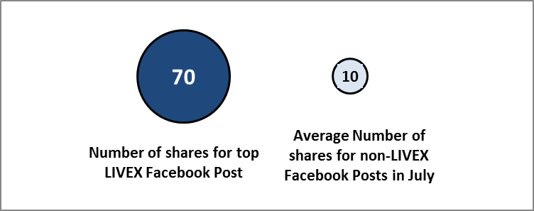

The sharing of posts are particularly important as they allow posts and images to be seen by a larger audience that those that receive updates directly as a result of following or liking the Trusts pages.

**York Hospital Trust Twitter Account**

Twitter was the primary social media tool for LIVEX. Over the week, in addition to re-tweeting some of the LIVEX participants and organisers tweets, the Trust posted 15 original tweets about LIVEX. These tweets served to be highly successful.

Engagement rate accounts for any action taken on the tweet - this could be a retweet, a comment, a like a post click or a view – essentially, any kind of action / interaction taken on the post by an individual.

**Chart 17. Engagement Rate (%) with Tweets from the Trust Twitter Account on LIVEX and other issues**

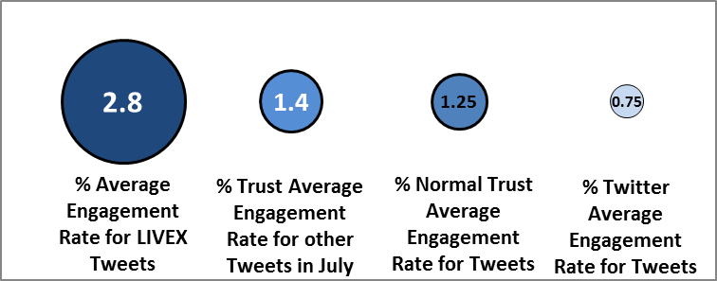

Twitter impressions are simply the number of times a particular Tweet was seen by someone on Twitter. Overall, of the 15 Tweets the Trust sent about Twitter, in total they were seen over 23,000 times. The chart below shows how LIVEX Tweets compared to the normal Trust average.

**Chart 18. Average number of impressions of LIVEX and non-LIVEX Tweets from the Trust Twitter account in July 2018.**

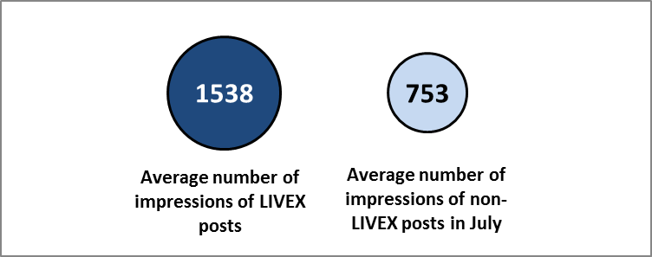

**Prominence on Twitter of the Hashtag #LIVEX18**

Throughout the week all those supporting LIVEX were encouraged to use the hashtag “#LIVEX18” when tweeting about LIVEX. Using an online Twitter analytics tool, it is possible to search for the presence of LIVEX18 throughout Twitter.

In total, during the period from the 3rd July to the 3rd August 2018:

A link to an online blog, written by Conservative Councillor Paul Doughty (Chair of the Health & Adult Social Care Policy and Scrutiny Committee for City of York Council) who attended the VIP visitors day at LIVEX was clicked on over 31,000 times.

## Television coverage

For both television and radio broadcasters, although visits and filming of LIVEX took place during LIVEX week, this was embargoed until 8am on Friday 6th July. This was to ensure that participants from Scarborough Hospital did not find out information about the York exercise prior to their exercise taking place.

LIVEX was covered by both main local news broadcasters. Teams from BBC Look North and ITV Calendar News both visited LIVEX on the 4th July to capture footage of the exercise in full flow and talk to participants and organisers of the events. Both broadcasters focussed on messages of re-assurance to the local public, the scale of LIVEX, the partnership between The Army and The NHS and the uniqueness of the exercise in the NHS. Both broadcasters had LIVEX as their main story of the day on Friday 6th July and ran the piece in all bulletins throughout the day.

LIVEX was also visited by Forces TV. Forces TV is available online or via digital TV (including Sky, Virgin, Freeview etc). This is a factual channel and focusses on the work of the UK Military and Armed Forces across the world.

## Newspapers, Radio and Other Media Coverage

The week following LIVEX on the 10th July, The Trust Communications Team issued a press release. This resulted in further local newspaper coverage of LIVEX in publications such as the York Press, Scarborough News and Filey & Hunmanby Mercury. The York Press also gave over a portion of their editorial on the 13th July to LIVEX, which stated:

*“We dearly hope what they [staff participating in LIVEX] have learned never has to be put into use – but we should be assured that they are prepared and ready should that day come.”*

LIVEX was also visited by Minster FM (the local commercial York radio station) and Forces Radio on the 4th July. Minster FM included reference to LIVEX on their bulletins throughout the day on the 6th July and posted a video, including interviews with participants on their website.

## VIP & VVIP Visitors Days

On the 2nd July, 2nd Medical Brigade and the Trust invited a number of VIP guests to AMSTC to have a tour of the facility, speak to staff involved and learn a little more about how LIVEX came about. In all 71 VIPs attended, including dignitaries such as the Chief Medical Officer for Scotland, The Deputy Permanent Secretary for Northern Ireland, Managing Director of NHS Leadership Academy, NHS England Regional Director for EPRR and the Chief Executive of Yorkshire Ambulance Service (a full list is available in the appendix). Following the visit, several of these individuals also tweeted their support of LIVEX.

On the 5th July, the Surgeon General of the UK Armed Forces visited LIVEX. The Surgeon General is the most senior medical officer in the UK Military, overseeing the provision of medical care and services in the RAF, Navy, Marines and Army. Following the visit, he tweeted his support for LIVEX via a short video, which he stated he intended to use in conference presentations later in the year.

As a result of these days, the team are following up a number of contacts and leads to support future work in a range of different areas.

## Communications Conclusions

The extensive media and communications coverage generated from LIVEX served as a huge opportunity for both the Trust and the Military not just to train and support our staff the event of a major incident, but also to help with broader issues of; recruitment, retention, reputation and reassurance.

Amongst many non-measurable benefits of LIVEX, the exercise had a significant boost to the morale of staff who took part. Many of them expressed a sense of pride having taken part and thanks to the Trust for organising an exercise on this scale. Being seen as an organisation pushing the boundaries, innovating and successfully executing events on the scale of LIVEX is a boost to our teams and should support recruitment and retention campaigns across the Trust. Consideration should be given to including links to LIVEX materials on future recruitment materials.

Reputationally, the Trust is now seen as a leader in the region for running live training exercises, and the LIVEX team have already received a number of requests to visit other organisations to share the learning. This too will help future recruitment initiatives, including initiatives targeting ex-military officers and medics.

Finally, as the Editorial in the York Press stated, the public should also be reassured that their local hospital has a tested plan, with trained staff, ready to respond to such an incident.

# Building on LIVEX



## The Relationship with the Military in York

The Trust has long enjoyed a successful and productive relationship with the Military in and around York and Scarborough. York Hospital inparticular is located in an area with at least five significant military establishments around it, including the home of 2nd Medical Brigade and 34 Field Hospital. To date the relationship has resulted in the Trust holding Away/Training Days in the Army Training facilities, Military Medical and Nursing personnel attending clinical Training sessions at the Trust, staff placements and secondments between both organisations and much more.

Given the way in which teams have worked together at LIVEX there is an opportunity to work even more closely with the Military in future.

**Training Methodologies**

Working closely with the Army team for 12 months or more developing LIVEX has given insight into how to prepare staff and organise events on the scale of LIVEX. The Crawl-Walk-Run methodology, was adopted for LIVEX and while it’s concepts are familiar, time and operational pressures often prevent the NHS from developing our plans and staff in this way. LIVEX serves as a reminder as to the importance and benefit that can be derived from thorough long-term planning, engagement of teams and working towards a specific end point.

**Supporting Reservists**

Firstly, on an on-going basis, the Military is looking to recruit trained, clinical personnel to act as reservists. These people may be called forward to serve in operations at any stage, but while they continue to be based in the UK, they need to maintain their skills ready to be deployed. In order to do this they need a flexible employer ready to support them to do this.

Secondly, the Military is always looks to recruit new people to act as reservists. The Trust should take a more active role in encouraging and supporting this initiative. It offers a unique opportunity for staff (and there are dozens currently employed by the Trust that have served in the Armed Forces), which will ultimately benefit the Trust and people of York too.

**Recruitment of ex-Military Officers**

Given the density of Military establishments around York, there is a real opportunity for the Trust to recruit non-clinical personnel into roles within the Trust. However, many of these ex-officers report that the NHS is difficult to get into without previous experience of working in the NHS. These individuals are highly trained leaders, reliable and committed who may be able to bring new skills and perspectives to our Trust. The Trust HR department will continue to support work with charities like the Officers Association to help attract the right people to our Trust and help them to find employment in the NHS.

**Employers Recognition Scheme**

NHS Employers run an Employers Recognition Scheme (ERS) for NHS Organisations who are actively supporting the Military in these areas. Currently the Trust has been awarded a “Silver” award, with only around 20 NHS Organisations nationally being awarded the prestigious Gold award. There is a plan in place to use experience of LIVEX to apply for this Gold award in 2019.

## Future Exercises & Training

The opportunity to utilise the facilities at AMSTC is unlikely to occur again in the next few years, and so a repeat of an exercise on the scale of LIVEX is highly unlikely. However there is much to learn from LIVEX.

Firstly, many of the materials developed for LIVEX can be used again in a variety of ways with both clinical and non-clinical staff. Casualty story boards can be used with clinical staff to ask what they would do, and the schedule of non-clinical events that the teams in Silver & Gold command dealt with can be used in future iterations of their training too.

Secondly, while more than 80 live-casualties were put through the ED at LIVEX, all of the Bronze Command areas were in-effect running an advanced table top exercise. If ED too were represented by a map and patients and staff with counters LIVEX could be run as an advanced table top exercise. We are continuing to work with the Army on this at the present time.

## Sharing Learning Within the NHS

**Presentations**

The team continue to receive invitations to speak to other NHS Trusts and Groups about LIVEX, how it was done and what it achieved. To date, appointments are booked with Harrogate Trust, the Yorkshire Blood and Transfusion Conference and NHS England. We will continue to share our contacts and expertise across the NHS. We have also been in touch with the NHS Leadership Academy to share the work we’ve done and advise about what role a national body may have in this area.

**LIVEX in a Box**

In conjunction with the Army, we are developing a table-top version of LIVEX that can be shared witho all NHS Trusts across the country. The materials developed at LIVEX, including the casualty stories, the KPI markers, the schedule of non-clinical incident related events, the feedback methodology etc are all equally applicable to a table top exercise. Individual Trusts would simply need to print off maps of their key departments to replicate their capacity and resources. Our aspiration is to have something ready to share in 2019.

# Conclusions

**LIVEX in Numbers**

Over the week, LIVEX exercised over **200 front-line NHS staff**, representing **18 hospital departments** and services, who managed **175 individual casualties**, played by **70 casualty actors.** The exercise tested more than **40 Action Cards** and was supported and enabled by a joint team of **50 NHS and Military** staff, from **five different NHS organisations.** LIVEX was reported on by at least **seven media outlets**, #LIVEX18 was seen over **91,000 times** on Twitter and one of the Trust’s LIVEX18 Facebook posts was the **third most popular** in the whole of 2018.

**Priority Areas for Action**

The full set of recommendations falling out from LIVEX can be seen in the appendix to this report. The table below shows those issues that are Trustwide in nature and require priority action.

**Table 19. Main Trustwide Recommendations from LIVEX**

|  |  |  |  |  |
| --- | --- | --- | --- | --- |
| **No.** | **Site** | **Area/ Dept** | **Action Required** | **Proposed Owner** |
| 1 | Trustwide | Trustwide | Develop training package for those in command roles to improve their command, control and communications capability, knowledge and skills. | Chair EPSG |
| 2 | Trustwide | Trustwide | Work with the Police, CPS and Coroner to review requirements for ensuring Trust is able to contribute to any post-incident inquiry. This includes the establishment of a casualty bureau and that evidence is retained for future possible forensics work. | Chair EPSG |
| 3 | Trustwide | Trustwide | Develop a CPD solution for the timely booking in of patients during a major incident. | Chair EPSG & Head of IT Development |
| 4 | Trustwide | Trustwide | Develop and roll out a consistent process across all hospital departments for the registration of “unknown” patients on CPD. This process must meet the needs of ED, all diagnostic areas and all other possible destinations for patients. Consideration should be given to how this process functions at the regional Major Trauma Centres. | Chair EPSG & Head of IT Development |
| 5 | Trustwide | Trustwide | Review and modify CPD to identify appropriate processes for the tracking of casualties in the currency of (P1/2/3) across the patient pathway | Chair EPSG & Head of IT Development |
| 6 | Trustwide | Trustwide | The IRP should be updated setting out how staff should be strategically deployed across sites to enable an effective response to an incident, especially if the incident occurs closer to one site. | Chair EPSG |
| 7 | Trustwide | Trustwide | The process for calling in staff in the event of a major incident should be reviewed, a new process agreed and the IRP and training should be updated accordingly. | Chair EPSG |
| 8 | Trustwide | Trustwide | Participant feedback relating to future trauma training requirements should be reviewed and a new training package established to address this | Clinical Leads for Trauma and ED on both sites |

The table above sets out the significant Trustwide areas to focus on, and include training, forensics and how CPD can be used in the event of an incident being declared. Looking across the breadth of other recommendations contained in this report, there are other groups or themes of actions required. They include:

* Establishment of an Incident Recovery Team, and ensuring departments are planning and preparing for the 96 hour period following incident declaration.
* Ensuring there is the appropriate emotional and psychological support available for staff and patients that have been involved in the incident or its response.
* Significant numbers of clinical staff have requested further clinical skills training around the management of trauma cases, and there are other areas that would benefit from further training, including management of a control centre.
* There are some practical things need that resolution, these include the preparation of visual aids for the command teams, the location of the command teams, tabards for those in leadership roles and up to date copies of the IRP available across the Trust.

Whilst the overall responsibility for the completion of these actions sits with the Accountable Emergency Officer (who in this Trust is the Chief Operating Officer), the implementation of these actions will be managed by the Emergency Planning Steering Group, which is a sub-group of the Trust Executive Board.

**The Benefits of LIVEX**

LIVEX allows the Trust to demonstrate compliance with the NHS England standard to undertake a live training exercise at least once every three years. LIVEX therefore supports the Trust to improve its compliance rating in the annual NHS England EPRR assessment – which is an important part not only of NHS assurance but also of the Trust’s responsibilities under the Civil Contingencies Act.

In relation to the IRP and associated Action Cards, LIVEX clearly demonstrated that they are generally fit for purpose. In recognising there is still work to do to improve, there were important components of the IRP that were tested at LIVEX and that worked successfully. While there was a degree of apprehension early on, Trust staff quickly overcame any concerns, worked incredibly hard and produced an excellent collective response to a challenging situation. This should give the Trust and the local population it serves confidence and reassurance that both acute sites would be able to respond effectively in the event of an incident occurring.

There are also many other benefits of LIVEX. The boost to staff morale, confidence and the team working between departments also have huge, if unmeasurable benefits. Many staff commented on how much they learnt from working with colleagues from the other Trust site (particularly in ED) and how benefits would be gained from bringing teams together in future. The learning about how to work in a challenging environment will stay with staff for the rest of their careers and they will be able to take lessons back to others in their departments. In both the feedback forms and on social media LIVEX participants expressed their pride in what they’d been part of and praised the Trust for organising such an exercise.

**In-direct Learning from LIVEX**

The Trust (and the NHS at large) needs to think differently about how it goes about undertaking large scale training. LIVEX shows there is a big difference between training that essentially involves telling people what is in a plan, and actually trying to enact the plan. Training in this area inparticular needs to be seen as beneficial on a number of levels rather than just “nice to do”. Shifting our training methodology in Emergency Planning so that it is more practical in nature, and involves those attending training practicing components of the plan is a far more beneficial way of developing our staff – particularly those in leadership roles. LIVEX should mark a significant change to how we go about training our staff to be prepared for a major incident.



# Collated List of Recommendations

|  |  |  |  |  |
| --- | --- | --- | --- | --- |
| **No.** | **Site** | **Area/ Dept** | **Action Required** | **Proposed Owner** |
| 1 | Trustwide | Trustwide | Develop training package for those in command roles to improve their command, control and communications capability, knowledge and skills. | Chair EPSG |
| 2 | Trustwide | Trustwide | Work with the Police, CPS and Coroner to review requirements for ensuring Trust is able to contribute to any post-incident inquiry. This includes the establishment of a casualty bureau and that evidence is retained for future possible forensics work. | Chair EPSG |
| 3 | Trustwide | Trustwide | Develop a CPD solution for the timely booking in of patients during a major incident. | Chair EPSG & Head of IT Development |
| 4 | Trustwide | Trustwide | Develop and roll out a consistent process across all hospital departments for the registration of “unknown” patients on CPD. This process must meet the needs of ED, all diagnostic areas and all other possible destinations for patients. Consideration should be given to how this process functions at the regional Major Trauma Centres. | Chair EPSG & Head of IT Development |
| 5 | Trustwide | Trustwide | Review and modify CPD to identify appropriate processes for the tracking of casualties in the currency of (P1/2/3) across the patient pathway. | Chair EPSG & Head of IT Development |
| 6 | Trustwide | Trustwide | The IRP should be updated setting out how staff should be strategically deployed across sites to enable an effective response to an incident, especially if the incident occurs closer to one site. | Chair EPSG |
| 7 | Trustwide | Trustwide | The process for calling in staff in the event of a major incident should be reviewed, a new process agreed and the IRP and training should be updated accordingly. | Chair EPSG |
| 8 | Trustwide | Trustwide | Participant feedback relating to future trauma training requirements should be reviewed and a new training package established to address this. | Clinical Leads for Trauma and ED on both sites |
| 9 | Trustwide | Gold & Silver | Action Card/IRP to be amended setting out the process more clearly around incident declaration and dissemination. | Chair EPSG |
| 10 | Trustwide | Gold | In addition to the Gold Action Card, a list of the top 5 to 10 issues for the Gold team to consider should be set out, split by incident type (i.e terrorist, fire, CBRN or Cyber Attack). This would include issues such as; Public Health Issues, Media Plan, 96 hr plan etc. | Chair EPSG |
| 11 | Trustwide | Gold & Silver | Additional training to be given around the site Lockdown policies and processes. The Lockdown process should also be tested and exercised annually. | Head of Security |
| 12 | Trustwide | Gold | Lists of relevant external agencies, including social care organisations, Air Ambulance and Public Health England (PHE) should be accessible to Gold Command. | Chair EPSG |
| 13 | Trustwide | Gold | The location of the senior Communications expertise should be in Gold Command. | Communications Lead |
| 14 | Trustwide | Gold | A review of the emotional and pastoral support available for staff responding to an incident should be undertaken. This should include the role of the Trust Chaplain. | Chair EPSG |
| 15 | Trustwide | Gold | Training should include explanation of the function and make up of an Incident Recovery Team. | Chair EPSG |
| 16 | Trustwide | Gold & Silver | Ensure all in a command and leadership role are trained and clear on how best to use the loggist role. | Chair EPSG |
| 17 | Trustwide | Gold | The Gold Action Card should be updated stating that two loggists are required for the team. | Chair EPSG |
| 18 | Trustwide | Gold | IRP should include information on the process around the administration of Hep B/Post Exposure Prophylaxis. This should then be incorporated into training. | Clinical Lead for Microbiology |
| 19 | York | Silver | A new location, convenient to most is required at York Hospital to house Silver Command. This should include positioning of aids and equipment to support Silver, including signage that can by deployed in the Hospital so others can find Silver Command. | Chair EPSG |
| 20 | Trustwide | Silver | The role of Medical Lead in Silver Command should be taken only by individuals who have received specific training for this role (i.e. it should not default be a Deputy Medical or Clinical Director). It is likely this list will be made up of Medical Physicians. | Chair EPSG |
| 21 | Trustwide | Silver | A new Action Card for the Medical and Nursing Leads in Silver Command should not be developed. However, “hints, tips and questions to ask” should be added to the Silver Commander Action Card to help guide their work. | Chair EPSG |
| 22 | Trustwide | Silver | The YAS Hospital Advice and Liaison Officer (HALO) role should have an action card developed to clarify its function. | YAS Head of EPRR |
| 23 | Trustwide | Silver & Gold | Given YAS are an external organisation, clarity is needed as to who should liaise with the YAS Silver Command/incident based team. | YAS Head of EPRR |
| 24 | Trustwide | Silver | Further training and aids should be included in the IRP to support Silver Command in dealing with Communications (inc. Social Media) issues. | Trust Communications Lead |
| 25 | Trustwide | Silver | The IRP should have a copy of the site Action Cards structure, and Yorkshire Casualty Distribution Framework included in it. This should also be included in the incident box held in Silver Command. | Chair EPSG |
| 26 | Trustwide | All Bronze | All Bronze level action cards should make reference to planning for the 96 hours following the incident, including planning for what activity is likely to be needed and the staffing resource to deliver that. | Chair EPSG |
| 27 | Trustwide | All Bronze | All other Bronze Commanders entering the ED should report to the EPIC upon arrival. This should be added to all Action Cards. | Chair EPSG |
| 28 | York | Pharmacy Bronze | The Pharmacy Command card should include reference to reviewing the relevant stocks at both sites soon after incident declaration. This should include Antibiotics, Control Drugs and Anti-virals. | Chief Pharmacist |
| 29 | Trustwide | All Areas | Each department should have a major incident box available, which includes all plans, tabards and some specialist equipment. | Chair EPSG |
| 30 | Trustwide | All Areas | A review should be undertaken of how to improve communication between all in Command roles. This should include consideration of radios, deck phones, use of wifi etc. | Chair EPSG |
| 31 | York | All Bronze | Future training for all departments should include an explanation of how other areas would function and organise themselves in a major incident. | Chair EPSG |
| 32 | Trustwide | Critical Care | The Critical Care Bronze Action Card should make more explicit the process around how capacity should be doubled, including location, staffing and how it will be maintained for 96 hours. | Clinical Lead for Critical Care |
| 33 | Trustwide | Surgery & Anaesthesia | Bronze Command Action Cards for Surgery and Anaesthesia should be updated to state that once directed, Directorate Management teams should be responsible for coordinating any cancellation of elective surgery (not the Bronze Commander themselves). | Clinical Directors for Surgery & Anaesthesia |
| 34 | Trustwide | Surgery & Anaesthesia | Contact details for the organisation that supplies External Fixators for patients who have undergone surgery to stabilise bone and soft tissue should be included in the Action Cards. | Clinical Directors for Surgery & Anaesthesia |
| 35 | York | ED | The ED Bronze Commander should have a liaison officer to shadow them, to attend briefings and gather information on behalf of the ED Bronze. An action card should be developed (in line with the Scarborough one) for this. | Directorate Manager – Acute Medicine/ED |
| 36 | York | ED | The front reception desk plan for a major incident should be explicitly document and exercised with front line staff. This should include where extra staff could be sourced from. | Directorate Manager – Acute Medicine/ED |
| 37 | York | ED | Consideration should be given to having a single point of entry and triage for ambulances and walk-in patients during a major incident (as per Scarborough) and all Ambulances should book in, as per normal upon arrival at ED. | Clinical Director for Emergency Medicine |
| 38 | Trustwide | ED | The department should have pre-prepared major incident packs ready to use. These should contain; trauma booklet, blood forms, bottles, labels, consent forms, transfusion forms ID bracelets etc. | Directorate Manager – Acute Medicine/ED |
| 39 | Trustwide | ED | Personal Protective Equipment (i.e. gloves, masks and aprons) were not routinely worn when managing patients. This should be addressed in future trauma training. | Clinical Leads for Trauma – York & Scarborough |
| 40 | Trustwide | Gold & Silver | The locations of all Command cells on all sites should be confirmed. All locations should have video conferencing, access to TV news and at least two phone lines available. These locations should be equipped with a major incident box, containing all relevant information and visual aids. | Chair EPSG |
| 41 | Scarborough | Gold | Consideration should be given to how a Gold “forward” team might function. This may include a liaison officer role. | Chair EPSG |
| 42 | Trustwide | Gold | The Gold Card should make explicit the requirement to establish a Recovery Working Group early on in the incident. | Chair EPSG |
| 43 | Trustwide | Gold | Training around JESIP principals should be incorporated into future Gold Command training. | Chair EPSG |
| 44 | Trustwide | Gold & Silver | Media training should be given to a wider pool of individuals who may be needed to speak to media outlets. Emergency lines to take (holding statements) should be included in the IRP. | Trust Communications Lead |
| 45 | Trustwide | Gold & Silver | The format of the Trust loggist book should be confirmed and communicated to all loggists. | Chair EPSG |
| 46 | Trustwide | Gold & Silver | In addition to loggists, a pool of individuals willing to act as “runners” should be developed. | Chair EPSG |
| 47 | Trustwide | Silver | Use of the METHANE structure of reporting incidents should be built into training. | Chair EPSG |
| 48 | Trustwide | Silver | Silver Action Card should be updated to state that Silver should work with medical and nursing leads in Silver, ED and Critical Care to establish what the remaining capacity is for P1 and P2 patients for sitrep reports. | Chair EPSG |
| 49 | Trustwide | Silver | Silver Command should have a list of extra posts that need to be filled across the site in the event of a major incident being declared, e.g. booking in clerks, runners, loggists etc. | Chair EPSG |
| 50 | Trustwide | Silver | A laminated A1 poster should be included in the designated Silver Command room that allows the Silver Command to record who is in each of the bronze command roles and what their contact details are. | Chair EPSG |
| 51 | Scarborough | Silver | Action Cards for those in Silver Command representing Estates & Facilities and Security should be developed. | Chair EPSG |
| 52 | Trustwide | Bronze | All Bronze Command roles should also be accompanied by a loggist and this should be documented on their Action Card. | Chair EPSG |
| 53 | Trustwide | All Command Roles | Given the difficulty of obtaining loggists for all in command roles, consideration should be given to obtaining Dictaphones and video recording equipment for all in command roles to record decisions on. | Chair EPSG |
| 54 | Scarborough | Bronze | The ability at Scarborough to maintain a doubling of Critical Care capacity for 96 hours should be reviewed. | Clinical Lead for ICU at Scarborough |
| 55 | Trustwide | Bronze | The theatres Action Cards should have two actions added to them: 1) Review Blood Product Stocks & 2) Reference to Damage Limitation Surgical Guidance. | Clinical Director – Theatres & Anaesthetics |
| 56 | Trustwide | Bronze Theatres | A simple form should be developed to allow Theatres staff to track patients waiting for, going into and out from Theatres. | Lead Nurse for Theatres |
| 57 | Trustwide | Bronze Theatres & Critical Care | As Theatre recovery is going to be used as the space to expand ICU into, an agreed set of working principals and arrangements are needed. | Clinical Director – Theatres & Anaesthetics |
| 58 | Scarborough | Bronze | Scarborough Action Cards need to link to Action Cards in the Community Healthcare provider (Humber NHS FT). | Chair EPSG |
| 59 | Trustwide | Bronze | All Action Cards should have an action added to ensure that all members of the team are taking breaks and refreshments. Estates & facilities cards should detail how to obtain food and drink out of hours. | Chair EPSG |
| 60 | Scarborough | Bronze | The exact transfer route for patients from the helipad to the hospital should be confirmed. | Chair EPSG |
| 61 | Scarborough | ED | Each section of the ED should have a clearly identified leader, with a pre-authored Action Card that is handed to them. That individual should wear a tabard. | Directorate Manager – Acute Medicine/ED |
| 62 | Trustwide | ED | While IT issues relating to the tracking of P1/P2/P3 patients is resolved, the tracking of these patients should be the responsibility of the Liaison Officer (or triage officer if not present) – Action Card to be amended. | Directorate Manager – Acute Medicine/ED |
| 63 | Trustwide | ED | The department should be equipped with sufficient log books and a loggist to support record keeping. | Directorate Manager – Acute Medicine/ED |
| 64 | Trustwide | ED | Trust Antibiotic guidelines and management of Blood Borne Virus guidance should be included in the ED major incident box. | Clinical Lead for Microbiology |
| 65 | Scarborough | ED | A role based within the ED waiting area to communicate with those waiting to be seen (P3’s) would be beneficial. | Directorate Manager – Acute Medicine/ED |

# Appendix



## Links to EPRR policy documents

**NHS England – Emergency Preparedness**

<https://www.england.nhs.uk/ourwork/eprr/>

**NHS England – Emergency Preparedness, Resilience and Response Framework**

<https://www.england.nhs.uk/wp-content/uploads/2015/11/eprr-framework.pdf>

**NHS England - Concept of Operations for Management of Mass Casualties**

<https://www.england.nhs.uk/wp-content/uploads/2018/03/concept-operations-management-mass-casualties.pdf>

**The Kerslake Report: An Independent Review into the Preparedness for, and Emergency Response to, the Manchester Arena Attack on 22nd May 2017**

<https://www.kerslakearenareview.co.uk/media/1022/kerslake_arena_review_printed_final.pdf>

**The Civil Contingencies Act 2004**

<https://www.legislation.gov.uk/ukpga/2004/36/contents>

## List of delegates for the VIP day

|  |  |  |  |
| --- | --- | --- | --- |
| **Title** | **Forename** | **Surname** | **Role** |
| Col | Ben | Bannerjee | Consultant Surgeon, Sunderland Royal Hospital |
| Col | Kathleen | McCourt | Fellow of the Royal College of Nursing, Non-Executive at Newcastle Hospitals NHS FT |
| Col | Matt | Wills | Commanding Officer, 204 North Irish Field Hospital |
| Prof | Martin | Bradley | Fellow of The Queen's Nursing Institute |
| Mr | Ray | Hannon | Associate Medical Director, Acute Services, Belfast NHS Trust |
| Ms | Jackie | Johnston | Deputy Permanent Secretary, Northern Ireland |
| Brig | Simon | Goldstein | Royal College of Defence Studies |
| Col | Helen | Singh | Commanding Officer for 306 Field Hospital |
| Col | Gemma | Wright | Engagement Lead, NHS Employers |
| Ms | Nicola | Smith | NHS Employers |
| Ms | Olivia | Desmond | NHS Employers |
| Mr | Paul | Dickens | NHS England, North of England Lead for Emergency Preparedness |
| Ms | Helena | Charlton | Resilience Officer, NHS England |
| Ms | Carol | Stubley | Regional Director of Assurance & Delivery, NHS England North |
| Col | Damien | Griffin | Commanding Officer, 202 Field Hospital |
| Col | Mark | Porter | Consultant Anaesthetist, University Hospitals Coventry & Warwickshire NHS Trust |
| Ms | Helen | Ashley | Deputy Chief Executive, University Hospitals of North Midlands NHS Trust |
| Dr | Bruno | Holthoff | Chief executive, Oxford University Hospital NHS Trust |
| Col | Douglas | Kennedy | Commanding Officer, 205 Field Hospital |
| Dr | Katherine | Calderwood | Medical Director for NHS Scotland |
| Dr | Martin | McKechnie | National Clinical Lead, Scottish Trauma Network |
| Dr | David | Chung | Vice President, Royal College of Emergency Medicine |
| Mr | Paul | Doughty | Chair of Health, Housing and Adult Social Care Policy and Scrutiny, City of York Council |
| Mr | Rueben | McGarry | Emergency Planning Officer, City of York Council |
| Mr | Alex | Brown | Emergency Planning Officer, City of York Council |
| Mr | Rod | Barnes | Chief Executive, Yorkshire Ambulance Service |
| Dr | Julian | Mark | Medical Director, Yorkshire Ambulance Service |
| Mr | Alan | Baranowski | Head of EPRR, Yorkshire Ambulance Service |
| Mr | Nigel | Hutchinson | Chief Fire Officer, Emergency Planning, Fire Brigade |
| Col | Tim | Davies | Commanding Officer, 203 Field Hospital |
| Mr | Matthew | Thornton | Clinical Simulation Lead |
| Col | Nick | Medway | Commanding Officer, 207 Field Hospital |
| Prof | Tony | Redmond | Prof of International Emergency Medicine & Consultant in Trauma and Emergency Medicine |
| Dr | Richard | Preece | Executive Lead for Quality, Manchester Health and Social Care Partnership |
| Dr | Sarah | Wheatly | Consultant Anaesthetist, Manchester University NHS Trust |
| Lt Col | Stuart | Irvine | Commanding Officer, 253 Medical Regiment |
| Prof | Hugh | McKenna | Dean, Medical School, Ulster University |
| Capt | Johnnie | Wroe | 253 Medical Regiment |
| Mr | Alex | Sutcliffe | Lead for the Major Incident Response Team, City of York |
| Mr | Matthew | Robinson | Emergency Planning Lead ,North Yorkshire County Council |
| Ms | Frances | Bowden | EPRR Lead, Harrogate NHS FT |
| Ms | Alison | Knowles | Accountable Emergency Officer – NHS England Yorkshire & Humber |
| Col | Ron | Siddle | Commanding Officer, 208 Field Hospital |
| Col | John | Earis | Director of Medical Education, Aintree University Hospital NHS FT |
| Col | Chris | Mason | Commanding Officer, 212 Field Hospital |
| Mr | Mark | William | Executive Director of HR, Sheffield Teaching Hospitals NHS FT |
| Mr | Tom | Evans | Recruitment Manager, Sheffield Teaching Hospitals NHS FT |
| Lt Col | Maggie | Durrant | Second in Command, 202 Field Hospital |
| Col | Alan | Moore | Honorary Colonel |
| Mr | Stewart | Mason | Emergency Planning Officer, Shrewsbury & Telford Hospital NHS Trust |
| Mr | Shaun | Jones | Interim Chair, North Yorkshire Local Health Resilience Partnership, NHS England |
| Mr | Tim | Allison | Public Health England |
| Prof | Martin | Vesey | Programme Director, Hull and York Medical School |
| Col | Al | Taylor | Commanding Officer, 243 Field Hospital |
| Col | Mike | Seeley | Associate Director of HR, Gloucestershire Hospitals NHS FT |
| Col | Marie | Richter | Commanding Officer, 256 Field Hospital |
| Mr | Dan | Purnell | CEO A&E Training Solutions |
| Col | Ian | Corrie | Principal Lecturer in Nursing, Health and Professional Practice, University of Cumbria |
| Ms | Louise | Nelson | Non-Executive Director, Cumbria NHS FT |
| Mr | Colin | Cutting | Consultant Urologist, Lancaster NHS Trust |
| Capt | Johrene | Jowett | Nurse, 254 Medical Regiment |
| Capt | Adam | Horner | Senior Lecturer, Mental Health, University of Lincoln |
| Lt Col | Caroline | Vincent | SO1 Medicine, 1 Division |

The Surgeon General, Lt Gen Martin Bricknell also visited LIVEX on Thursday 5th July.

## Acknowledgments

The success of LIVEX is the product of the dedication and hard work from a large number of people from within both our organisations - so many that there are too many to mention all by name. However, special mention should be made of the following:

* Dr Phil Dickinson
* Mark Hindmarsh
* Lt Col Richard Chadwick
* Lt Col Jayne Cumming
* Sqd Ldr Rebecca Dennett
* Maj Paul Wincup
* Sarah Tomlinson
* WO1 Polly Daniel
* WO1 Darren Potter
* Flt Lt Gill Wilson
* Capt Chris McFarlane
* Dr Steve Lord
* Dr Bahir Almazedi
* Rebekah Walkington
* Dr Ed Smith
* David Thomas
* Tracey Wright
* Dr David Humphriss
* Mr Robert Marsh
* Lucy Brown
* Shane Martin
* SSgt Mark Archer
* Fay Hardie
* Lisa Haigh

1. The Kerslake Report: An independent review into the preparedness for, and emergency response to, the Manchester Arena attack on 22nd May 2017. (pg 221) <https://www.kerslakearenareview.co.uk/>