**Coaguchek PRO II Recertification Quiz**

Please answer all questions, you must get a score of 80% or more to pass and be recertified to use the Coaguchek PRO II INR meter. **Once complete return quiz via internal post to POCT, Pathology, or via email to** [**POCT.Team@york.nhs.uk**](mailto:POCT.Team@york.nhs.uk)

1. Identify A-H on the image below:

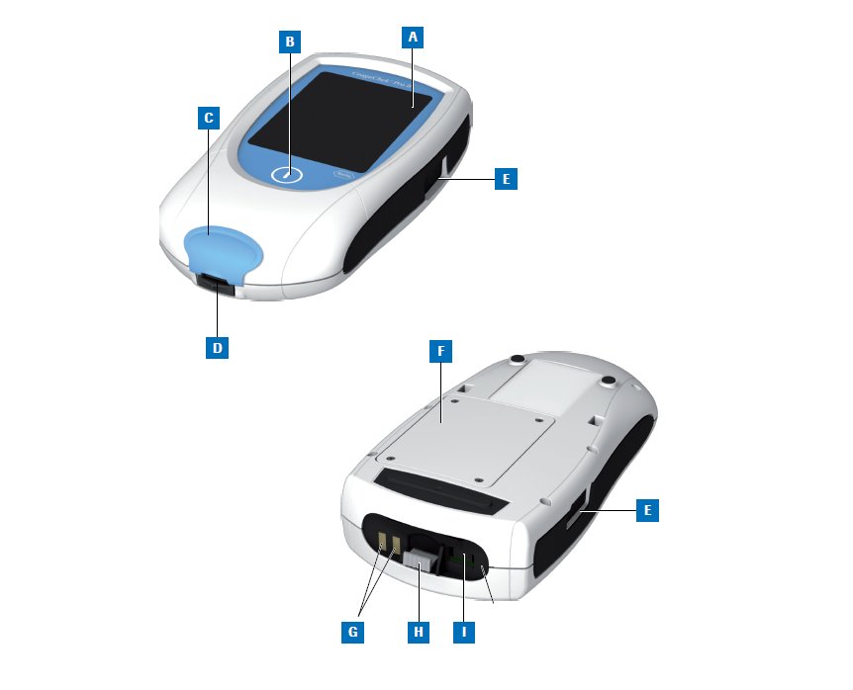

* Touch Screen
* Barcode Scanner
* On off button
* Power connector socket
* Battery cover
* Strip port
* Strip port cover
* Code chip slot
* Charging contacts

1. What is the function of the code chip found in the box of strips? What should you do with it?
2. How should the meter be cleaned? And how often?
3. How do you report a broken meter?
4. How often should Quality Control samples be run?
5. How should the control vials be prepared?
6. Place the following images in the order required to perform a quality control (QC) test.





1. What should you do if the QC is out of range?
2. Obtaining a good capillary sample:
   1. How should you prepare the patient?
   2. What infection control procedures should be used?
3. Place the following images in the order required to perform a patient test:



1. How should you dispose of a used strip?
2. Where and how should the results be recorded?
3. At what level would you send a sample to the Laboratory for confirmation?

Name …………………………………………….

Operator ID …………………………………..

Signature …………………………………………

Date ……………………………………………….

Marked by……………… Mark………./21