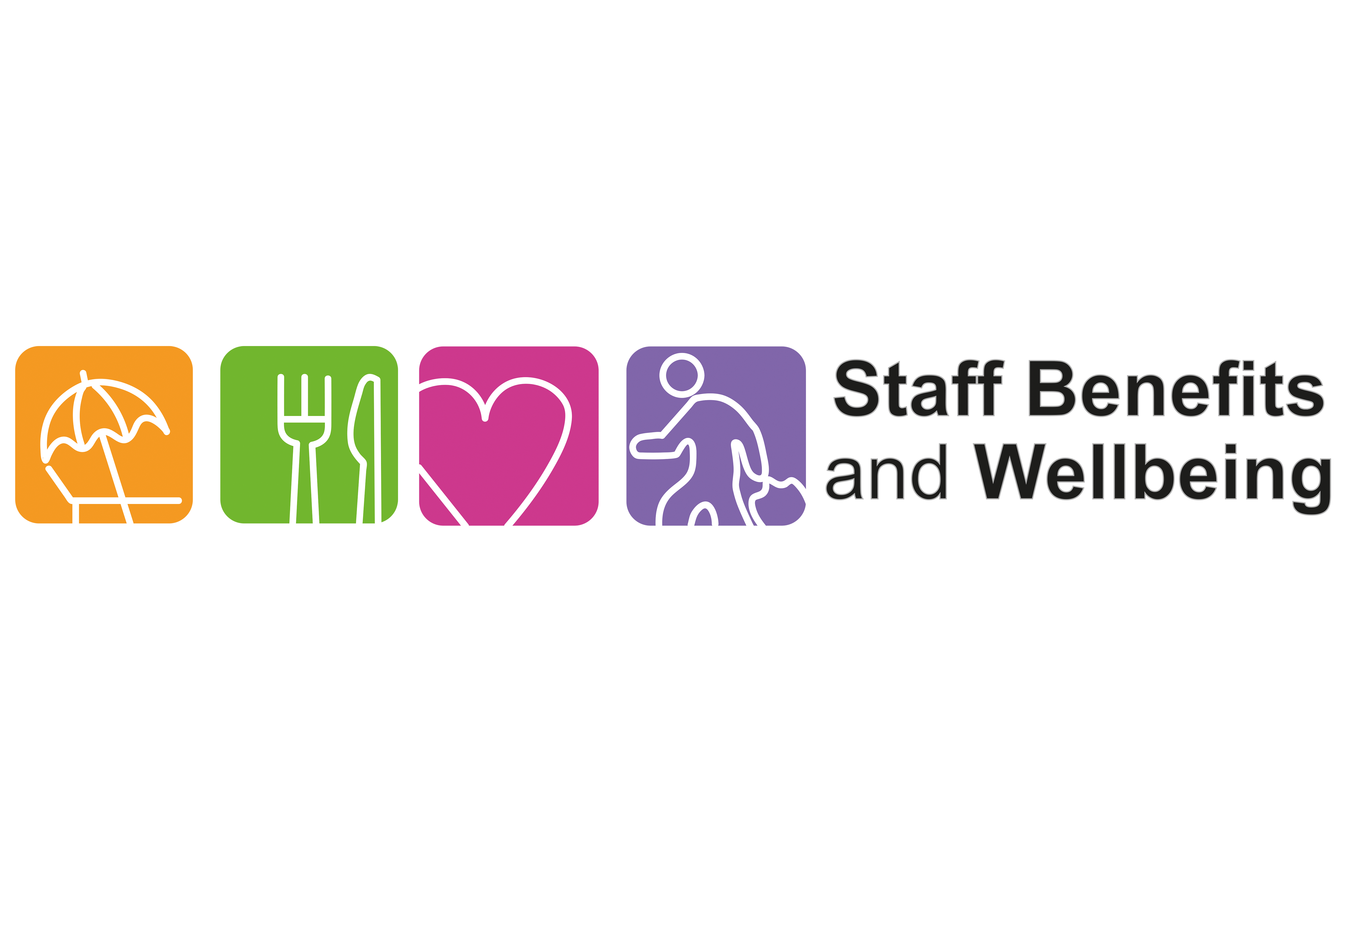
Scarborough Hospital Gym and Squash Court
Standing Order Payments

Thank you for your interest in becoming a member of the Scarborough Gym and Squash Court
As you are not on a permanent or fixed term contract with York and Scarborough Teaching Hospital you are not eligible to pay your gym membership from your salary.
Please could you arrange to set up a standing order for the amount of £5.95 per member, to be paid into the account details below. It will need to paid on the 28th of each month.
You will not be eligible to use the gym until your standing order has been set up. Please send evidence and a completed application form to yha-tr.staffbenefits@york.nhs.uk to allow us to process your application further. Once we have seen evidence of your standing order details about how to access the gym will forwarded to you.

Best Wishes
York and Scarborough Teaching Hospital NHS Foundation Trust
Bank | RBS Natwest
Account Number | 10007652
Sort Code | 60-70-80
Name of receiving account | GBS RE York Teach Hosp NHS FT
Address of receiving account | National Westminster Bank plc  Government Banking Service Branch  2nd Floor  280 Bishopsgate  London  EC2M 4RB
Reference | Gym Membership Scarborough Hospital
The Staff Benefits Team

