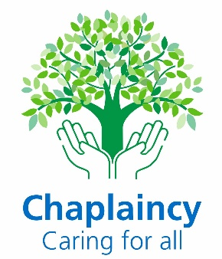

Information for People Considering Volunteering with the Chaplaincy Service

Thank you for considering volunteering with the Chaplaincy Service at York and Scarborough NHS Teaching Trust. This document aims to give you information about the volunteer role and the Chaplaincy service, and it includes information on:
- The application process and training
- The chaplaincy service in general
- What our volunteers do
- What kind of volunteers we are looking for

- The Application Process and Training:
We are keen to meet with people who are interested in exploring chaplaincy volunteering with our team. There is a formal application process which is in line with NHS England standards for volunteering in a hospital context and ensures patient safety. Please note that this process can take several months.
The first step is to complete an expression of interest form on the York and Scarborough NHS Teaching Trust website, to share your contact details and some basic information with the chaplaincy team:
York and Scarborough Teaching Hospitals NHS Foundation Trust - Volunteering
We open the application process twice per year, so when the applications open, we will email you to send you an application form. Once we receive your completed application form, we will review this and may invite you to attend for an interview. The interviews will be with two chaplains at one of our hospitals.
If both you and the chaplaincy team decide you would be suitable for the role, there will be a process to complete which involves the following:
- We will pass your application form to our Trust Volunteer team who will organise an enhanced DBS check, review ID documents, and ask you to complete an occupational health check/form.
- You will be asked for the names of two people we can approach for references, both of whom need to have known you in a formal capacity for at least two years.
- If you have lived abroad in the last five years, additional ‘right to work’ paperwork and international DBS checks will be required, which you will need to organise and pay for.
- You will be required to complete online mandatory volunteer training for the Trust, on a platform called ‘Assemble’. This includes modules on health and safety, confidentiality, fire training etc.
- All of the above may take at least 12 weeks to complete.
- We will invite you to attend two days of role specific training in person with the chaplains. As training is time intensive for our chaplains, we can only offer the training days twice per year, with dates set in advance. You would be required to attend both of the chaplaincy training days.

- You will then spend some time shadowing current volunteers and staff on the wards.
Please note that throughout this time of training and shadowing, we see this as a period of mutual discernment – so a chance for you to try chaplaincy and decide whether it is right for you; but equally if we have concerns and feel you are not suitable for chaplaincy volunteering, we do reserve the right to end your volunteering process.

- About The Chaplaincy Service
The chaplaincy team consists of eight paid chaplains (six are part-time) and a growing team of volunteers, including Roman Catholic Priests who offer on call/emergency support. The staff team currently consists of 7 ordained Anglican Chaplains and a Buddhist Chaplain, and we have links with other faith leaders in the community. We provide support at the two main hospital sites of York and Scarborough, as well other locations such as Selby Hospital, Nelson’s Court, White Cross Court, St Monica’s, Bridlington and Malton Hospitals.
We are here for patients, their family, staff, carers and visitors. We are committed to caring for people regardless of race, religion, sexual orientation, gender or culture.
Caring for people’s spiritual needs is an important part of patient centred, holistic care, in the NHS. Supporting spiritual needs can help a person’s recovery and wellbeing and should be addressed alongside physical and emotional concerns. Through times of trauma, ill health, crisis or suffering, anxiety or bereavement, a person may struggle with their sense of meaning, purpose, self-worth, and hope.
Chaplains are specialists in providing spiritual care and being a comforting presence to those in need. Our staff and volunteer team support anyone, regardless of faith, belief or religion, at all stages of life and death.
We offer:

Pastoral Care:
Listening attentively and valuing people of all faiths and none. Accompanying people through loss and difficult times.


Spiritual Care:
Helping people who lose meaning, purpose and hope. Supporting those who fear death, have regrets, or need strength.

Religious Care:
For those who require it, we offer prayers, rituals such as Holy Communion, religious services, end of life prayers and funerals, multi-faith support and links with community faith groups.

- What do our volunteers do?

Our volunteers are a valued part of the chaplaincy team and include people of different faiths and none. They contribute to patient care by generously giving their time each week to meet with and talk to patients on the wards, as well as supporting visitors, carers and staff. Our volunteers offer a listening ear, pastoral and emotional support. They also offer spiritual care by tending to a patient’s spiritual needs and being a comforting presence, whether their needs are realised in a religious way or not. Some volunteers will offer prayers and share Holy Communion with patients who have consented to religious or faith-based support. Our volunteers may also help with, or attend, the weekly service in the hospital chapel.

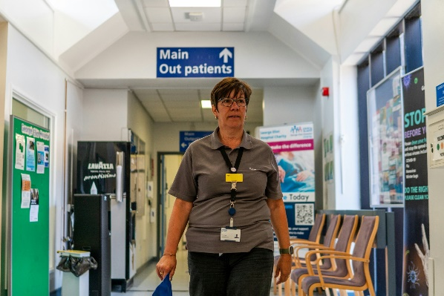
We ask for a weekly commitment of 2-3 hours on an agreed day, for at least six months. Due to continuity and the time spent in training for this role, we particularly welcome those who are able to volunteer their time for longer than six months.

We are moving towards our volunteers having a specific ward to visit, which is a good way to build relationships with staff. We ask volunteers to document who has been seen each time they visit and to feedback any issues or key information which a chaplain may need to know or follow up on. We also ask volunteers to debrief with the staff team if there has been an upsetting or difficult encounter with a patient, visitor or staff member.

As well as providing initial training and shadowing with other volunteers, we also hold regular volunteer meetings, both in localities and as a whole group across the trust (online or in person). These meetings are an important opportunity for volunteers to connect with one another, as well as to be supported and receive updates and training.

- What skills does a volunteer need?

All of our chaplaincy volunteers offer pastoral/emotional and spiritual support, whether or not a person is religious. This means coping with people’s emotions and supporting them through spiritual distress, such as the loss of hope and meaning, and fear of the future. Our volunteers therefore need to have excellent communication skills and be able to relate to people of all ages and walks of life. They need to be excellent listeners who listen without judgment or giving advice, as well as being a gentle, comforting presence. Volunteers need to present a professional, friendly and caring approach to patients, relatives, carers, clinical and other staff. They also need to uphold the Trust values of kindness, openness and excellence.

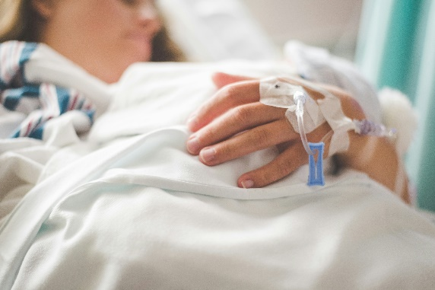
Patients can often be distressed in hospital and so our volunteers need to be resilient to cope with potentially difficult situations and conversations. Patients may also want to talk about difficult topics including end of life, their funeral, their suffering or diagnosis, family issues and life regrets. Empathetic listening, good communication and resilience are again needed. Some sights and smells can also be a challenge on the wards, so a strong stomach may be necessary. Volunteers also need to be in good physical health to travel around the wards and potentially stand for periods of time.
Some of our volunteers offer religious support in terms of having faith-based conversations, praying with a patient and sharing Holy Communion. Any volunteer who offers such support should be in good standing within their faith or belief group. They should be rooted in a personal faith or conviction that sustains their personal integrity and who can articulate their own faith or belief, whilst respecting other’s views. They also need to have the confidence to pray and share Holy Communion amidst a busy ward, and to try to find some sacred space, even in the hussle and bussle of hospital surroundings.
Please note that chaplaincy volunteering is not an opportunity to evangelise or proselytize.
- What’s in it for you?
Our volunteers tell us that they feel privileged to be part of the team and to offer support and comfort to patients at a time of difficulty or distress.
If you volunteer with us, you can expect to receive:
- A supportive team who will care for your wellbeing and fulfilment in the role
- Free parking at the hospitals for the time of your volunteering
- A mandatory training programme
- Role specific chaplaincy training
- Access to other training as appropriate
- The support of staff and other volunteers
- Regular volunteer meetings
- Linking you with a volunteer supervisor who will be your main contact
- Access to the Volunteer Services Team in the trust
- NHS and chaplaincy experience
- Any PPE necessary for the role
- The opportunity to give feedback about your role

Please also refer to the Chaplaincy Volunteer Role Description.

Thank you for considering volunteering with the chaplaincy team at York and Scarborough NHS Teaching Trust. You are welcome to contact us to discuss any queries you may have:

York Hospital: 01904 725579
Scarborough Hospital: 01723 342500
Email: yhs.tr-chaplaincy@nhs.net

Information Correct at the time of writing: June 2026
To be reviewed: June 2027

Photo Attributions:
Volunteer: Photo by Centre for Ageing Better on Unsplash
Canula: Photo by Stephen Andrews on Unsplash
Hands: Photo by Jon Tyson on Unsplash
Hope Rock: Photo by Nick Fewings on Unsplash

