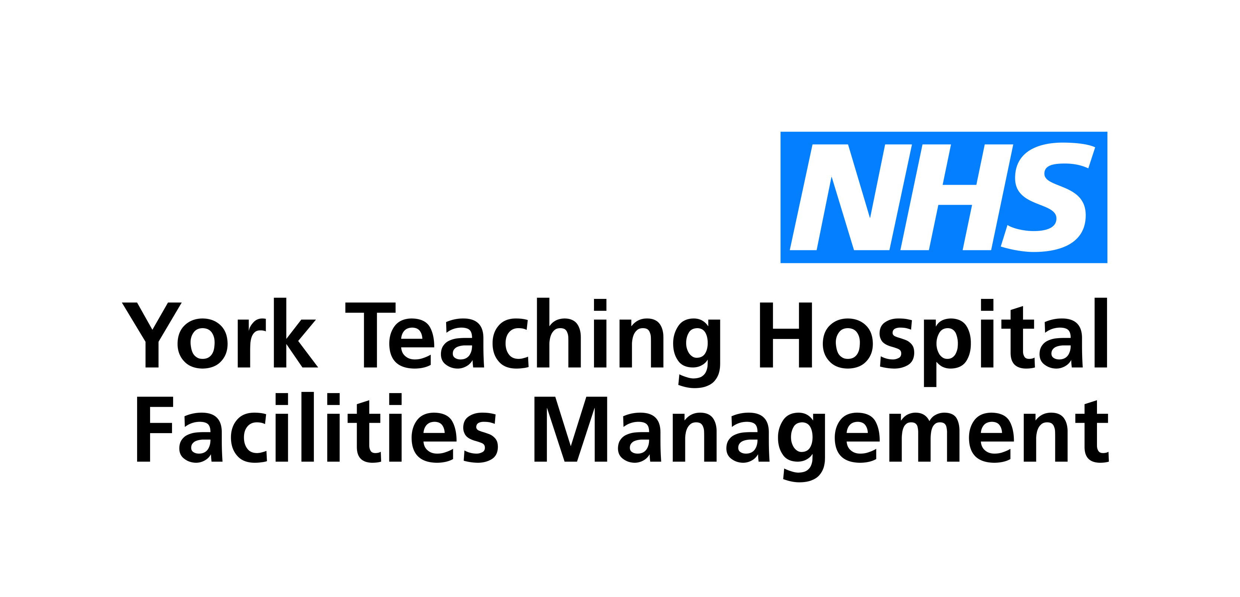

Guidance for NHS Staff - Hotel Accommodation

For those staff affected by PHE’s 14 day household isolation policy, staff should – on an entirely voluntary basis – be offered the alternative option of staying in NHS-reimbursed hotel accommodation while they continue to work.
NHS England and NHS Improvement have therefore established a single process for NHS staff to be able to secure accommodation at hotels within their immediate area, if they have been affected by Covid-19 in some way.
The national response provides easy access to staff and whilst initially it will be a single phone number, in due course it will also be available via an online portal.
The supplier of the service is CTM. In due course, an online booking system will be made available in addition to the phone number.
CTM has national agreements with a wide number of hotel operators across the country. They will be able to confirm availability at hotels as close to the required location as possible, however, certain conditions will apply;

Central Booking System
NHS staff who require accommodation at a hotel should;
Confirm with their line manager that accommodation is required; the line manager should then inform the relevant finance team that bookings are being made so that this can be tracked by finance teams.
The Corporate Travel Management (CTM) call line for booking remains in use, however they have also now created a new online booking form.
Contact CTM call centre on 01274 726424 (choosing ‘Hotel team’, then ‘Option 1’)
The booker should then be prepared to provide;
- Project code: NHS Support
- Guest name
- Telephone number for emergency
- Email address for confirmation
- Organisation name
- Organisation cost code ( 11312 add care group number at the end of code)
- Department
- Job title

Conditions:
- That you an employee for York Teaching Hospital NHS Foundation Trust or York Teaching Hospital Facilities Management
- Hotels should be informed as soon as possible if rooms are going to be cancelled, or room stays are being extended
- Where food is currently not included, or where there are additional expenses for meals or sundry items, please agree with your line manager and direct this to your employer rather than adding it to the hotel bill.
- Hotels must be booked through this process, booked outside of this process will not be paid for through central finance
- The cost of the rooms will be paid on a central basis, but charged to the organisations cost code connected to the Covid-19 response
Guidance for staff using this service:
Hotel accommodation will be available to a range of health bodies and therefore members of staff of a number of organisations will be sharing common areas within the hotels. This may obviously increase the risk of passing the virus between healthcare colleagues working in different environments. We are therefore requesting that where possible, staff:
- Minimise time in communal areas of the hotel including receptions and corridors to reduce risk of infection to colleagues
- Where possible, to limit to 1 or 2 people at a time in lifts where possible, or to use the stairs if appropriate
- Ideally eat in your room. If meals are provided within the hotel, please try to sit at tables at least 2 meters apart from other residents in any bar or restaurant
- We will be working with the hotels and providing guidance so they are aware of this and are working to support you.

