Cycle2Work Scheme
The Trust offers staff the chance to purchase cycles through a salary sacrifice scheme. The scheme allows you to make tax and National Insurance savings on the purchase of a bike and accessories for travelling to work. The scheme is facilitated by Halfords but there are many independent shops on the scheme. You are able to claim up to £1000 on a cycle and accessories.

To sign up all you need to do is go to www.cycle2work.info or call 0345 504 6444 use the code: YTHNHSC2W

To find independent stores on the scheme please follow these instructions
Go to the website www.cycle2work.info and on the first page
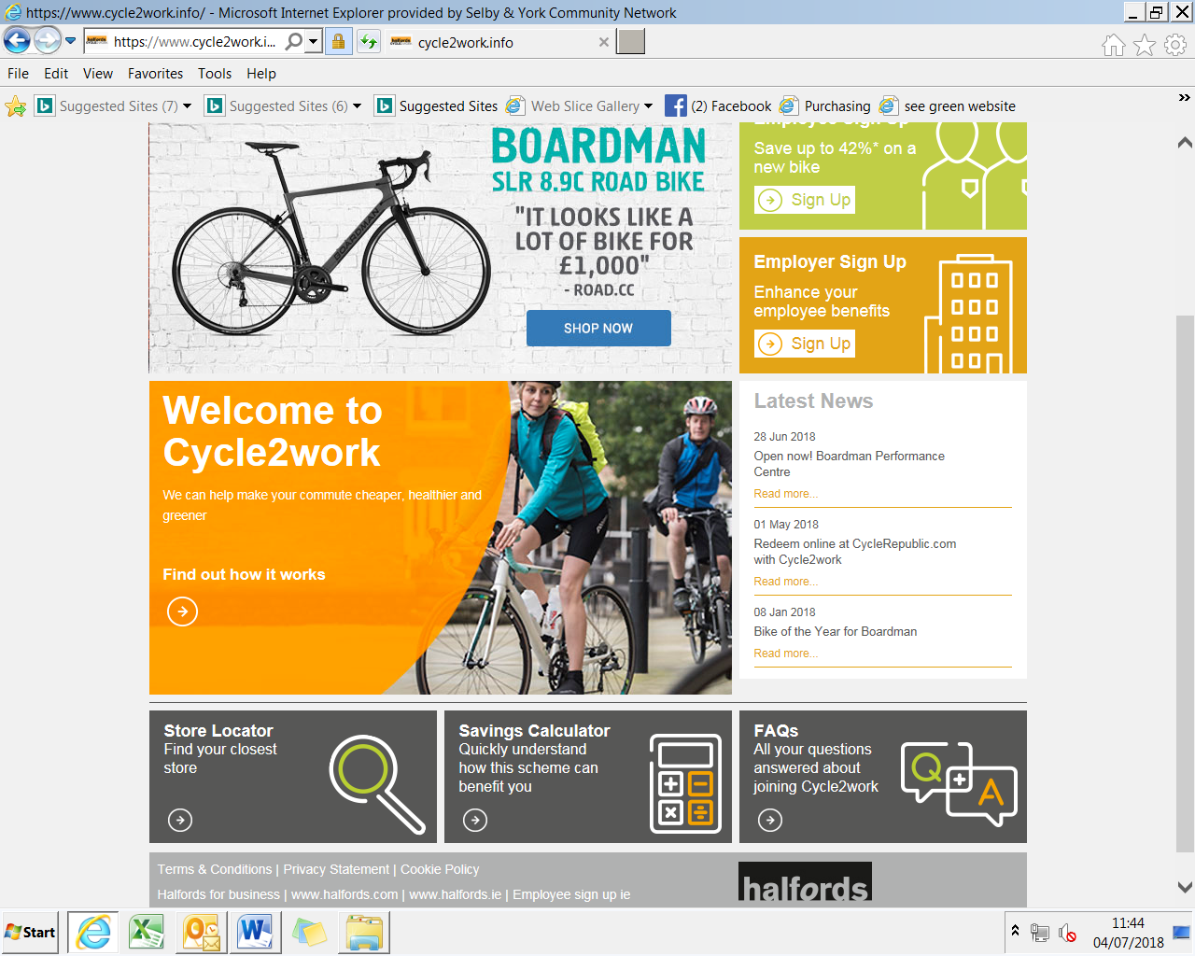
Click here to find all stores involved in the scheme
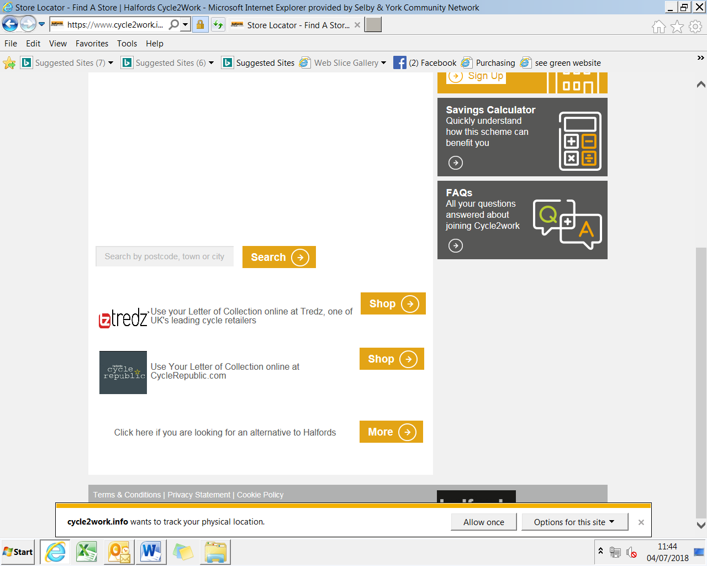
Click here to find independent store near you

