Advice on the Sample Requirements & Transport to the Laboratory

Samples must be labelled with:
- patient's full name (surname / family name and given/individual name)
- date of birth and unique NHS/hospital number
- date of collection.
Specimens should be placed in the appropriate container and must be securely fastened. This must be placed in the clear plastic bag and sealed.
For Histology / Cytology samples PLACE REQUEST FORM IN THE POCKET - NOT IN THE BAG WITH THE SAMPLE
These samples must be delivered by hand to the laboratory and not via the pod vacuum transport system:

Any Histology or Cytology samples
150ml urine pots
CSF samples and precious samples
Respiratory Samples
Any Unrepeatable samples

PLEASE NOTE FOR POD SUITABLE SAMPLES: The air tube may take up to 45 minutes to deliver a sample to its location. If you require results quickly it may be best to hand deliver the sample to the laboratory. Please do not over fill the carriers!!

Further information can be found on the link on Staff Room: Search for:
Laboratory Medicine Services: General Information: Information for Health Care Professionals

,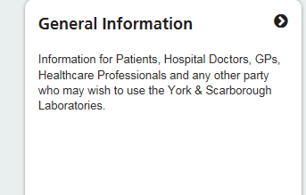 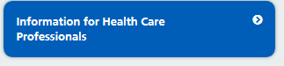
Here you will also find a link to: Transportation of Samples and Postage.

