Governor Report
Ryedale & East Yorkshire
July 2017
Since the last report Sheila has helped with a Recruitment day at Scarborough where we attracted quite a number of new younger members to the Trust.

Sheila also took part in a Patient-led assessment of the care environment (PLACE) at Scarborough hospital. The PLACE assessments form the bulk of the scores which are found when you search for a hospital on the NHS Choices website. Many governors look forward to PLACE assessments as they provide a great route to work with Healthwatch and other hospital volunteers, talk to staff and patients about their care and provide a balanced view of how a hospital is running.

At the Trust's Transport Group meeting, which Sheila sits on to represent Governor views, there was a very useful presentation by Dan Bradley from York City Council on ways to help staff, patients and visitors to find the best route to our Hospitals.

Jeanette was able to attend the Trust's annual Patient Safety Conference in York which was attended by five hundred and sixty delegates from across the region including volunteers, Doctors, Nurses, Midwives and other Healthcare Professionals. Seeing continuous improvement in patient safety is one of the ways Governors assess the Board of Directors' effectiveness, so attending this Conference was invaluable.
Both Sheila and Jeanette were thrilled to attend the official opening of the Mobile Chemotherapy Unit at Malton. We are all immensely grateful for the terrific hard work York Against Cancer has put in to providing this £700,000 unit, which will give high quality cancer treatments much closer to home for people in North Yorkshire. If you would like to know more about the unit, please visit: http://www.yorkagainstcancer.org.uk/news/first-mobile-chemotherapy-unit-yorkshire-launched
Over the next year, the Ryedale & East Yorkshire Governors will be considering the appointment of the Trust's auditors through our Constitutional Review Group. We will decide if we should extend the contract of the current auditors, or if we should instruct Trust's officers to engage in a competitive tender for auditors. We promise to update you all on this thoroughly exciting exercise later in the year.

As Governors, all three of us have strong reservations about the "capped expenditure process". It seems to us that patients would be better served by more equitable funding so that local doctors concentrate on providing great health care, rather than the constant search for increasingly unachievable savings.

We are all for a modern, cost effective healthcare system so we'll be studying all the proposals as they come out and helping to explain how changing some things could be for the better - but reckless or unsafe cost savings at the expense of local healthcare simply won't be stood for.

Please do get involved in the consultations for this process and make sure your views are heard. You can find out more about this here: https://www.healthwatchnorthyorkshire.co.uk/news/press-release-joint-statement-healthwatch-north-yorkshire-and-healthwatch-york

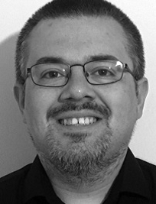
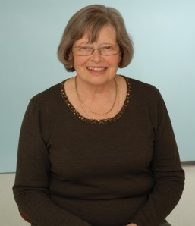
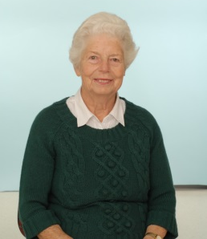

By:

Sheila Miller, Public Governor – Ryedale & East Yorkshire
Andrew Butler, Public Governor – Ryedale & East Yorkshire
Jeanette Anness, Public Governor – Ryedale & East Yorkshire

