Roche Performa Recertification Quiz
Name
Location
Meter serial number
Date

- Label the diagram with the correct parts

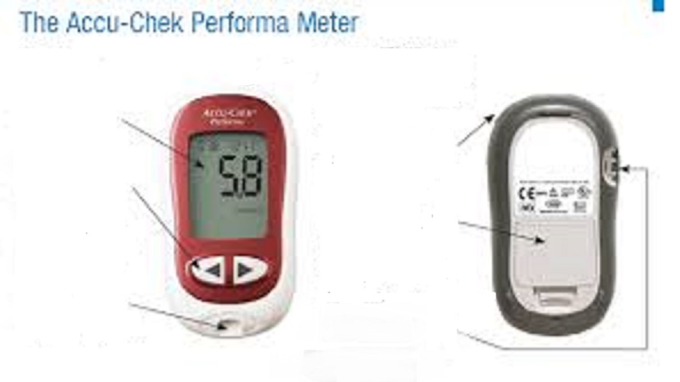
- Display/Screen
- Right/Left arrow button (to adjust settings)
- Test strip slot
- Power/set button
- Battery door
- Code chip slot

- What is the measurement range of the meter?

- Below what level of glucose should the hypo policy be implemented?

- When should the code chip be changed?

- Why should we run the control solutions?

- How often should the quality control solutions be run?
- b.

- How long do the quality control solutions last once opened?

- What should be done when the QC bottles are opened for the first time?

- Where should the QC results be recorded?

- Why should you record the quality control results?

- How should you prepare the patients hands before taking a glucose sample?

- Where should you record the patients results?

- How would you deal with an external quality assurance sample?

- What would you do with the result from an external quality assurance sample?

- Who would you report a broken/lost meter to?

