**Continence Screening Tool**

**Name:**

**Address:**

**Date of Birth:**

**NHS No (if known):**

**Date completing this form:**

**Date of last medical review/GP contact relating to urinary and or bowel issues completed.**

|  |
| --- |
|  |

**Outcome of medical review**

|  |
| --- |
|  |

**To be completed by patient or someone on their behalf, such as; Carer, Partner, Health Care Assistant, Registered Nurse.**

**If you are unable to complete this form or do not have anyone to assist please contact the District Nurse on 01904 721200.**

**Bladder**

Are you experiencing bladder problems? (problems with weeing)

* Yes
* No

Please complete a **3-day bladder frequency volume chart** if you have bladder problems only, this chart can be found at the end of this document.

**Bowels**

Are you experiencing bowel problems? (problems with pooing)

* Yes
* No

Please complete a **7 day bowel frequency chart** for bowel problems only, this chart can be found at the end of this document.

If you are experiencing bladder and bowel problems, please complete both charts.

If you have answered no to both questions above and your symptoms have resolved you do not need to complete this form. Please inform us by contacting Single Point of Access on 01904 721200

**Please explain; In what way does the bladder and/or bowel problem affect your life?** For example does it stop you from going out or does it cause you to worry

**Continence Products**

Are you currently using continence products?

* Yes
* No

If you are currently using continence products, please select from the following options. Are you currently

* Buying these yourself
* Receiving them on home delivery
* Both

What type of product and absorbency are you using and how many do you use in 24 hours? Please provide details in the box below.

**Past medical history**

Do you have any of the following long-term conditions (please tick all that apply and provide further information in the box below)

* Any bladder conditions (including any past/previous investigations/treatments)
* Any bowel conditions (including any past/previous investigations/treatments)
* Have you had bowel screening? (If so, what were the results)
* Enlarged prostate
* MS, Parkinson’s, Stroke, Epilepsy, Diabetes, Dementia, Spinal Cord Injury, fibromyalgia (or any other neurological conditions?)
* Hypertension
* Arthritis
* Abdominal Surgery
* Cancer of any kind
* Any problems with sight
* Any problems with dexterity
* Any problems with decision making
* Any memory problems
* Do you smoke or an ex-smoker

**Medications**

Are you taking any of the following medications? These medications affect bladder & bowel function (please tick all that apply)

* Alphablockers e.g. Tamsulosin, or Finasteride;
* Anticholinergic e.g Solifenacin, Tolterodine, Oxybutynin, Mirabegron;
* Antidepressants;
* Oestrogen, patches, gel, pessaries;
* Water tablets e.g Furosemide; Spironolactone, Bumetanide
* Laxative e.g Laxido, Movicol, Senna, Lactulose, Fybogel, Docusate, Bisacodyl;
* Pain relief e.g Co-Codamol, Morphine, Tramadol;
* Sedatives e.g Diazepam, Lorazepam, Clonazepam;
* Recreational drugs?

If you have ticked any of the boxes above, please provide further information on dosage and daily amount in the box below.

Are you allergic to anything? If yes, provide information in the box below. (Medications, pads, creams, sheaths, catheters etc).

* Yes
* No

**Women’s Health**

**Obstetric History:** number of pregnancies and childbirths, information on assisted deliveries or trauma/complications experienced.

**Menopausal status:** Any vaginal dryness, itching or discharge? Are you aware of any prolapses?

Please provide any information in the box below.

**Skin Health**

Do you have any concerns or soreness of your skin around the genitals, groin or bottom area?

* Yes
* No

If yes, what problems are you currently having and are you using any treatment to help with this? Provide details in the box below

**Home Situation**

Please tick all that apply and provide further details in the box below

Type of accommodation

* House
* Bungalow
* Residential home
* Nursing home
* Other please state below
* Can you access toilet facilities independently?
* Do you have any mobility problems or use any walking aids?
* Have you had any falls in the last 12 months?

Free text for any additional information which may help us

**Carers**

Do you have carer support day to day?

* Yes
* No

If yes, provide information in boxes below

**Name of care company**

**Contact Number**

**How many calls per day**

**Provide details in the box below of what tasks the carers support you with when they visit?**

For example, toileting, cooking, cleaning, showering, dressing, pad changes etc

**Diet**

Please provide information and examples in the boxes below of what you eat in a typical day. Do you get the recommended daily amount of 5 portions or fruit/veg daily? Are your meals homemade or do you have microwave meals?

**Breakfast**

**Lunch**

|  |
| --- |
|  |

**Tea**

**Snacks**

**Fluids**

Which drinks do you mainly drink (please tick all that apply and provide further information in the box below)

* Water
* Tea
* Decaffeinated tea
* Fruit tea
* Herbal tea
* Coffee
* Decaffeinated coffee
* Fresh juices
* Juice (squash, cordial etc)
* Fizzy drinks
* Alcohol
* Other, please specify below.

Do you mainly drink from (tick all that apply)

* Tea cups
* Mugs
* Glasses
* Beakers
* Bottles
* Cans

How many of these do you drink in a typical day? Provide information in the box below

**Bladder Problems**

**Urine infection/urine dip**

Do you currently have any symptoms of urinary tract infection

* Yes
* No

If yes, tick all that apply

* Pain on weeing
* Do you think you have a high temperature?
* New symptoms of weeing more often
* New symptoms of urine leakage/having accidents
* New onset of confusion, difficulty making decisions
* New lower stomach pain
* Strong smelling urine
* Blood in urine

Please state in the box below how long have you had these symptoms and if more than three days please ring GP and provide urine sample (mid-stream, if possible). Provide date urine specimen sent to GP.

**Please read through the following sections and tick all the symptoms that apply to you and provide any further information in the boxes below each section.**

# Stress Bladder Symptoms

* Wee leaks when coughing, sneezing, doing exercises or during sexual intercourse.
* Problem may have existed for some time before help sought
* Problem may be worse at different times of the monthly cycle, if applicable
* Problem may have become worse following the menopause.
* Males only, recent prostatectomy

Additional information

**Frequency/Urgency Bladder Symptoms**

* Always wanting to go to the toilet (more than 6/8 times a day for a wee)
* Always needs to know where toilet is.
* May be wet before the toilet is reached
* Anxiety about the problem
* May drink mostly tea/coffee/alcohol/fizzy drinks.
* May have to get up more than twice a night for a wee
* May leak again after going to the toilet.
* May have a history of stroke/diabetes/MS/surgery in pelvic or spinal area/early stages of dementia/behavioural problems/other neurological conditions
* May have a urinary tract infection.

Additional information

**Overflow symptoms/bladder not emptying**

* Urine flow not as fast as previously
* Difficulty or hesitation to have a wee when on toilet.
* May not be able to wee at all.
* Without warning do you ever wee yourself
* May have an enlarged prostate gland, urethral stricture or out flow obstruction, if known (male patients only)
* May have a history of recurrent urinary tract infections.
* May have a history of constipation.

Additional information

**Functional Loss/Reflex**

* Have no idea when need to have a wee or poo.
* Usually, will wee and poo with very little warning
* Does not have opportunity to sit on the toilet.
* May be terminally ill or extremely sedated.
* May only be a nighttime problem

Additional information

**Bowel Problems**

**Please read through the following sections and tick all the symptoms that apply to you and provide any further information in the boxes below each section.**

**Symptoms of bowel cancer – red flags**

* Bleeding from your bottom
* Blood in your poo
* A change in your pooing habits – going more or less often, or have diarrhoea or constipation that might come and go
* Losing weight but you are not sure why.
* Feeling very tired all the time but you are not sure why.
* A pain or lump in your stomach.

**Having these symptoms doesn’t always mean you have bowel cancer, but it’s still important to find out what is causing them.**

**Please contact your surgery to arrange an appointment with a GP to discuss this.**

**Bowel Symptoms**

* Poo type (Bristol Stool Chart on back of form) record score 1-7
* Do you have a poo less than 3 times a week?
* Do you have to rush to the toilet when you need a poo?
* Are you unable to control leakage or are you having accidents?
* Does poo mark your underwear before or after you’ve been to the toilet?
* After having a poo do you need to go to the toilet again soon after?
* Have you noticed you are going to the toilet less or more often?
* Do you ever see mucus in your poo or when wiping your bottom?
* Is there any family history of bowel problems?
* Any pain or discomfort when having a poo?
* Do you struggle to sit on the toilet/commode in a comfortable position?
* Are you able to get to the toilet independently?
* Do you rely on carers to take you to the toilet when you need a poo?
* Do carers give you the opportunity to sit on the toilet?
* Do you have anxiety about the problem?
* Are you already using a device to assist in the removal of poo?
* Do you ever have to use your fingers to help remove poo from your bottom?
* Do you need to take medication to help you go to the toilet (if yes please include this in the medication section)

Thank you for completing the screening tool, please return the document using the preaddressed envelope enclosed. The District Nurses will then be in touch. In the meantime, you may need to provide your own incontinence supplies until your assessment has been completed.

If you do not return the form within four weeks, a member of the District Nurse team will contact you to discuss further. If the District Nurse is unable to contact you on two separate occasions you will be sent a ‘no contact letter’.

**BOWEL FREQUENCY CHART**

**Name Date of Birth:**

**NHS No:**

|  |  |  |  |
| --- | --- | --- | --- |
| **Date** | **Time** | **Type of Stool**  **(Bristol Scale)** | **Comments/Additional Information**  **Any leakage? What time?** |
|  |  |  |  |
|  |  |  |  |
|  |  |  |  |
|  |  |  |  |
|  |  |  |  |
|  |  |  |  |
|  |  |  |  |
|  |  |  |  |
|  |  |  |  |
|  |  |  |  |
|  |  |  |  |
|  |  |  |  |
|  |  |  |  |
|  |  |  |  |
|  |  |  |  |
|  |  |  |  |
|  |  |  |  |
|  |  |  |  |
|  |  |  |  |

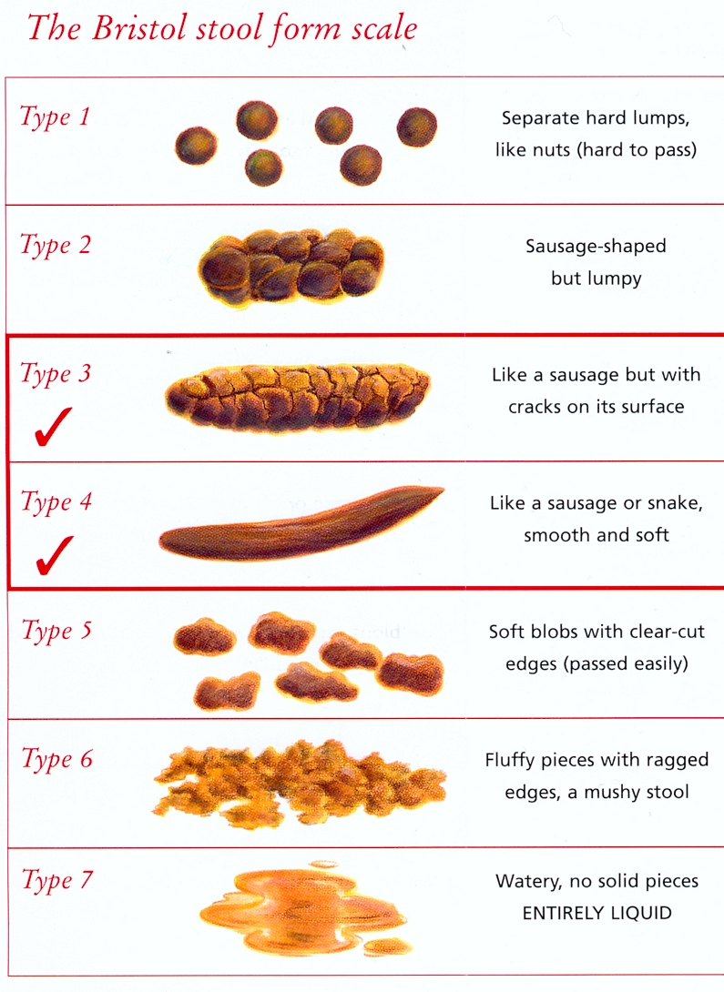

**IMPORTANT - Please read this carefully**

* It is very important that you fill in the chart.
* It is designed to give us an idea of your average fluid intake, urine output and leakage. This assists us greatly in the diagnosis of your condition.
* For each day record how much you drink (metric i.e.mls if possible) and when you drink it (put the volume in the square provided for that time). If you often drink from the same or similar cups, then you need only measure how much it holds once and put that value down every time you drink from it.
* When you go to the toilet, measure the urine you pass using a small jug. If possible record the volume in mls rather than fluid ounces, and again record it in the box next to the nearest hour.
* Every time you leak put a cross in the column marked "Wet".
* When you go to bed put a line on the chart next to the right time, so that we can tell how many times you have to get up in the night to pass water.
* Below is an example of a correctly completed section.

|  |  |  |  |
| --- | --- | --- | --- |
| Time | Day 1 Monday | | |
|  | In | Out | Wet |
| 6 am |  |  |  |
| 7 am | 100 |  | X |
| 8 am |  | 300 |  |
| 9 am |  |  |  |
| 10 am |  | 290 |  |
| 11 am | 250 |  |  |
| 12 noon |  |  | X |
| 1 pm | 400 |  |  |

BLADDER FREQUENCY / VOLUME CHART

Name: Date of Birth:

NHS No:

Please see instructions on the back of this page.

|  |  |  |  |  |  |  |  |  |  |
| --- | --- | --- | --- | --- | --- | --- | --- | --- | --- |
| **Date Commencing and Time** | **Day 1** | | | **Day 2** | | | **Day 3** | | |
|  | In | Out | Wet | In | Out | Wet | In | Out | Wet |
| **6 am** |  |  |  |  |  |  |  |  |  |
| **7 am** |  |  |  |  |  |  |  |  |  |
| **8 am** |  |  |  |  |  |  |  |  |  |
| **9 am** |  |  |  |  |  |  |  |  |  |
| **10 am** |  |  |  |  |  |  |  |  |  |
| **11 am** |  |  |  |  |  |  |  |  |  |
| **12 noon** |  |  |  |  |  |  |  |  |  |
| **1 pm** |  |  |  |  |  |  |  |  |  |
| **2 pm** |  |  |  |  |  |  |  |  |  |
| **3 pm** |  |  |  |  |  |  |  |  |  |
| **4 pm** |  |  |  |  |  |  |  |  |  |
| **5 pm** |  |  |  |  |  |  |  |  |  |
| **6 pm** |  |  |  |  |  |  |  |  |  |
| **7 pm** |  |  |  |  |  |  |  |  |  |
| **8 pm** |  |  |  |  |  |  |  |  |  |
| **9 pm** |  |  |  |  |  |  |  |  |  |
| **10 pm** |  |  |  |  |  |  |  |  |  |
| **11 pm** |  |  |  |  |  |  |  |  |  |
| **12 midnight** |  |  |  |  |  |  |  |  |  |
| **1 am** |  |  |  |  |  |  |  |  |  |
| **2 am** |  |  |  |  |  |  |  |  |  |
| **3 am** |  |  |  |  |  |  |  |  |  |
| **4 am** |  |  |  |  |  |  |  |  |  |
| **5 am** |  |  |  |  |  |  |  |  |  |
| **Totals** |  |  |  |  |  |  |  |  |  |

I cup = approximately 150mls 1 beaker = approximately 200mls