**Update on ICE Online ordering system for All Clinical Users**

This is a message to help you select the correct option on ICE when ordering your blood tests and to make it clear when orders can be edited and when they cannot be

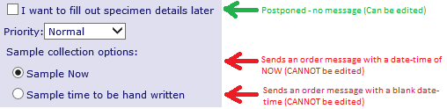

If you are collecting the sample within the next 30 minutes then please choose the “Sample Now option. Do **not** use this option if patient is being bled at a future point in time. The order **CANNOT** then be edited

If the patient will be attending for phlebotomy at the hospital, Monks Cross or other location at a later date then please choose “Sample time to be handwritten” option. The order **CANNOT** then be edited

If the patient is coming back for a phlebotomy appointment at the surgery at a later date then you have the option to “Go Green” and choose the option

“I want to fill out the specimen details later”

Choosing this option will allow the order to be edited if further tests are required prior to phlebotomy. The phlebotomist at your surgery can print the request form and select “Sample Now” when they come to bleed the patient.

If you select one of the “Red” options above and then attempt to edit the order then **this will not work** and you will **not** get the extra tests you ask.

Handwriting extra tests on the form will also **not** usually get you the extra tests as this can be missed in the lab.

In this case of additional tests being needed when a “Red” option has been selected, it is essential to generate a fresh order including the additional tests

If you want to add extra tests to a sample already in the laboratory then please see:

<https://www.yorkhospitals.nhs.uk/our-services/a-z-of-services/lab-med/general-information/information-for-health-care-professionals1/add-on-requests/>

Any queries please email us [yhs-tr.pathologyit@nhs.net](mailto:yhs-tr.pathologyit@nhs.net).