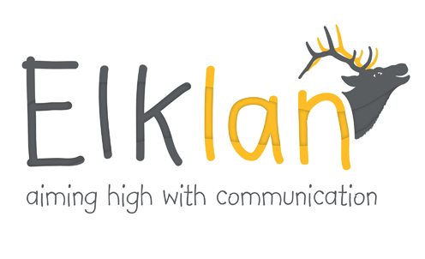
Elklan Course - Speech and Language Support for 3-5s
Course Tutors –
Melanie Feeney, Specialist Early Years Teacher (SEN)
Rachel Shearer, Advanced Clinical Specialist Speech and Language Therapist
Venue – Pineapple room, Hob Moor, Children’s Centre, Green Lane, Acomb, York. YO24 4PS.
Dates : Wednesday Mornings – Wednesday September 20th - Wednesday 29th November, with no session on Wed 1st Nov for half term.
9.30am to 11.45am.
Cost £265. This cost includes 10 taught sessions, Accreditation Fee, portfolio marking and a copy of the course handbook ‘Language Builders’
Completion of this course will give you an externally verified and accredited level 2 or 3 qualification which is on the Qualifications and Curriculum Framework (QCF).
Booking Details:
Name_________________________________________School/Setting______________________________
Contact number_______________________ School/setting email__________________________________
Course participant contact number and email__________________________________________________
An invoice will be sent for £265 once a place is confirmed. Please indicate where this invoice should be sent
Invoice to:______________________________________________________________________________
______________________________________________________________________________________
______________________________________________________________________________________
Purchase order number if required__________________________________________________________
Please return this booking form to Gill Clarke, Tadcaster Health Centre, Crab Garth, Tadcaster, LS24 8HD or email it to childrenstherapytraining@york.nhs.uk

