# Quick Guide to Pathology Requesting

## Creating Order /s

* Find your patient on SystmOne
* Click on the ‘Flask Icon’ on the tool bar to launch the ICE window within SystmOne

Icon for accessing ICE Requesting

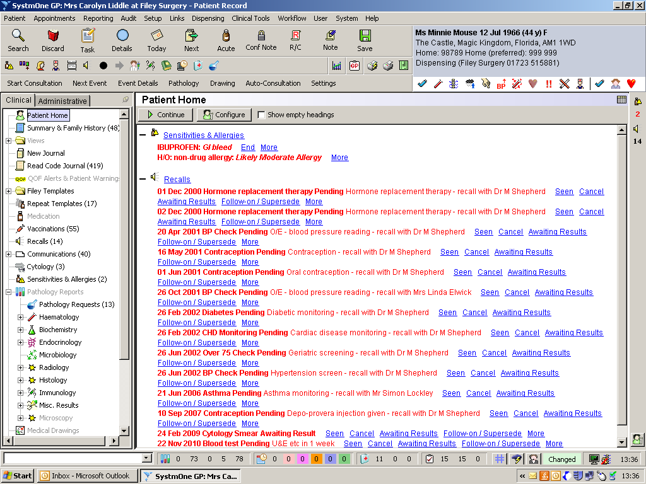

* The Common tests page (below) shows the most commonly requested tests: note the scroll bar on the right.
* Test by specialty can be found under the relevant tab on the left hand side – if you do not know which heading, your test is under use the search page.

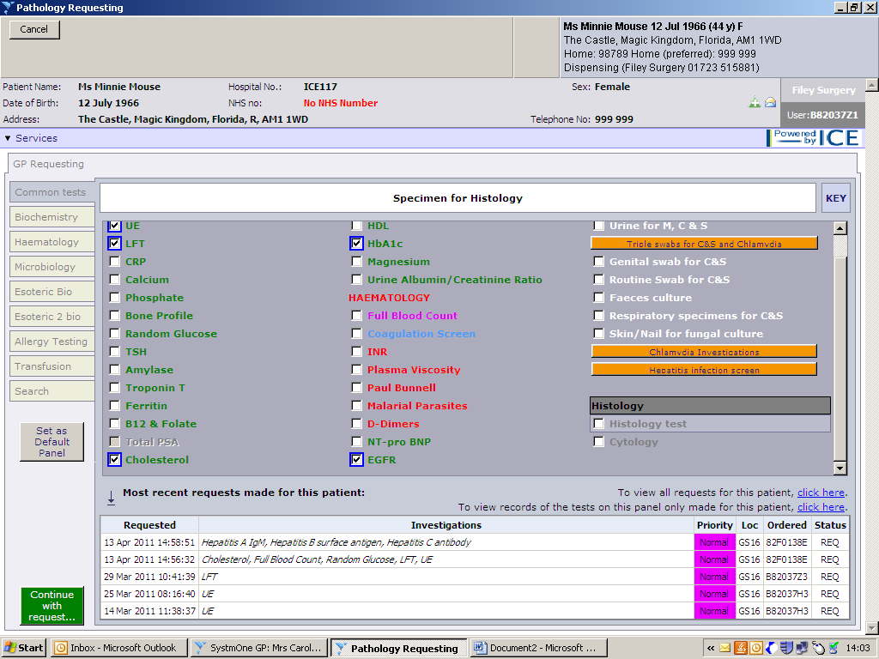

Search Here

Common test tab (default)

View all patient results

Latest requested tests

Selected Tests

* The bottom part of the screen shows the latest requested tests
* To view all Pathology results including those tests carried out by the hospital select **‘Services**’ from the top left of the screen and select patient report list.

To view all requests only for this patient click here.

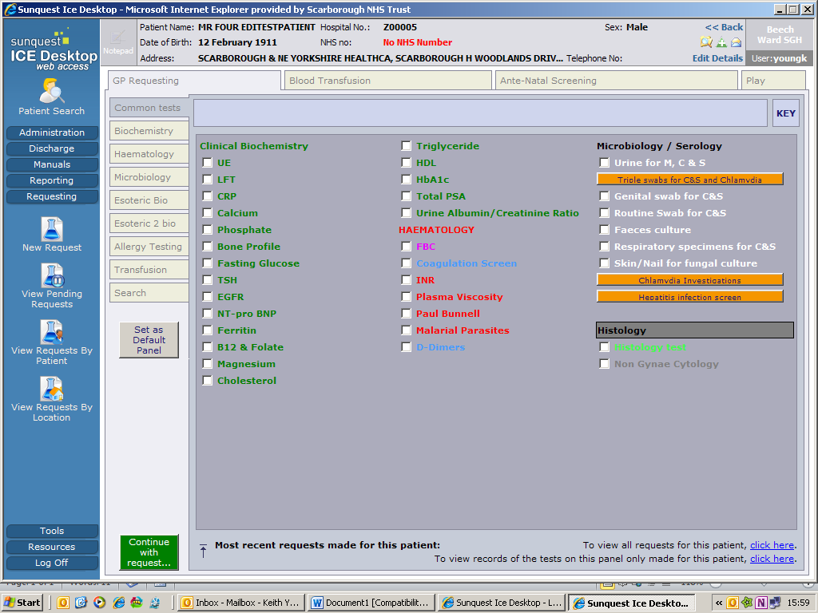

To view records of the tests on this panel only for this patient only for click here.

* Select the tests you require and then click the **‘Continue with request’** button

## Completing Order /s

* Once your order/s are placed . . . . . click on the **“Continue with Request Button”**
* **IMPT:** If you’re a proxy requestor or ordering on behalf of someone) ensure the correct Clinician is displayed in the Requesting Consultant/GP field
* Add Global Clinical Details – as you would on the paper form 80 characters maximum and complete any other dialog boxes you may encounter
* If the sample/s are to be taken as part of the consultation so ensure ‘**Sample Now’** is selected from the order details.
* You can mix / match e.g. sample now microbiology but not biochemistry
* **IMPT:** you can click on **”Sample Time to be Hand Written”** if the patient
  + is going to take the request form to phlebotomy (and ASDA) at a later date
  + or a community nurse for example will take the specimen later
* **For Postponed Requests – see “Postponed Requests” below**

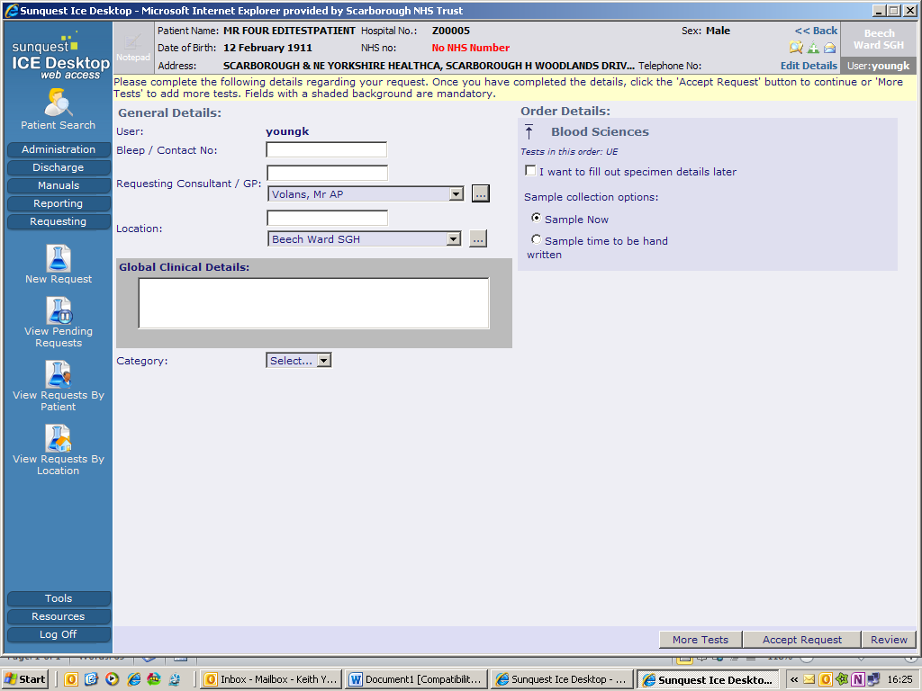

Correct requesting Clinician?

* Patient category **defaults to NHS**. However you need to click and select if you want to choose another option from the drop down list
* Click ‘**Accept Request’** at the bottom of the screen

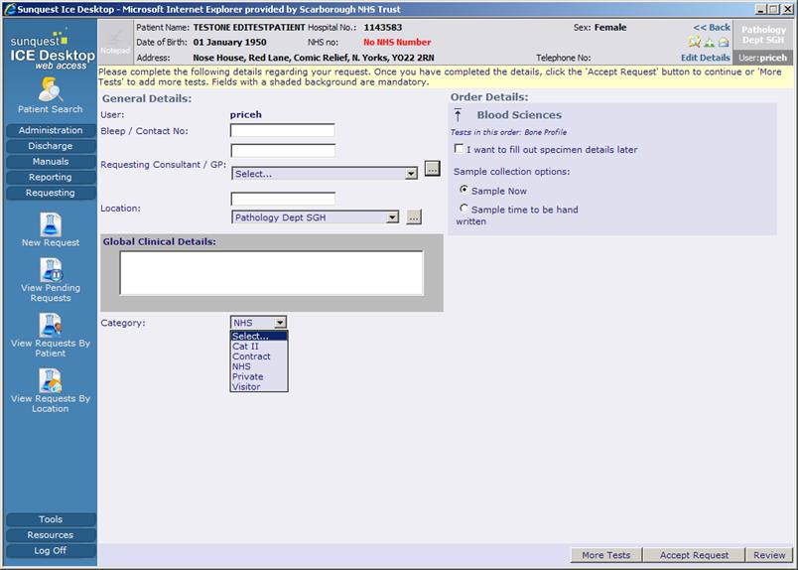

Accept Request to place & print order

Change patient category here

## Printing the Request

* Select the correct printer from the list ensuring the correct stationery is available
* Click ‘Print’
* Ensure that the form has printed correctly before selecting ‘proceed’ or otherwise select reprint before proceeding.

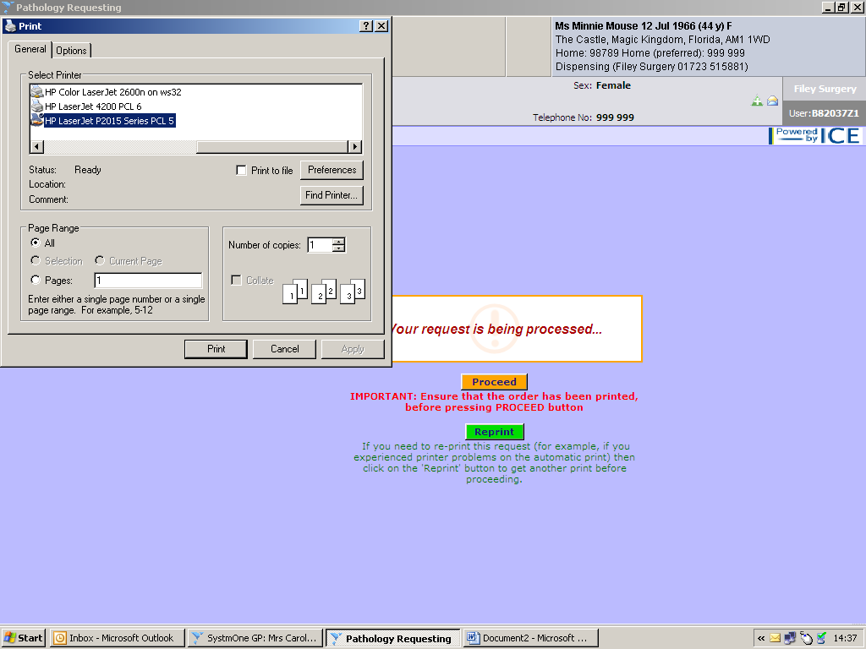

* The SystmOne record will be updated to show that the test has now been requested

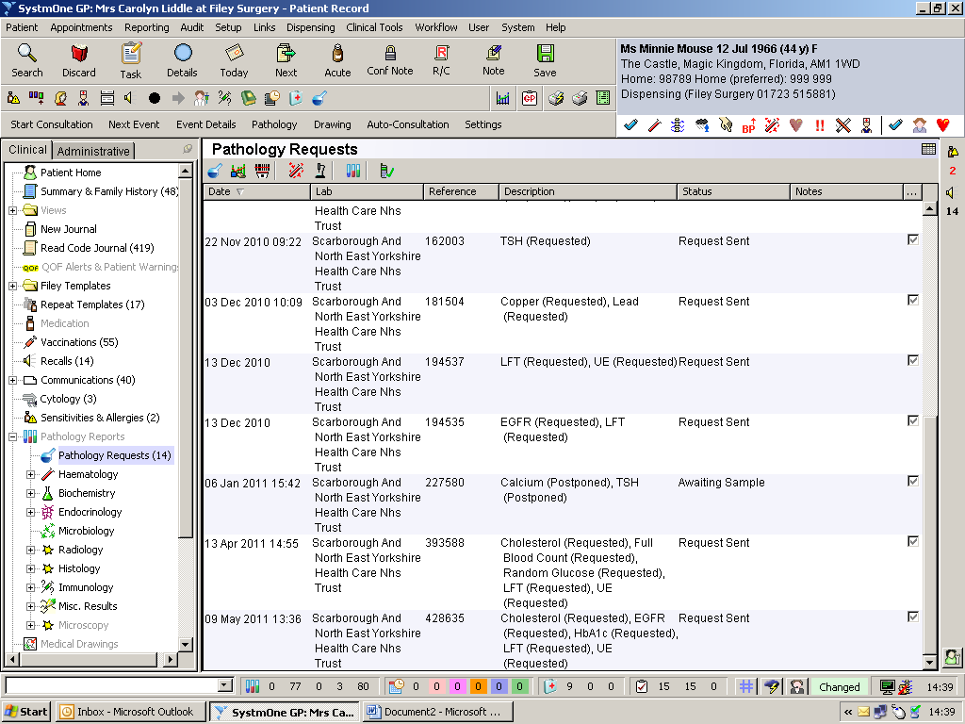

## Postponed Requests

* As above: ensure the correct Clinician is displayed in the Requesting Consultant/GP field.
* Add Global Clinical Details – as you would on the paper form 80 characters maximum
* Tick **‘I want to fill out specimen details later’** button – this will mark the request as **Postponed** in the SystmOne journal
* Click **`Accept Request’** and an entry will appear in the SystmOne patient journal marked as **`Postponed (Awaiting Sample)’**



Create a Postponed Request

Accept Request

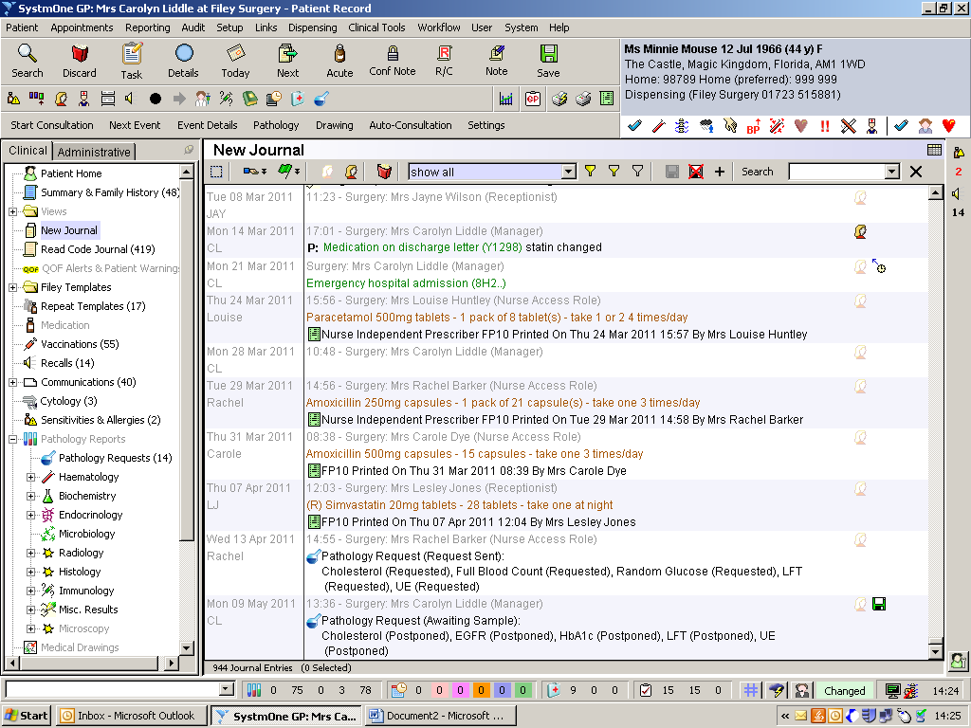

When in the `New Journal’ Click on the filter & select “Show All”

Pathology Request Heading

Journal Entry

## Update the Request . . . add further tests and change supporting information

* Right mouse click on the SystmOne entry for the patient either from the journal or from pathology requests
* If you wish to add any tests to the original request double click on the journal entry and select **Update Request** and amend as required, ensure that you do this before you **‘Take Sample’**

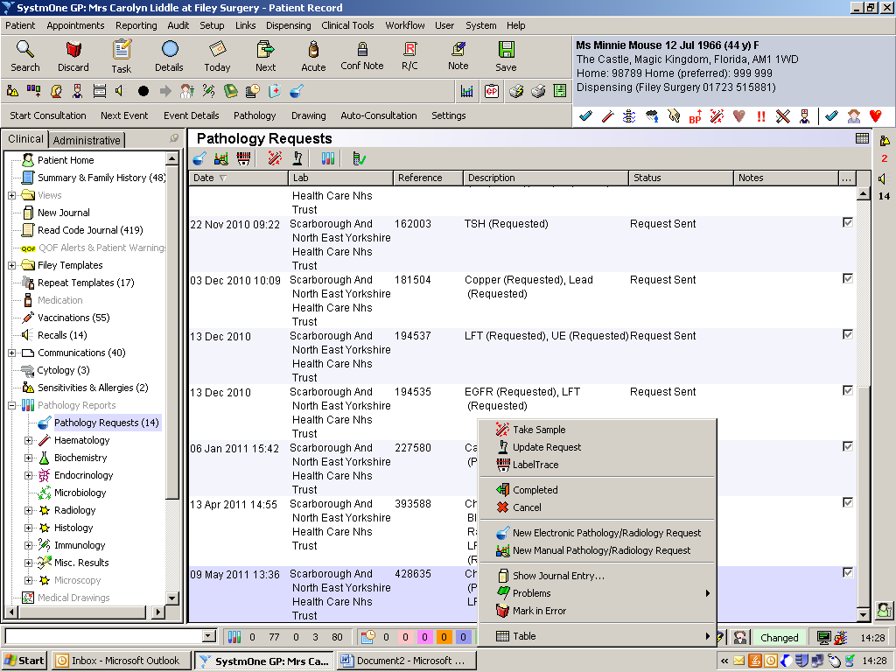

* Click **‘Edit Request’** to make any changes to the request
* You can also **‘Delete and Reprint Requests’** from this menu

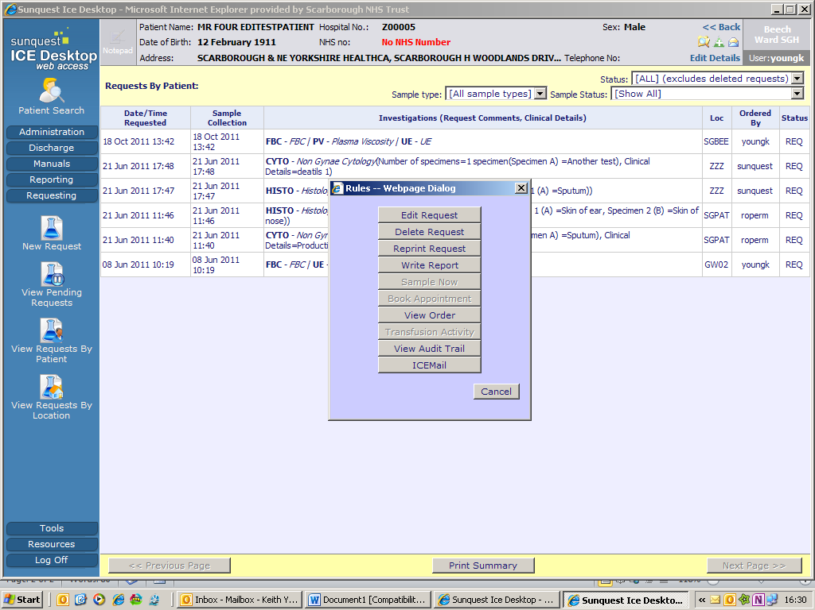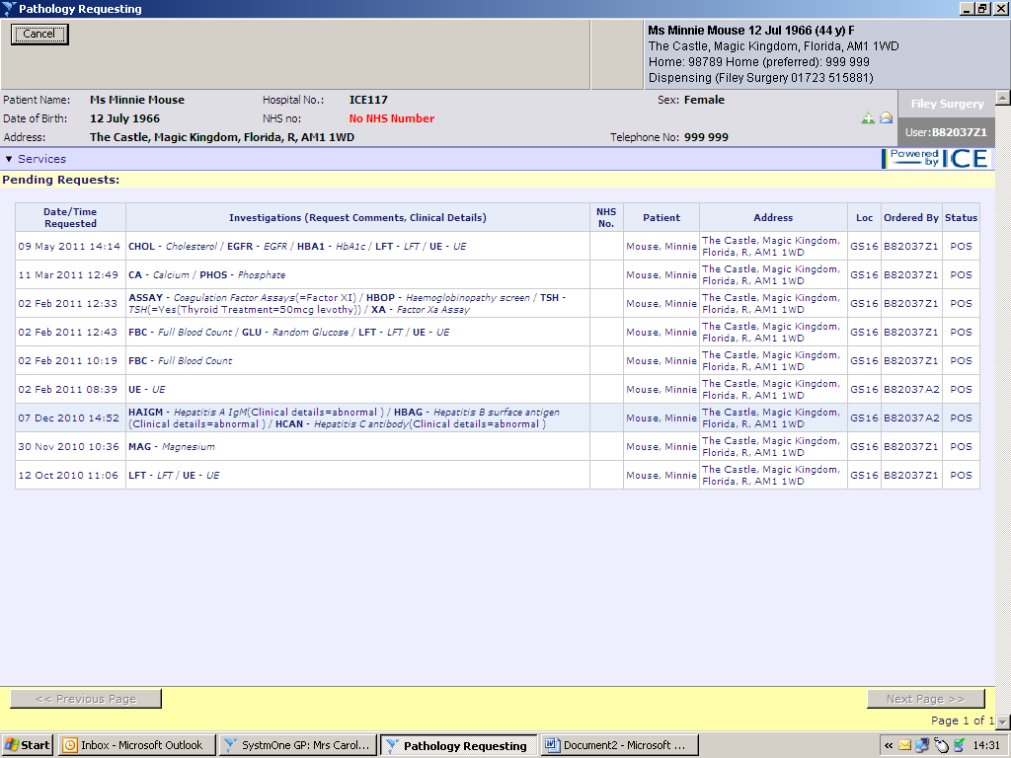

Edit request allows changes to be made prior to taking the samples and accepting request prior to printing.

When the sample is taken – select ‘Take Sample’ to continue the process of printing the sample form and labels



**Note:**

* After selecting the appropriate request (by double clicking) the request details will show select either **‘Sample Now'** ‘**Sample to be hand written’** date and time to added later (see above)
* Click **‘Accept Request’**

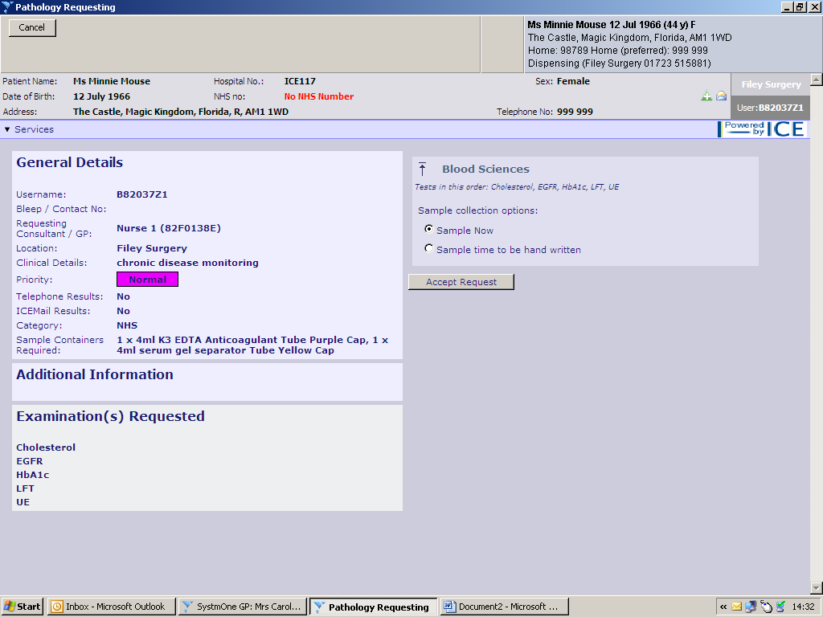

## Printing the Request (as above)

* Select the correct printer from the list ensuring the correct stationery is available.
* Click ‘Print’
* Ensure that the form has printed correctly before selecting ‘proceed’ or otherwise select reprint before proceeding.
* The SystmOne record will be updated to show that the test has now been requested

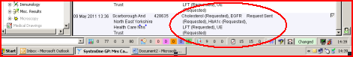

# FAQs:

1. Printer has jammed and I’ve lost the form
   1. Reprint from ICE
2. I can’t request electronically
   1. Create a hand written request. The lab will not turn is down
3. I want to add more tests:
   1. If specimens have not been taken modify the orders you have created
   2. If specimens have been taken contact the lab to have the new tests added or . . if this is not appropriate . . . create an new order on ICE (e.g. you need to send a new specimen type for the test to be performed)
4. I’ve made a mistake which I’ve noticed after completing the order
   1. Delete Request (see Page 6) or create a new order