

**Equality, Diversity and Inclusion Annual Report April 2023 - March 2024**

**Public Sector Equality Duty (PSED)**

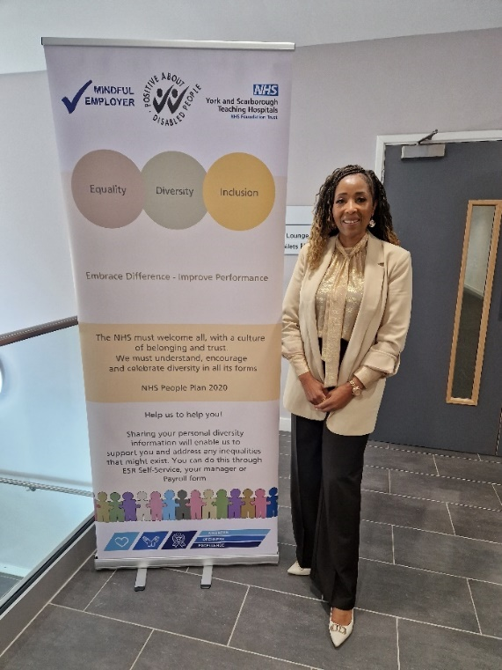

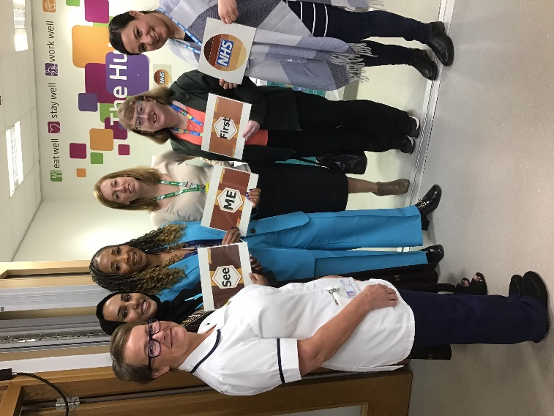

**Contents**

Glossary of Terms 3

Introduction 4

The Equality Act 2010 and the Public Sector Equality Duty (PSED). 4

The NHS Equality Delivery System (EDS 2022) 5

Our Commitment to Equality, Diversity and Inclusion (EDI) 7

Communication and Engagement 8

Celebration of Achievement Awards 8

Equality Objectives Activity 9

Workforce Objectives 2020-2024 9

Patient Objectives 2020-2024 16

Accessible Information Standard Complaints 20

Building Environments Objective 2020-2024 21

Workforce and Patient Equality Monitoring Information 22

Workforce 22

Patient 23

Conclusions and Next Steps 23

Appendix 1 24

## Glossary of Terms

Accessible Information Standard AIS

Black and Minority Ethnic BME

British Sign Language BSL

Electronic Staff Record ESR

Equality Delivery System EDS 2022/EDS

Equality, Diversity and Inclusion EDI

Gender Pay Gap GPG

Hard of hearing or deaf d/Deaf

Integrated Care System ICS

Lesbian, Gay, Bisexual, Transgender, Questioning and other identities LGBTQ+

National Health Service NHS

National Health Service England NHSE

Public Sector Equality Duty PSED

Race Equality Network REN

Values Based Recruitment VBR

Workforce Access Programme WAP

Workforce Disability Equality Standard WDES

Workforce Race Equality Standard WRES

York Teaching Hospital Facilities Management YTHFM

## Introduction

York and Scarborough Teaching Hospitals NHS Foundation Trust provides a comprehensive range of acute hospital, community and specialist healthcare services for approximately 800,000 people living in and around York, North Yorkshire, North East Yorkshire and Ryedale - an area covering 3,400 square miles.

We manage 8 hospital sites and have a workforce of around 12,000 staff, inclusive of bank, substantive and fixed-term staff, working across our hospitals within the community and York Teaching Hospitals Facilities Management (YTHFM.)

**Our hospitals**

* [York Hospital](https://www.yorkhospitals.nhs.uk/our-hospitals/-the-york-hospital/)
* [Scarborough Hospital](https://www.yorkhospitals.nhs.uk/our-hospitals/scarborough-hospital/)
* [Bridlington Hospital](https://www.yorkhospitals.nhs.uk/our-hospitals/bridlington-hospital/)
* [Malton Hospital](https://www.yorkhospitals.nhs.uk/our-hospitals/malton-community-hospital/)
* [The New Selby War Memorial Hospital](https://www.yorkhospitals.nhs.uk/our-hospitals/the-new-selby-war-memorial-hospital/)
* [St Monica's Hospital Easingwold](https://www.yorkhospitals.nhs.uk/our-hospitals/st-monicas-easingwold/)
* [White Cross Rehabilitation Hospital](https://www.yorkhospitals.nhs.uk/our-hospitals/whitecross-court/)
* [Nelsons Court Inpatients Unit](https://www.yorkhospitals.nhs.uk/our-hospitals/nelsons-court/)

York and Scarborough Teaching Hospitals NHS Foundation Trust is a diverse employer and provider of care. Our aim is to create a culture of inclusion where everyone feels valued and respected for who they are and what they bring to our organisation.

Our Public Sector Equality Duty (PSED) Annual Review Report highlights the progress we have made from April 2023 to March 2024 in line with our Equality Objectives which covered 2020-2024.

### **The Equality Act 2010 and the Public Sector Equality Duty (PSED).**

The Equality Act 2010 introduced a general equality duty requiring organisations to have due regard in the exercising of their functions.

**These are to:**

1. Eliminate discrimination, harassment, and victimisation.
2. Advance equality of opportunity between people who share a protected characteristic and people who do not.
3. Foster good relations between people who share a protected characteristic and those who do not.

**We are required to do this by:**

1. Removing or minimising disadvantages suffered by people due to their protected characteristic.
2. Taking steps to meet the needs of people from protected groups where these are different from the needs of other people.
3. Encouraging people from protected groups to participate in public life or in other activities where their participation is disproportionately low.
4. Taking the steps needed in meeting the needs of disabled persons that are different from the needs of persons who are not disabled; and include steps to take account of disabled person’s disabilities.
5. Having due regard towards the need to foster good relations between persons who share a relevant protected characteristic and persons who do not share it, to tackle prejudice and promote understanding.

**The Protected Characteristics covered by the Equality Act 2010 are**:

* Age
* Disability
* Gender Reassignment
* Marriage and Civil partnership
* Pregnancy and Maternity
* Race
* Religion or Belief
* Sex
* Sexual Orientation

**The PSED places additional specific duties on public authorities, including NHS Trusts, these are to:**

* Publish sufficient information to demonstrate compliance with the general duty by 31 January 2012 and thereafter annually, and
* Prepare and publish 1 or more equality objectives by 6 April 2012 and no more than 4 years thereafter.

### **The NHS Equality Delivery System (EDS 2022)**

Implementation of the EDS 2022 is a requirement on both NHS commissioners and NHS providers.

The EDS is an improvement tool for patients, staff and leaders of the NHS. It supports NHS organisations in England - in active conversations with patients, public, staff, staff networks, community groups and trade unions - to review and develop their approach in addressing inequalities in health access, experiences, impact and outcomes through three domains: Services, Workforce Health and Wellbeing and leadership. It is driven by data, evidence, engagement and insight and has been amended to be brought into line with the NHS Long Term Plan, and in response to COVID-19.

Organisations must work with partners and stakeholders across the Domains. Each Outcome is to be scored based on the evidence provided. Once each Outcome has been scored an improvement plan is developed and implemented.

**EDS Domain 1 - Commissioned or provided services**

**Outcome 1A**: Patients (service users) have required levels of access to the service.

**Outcome 1B**: Individual patients (service users) health needs are met.

**Outcome 1C**: When patients (service users) use the service, they are free from harm.

**Outcome 1D**: Patients (service users) report positive experiences of the service.

**EDS Domain 2** - **Workforce health and well-being**

**Outcome 2A**: When at work, staff are provided with support to manage obesity,

diabetes, asthma, COPD and mental health conditions.

**Outcome 2B**: When at work, staff are free from abuse, harassment, bullying and

physical violence from any source.

**Outcome 2C**: Staff have access to independent support and advice when suffering from

stress, abuse, bullying, harassment and physical violence from any source.

**Outcome 2D**: Staff recommend the organisation as a place to work and receive treatment.

**EDS Domain 3 - Inclusive leadership**

**Outcome 3A**: Board members, system leaders (Band 9 and VSM) and those with line

management responsibilities routinely demonstrate their understanding of,

and commitment to, equality and health inequalities.

**Outcome 3B**: Board/Committee papers (including minutes) identify equality and health

inequalities related impacts and risks and how they will be mitigated and

managed.

**Outcome 3C**: Board members, system and senior leaders (Band 9 and VSM) ensure levers

are in place to manage performance and monitor progress with staff and

patients.

## 

## Our Commitment to Equality, Diversity and Inclusion (EDI)

York and Scarborough Teaching Hospitals NHS Foundation Trust is dedicated to encouraging a supportive and inclusive culture where all our patients can receive high quality, person-centred healthcare which meets their needs. It is within our best interest to promote diversity and eliminate discrimination amongst our workforce in the development of services and our hospital environments. We are working hard to engage and listen to our colleagues to ensure that we continuously support the development of an inclusive culture in line with our Trust Value.

We are committed to taking our responsibilities seriously in providing equity and fairness to all our staff, ensuring we provide no less favourable treatment on the grounds of the 9 protected characteristics.

The aim of this report is to not only meet the requirement of the Equality Act 2010, but to also highlight areas of good practice and any gaps that the Trust needs to focus on. It is important for us to comply but also move beyond this by creating a culture of inclusion.

**York and Scarborough Teaching Hospitals NHS Foundation Trust commits to**:

* Being an organisation that is welcoming and accessible to all.
* Ensuring that there are no barriers to accessing jobs, training or promotion.
* Engaging with patients, communities and colleagues, whilst working collaboratively with our partners and stakeholders.
* Not tolerating any forms of discrimination and will challenge it safely wherever we see it, ensuring that Equality, Diversity and Inclusion (EDI) is everybody’s business – continuing to embed our values and behavioural expectations; a ‘Just Culture’ and learning environment for all.
* Acting on staff feedback.
* Developing interventions which help our staff to understand and support one another for the benefit of each other and patients in our care.

The Trust has made good progress by providing dedicated focus on our EDI agenda. 2024 sees the Trust in a very different position to where it was two years ago. We acknowledge that we are still on a journey but embedding inclusive practices is of great focus for us.



Simon Morritt

Chief Executive

## Communication and Engagement

The Trust’s Communications and Engagement Strategy has, at its core, several communications principles which are rooted within the organisation’s values and behaviours and aim to ensure that EDI influence our communications approach and activities. The Trust’s communications team has continued to work with the Head of EDI to ensure internal and external communications continue to be inclusive of people with protected characteristics.

### **Celebration of Achievement Awards**

The Trust’s annual recognition awards took place in November 2023 and, for the first time, included a category for Excellence in Diversity and Inclusion. Nominations were received for an individual or team who had demonstrated an outstanding commitment to valuing and promoting EDI for patients and/or staff in order to create a safe and inclusive culture that helps foster a positive experience for all.

Nominations were judged on the following criteria:

1. Examples of how they have shared knowledge and applied EDI in the workplace
2. Demonstrated initiating, leading or supporting a service improvement of EDI in the workplace
3. Evidence of the recognisable impact EDI changes have made.

This category will continue to be included in the annual awards process. For the 2024 awards, there will be a focus on increasing the visibility of the category and encouraging an increase in the number of nominations.

## Equality Objectives Activity

Past progress in meeting our Equality Objectives has been reported on an annual basis and published on our website. Below is a thorough but not exhaustive overview of the work that has been carried out from April 2023 – March 2024 to meet the 2020-2024 objectives, these have now come to an end. The next timeline for the objectives is April 2024 – March 2028, these are published in a separate document.

### 

### **Workforce Objectives 2020-2024**

**Objective 1: To be regarded as a fully inclusive employer by** c**ontinuously reviewing our recruitment processes to remove any unintended bias.**

**Recruitment and Selection**

The Trust continues to emphasise the importance of a Values-Based Recruitment (VBR) approach. All recruitment campaigns which are centrally supported by the Recruitment Team utilise this methodology. The VBR approach relies on the attraction and selection of new staff according to their motivations and drivers and ensures that experience and qualifications are not given a disproportionate level of attention in the selection process. Research has shown that VBR increases workforce diversity as it takes a much broader view, not only of applicants, but of the attributes which make someone suitable to undertake a particular role.

Trac (the Trust’s onboarding system) ensures that candidate details, other than those required to evaluate the application against the role requirements, are not available to the shortlisting panel until shortlisting has been finalised. This anonymity helps to remove any bias, unconscious or otherwise, at shortlisting stage. YTHFM have trade union representatives observing recruitment panels.

**Recruitment and Selection Policy**

The Recruitment and Selection policy is due for review by September 2024. This will be refreshed to ensure that we embed fair and inclusive recruitment processes and remove any unintended bias. This will include a section for recommendations that recruiting managers consider diverse interview panels, with an emphasis on recruiting to Band 6 vacancies and above, an area we know needs effort to improve diversity.

**Recruitment and Selection Training**

The Trust’s Recruitment & Selection training, which is available to all staff, has recently been updated to incorporate suggestions made by our Head of EDI. In addition to EDI updates the training is regularly reviewed to ensure that it reflects current legislation and best practice. The training will also encourage diverse interview panels.

**Recruitment Website**

Our recruitment website will be updated to be more inclusive, for example it will include a range of diverse images and have a dedicated EDI page.

**Continuing to undertake activity which ensures we maintain our disability confident status.**

**Disability Confident**

Disability Confident is a government scheme that encourages employers to think differently about disability and take action to improve how they recruit, retain, and develop disabled people. We are a Disability Confident employer which from a recruitment perspective means that eligible candidates are offered a guaranteed interview if they meet the essential criteria for the role. All applicants who are invited for an interview are encouraged to make us aware if they require any adjustments to be made to their interview arrangements. All our adverts carry the Disability Confident logo.

**Mindful Employer**

We have retained our Mindful Employer status, which demonstrates our commitment to supporting mental health at work. All our adverts carry the Mindful Employer logo.

**Engaging with members of our community, local charities and internal stakeholders to become a fully diverse employer that is reflective of society.**

The Trust’s schools and work experience programme supports local students with aspirations of a career in healthcare by broadening horizons, raising awareness of the full range of roles available in the NHS and supporting students on the path to their career of choice.

The Trust has fostered a strong network of staff to respond to demand for off-site activities from schools and students. In the 2022-23 academic year, the Trust engaged with 36 of the 43 local secondary schools, sixth forms and colleges at more than 70 events in our communities. Our staff have met 16 400 students and 650 parents, and spent more than 900 hours attending careers fairs, delivering talks and running interactive workshops. In addition, over 550 students in our Integrated Care System (ICS) area have engaged with our virtual work experience offer.

The Trust has also run on-site pre-employment activities to students, such as work shadowing, work experience, taster sessions and site tours; 2022-23 has been the first year running these activities since the onset of the Covid pandemic. In the region of 100 students attended our hospitals in connection with these activities in July and August.

Alongside this, the Trust is developing a new work experience policy following the launch of a Work Experience Quality Standard by NHS England. The new policy has been informed by consultations with staff, schools, colleges and external agencies. The focus is to produce something which works for students, schools and our staff, in the form of safe and meaningful placements that have clear learning outcomes and will support applications to train and work in the NHS. The Trust plans to apply for the Quality Standard in 2024.

The processes behind this will also support greater monitoring of protected characteristics and will allow prioritisation of applications which support our Widening Access and Participation (WAP) goals (where a selection decision is required, equal weight will be given through the process to WAP data and the quality of the personal statement on application).

The Trust’s Inclusion Forum is chaired by the Trust’s Chief Executive and meets on a quarterly basis. Its purpose is to have an overview of the Trust’s EDI responsibilities in relation to employment practices and service provision. Its membership includes the patient and workforce EDI leads, Care Group and Corporate Directors, the Chairs/Vice Chairs of the staff networks, trade union representatives, Trust Governors and external stakeholders when necessary.

External organisations and members of the Voluntary, Community and Social Enterprise Sector have been invited to the Trust to support the launch of the staff networks, deliver training and provide information at a carers event for National Carers Week.

**Objective 2: To contribute to the overall Trust’s retention strategy by working to reduce inequalities experienced by staff from across the protected characteristics by engaging with key stakeholders to fully implement the Trust’s EDI action plans, which include Gender Pay Gap, Disability Confident, WRES, WDES and, the annual staff survey action plan.**

The Trust has compliance responsibilities regarding the collation and analysis of data. A plan of action is then co-produced to address areas of improvement. This plan is then discussed by the relevant committees and the Trust’s Board of Directors.

The Gender Pay Gap (GPG) describes the difference between the average earnings of all the women in an organisation compared to the average earnings of all the men in that organisation. This is not the same as equal pay, which is about ensuring men and women doing the same or comparable jobs are paid the same.

Our GPG Report was published in 2023 (the data is a snapshot taken on 31 March 2022) which provides an analysis of pay by gender. It also provides information regarding the areas of focus and the progress made against them.

The Trust’s GPG saw an improvement in 2023. The report can be found here: [www.yorkhospitals.nhs.uk.docx (live.com)](https://view.officeapps.live.com/op/view.aspx?src=https%3A%2F%2Fwww.yorkhospitals.nhs.uk%2Fseecmsfile%2F%3Fid%3D7598&wdOrigin=BROWSELINK).

The 2024 report has also demonstrated an improvement in its GPG and the report can be found here: [www.yorkhospitals.nhs.uk.docx (live.com)](https://view.officeapps.live.com/op/view.aspx?src=https%3A%2F%2Fwww.yorkhospitals.nhs.uk%2Fseecmsfile%2F%3Fid%3D7599&wdOrigin=BROWSELINK).

**Workforce Race Equality Standard (WRES) and Workforce Disability Equality Standard (WDES)**

The WRES and WDES are national annual reporting obligations which York and Scarborough Teaching Hospitals NHS Foundation Trust complies with. Trusts are required by the NHS Standard Contract to use their data to develop action plans aimed at improving the experiences of Black and Minority Ethnic (BME) and disabled colleagues. The data is submitted to NHS England (NHSE) by 31 May on an annual basis. An action plan is then co-produced, with just the WRES action plan submitted to NHSE, but both plans are published on the Trust’s website by 31 October.

The WRES covers 9 Metrics and the WDES covers 10 Metrics regarding the career progression and work experiences of colleagues. The data was collected for the period of 1 April 2022 - 31 March 2023 and is taken from the Electronic Staff Record (ESR) and the national Staff Survey, with a snapshot of the data as of 31 March 2023. The Staff Survey data is from the 2022 Staff Survey.

A review of our WRES metrics has enabled us to establish where we are with race equality. The Trust acknowledges there are several areas of racial equality that have either deteriorated or have not made any statistical improvement. A two-year action plan has been co-produced to improve this. The Trust is also integrating the NHSE EDI Improvement Plan into its practices to support the embedding of inclusion this will enable an holistic approach to racial equality.

The full report can be found here: [www.yorkhospitals.nhs.uk.docx (live.com)](https://view.officeapps.live.com/op/view.aspx?src=https%3A%2F%2Fwww.yorkhospitals.nhs.uk%2Fseecmsfile%2F%3Fid%3D7498&wdOrigin=BROWSELINK)

Disability equality continues to improve within the Trust, especially in relation to harassment, bullying and abuse.

The full report can be found here: [www.yorkhospitals.nhs.uk.docx (live.com)](https://view.officeapps.live.com/op/view.aspx?src=https%3A%2F%2Fwww.yorkhospitals.nhs.uk%2Fseecmsfile%2F%3Fid%3D7356&wdOrigin=BROWSELINK)

The staff survey action plan has been developed to cover all of the elements of the People Plan. We have developed a new Civility, Respect and Resolution Policy, combining the Challenging Bullying and Harassment Policy and the Grievance Policy to makes it easier for staff to raise concerns. Application of a just approach to case management ensures that any personal mitigations from an individual are considered prior to any decisions about taking formal action under the Trust’s Disciplinary Policy. Actions from the staff survey action plan that have been completed include the relaunch of the staff networks, Executive sponsorship for each network and a relaunch of the Trust’s Inclusion Forum which is chaired by the Chief Executive.

The health and well-being of the workforce was assessed against Domain 2 of the EDS 2022 in December 2023. An improvement plan has been co-produced with staff and will be implemented in 2024.

**Providing a voice to our workforce through the development and implementation of staff networks.**

The Trust’s five staff networks were celebrated at a dedicated launch event in October 2023. This was supported by acclaimed author Cherron Inko-Tariah MBE, her aim was to boost support for the networks. Cherron said they help organisations make “better inclusive choices” and aid in “stopping putting people into boxes.” Staff network groups play a crucial role in advancing working culture.

All five networks have been chosen for their diversity value and are recognised as an area where progressive change is needed. Networks support the employee journey and inspire a feeling of belonging. They are free for staff and run by staff. All staff can support a network even if they don’t necessarily have a personal affinity to it. The networks have introduced some fantastic practices.

**The Trust’s networks for 2023 are:**

* Race Equality Network (REN)
* Enable Network
* LGBTQ+ Network
* Caring 4 Carers Network
* Women’s Network.

The Trust also has a Veterans Network.

The five staff networks have an Executive Director Sponsor that supports them, the work they undertake and champions the area of equality they are focusing on.

**Fully equipping our workforce through training and development to proactively support staff to work in an equal, diverse and inclusive manner and environment.**

The Trust has mandatory Equality, Diversity and Human Rights training which all staff are required to complete. The achievement rate was at 89% as at March 2024.

EDI training and development ensures that our staff have the knowledge and skills to support them in the delivery of care and enables them to work cohesively with colleagues. The Trust continues to implement a programme of EDI training and is also adding Inclusive Recruitment and Interview Skills to its offer.

**EDI Workshops for 2022-2024:**

* Transgender Awareness and Gender Diverse Communities
* Conscious Inclusion
* Cultural Competence
* Neurodiversity in the Workplace
* Race and Racism Conversations at Work
* Interview Skills
* Inclusive Recruitment
* Makaton (a unique language that uses symbols, signs and speech to aid communication)
* BME Leadership Development Programme

Our new leadership framework sets out the standards for the compassionate and inclusive leadership that we expect from all our leaders, whatever their role, background, or level.

The framework promotes the behaviours we require all our leaders to role model and is underpinned by our Trust Values of ‘Kindness’, ‘Openness’ and ‘Excellence’.

Good, people centred leadership, in our Trust will enable individuals and teams to perform at their best; it provides safer and more effective patient care, improves patient experience and ultimately will make our people feel valued and choose to stay in our organisation.  The ambition of our Leadership Framework is to support every leader, at whatever level across the organisation, to recognise, reflect and role model three core principles of people centred leadership, which align to our Trust Values of Kindness, Openness and Excellence.

Compassionate, inclusive leadership runs throughout our range of leadership programmes and workshops and our course content reflects the value and impact of difference and highlights the importance of understanding the impact of self on others and how individual behaviours create culture.

Career conversations are available through external/internal coaching and mentoring offers. Whilst our programmes, workshops, and coaching offers are available to all staff, we recognise the need to target staff more effectively in disadvantaged groups to reinforce that message. We will work with our staff networks to ensure that our development offers are widely understood in order to improve the participation and support the career progression of those targeted staff groups.

Our Reverse Mentoring programme continues to create dialogue with staff from disadvantaged groups and senior staff – our next cohort will invite staff who identify as having a disability, long term health condition or who are neurodiverse to engage with a senior member of staff to enhance understanding and identify actions to create a more inclusive culture.

The Workforce Department has implemented a Line Manager Toolkit which incorporates EDI to support line managers in carrying out their role.

Training and development are also implemented at a local level addressing the specific needs of staff and services.

**Supporting our staff to work flexibly wherever possible.**

The 2023 staff survey showed that the Trust was above average for supporting flexible working sub-score (see graph below) and saw an increase in supporting our workforce with their work-life balance.

Ahead of the changes to the National Terms and Conditions we enabled staff to request flexible working from day one of employment with the Trust. The Trust actively supports flexible retirement options and has worked with union colleagues to change processes to remove barriers.

Our current policy is under review to continue our progression on this agenda and line management training is being developed. Working with our Caring 4 Carers Network we have doubled the amount of carers leave that an individual can take to support carers within the workplace.

**Ensuring that our HR policies and procedures support the needs of a diverse workforce**

Our policies and procedures are shared with trade union representatives, Head of EDI, Freedom to Speak Up Guardian and our five established staff networks for feedback as they are reviewed for best practice. Policies are then negotiated with the trade union forums, considering any feedback received. Due Regard Impact Assessments are completed on all policies.  As standard, formal letter templates are being reviewed and statements are being added, to ask individuals if they need any adjustments to enable them to attend meetings. Where appropriate, staff network members will be invited to join panels for formal meetings under the Trust’s new Civility, Respect and Resolution policy which replaced the Grievance and Challenging Bullying and Harassment Policies.

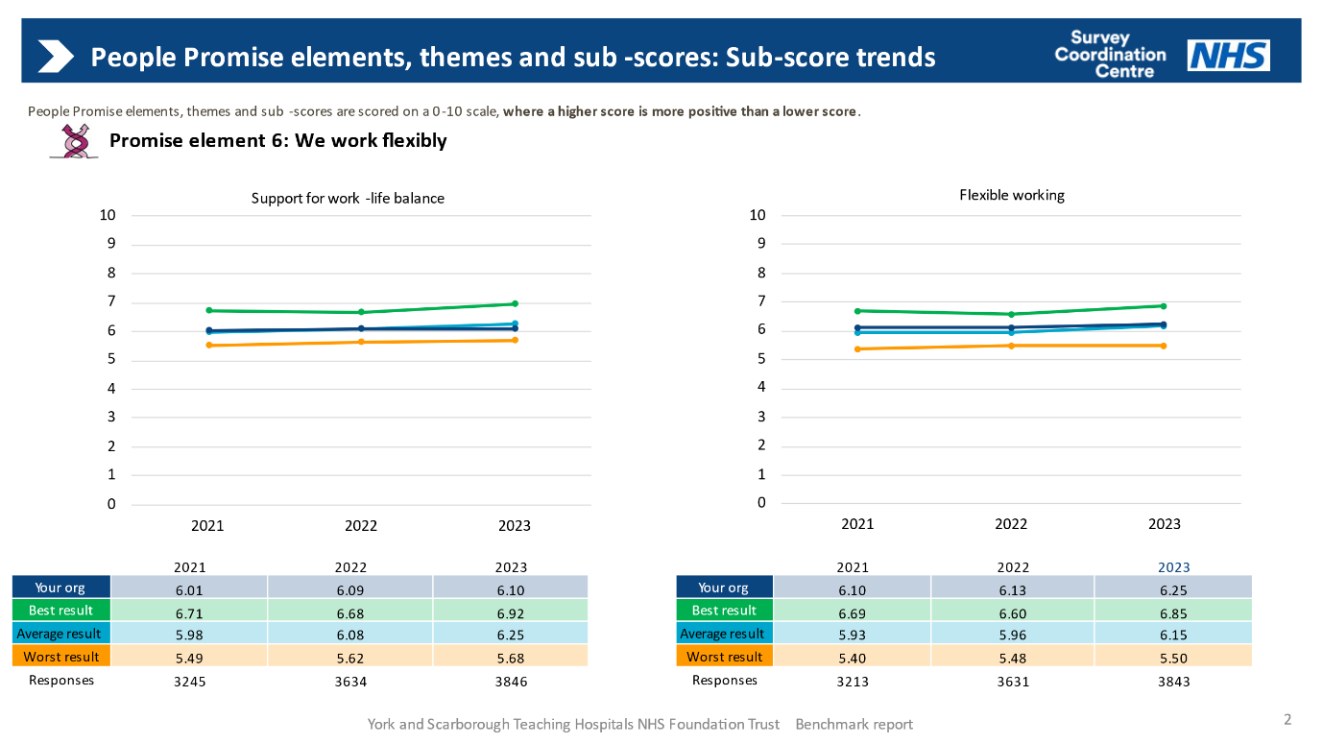

### **Patient Objectives 2020-2024**

**Objective 1: To engage with patients, visitors, carers, governors and local stakeholders and organisations to listen and understand their needs and experiences across the protected characteristics.**

Activity:

* The PLACE programme has resumed, with volunteers from Healthwatch North Yorkshire, Healthwatch York and Scarborough Disability Action Group involved. Invitations were extended to Yorkshire Coast Sight Support, York Deaf Café and York Disability Rights Forum to get involved. As a result, there was a good representation of disabled people with issues identified including those for people with dementia and around accessibility.
* Work continued with the Patient and Public Involvement Lead to ensure representation of a wide variety of people and communities in Trust engagement and activity. This included autism focus groups, text messaging focus groups, engagement on the assistance dog’s policy, engaged with 35 stakeholder groups regarding the visiting policy. In addition, Healthwatch volunteers supported our National Dementia Surveys and provided feedback on our visitor policy.
* We engaged a number of external organisations in our Domain 1 EDS work to comment on our interpreting provision and maternity services. These included members of hearing impaired/Deaf (d/Deaf) community, members of MySight York, Healthwatch North Yorkshire and Healthwatch York and members of our local Maternity and Neonatal Voices Partnership.
* We have continued to review feedback from inpatient surveys and complaints/concerns to identify themes for equality and diversity improvements and act on these.
* We have engaged with Humber and North Yorkshire Integrated Care Partnership colleagues in the local area on shared actions for improvement.
* We are in the process of developing a new trans and gender diverse communities policy, applicable to patients and staff.
* We have worked with local carers groups and a local carers forum to build better links with carers organisations and develop a carers patient information leaflet and information for the Trust’s website.

**Objective 2: To engage internally with services to discuss how the needs of patients and visitors can be met to ensure that:**

1. Health inequalities are reduced.
2. Discrimination is eliminated.
3. Patients are provided with the appropriate support to meet their needs.

**Interpreting and translation provision:**

* We carried out an initial review to understand our current position and worked to tackle underperformance through effective contract management and weekly monitoring. This was successful as performance improved throughout the period.
* We reviewed procurement options and agreed to move to system-based procurement in partnership with North Lincolnshire and Goole NHS Hospitals Trust and Hull and East Yorkshire NHS Hospitals Trust. This should be completed by the end of the financial year 2023 – 2024.
* We engaged with d/Deaf people who are British Sign Language (BSL) users (and a BSL interpreter) to inform our future procurement.
* Rolled-out interpreting video tablet devices on a demand basis which proved successful as all language (including BSL) translation was available immediately where appropriate. This was particularly helpful in emergency departments.
* We introduced a new BSL relay service which enabled users of BSL to contact the hospital directly via three phone numbers via a BSL interpreter available during working hours.

**Due Regard Impact Assessments:**

* We developed Due Regard Impact Assessments for all appropriate policies including the updated Visitor Policy, Eliminating Mixed Sex Accommodation Policy and Animals on Trust Sites Policy and carried out external engagement to get feedback for these in line with the guidance. We also carried out Due Regard Impact Assessments for the new Emergency Department in York and provided advice for the assessment for the new Emergency Department in Scarborough.
* We provided advice to maternity colleagues on developing an audit for women with communication needs. The issues identified were followed up as part of the EDS work on maternity.
* Work started in the period to review and update the Due Regard Impact Assessment templates and guidance. This work will be completed in 2024.

**Other actions:**

* Reviewed patient experience and patient safety information which relates to equality and diversity issues to understand the circumstances, identify improvements, and share best practice.
* An issue highlighted the need for improvement in the Datix system to introduce categories for equality and harm, which were implemented.
* We have continued to be part of a number of internal groups to champion the needs of all patients. These included:
  + Dementia Improvement Group
  + Learning Disability and Autism Steering Group
  + Establishing the Mental Health Working group
  + Working with the Autism Liaison Lead.
* Work continued to ensure hospital passports for people with a learning disability (which help staff understand people’s individual needs), are stored and appropriately accessible on the hospital electronic patient record system. More than 1,000 passports are now uploaded into the system.
* A project exploring development of a patient passport who need reasonable adjustments was initiated in this period. We also started work with colleagues leading on the development of Nucleus, a patient information recording system, to ensure that information about reasonable adjustments can be noted and flagged to colleagues working with inpatients and outpatients.
* Work started on a policy regarding animals on Trust sites, particularly focusing on assistance dogs. This was prompted by a complaint and has included input from people with assistance dogs and assistance dog support organisations.
* Level 1 Oliver Magowan training on autism and learning disability has been rolled out across the Trust.
* We worked with colleagues to ensure menus are provided in a pictorial format to support a range of patients to effectively choose what they want to eat. A pilot is scheduled for White Cross Court in York for stroke patients.
* Delivered an EDI session as part of the Patient Experience Team session for the preceptorship training for staff newly qualified clinical staff (non-medical) recruited to the Trust.
* We initiated a project around wheelchairs as a result of complaints and patient feedback about the lack of available wheelchairs for outpatients at York and Scarborough sites. We are also investigating a wheelchair passport for inpatients who are wheelchairs users.

**Objective 3: To achieve compliance with the Accessible Information Standard (AIS) 2016*.***

During this period our work to deliver this objective has included:

* Introduction of BSL video translation services and the BSL relay service.
* Identification of issues via AIS complaints feedback
* Drafting a formal response to the Healthwatch York and Healthwatch North Yorkshire accessible information report outlining what the Trust had already done and plans for future improvements.
* Working with colleagues to introduce Synertec to deliver patient letters including large print (16 point), Easy Read and Braille versions. Draft letters were shared with appropriate partners for feedback on their accessibility before Synertec was introduced.
* Engagement with two patients who have sensory impairments and assistance dogs to input into the draft Animals on Trust Sites Policy.
* Working with the d/Deaf and sight loss communities and organisations.
* Working with colleagues in systems and network teams to update our patient information recording system.
* Developing a plan for staff training on disability awareness, AIS, d/Deaf and sight and hearing loss awareness with colleagues.
* Working in partnership with the Patient Information Leaflets team to update the standard information for leaflets to ensure patients, carers and others are aware that they can access information in other formats and languages on our website using the accessibility tools available (ReachDeck facility).
* Starting to develop Easy Read patient information leaflets.

**Patient Complaints**

From June 2022 to November 2023 the Trust received 21 complaints and 14 concerns from patients about inequality or discrimination.

This is significantly higher than in previous years with 14 such complaints or concerns received in 2020 - 2021 and nine in 2021 - 2022. The increase is in line with the increase in overall complaints and concerns the Trust receives, which have doubled in the past year.

Of the complaints and concerns raised, 11 related to a lack of reasonable adjustments to meet a patient’s needs; 4 related to discrimination due to someone’s neurodiversity; 9 related to discrimination due to someone’s disability (including sensory impairments or a learning disability); 4 related to discrimination due to someone’s race; 2 related to discrimination due to someone’s sexuality and 5 related to a lack of accessible information or no interpreter provision.

Following investigation, 3 complaints were upheld, 6 were partially upheld and 10 were not upheld. 2 are ongoing.

From June 2022 - November 2023, the most common complaint themes received by the Trust were:

* Communication with relatives, carers, patients
* Values and behaviours of staff
* Discharge arrangements
* Diagnosis
* Investigations: not ordered, delayed results, misdiagnosis
* Personal care
* Prescribing errors
* Clinical treatment.

We recognise some of these themes can potentially have a greater impact on some people with protected characteristics, including people with specific communication needs and people who have lived experience of discrimination.

### **Accessible Information Standard Complaints**

Between June 2022 and November 2023, we received 5 concerns/complaints specifically about accessible communication and lack of interpreting services (included in the numbers above). This is compared with 6 concerns/complaints in 2021 - 2022 and 1 concern and 2 enquiries in 2020-2021.

The Trust is committed to ensuring that we communicate with patients in their chosen format and accessible information continues to be a key priority in our equality objectives 2024 – 2028.

**Patient and public engagement**

During 2022-2023, the Trust has continued to engage with several organisations to understand clients across the protected characteristics.

Colleagues from Healthwatch and My Sight York have supported us by attending Trust Patient Experience Steering Group meetings and sharing feedback on equality and diversity themes.

We have initiated a joint Patient and Carer Experience (PACE) Forum covering the Scarborough, Ryedale and Bridlington areas in partnership with Humber Teaching Hospitals NHS Foundation Trust. Two Forums have been held and have helped us improve links with organisations and individuals in this area including the Bridlington Health Forum, Save Scarborough Hospital, Yorkshire Coast and Ryedale Disability Forum, Carers Plus, Yorkshire Coast Sight Support, Wilf Ward Family Trust and others.

### **Building Environments Objective 2020-2024**

**Objective 1: To monitor progress against the Trust’s inclusive built environment policy and strategy.**

Activity:

The monitoring of progress with compliance with the Inclusive and Accessible Built Environment strategy is carried out quarterly via a report that goes to the Health, Safety & Non-Clinical risk group. The main items monitored by the group are:

* Progress with the Trust’s annual access audit schedule
* To provide and maintain a Trust Access Plan
* Progress with the Access advisor workplan

The objective has been met as we have delivered the agreed access audit programme for the Trust for the year 2023. The Trust access plan is in place and is a live document, it was last reviewed on 15th January 2024, a summary of the most significant access barriers within our environment is reviewed on a quarterly basis by Health, safety and Non-Clinical Risk Group.

## Workforce and Patient Equality Monitoring Information

### **Workforce**

This section focuses on internal demographics regarding staff employed by York and Scarborough Teaching Hospitals and YTHFM and has been extracted from ESR on a snapshot date of 30 November 2023.

In relation to gender, our workforce is heavily made up of females which is reflective of the NHS profile. The national ESR system does not yet enable organisations to collect data on other gender identities.

There is a proportion of staff that chose not to share whether they have a religious affiliation or not and this is their right. The Trust promotes the benefits of sharing personal diversity information and will continue to do so.

Our age demographics show that there is an even spread of staff from ages 26-60, but less staff are employed below and above this. This will influence our work on apprenticeships, retirement and workforce planning.

Our sexual orientation profile shows that many staff have not disclosed their orientation and there will be different reasons for this. This will influence our EDI work on engagement, culture, psychological safety, training and equality monitoring. The LGBTQ+ staff network are incorporating this into their annual objectives.

The staff ethnic profile of the Trust, whilst states BME in the pie chart, is broken down further. This is important, to show the different ethnicities, but also to acknowledge and recognise that different ethnic groups have a variety of different needs and therefore should not be treated as one homogeneous group. The is only a small proportion of staff that have not shared their ethnicity. The WRES annual report goes into detail about their experiences.

The ethnic groups that are more represented than others are White, Black or Black British African, and the Asian or Asian British categories. This is likely to be reflective of our localities with the some BME groups being in situ due to international recruitment and representation in certain professions.

There has been an increase in staff sharing their disability identity, it is important to continue to support staff so this is incorporated in our equality monitoring work and WDES action plan.

Our marital status and civil partnership data shows that a high percentage of staff either identify as married or single. This will continue to influence the development of policies.

The Trust’s workforce equality monitoring data can be found in Appendix 1.

### **Patient**

The Trust acknowledges that its systems need to improve in capturing patient equality monitoring information and correlate it with information about the communities we serve. This will be included in in future PSED reports once available. However, a link to the following app [Microsoft Power BI](https://app.powerbi.com/view?r=eyJrIjoiODZmNGQ0YzItZDAwZi00MzFiLWE4NzAtMzVmNTUwMThmMTVlIiwidCI6ImVlNGUxNDk5LTRhMzUtNGIyZS1hZDQ3LTVmM2NmOWRlODY2NiIsImMiOjh9) provides information on the Trust’s catchment populations and segregates the data in terms of age, gender and ethnicity.

## Conclusions and Next Steps

This EDI Annual report provides an overview of the activities undertaken to meet our Equality Objectives and demonstrates the Trust’s commitment to embed inclusivity into service provision and employment practices.

We will continue to focus on the objectives stated above by ensuring they are integrated into current streams of work. The Trust’s Inclusion Forum has oversight of the Trust’s EDI compliance requirements and progress towards meeting its duty under the Equality Act 2010. The Trust’s Equality Objectives for April 2024 - March 2028 can be found in a separate report on the Trust’s website.

## Appendix 1

**Public Sector Equality Duty, Workforce Equality Monitoring Information**

The below data covers York & Scarborough Teaching Hospitals, York Teaching Hospital Facilities Management (YTHFM) LLP and Bank workers.

**Staff in post headcount = 12,281**

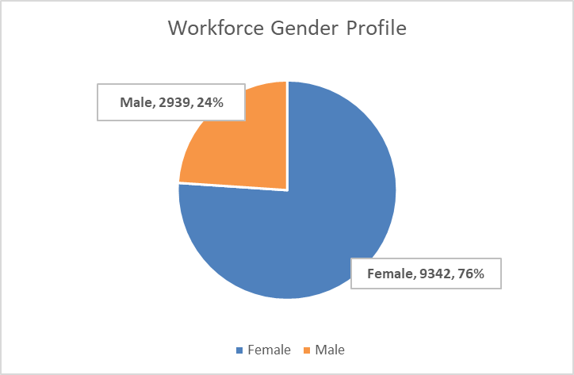

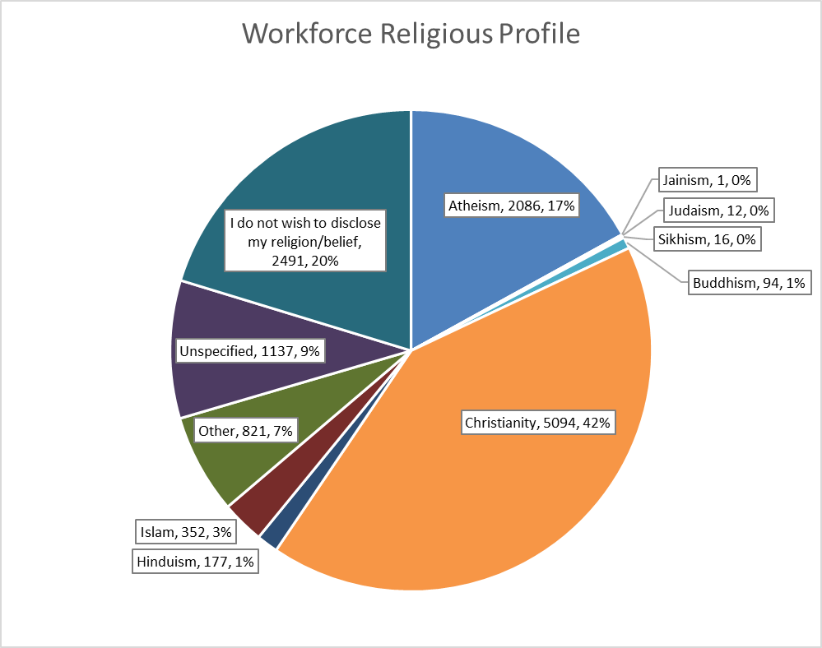

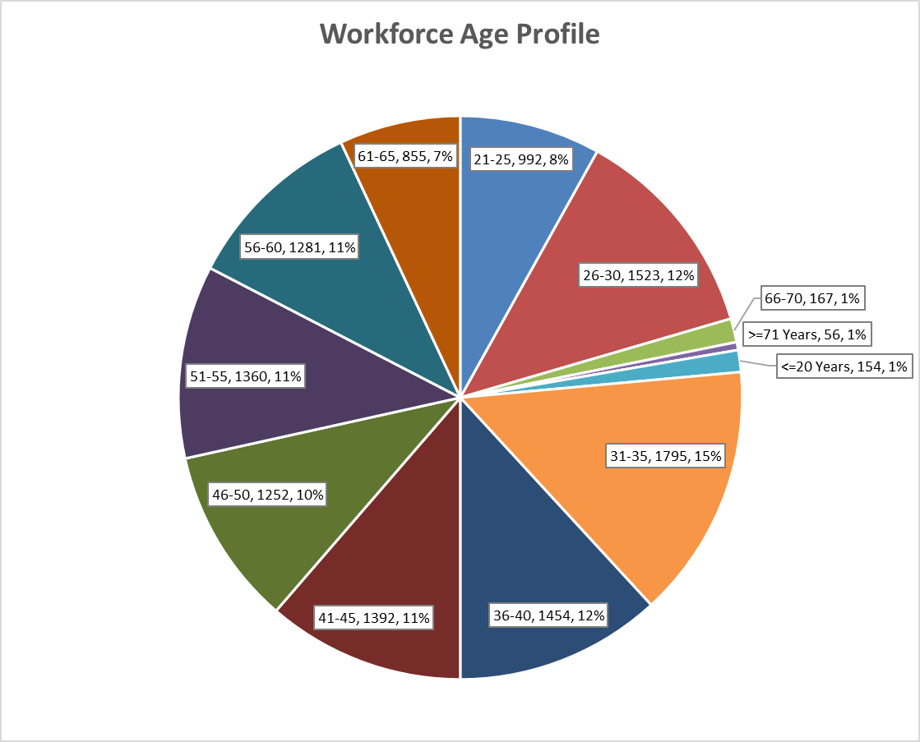

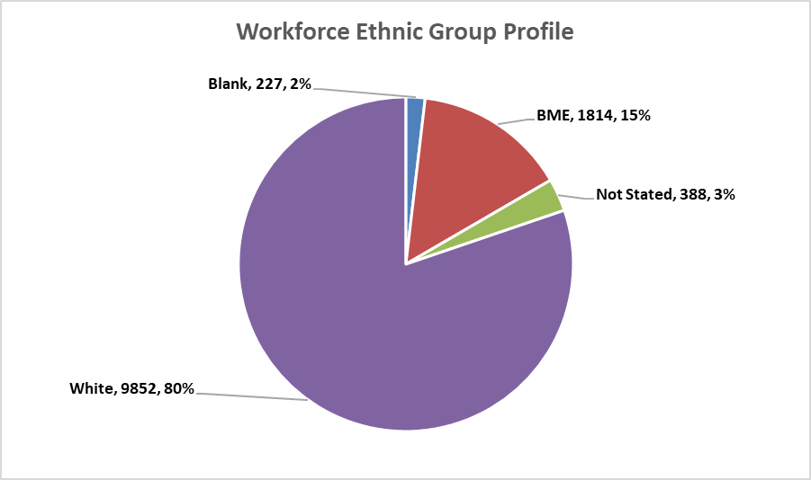

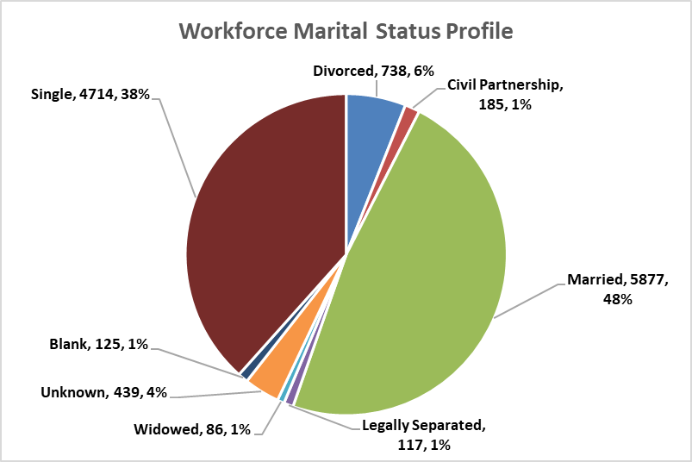

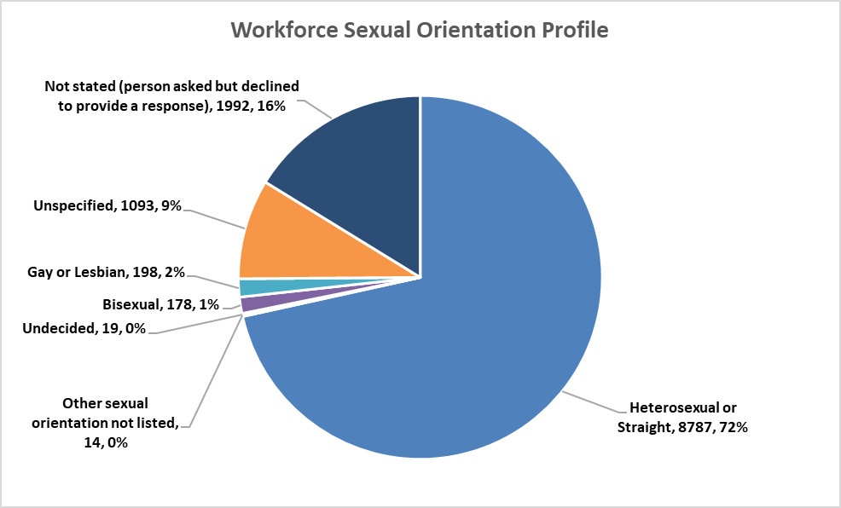

|  |  |  |
| --- | --- | --- |
| **Ethnic Origin** | **Headcount** | **Origin vs Total (%)** |
| Any Other Ethnic Group | 170 | 1.38% |
| Asian British | 9 | 0.07% |
| Asian Mixed | 3 | 0.02% |
| Asian or Asian British - Any other Asian background | 266 | 2.17% |
| Asian or Asian British - Bangladeshi | 23 | 0.19% |
| Asian or Asian British - Indian | 448 | 3.65% |
| Asian or Asian British - Pakistani | 63 | 0.51% |
| Asian Sinhalese | 2 | 0.02% |
| Asian Sri Lankan | 2 | 0.02% |
| Asian Unspecified | 3 | 0.02% |
| Black British | 3 | 0.02% |
| Black Mixed | 1 | 0.01% |
| Black Nigerian | 14 | 0.11% |
| Black or Black British - African | 466 | 3.79% |
| Black or Black British - Any other Black background | 22 | 0.18% |
| Black or Black British - Caribbean | 29 | 0.24% |
| Black Unspecified | 1 | 0.01% |
| Chinese | 64 | 0.52% |
| Filipino | 50 | 0.41% |
| Malaysian | 2 | 0.02% |
| Mixed - Any other mixed background | 22 | 0.18% |
| Mixed - Asian & Chinese | 2 | 0.02% |
| Mixed - Black & White | 1 | 0.01% |
| Mixed - Other/Unspecified | 20 | 0.16% |
| Mixed - White & Asian | 51 | 0.42% |
| Mixed - White & Black African | 53 | 0.43% |
| Mixed - White & Black Caribbean | 20 | 0.16% |
| Not Stated | 388 | 3.16% |
| Other Specified | 4 | 0.03% |
| Unspecified | 227 | 1.85% |
| White - Any other White background | 359 | 2.92% |
| White - British | 8718 | 70.99% |
| White - Irish | 68 | 0.55% |
| White Cypriot (non specific) | 1 | 0.01% |
| White English | 366 | 2.98% |
| White Greek | 5 | 0.04% |
| White Italian | 2 | 0.02% |
| White Mixed | 3 | 0.02% |
| White Northern Irish | 8 | 0.07% |
| White Other European | 73 | 0.59% |
| White Other Ex-Yugoslav | 2 | 0.02% |
| White Polish | 67 | 0.55% |
| White Scottish | 15 | 0.12% |
| White Serbian | 2 | 0.02% |
| White Turkish | 3 | 0.02% |
| White Unspecified | 157 | 1.28% |
| White Welsh | 3 | 0.02% |
| **Grand Total** | **12281** | **100.00%** |

|  |  |  |
| --- | --- | --- |
| **Care Group Area vs Employee Gender** | **Headcount of Gender** | **Percentage of Gender** |
| **419 CG Cancer Specialist & Clinical Support Services Group** | **2244** | **18.27%** |
| Female | 1742 | 14.18% |
| Male | 502 | 4.09% |
| **419 CG Chairman & Chief Executives Office Group** | **58** | **0.47%** |
| Female | 49 | 0.40% |
| Male | 9 | 0.07% |
| **419 CG Chief Nurse Team** | **121** | **0.99%** |
| Female | 87 | 0.71% |
| Male | 34 | 0.28% |
| **419 CG Corporate Services** | **32** | **0.26%** |
| Female | 24 | 0.20% |
| Male | 8 | 0.07% |
| **419 CG Digital Information Services Group** | **253** | **2.06%** |
| Female | 132 | 1.07% |
| Male | 121 | 0.99% |
| **419 CG Family Health Care Group** | **954** | **7.77%** |
| Female | 898 | 7.31% |
| Male | 56 | 0.46% |
| **419 CG Finance Group** | **224** | **1.82%** |
| Female | 137 | 1.12% |
| Male | 87 | 0.71% |
| **419 CG Medical Governance Group** | **62** | **0.50%** |
| Female | 46 | 0.37% |
| Male | 16 | 0.13% |
| **419 CG Medicine** | **3068** | **24.98%** |
| Female | 2478 | 20.18% |
| Male | 590 | 4.80% |
| **419 CG Operations Management Group** | **237** | **1.93%** |
| Female | 211 | 1.72% |
| Male | 26 | 0.21% |
| **419 CG Surgery** | **1936** | **15.76%** |
| Female | 1457 | 11.86% |
| Male | 479 | 3.90% |
| **419 CG Workforce and Organisational Development group** | **1776** | **14.46%** |
| Female | 1340 | 10.91% |
| Male | 436 | 3.55% |
| **419 LLP CG Estates & Facilities** | **1316** | **10.72%** |
| Female | 741 | 6.03% |
| Male | 575 | 4.68% |
| **Grand Total** | **12281** | **100.00%** |

|  |  |  |
| --- | --- | --- |
| **Care Group Area vs Religion** | **Headcount of  Religious Belief** | **Percentage of  Religious Belief** |
| **419 CG Cancer Specialist & Clinical Support Services Group** | **2244** | **18.27%** |
| Atheism | 436 | 3.55% |
| Buddhism | 14 | 0.11% |
| Christianity | 896 | 7.30% |
| Hinduism | 24 | 0.20% |
| I do not wish to disclose my religion/belief | 393 | 3.20% |
| Islam | 55 | 0.45% |
| Judaism | 4 | 0.03% |
| Other | 159 | 1.29% |
| Sikhism | 4 | 0.03% |
| Unspecified | 259 | 2.11% |
| **419 CG Chairman & Chief Executives Office Group** | **58** | **0.47%** |
| Atheism | 14 | 0.11% |
| Buddhism | 1 | 0.01% |
| Christianity | 25 | 0.20% |
| I do not wish to disclose my religion/belief | 11 | 0.09% |
| Other | 3 | 0.02% |
| Unspecified | 4 | 0.03% |
| **419 CG Chief Nurse Team** | **121** | **0.99%** |
| Atheism | 19 | 0.15% |
| Buddhism | 1 | 0.01% |
| Christianity | 66 | 0.54% |
| Hinduism | 1 | 0.01% |
| I do not wish to disclose my religion/belief | 23 | 0.19% |
| Other | 7 | 0.06% |
| Unspecified | 4 | 0.03% |
| **419 CG Corporate Services** | **32** | **0.26%** |
| Atheism | 4 | 0.03% |
| Christianity | 14 | 0.11% |
| I do not wish to disclose my religion/belief | 6 | 0.05% |
| Other | 1 | 0.01% |
| Unspecified | 7 | 0.06% |
| **419 CG Digital Information Services Group** | **253** | **2.06%** |
| Atheism | 61 | 0.50% |
| Buddhism | 1 | 0.01% |
| Christianity | 94 | 0.77% |
| Hinduism | 1 | 0.01% |
| I do not wish to disclose my religion/belief | 33 | 0.27% |
| Islam | 1 | 0.01% |
| Judaism | 1 | 0.01% |
| Other | 12 | 0.10% |
| Unspecified | 49 | 0.40% |
| **419 CG Family Health Care Group** | **954** | **7.77%** |
| Atheism | 196 | 1.60% |
| Buddhism | 4 | 0.03% |
| Christianity | 390 | 3.18% |
| Hinduism | 9 | 0.07% |
| I do not wish to disclose my religion/belief | 161 | 1.31% |
| Islam | 23 | 0.19% |
| Other | 71 | 0.58% |
| Sikhism | 2 | 0.02% |
| Unspecified | 98 | 0.80% |
| **419 CG Finance Group** | **224** | **1.82%** |
| Atheism | 45 | 0.37% |
| Christianity | 92 | 0.75% |
| I do not wish to disclose my religion/belief | 36 | 0.29% |
| Islam | 8 | 0.07% |
| Other | 15 | 0.12% |
| Sikhism | 1 | 0.01% |
| Unspecified | 27 | 0.22% |
| **419 CG Medical Governance Group** | **62** | **0.50%** |
| Atheism | 14 | 0.11% |
| Buddhism | 2 | 0.02% |
| Christianity | 26 | 0.21% |
| I do not wish to disclose my religion/belief | 11 | 0.09% |
| Islam | 3 | 0.02% |
| Other | 2 | 0.02% |
| Unspecified | 4 | 0.03% |
| **419 CG Medicine** | **3068** | **24.98%** |
| Atheism | 441 | 3.59% |
| Buddhism | 38 | 0.31% |
| Christianity | 1425 | 11.60% |
| Hinduism | 69 | 0.56% |
| I do not wish to disclose my religion/belief | 539 | 4.39% |
| Islam | 113 | 0.92% |
| Judaism | 4 | 0.03% |
| Other | 192 | 1.56% |
| Sikhism | 3 | 0.02% |
| Unspecified | 244 | 1.99% |
| **419 CG Operations Management Group** | **237** | **1.93%** |
| Atheism | 43 | 0.35% |
| Buddhism | 1 | 0.01% |
| Christianity | 107 | 0.87% |
| I do not wish to disclose my religion/belief | 48 | 0.39% |
| Other | 21 | 0.17% |
| Unspecified | 17 | 0.14% |
| **419 CG Surgery** | **1936** | **15.76%** |
| Atheism | 331 | 2.70% |
| Buddhism | 9 | 0.07% |
| Christianity | 781 | 6.36% |
| Hinduism | 43 | 0.35% |
| I do not wish to disclose my religion/belief | 369 | 3.00% |
| Islam | 66 | 0.54% |
| Other | 107 | 0.87% |
| Sikhism | 2 | 0.02% |
| Unspecified | 228 | 1.86% |
| **419 CG Workforce and Organisational Development group** | **1776** | **14.46%** |
| Atheism | 318 | 2.59% |
| Buddhism | 20 | 0.16% |
| Christianity | 636 | 5.18% |
| Hinduism | 24 | 0.20% |
| I do not wish to disclose my religion/belief | 384 | 3.13% |
| Islam | 69 | 0.56% |
| Jainism | 1 | 0.01% |
| Judaism | 3 | 0.02% |
| Other | 141 | 1.15% |
| Sikhism | 4 | 0.03% |
| Unspecified | 176 | 1.43% |
| **419 LLP CG Estates & Facilities** | **1316** | **10.72%** |
| Atheism | 164 | 1.34% |
| Buddhism | 3 | 0.02% |
| Christianity | 542 | 4.41% |
| Hinduism | 6 | 0.05% |
| I do not wish to disclose my religion/belief | 477 | 3.88% |
| Islam | 14 | 0.11% |
| Other | 90 | 0.73% |
| Unspecified | 20 | 0.16% |
| **Grand Total** | **12281** | **100.00%** |

|  |  |  |
| --- | --- | --- |
| **Care Group Area vs Age** | **Headcount  of Age** | **Percentage  of Age** |
| **419 CG Cancer Specialist & Clinical Support Services Group** | **2244** | **18.27%** |
| <=20 Years | 12 | 0.10% |
| >=71 Years | 10 | 0.08% |
| 21-25 | 147 | 1.20% |
| 26-30 | 237 | 1.93% |
| 31-35 | 289 | 2.35% |
| 36-40 | 309 | 2.52% |
| 41-45 | 298 | 2.43% |
| 46-50 | 248 | 2.02% |
| 51-55 | 270 | 2.20% |
| 56-60 | 242 | 1.97% |
| 61-65 | 161 | 1.31% |
| 66-70 | 21 | 0.17% |
| **419 CG Chairman & Chief Executives Office Group** | **58** | **0.47%** |
| 26-30 | 7 | 0.06% |
| 31-35 | 3 | 0.02% |
| 36-40 | 9 | 0.07% |
| 41-45 | 12 | 0.10% |
| 46-50 | 6 | 0.05% |
| 51-55 | 5 | 0.04% |
| 56-60 | 10 | 0.08% |
| 61-65 | 3 | 0.02% |
| 66-70 | 3 | 0.02% |
| **419 CG Chief Nurse Team** | **121** | **0.99%** |
| >=71 Years | 2 | 0.02% |
| 21-25 | 1 | 0.01% |
| 26-30 | 5 | 0.04% |
| 31-35 | 12 | 0.10% |
| 36-40 | 11 | 0.09% |
| 41-45 | 15 | 0.12% |
| 46-50 | 19 | 0.15% |
| 51-55 | 23 | 0.19% |
| 56-60 | 21 | 0.17% |
| 61-65 | 11 | 0.09% |
| 66-70 | 1 | 0.01% |
| **419 CG Corporate Services** | **32** | **0.26%** |
| 26-30 | 2 | 0.02% |
| 31-35 | 4 | 0.03% |
| 36-40 | 3 | 0.02% |
| 41-45 | 4 | 0.03% |
| 46-50 | 4 | 0.03% |
| 51-55 | 6 | 0.05% |
| 56-60 | 8 | 0.07% |
| 61-65 | 1 | 0.01% |
| **419 CG Digital Information Services Group** | **253** | **2.06%** |
| >=71 Years | 1 | 0.01% |
| 21-25 | 8 | 0.07% |
| 26-30 | 24 | 0.20% |
| 31-35 | 35 | 0.28% |
| 36-40 | 30 | 0.24% |
| 41-45 | 28 | 0.23% |
| 46-50 | 29 | 0.24% |
| 51-55 | 42 | 0.34% |
| 56-60 | 29 | 0.24% |
| 61-65 | 25 | 0.20% |
| 66-70 | 2 | 0.02% |
| **419 CG Family Health Care Group** | **954** | **7.77%** |
| <=20 Years | 2 | 0.02% |
| 21-25 | 86 | 0.70% |
| 26-30 | 119 | 0.97% |
| 31-35 | 148 | 1.21% |
| 36-40 | 148 | 1.21% |
| 41-45 | 128 | 1.04% |
| 46-50 | 91 | 0.74% |
| 51-55 | 92 | 0.75% |
| 56-60 | 90 | 0.73% |
| 61-65 | 43 | 0.35% |
| 66-70 | 7 | 0.06% |
| **419 CG Finance Group** | **224** | **1.82%** |
| 21-25 | 11 | 0.09% |
| 26-30 | 12 | 0.10% |
| 31-35 | 31 | 0.25% |
| 36-40 | 19 | 0.15% |
| 41-45 | 27 | 0.22% |
| 46-50 | 26 | 0.21% |
| 51-55 | 41 | 0.33% |
| 56-60 | 35 | 0.28% |
| 61-65 | 20 | 0.16% |
| 66-70 | 2 | 0.02% |
| **419 CG Medical Governance Group** | **62** | **0.50%** |
| 21-25 | 10 | 0.08% |
| 26-30 | 18 | 0.15% |
| 31-35 | 8 | 0.07% |
| 36-40 | 7 | 0.06% |
| 41-45 | 2 | 0.02% |
| 46-50 | 8 | 0.07% |
| 51-55 | 5 | 0.04% |
| 56-60 | 3 | 0.02% |
| 61-65 | 1 | 0.01% |
| **419 CG Medicine** | **3068** | **24.98%** |
| <=20 Years | 35 | 0.28% |
| >=71 Years | 11 | 0.09% |
| 21-25 | 297 | 2.42% |
| 26-30 | 440 | 3.58% |
| 31-35 | 503 | 4.10% |
| 36-40 | 347 | 2.83% |
| 41-45 | 336 | 2.74% |
| 46-50 | 335 | 2.73% |
| 51-55 | 320 | 2.61% |
| 56-60 | 250 | 2.04% |
| 61-65 | 164 | 1.34% |
| 66-70 | 30 | 0.24% |
| **419 CG Operations Management Group** | **237** | **1.93%** |
| <=20 Years | 1 | 0.01% |
| >=71 Years | 1 | 0.01% |
| 21-25 | 9 | 0.07% |
| 26-30 | 21 | 0.17% |
| 31-35 | 29 | 0.24% |
| 36-40 | 26 | 0.21% |
| 41-45 | 21 | 0.17% |
| 46-50 | 23 | 0.19% |
| 51-55 | 39 | 0.32% |
| 56-60 | 45 | 0.37% |
| 61-65 | 21 | 0.17% |
| 66-70 | 1 | 0.01% |
| **419 CG Surgery** | **1936** | **15.76%** |
| <=20 Years | 19 | 0.15% |
| >=71 Years | 5 | 0.04% |
| 21-25 | 164 | 1.34% |
| 26-30 | 255 | 2.08% |
| 31-35 | 285 | 2.32% |
| 36-40 | 207 | 1.69% |
| 41-45 | 223 | 1.82% |
| 46-50 | 214 | 1.74% |
| 51-55 | 219 | 1.78% |
| 56-60 | 200 | 1.63% |
| 61-65 | 125 | 1.02% |
| 66-70 | 20 | 0.16% |
| **419 CG Workforce and Organisational Development group** | **1776** | **14.46%** |
| <=20 Years | 58 | 0.47% |
| >=71 Years | 12 | 0.10% |
| 21-25 | 191 | 1.56% |
| 26-30 | 297 | 2.42% |
| 31-35 | 330 | 2.69% |
| 36-40 | 191 | 1.56% |
| 41-45 | 154 | 1.25% |
| 46-50 | 121 | 0.99% |
| 51-55 | 132 | 1.07% |
| 56-60 | 132 | 1.07% |
| 61-65 | 119 | 0.97% |
| 66-70 | 39 | 0.32% |
| **419 LLP CG Estates & Facilities** | **1316** | **10.72%** |
| <=20 Years | 27 | 0.22% |
| >=71 Years | 14 | 0.11% |
| 21-25 | 68 | 0.55% |
| 26-30 | 86 | 0.70% |
| 31-35 | 118 | 0.96% |
| 36-40 | 147 | 1.20% |
| 41-45 | 144 | 1.17% |
| 46-50 | 128 | 1.04% |
| 51-55 | 166 | 1.35% |
| 56-60 | 216 | 1.76% |
| 61-65 | 161 | 1.31% |
| 66-70 | 41 | 0.33% |
| **Grand Total** | **12281** | **100.00%** |

|  |  |  |
| --- | --- | --- |
| **Care Group Area vs Sexual Orientation** | **Headcount of  Sexual Orientation** | **Percentage of  Sexual Orientation** |
| **419 CG Cancer Specialist & Clinical Support Services Group** | **2244** | **18.27%** |
| Bisexual | 35 | 0.28% |
| Gay or Lesbian | 49 | 0.40% |
| Heterosexual or Straight | 1585 | 12.91% |
| Not stated (person asked but declined to provide a response) | 315 | 2.56% |
| Other sexual orientation not listed | 3 | 0.02% |
| Undecided | 7 | 0.06% |
| Unspecified | 250 | 2.04% |
| **419 CG Chairman & Chief Executives Office Group** | **58** | **0.47%** |
| Bisexual | 2 | 0.02% |
| Gay or Lesbian | 2 | 0.02% |
| Heterosexual or Straight | 45 | 0.37% |
| Not stated (person asked but declined to provide a response) | 5 | 0.04% |
| Unspecified | 4 | 0.03% |
| **419 CG Chief Nurse Team** | **121** | **0.99%** |
| Gay or Lesbian | 5 | 0.04% |
| Heterosexual or Straight | 100 | 0.81% |
| Not stated (person asked but declined to provide a response) | 12 | 0.10% |
| Unspecified | 4 | 0.03% |
| **419 CG Corporate Services** | **32** | **0.26%** |
| Heterosexual or Straight | 21 | 0.17% |
| Not stated (person asked but declined to provide a response) | 4 | 0.03% |
| Unspecified | 7 | 0.06% |
| **419 CG Digital Information Services Group** | **253** | **2.06%** |
| Bisexual | 6 | 0.05% |
| Gay or Lesbian | 7 | 0.06% |
| Heterosexual or Straight | 173 | 1.41% |
| Not stated (person asked but declined to provide a response) | 19 | 0.15% |
| Unspecified | 48 | 0.39% |
| **419 CG Family Health Care Group** | **954** | **7.77%** |
| Bisexual | 13 | 0.11% |
| Gay or Lesbian | 10 | 0.08% |
| Heterosexual or Straight | 702 | 5.72% |
| Not stated (person asked but declined to provide a response) | 132 | 1.07% |
| Undecided | 1 | 0.01% |
| Unspecified | 96 | 0.78% |
| **419 CG Finance Group** | **224** | **1.82%** |
| Bisexual | 2 | 0.02% |
| Gay or Lesbian | 3 | 0.02% |
| Heterosexual or Straight | 166 | 1.35% |
| Not stated (person asked but declined to provide a response) | 24 | 0.20% |
| Other sexual orientation not listed | 2 | 0.02% |
| Unspecified | 27 | 0.22% |
| **419 CG Medical Governance Group** | **62** | **0.50%** |
| Bisexual | 4 | 0.03% |
| Gay or Lesbian | 2 | 0.02% |
| Heterosexual or Straight | 45 | 0.37% |
| Not stated (person asked but declined to provide a response) | 8 | 0.07% |
| Unspecified | 3 | 0.02% |
| **419 CG Medicine** | **3068** | **24.98%** |
| Bisexual | 42 | 0.34% |
| Gay or Lesbian | 48 | 0.39% |
| Heterosexual or Straight | 2310 | 18.81% |
| Not stated (person asked but declined to provide a response) | 433 | 3.53% |
| Other sexual orientation not listed | 3 | 0.02% |
| Undecided | 4 | 0.03% |
| Unspecified | 228 | 1.86% |
| **419 CG Operations Management Group** | **237** | **1.93%** |
| Bisexual | 2 | 0.02% |
| Gay or Lesbian | 5 | 0.04% |
| Heterosexual or Straight | 184 | 1.50% |
| Not stated (person asked but declined to provide a response) | 30 | 0.24% |
| Unspecified | 16 | 0.13% |
| **419 CG Surgery** | **1936** | **15.76%** |
| Bisexual | 16 | 0.13% |
| Gay or Lesbian | 22 | 0.18% |
| Heterosexual or Straight | 1328 | 10.81% |
| Not stated (person asked but declined to provide a response) | 344 | 2.80% |
| Other sexual orientation not listed | 1 | 0.01% |
| Undecided | 3 | 0.02% |
| Unspecified | 222 | 1.81% |
| **419 CG Workforce and Organisational Development group** | **1776** | **14.46%** |
| Bisexual | 45 | 0.37% |
| Gay or Lesbian | 28 | 0.23% |
| Heterosexual or Straight | 1244 | 10.13% |
| Not stated (person asked but declined to provide a response) | 282 | 2.30% |
| Other sexual orientation not listed | 4 | 0.03% |
| Undecided | 2 | 0.02% |
| Unspecified | 171 | 1.39% |
| **419 LLP CG Estates & Facilities** | **1316** | **10.72%** |
| Bisexual | 11 | 0.09% |
| Gay or Lesbian | 17 | 0.14% |
| Heterosexual or Straight | 884 | 7.20% |
| Not stated (person asked but declined to provide a response) | 384 | 3.13% |
| Other sexual orientation not listed | 1 | 0.01% |
| Undecided | 2 | 0.02% |
| Unspecified | 17 | 0.14% |
| **Grand Total** | **12281** | **100.00%** |

|  |  |  |
| --- | --- | --- |
| **Care Group Area vs Disability** | **Headcount  of Disability** | **Percentage  of Disability** |
| **419 CG Cancer Specialist & Clinical Support Services Group** | **2244** | **18.27%** |
| No | 1693 | 13.79% |
| Not Declared | 99 | 0.81% |
| Unspecified | 366 | 2.98% |
| Yes | 86 | 0.70% |
| **419 CG Chairman & Chief Executives Office Group** | **58** | **0.47%** |
| No | 49 | 0.40% |
| Unspecified | 6 | 0.05% |
| Yes | 3 | 0.02% |
| **419 CG Chief Nurse Team** | **121** | **0.99%** |
| No | 100 | 0.81% |
| Not Declared | 2 | 0.02% |
| Unspecified | 10 | 0.08% |
| Yes | 9 | 0.07% |
| **419 CG Corporate Services** | **32** | **0.26%** |
| No | 22 | 0.18% |
| Unspecified | 9 | 0.07% |
| Yes | 1 | 0.01% |
| **419 CG Digital Information Services Group** | **253** | **2.06%** |
| No | 175 | 1.42% |
| Not Declared | 3 | 0.02% |
| Unspecified | 57 | 0.46% |
| Yes | 18 | 0.15% |
| **419 CG Family Health Care Group** | **954** | **7.77%** |
| No | 753 | 6.13% |
| Not Declared | 15 | 0.12% |
| Unspecified | 143 | 1.16% |
| Yes | 43 | 0.35% |
| **419 CG Finance Group** | **224** | **1.82%** |
| No | 170 | 1.38% |
| Unspecified | 42 | 0.34% |
| Yes | 12 | 0.10% |
| **419 CG Medical Governance Group** | **62** | **0.50%** |
| No | 52 | 0.42% |
| Not Declared | 3 | 0.02% |
| Unspecified | 6 | 0.05% |
| Yes | 1 | 0.01% |
| **419 CG Medicine** | **3068** | **24.98%** |
| No | 2503 | 20.38% |
| Not Declared | 91 | 0.74% |
| Prefer Not To Answer | 1 | 0.01% |
| Unspecified | 371 | 3.02% |
| Yes | 102 | 0.83% |
| **419 CG Operations Management Group** | **237** | **1.93%** |
| No | 194 | 1.58% |
| Not Declared | 7 | 0.06% |
| Prefer Not To Answer | 1 | 0.01% |
| Unspecified | 28 | 0.23% |
| Yes | 7 | 0.06% |
| **419 CG Surgery** | **1936** | **15.76%** |
| No | 1521 | 12.38% |
| Not Declared | 36 | 0.29% |
| Prefer Not To Answer | 2 | 0.02% |
| Unspecified | 313 | 2.55% |
| Yes | 64 | 0.52% |
| **419 CG Workforce and Organisational Development group** | **1776** | **14.46%** |
| No | 1435 | 11.68% |
| Not Declared | 30 | 0.24% |
| Prefer Not To Answer | 2 | 0.02% |
| Unspecified | 233 | 1.90% |
| Yes | 76 | 0.62% |
| **419 LLP CG Estates & Facilities** | **1316** | **10.72%** |
| No | 1203 | 9.80% |
| Not Declared | 36 | 0.29% |
| Prefer Not To Answer | 2 | 0.02% |
| Unspecified | 29 | 0.24% |
| Yes | 46 | 0.37% |
| **Grand Total** | **12281** | **100.00%** |

|  |  |  |
| --- | --- | --- |
| **Care Group Area vs Ethnic Group** | **Headcount of  Ethnic Group** | **Percentage of  Ethnic Group** |
| **419 CG Cancer Specialist & Clinical Support Services Group** | **2244** | **18.27%** |
| Blank | 31 | 0.25% |
| BME | 243 | 1.98% |
| Not Stated | 56 | 0.46% |
| White | 1914 | 15.59% |
| **419 CG Chairman & Chief Executives Office Group** | **58** | **0.47%** |
| Blank | 2 | 0.02% |
| BME | 3 | 0.02% |
| Not Stated | 1 | 0.01% |
| White | 52 | 0.42% |
| **419 CG Chief Nurse Team** | **121** | **0.99%** |
| BME | 6 | 0.05% |
| Not Stated | 2 | 0.02% |
| White | 113 | 0.92% |
| **419 CG Corporate Services** | **32** | **0.26%** |
| BME | 1 | 0.01% |
| Not Stated | 1 | 0.01% |
| White | 30 | 0.24% |
| **419 CG Digital Information Services Group** | **253** | **2.06%** |
| Blank | 1 | 0.01% |
| BME | 14 | 0.11% |
| Not Stated | 4 | 0.03% |
| White | 234 | 1.91% |
| **419 CG Family Health Care Group** | **954** | **7.77%** |
| Blank | 7 | 0.06% |
| BME | 84 | 0.68% |
| Not Stated | 13 | 0.11% |
| White | 850 | 6.92% |
| **419 CG Finance Group** | **224** | **1.82%** |
| BME | 14 | 0.11% |
| Not Stated | 3 | 0.02% |
| White | 207 | 1.69% |
| **419 CG Medical Governance Group** | **62** | **0.50%** |
| Blank | 2 | 0.02% |
| BME | 10 | 0.08% |
| Not Stated | 2 | 0.02% |
| White | 48 | 0.39% |
| **419 CG Medicine** | **3068** | **24.98%** |
| Blank | 64 | 0.52% |
| BME | 712 | 5.80% |
| Not Stated | 82 | 0.67% |
| White | 2210 | 18.00% |
| **419 CG Operations Management Group** | **237** | **1.93%** |
| Blank | 1 | 0.01% |
| BME | 4 | 0.03% |
| Not Stated | 3 | 0.02% |
| White | 229 | 1.86% |
| **419 CG Surgery** | **1936** | **15.76%** |
| Blank | 26 | 0.21% |
| BME | 356 | 2.90% |
| Not Stated | 96 | 0.78% |
| White | 1458 | 11.87% |
| **419 CG Workforce and Organisational Development group** | **1776** | **14.46%** |
| Blank | 69 | 0.56% |
| BME | 291 | 2.37% |
| Not Stated | 79 | 0.64% |
| White | 1337 | 10.89% |
| **419 LLP CG Estates & Facilities** | **1316** | **10.72%** |
| Blank | 24 | 0.20% |
| BME | 76 | 0.62% |
| Not Stated | 46 | 0.37% |
| White | 1170 | 9.53% |
| **Grand Total** | **12281** | **100.00%** |

|  |  |  |
| --- | --- | --- |
| **Care Group Area vs Marital Status** | **Headcount of  Marital Status** | **Percentage of  Marital Status** |
| **419 CG Cancer Specialist & Clinical Support Services Group** | **2244** | **18.27%** |
| Civil Partnership | 32 | 0.26% |
| Divorced | 128 | 1.04% |
| Legally Separated | 20 | 0.16% |
| Married | 1124 | 9.15% |
| Single | 835 | 6.80% |
| Unknown | 77 | 0.63% |
| Widowed | 16 | 0.13% |
| Blank | 12 | 0.10% |
| **419 CG Chairman & Chief Executives Office Group** | **58** | **0.47%** |
| Divorced | 3 | 0.02% |
| Married | 42 | 0.34% |
| Single | 13 | 0.11% |
| **419 CG Chief Nurse Team** | **121** | **0.99%** |
| Civil Partnership | 1 | 0.01% |
| Divorced | 9 | 0.07% |
| Legally Separated | 2 | 0.02% |
| Married | 80 | 0.65% |
| Single | 24 | 0.20% |
| Unknown | 4 | 0.03% |
| Widowed | 1 | 0.01% |
| **419 CG Corporate Services** | **32** | **0.26%** |
| Divorced | 3 | 0.02% |
| Married | 20 | 0.16% |
| Single | 7 | 0.06% |
| Unknown | 2 | 0.02% |
| **419 CG Digital Information Services Group** | **253** | **2.06%** |
| Civil Partnership | 2 | 0.02% |
| Divorced | 12 | 0.10% |
| Legally Separated | 3 | 0.02% |
| Married | 135 | 1.10% |
| Single | 95 | 0.77% |
| Unknown | 4 | 0.03% |
| Widowed | 1 | 0.01% |
| Blank | 1 | 0.01% |
| **419 CG Family Health Care Group** | **954** | **7.77%** |
| Civil Partnership | 12 | 0.10% |
| Divorced | 54 | 0.44% |
| Legally Separated | 5 | 0.04% |
| Married | 498 | 4.06% |
| Single | 352 | 2.87% |
| Unknown | 26 | 0.21% |
| Widowed | 3 | 0.02% |
| Blank | 4 | 0.03% |
| **419 CG Finance Group** | **224** | **1.82%** |
| Divorced | 22 | 0.18% |
| Legally Separated | 2 | 0.02% |
| Married | 117 | 0.95% |
| Single | 74 | 0.60% |
| Unknown | 6 | 0.05% |
| Widowed | 3 | 0.02% |
| **419 CG Medical Governance Group** | **62** | **0.50%** |
| Civil Partnership | 1 | 0.01% |
| Divorced | 1 | 0.01% |
| Married | 21 | 0.17% |
| Single | 35 | 0.28% |
| Unknown | 2 | 0.02% |
| Blank | 2 | 0.02% |
| **419 CG Medicine** | **3068** | **24.98%** |
| Civil Partnership | 40 | 0.33% |
| Divorced | 185 | 1.51% |
| Legally Separated | 23 | 0.19% |
| Married | 1499 | 12.21% |
| Single | 1185 | 9.65% |
| Unknown | 88 | 0.72% |
| Widowed | 21 | 0.17% |
| Blank | 27 | 0.22% |
| **419 CG Operations Management Group** | **237** | **1.93%** |
| Civil Partnership | 4 | 0.03% |
| Divorced | 27 | 0.22% |
| Legally Separated | 4 | 0.03% |
| Married | 121 | 0.99% |
| Single | 66 | 0.54% |
| Unknown | 13 | 0.11% |
| Widowed | 2 | 0.02% |
| **419 CG Surgery** | **1936** | **15.76%** |
| Civil Partnership | 15 | 0.12% |
| Divorced | 93 | 0.76% |
| Legally Separated | 18 | 0.15% |
| Married | 983 | 8.00% |
| Single | 719 | 5.85% |
| Unknown | 80 | 0.65% |
| Widowed | 7 | 0.06% |
| Blank | 21 | 0.17% |
| **419 CG Workforce and Organisational Development group** | **1776** | **14.46%** |
| Civil Partnership | 23 | 0.19% |
| Divorced | 102 | 0.83% |
| Legally Separated | 15 | 0.12% |
| Married | 699 | 5.69% |
| Single | 823 | 6.70% |
| Unknown | 71 | 0.58% |
| Widowed | 15 | 0.12% |
| Blank | 28 | 0.23% |
| **419 LLP CG Estates & Facilities** | **1316** | **10.72%** |
| Civil Partnership | 55 | 0.45% |
| Divorced | 99 | 0.81% |
| Legally Separated | 25 | 0.20% |
| Married | 538 | 4.38% |
| Single | 486 | 3.96% |
| Unknown | 66 | 0.54% |
| Widowed | 17 | 0.14% |
| Blank | 30 | 0.24% |
| **Grand Total** | **12281** | **100.00%** |