**Pregnancy Test Using QuPID One Step Pregnancy Test**

|  |  |
| --- | --- |
| Document Author/Reviewer | Jane Mason |
| Document Owner | Rachel Lampard |
| Approved By | Rachel Lampard |
| Review Interval | 2 Years |

**Changes from last version of this document**

New format

Update of references

Table of Contents

[1 Purpose and Principle 3](#_Toc256000000)

[2 Patient Preparation & Sample Requirements 3](#_Toc256000001)

[3 Tasks, Responsibilities and Authorisations 3](#_Toc256000002)

[4 Equipment 4](#_Toc256000003)

[5 Chemicals and Reagents 4](#_Toc256000004)

[6 Risk Assessment (Environmental and Safety Controls) 4](#_Toc256000005)

[7 Calibration 5](#_Toc256000006)

[8 Quality Control 5](#_Toc256000007)

[9 External Quality Assurance (EQA) 5](#_Toc256000008)

[10 Procedural Steps 5](#_Toc256000009)

[11 Reporting of Results 5](#_Toc256000010)

[12 Reference Intervals 7](#_Toc256000011)

[13 Performance Characteristics and Known Limitation 7](#_Toc256000012)

[14 Related Forms/Templates and Documents 8](#_Toc256000013)

[15 References 8](#_Toc256000014)

# Purpose and Principle

Human chorionic gonadotrophin (hCG) is a glycoprotein hormone, which is produced by the developing placenta shortly after conception. In normal pregnancy the hormone level doubles every 24-48 hours and can be detected as early as six days after conception. This makes it a good marker for confirming pregnancy.

The QuPID test is a qualitative immunoassay, which detects the intact hCG molecule in urine. The test uses both monoclonal and polyclonal antibody reagents to detect an elevated level of hCG. The positive hCG specimens react with the specific antibody-dye conjugate to form a coloured line in a specific area of the test strip.

# Patient Preparation & Sample Requirements

The urine sample must be collected into a clean dry plastic or glass container without preservatives. Specimens collected at any time of day may be used, but the first urine sample of the day usually contains the highest concentration of hCG and is therefore the sample of choice .If the test is not to be done immediately the sample should be labeled with the patients full name, DOB and NHS number and stored at 2-8 C for up to 72 hours or can be frozen for up to 3months. Before analysis the sample must be bought to room temperature.

* All human samples must be treated as potentially BIO-HAZARDOUS.
* Approved Personal Protective Equipment (PPE) including lab coats, gloves and eye-protection should be worn when handling urine samples.

|  |  |
| --- | --- |
| msotw9_temp0 | When performed according to the protocol detailed in this SOP, and in conjunction with adherence to Trust Policies and Good Laboratory Practice, the handling of patient samples represents minimal risk to staff. |

Exposure to Bio-Hazardous Material

In the event of a needle stick injury or accidental blood splashes to eyes or mouth:

* If skin has been punctured encourage bleeding by gently squeezing. Wash with soap and running warm water then dry and dress the wound.
* Splashes to the eyes: irrigate eyes thoroughly with eye wash / saline
* Splashes to the mouth: gargle with drinking water (avoid swallowing)

Contact the Occupational Health Department / Emergency Department for guidance and report all adverse incidents to your line manager / complete a DATIX form.

Disposal of Patient Samples

Samples are to be disposed of with reference to Trust recomendations: LM-POL-RSDS.

# Tasks, Responsibilities and Authorisations

* These procedures must only be carried out by staff who have received documented training on the use of the test strips. Training is documented in Cobas IPOC

# Equipment

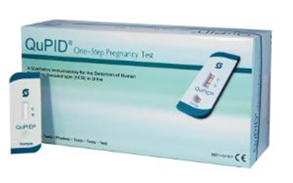

Stanbio QuPID pregnancy test strips are supplied by:

Abbott Limited

Pepper Road

Hazel Grove

Stockport

Cheshire

SK7 5BW

UK

+44 (0)161 483 5884

POCT supply kits to end users in the Trust upon receipt of completed QuPID audit sheets.

# Chemicals and Reagents

The QuPID test strip comes in a sealed foil pouch and is stable until the expiry date when stored at room temperature (15-30 C). The Pouches **MUST NOT BE FROZEN.**

The test strips are obtained from Pathology on production of a completed audit sheet. If any area has any issues with the test strips please contact the POCT team on:

* York 5890
* Scarborough 2659
* Bridlington 3321

# Risk Assessment (Environmental and Safety Controls)

For a full risk assessment please see PC-RA-YS-17

BD16563_Staff carrying out this procedure should have read and understood the Local Rules or Health and Safety Manual applicable to their site which should be followed at all times during the procedure.

* All human samples must be treated as potentially BIO-HAZARDOUS.
* Approved Personal Protective Equipment (PPE) including laboratory coats, disposable gloves must be worn. Eye protection should also be considered and must be worn when directed within the procedure.

.

This SOP and the associated risk assessment(s) have considered all hazards and necessary precautions required to control any risks identified. Where appropriate this is detailed in the COSHH assessment and Risk Assessment. Any risk; where possible is mitigated and or monitored with health surveillance to ensure health and safety for all those affected by this procedure

# Calibration

N/A

# Quality Control

A positive procedural control is built into the QuPID test strip (control zone C) the control line will always be visible if the test has been performed correctly and if the test strip is working correctly. If the control line is missing the assay should be repeated with a fresh test strip, if the control fails to appear on repeat do not report the patients result. Contact the Point of Care Team on ext. 5890.

# External Quality Assurance (EQA)

All areas are registered with WEQAS EQA scheme for urine hCG and samples are distributed every two months. The samples should be analysed immediately or stored at 4-8 C until analysed. The results should be recorded on the audit sheet and the return slip provided with the samples. Please return the results to the POCT office in York, Scarborough or Bridlington as soon as possible.

# Procedural Steps

1. Collect a fresh urine sample in a universal container labelled with patient details and ensure it is at room temperature. Also collect a pregnancy test kit, timer and the audit sheet to fill in (PC-TEM-QUPID).
2. Remove the pregnancy test strip and dropper from the foil wrapper and place on a flat surface. Label the strip with the patient’s name/NHS number.
3. Using the dropper provided dispense two full drops of urine into the round sample well (labelled ‘Sample’).
4. Set the timer for **three minutes**. Interpret the results at exactly **three minutes**.

**Do not interpret the results after three minutes**.

# Reporting of Results

To interpret the results please ensure that you are in good light. See below for interpretation guidance:

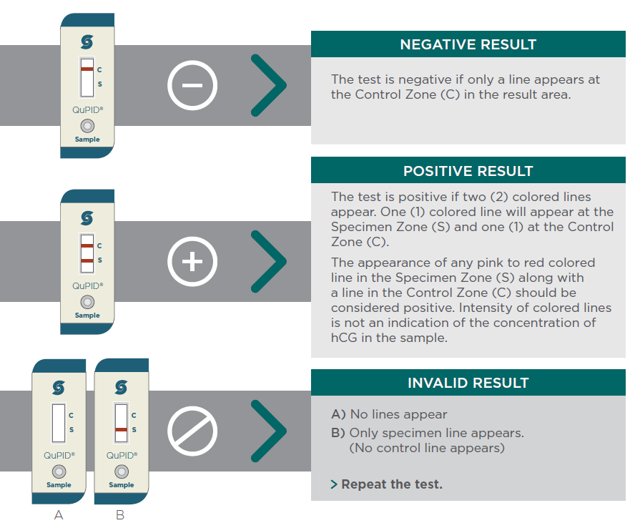

Ask a colleague to confirm your interpretation if you are in any doubt.

Please remember that a blood hCG sample to the laboratory can also be requested to confirm results.

**All results (including invalid results) must be recorded in the patients’ notes and on the Audit sheet provided (PC-TEM-QUPID). Failure to do so will result in the test kits being withdrawn.**

**Please note: This pregnancy test kit is particularly sensitive, therefore positive/equivocal results can appear as a very faint line at ‘S’ at the three minute mark. Please see the example External Quality Assurance sample below for a very faint positive/equivocal result:**

**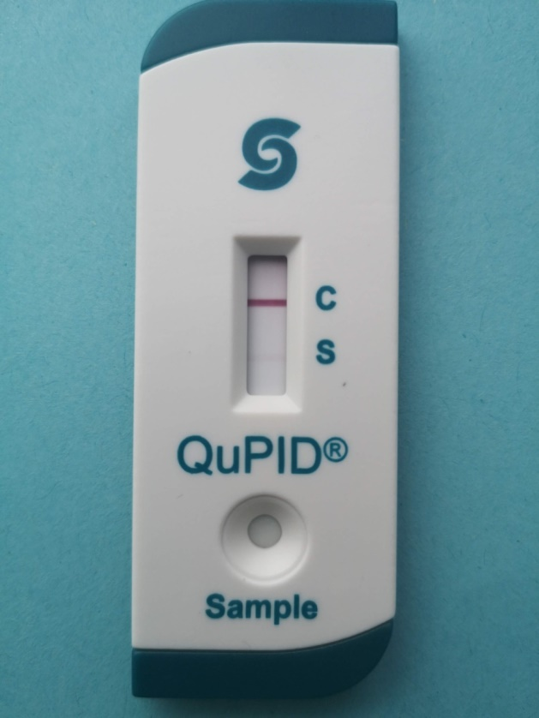**

# Reference Intervals

The QuPID test for pregnancy can detect hCG concentrations of 20mIU/mL and greater

# Performance Characteristics and Known Limitation

False Positive Results may occur in the following conditions

* Chorionic Epithelioma
* Hydatid mole
* Patients who have received preparations of human anti-mouse antibodies

Normal pregnancy cannot be distinguished from an ectopic pregnancy and confusing results may be obtained in cases of spontaneous miscarriage.

hCG levels may remain detectable in patients several weeks post-delivery, spontaneous abortion, therapeutic abortion or hCG injections.

A faint coloured line in the specimen zone indicates a positive result; however the result must be looked at in light of the possible clinical and physiological conditions, which may cause slightly elevated hCG levels. If such conditions exist the patient should be re tested 48-72 hours later.

Negative Results may be obtained if the urine sample is too dilute. If pregnancy is still suspected a second test should be carried out on an early morning urine or a blood sample should be taken (Brown topped gel tube) and sent to Clinical Biochemistry for a serum hCG.

For information on the accuracy and precision of these test kits please refer to the manufacturers insert One step Pregnancy test procedure 1220.provided with the test kits.

# Related Forms/Templates and Documents

PC/RA/YS-17

PC/COM/YS-16

PC/COM/YS-10

PC-VERI-QUPID

PC/FOR/YS-10

# References

* Stanbio QuPID package insert