**Pregnancy Test Using CLINITEST hCG on the CLINITEK Status analyser.**

|  |  |
| --- | --- |
| Document Author/Reviewer | Jane Mason |
| Document Owner | Rachel Lampard |
| Approved By | Rachel Lampard |
| Review Interval | 2 Years |

**Changes from last version of this document**

Amendment to how to deal with borderline results- to align to link trainer guide.

Addition of calibration data.

Table of Contents

[1 Purpose and Principle 3](#_Toc256000000)

[2 Patient Preparation & Sample Requirements 3](#_Toc256000001)

[3 Tasks, Responsibilities and Authorisations 3](#_Toc256000002)

[4 Equipment 4](#_Toc256000003)

[5 Chemicals and Reagents 4](#_Toc256000004)

[6 Risk Assessment (Environmental and Safety Controls) 4](#_Toc256000005)

[7 Calibration 5](#_Toc256000006)

[8 Quality Control 5](#_Toc256000007)

[8.1 How to analyse QC: 5](#_Toc256000008)

[9 External Quality Assurance (EQA) 5](#_Toc256000009)

[10 Procedural Steps 6](#_Toc256000010)

[11 Reporting of Results 7](#_Toc256000011)

[12 Troubleshooting 7](#_Toc256000012)

[12.1 Reprinting patient results 7](#_Toc256000013)

[12.2 Changing printer roll 7](#_Toc256000014)

[13 Reference Intervals 8](#_Toc256000015)

[14 Performance Characteristics and Known Limitation 8](#_Toc256000016)

[15 Related Forms/Templates and Documents 8](#_Toc256000017)

[16 References 9](#_Toc256000018)

# Purpose and Principle

Human chorionic gonadotrophin (hCG) is a glycoprotein hormone, which is produced by the developing placenta shortly after conception. In normal pregnancy the hormone level doubles every 24-48 hours until it peaks at 8-10 weeks after the last menstrual period and can be detected as early as six days after conception. This makes it a good marker for the early detection of pregnancy.

The CLINITEST hCG Pregnancy Test is a rapid, chromatographic immunoassay for the qualitative determination of hCG in urine. The test uses monoclonal antibodies to selectively detect elevated levels of hCG in urine specimens. The test cassette is utilized with CLINITEK Status+ analyser.

# Patient Preparation & Sample Requirements

* Approximately 200 µL of fresh urine is required for a single test
* The urine sample must be collected into a clean dry plastic or glass container without preservatives and labelled with the patients full name, DOB and NHS number
* Labelled samples can be refrigerated at 2–8°C for up to 72 hours, samples must be brought to room temperature prior to testing
* Specimens collected at any time of day may be used, but the first urine sample of the day usually contains the highest concentration of hCG and is therefore the sample of choice.
* Avoid pulp urine bowls or decant into a sterile container as soon as possible

All human samples must be treated as potentially BIO-HAZARDOUS.

Approved Personal Protective Equipment (PPE) including lab coats, gloves and eye-protection should be worn when handling urine samples.

|  |  |
| --- | --- |
| msotw9_temp0 | When performed according to the protocol detailed in this SOP, and in conjunction with adherence to Trust Policies and Good Laboratory Practice, the handling of patient samples represents minimal risk to staff. |

Exposure to Bio-Hazardous Material

In the event of a needle stick injury or accidental blood splashes to eyes or mouth:

* If skin has been punctured encourage bleeding by gently squeezing. Wash with soap and running warm water then dry and dress the wound.
* Splashes to the eyes: irrigate eyes thoroughly with eye wash / saline.
* Splashes to the mouth: gargle with drinking water (avoid swallowing)

Contact the Occupational Health Department / Emergency Department for guidance and report all adverse incidents to your line manager / complete a DATIX form.

Disposal of Patient Samples

Samples are to be disposed of with reference to Trust recommendations: LM-POL-RSDS.

# Tasks, Responsibilities and Authorisations

* These procedures must only be carried out by staff who have received documented training on the use of the CLINITEK analyser. Training is documented in Cobas Infinity
* All tasks should be performed under supervision of trained, competent colleague until staff member has passed competency and feels competent to perform tasks alone.

|  |  |  |
| --- | --- | --- |
| **Tasks** | **Responsible** | **Authorised** |
| Patient testing | Clinical staff who have received POCT training as above | Trained member of POCT staff or certified POCT link trainer |
| Maintenance tasks | POCT staff who have received training | Trained member of POCT staff |

# Equipment

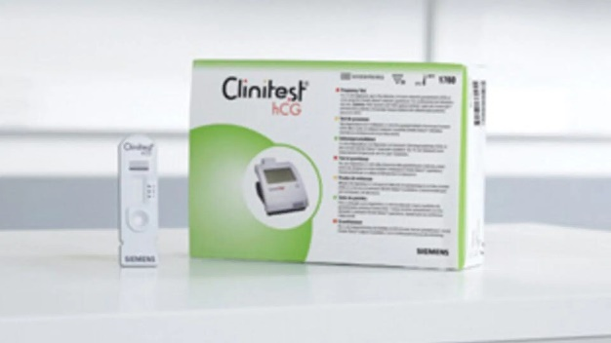 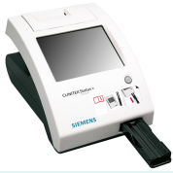

* CLINITEK Status + analyser
* CLINITEST pregnancy test strips are supplied by Siemens and stock is ordered by the POCT Team.
* POCT staff see PC/SOP/YS-1for ordering information:

|  |  |
| --- | --- |
| Product code | Item |
| 10310618 | Clinitest hCG Cartridges |
| 10328736 | Printer Paper |

# Chemicals and Reagents

The CLINITEST comes in a sealed foil pouch and is stable until the expiry date when stored at room temperature (15-30°C). The pouches **MUST NOT BE FROZEN.**

Tests can obtained by contacting the POCT team on:

* York ext. 5890
* Scarborough ext. 2659
* Bridlington ext. 3321

# Risk Assessment (Environmental and Safety Controls)

For a full risk assessment please see PC/RA/YS-3

BD16563_Staff carrying out this procedure should have read and understood the Local Rules or Health and Safety Manual applicable to their site which should be followed at all times during the procedure.

* All human samples must be treated as potentially BIO-HAZARDOUS.
* Approved Personal Protective Equipment (PPE) including laboratory coats, disposable gloves must be worn. Eye protection should also be considered and must be worn when directed within the procedure.

This SOP and the associated risk assessment(s) have considered all hazards and necessary precautions required to control any risks identified. Where appropriate this is detailed in the COSHH assessment and Risk Assessment. Any risk; where possible is mitigated and or monitored with health surveillance to ensure health and safety for all those affected by this procedure

# Calibration

The CLINITEK Status+ analyser calibrates automatically before each measurement. The analyser calibrates by reading the white calibration bar at the appropriate wavelengths to ensure accurate test results.

# Quality Control

A positive procedural control is built into the CLINITEST cassette.

Quantimetrix urine QC is analysed on a weekly basis by the POCT Team – Level 1 = negative and Level 2 = positive qualitative QC.

## How to analyse QC:

1. Touch **QC Test > QC cassette test**
2. Enter Operator ID
3. Enter:
   1. Name of control ‘Quantimetrix’
   2. Name of Level ‘1’ / ‘2’
   3. Control Lot – scan control bottle barcode
   4. Control expiration – enter as written on control bottle
4. At Cassette Lot screen press **Enter new lot & expiration date** – scan cassette barcode from foil packaging
5. Place cassette on test table and press **START**
6. 8 second countdown on screen to apply **6 drops** of QC from QC dropper bottle
7. Repeat for 2nd level of QC

# External Quality Assurance (EQA)

All areas are registered with WEQAS EQA scheme for urine hCG and samples are distributed every two months. The samples should be analysed immediately or stored at 4-8 C until analysed. The results should be returned to the POCT office in York, Scarborough, or Bridlington as soon as possible.

# Procedural Steps

1. Collect a fresh urine sample in a clean, plain container labelled with patient details. Ensure the sample is at room temperature. Ensure appropriate PPE.
2. At the Clinitek Status+ analyser touch the **Cassette Test** button
3. When prompted scan to **Enter your Operator ID** using the barcode scanner > press Enter
4. At **Enter new patient ID** use the keypad to enter the patient’s name then NHS Number > press Enter
5. Touch the **Clinitest hCG cassette** then **Enter new lot and expiration date – scan the barcode from the test strip foil package.**

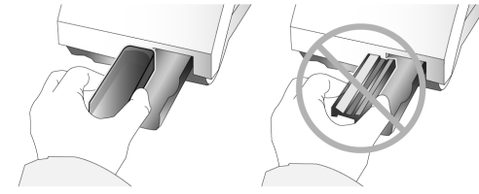

1. At the **Prepare Test** screen, ensure the cassette holder of the table insert is facing upwards:
2. 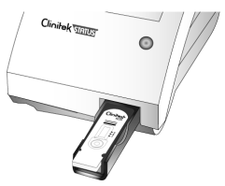Remove a pregnancy test cassette from the foil pouch and place it onto the test table and keep the pipette to one side:
3. Once you touch the **START** button, there is an 8 second countdown to:
   1. 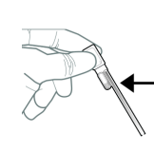squeeze the pipette bulb, put it in the patient urine and gently release the bulb to draw up patient urine
   2. then gently squeeze the bulb to dispense the full urine pipette into the sample well on the cassette.
4. 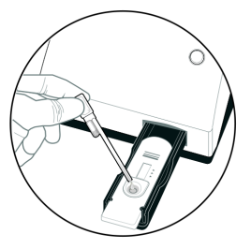At the end of the 8 second countdown, the test table and cassette will automatically be pulled into the instrument.
5. When analysis is complete, the **Results screen** will be displayed and an automatic printout provided.
6. After analysis, remove the used cassette and dispose of it in yellow clinical waste (eg. sharps bin). Patient urine can be discarded as clinical waste if no longer required.

*(WARNING: Do not manually push/pull or knock the table insert.)*

1. Touch **Done** to complete the test and return to the main screen.
2. Clean the cassette holder by pulling out the tray and rinsing with warm soapy water after each test. Occasionally or is the strip holder/analyser appears particularly dirty it may be cleaned with clinell wipes or any commercial cleaning product containing 70% alcohol.

# Reporting of Results

Results will be displayed as follows:

* POSITIVE: hCG is detected in urine sample
* BORDERLINE: Result is indeterminate, wait 48-72 hours and rerun a fresh sample on the clinitek or send a blood sample to the labs for analysis
* NEGATIVE: hCG is not detected in urine sample
* INVALID: due to procedural error or cassette strip issue – repeat test. If error is persistent contact POCT for support

The results should always be recorded into the patients’ notes. The following information should be recorded.

* Result as printed on the printout
* Date and time of analysis
* Identity of the person carrying out the test
* Results seen by clinician in charge of the patient.

NOTE: Results printouts are on thermal paper, be careful when handling the report with wet hands or alcohol hand gel.

If in any doubt about the results send hCG request bloods to the main laboratory.

# Troubleshooting

## Reprinting patient results

1. From the homescreen choose ‘Recall Results’ and scan your operator ID
2. **Select** to ‘recall all patient test or QC tests’ then choose ‘Patient Tests’ > **Next**
3. Choose to either search by name or ID, test date, or View All
4. Highlight the patient result of interest > **Select**
5. **Print** button is on the right side of the screen

## Changing printer roll

1. With the back of the analyzer facing you, open the printer cover by pulling up on the tab.
2. Open the paper roll compartment cover by pressing down on its tab and pulling out the cover.
3. Lift the paper holding arm into the open, upright position.
4. Place the new paper roll into the printer paper compartment with the paper unrolling from underneath and toward the compartment wall.
5. 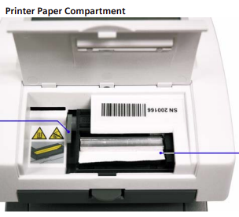Feed the paper up along the wall and through the printer until you have approximately 10 cm (or 4 inches) of paper through the printer.
6. Feed the edge of the paper through the printer cover.
7. Push the paper holding arm down in the closed position.
8. Close the paper roll and printer covers by clicking them into position.

Paper holding arm

Paper roll

# Reference Intervals

The Clinitest test for pregnancy can detect hCG concentrations of 25mIU/mL and greater.

Healthy men and healthy non-pregnant women do not have detectable hCG levels when using the CLINITEST hCG Pregnancy Test. For pregnant women, hCG levels of 100 mIU/mL can be reached on the first day of the missed menstrual period. hCG levels peak about 8–10 weeks after the last menstrual period and then decline to lower values for the remainder of the pregnancy. hCG levels rapidly decrease and usually return to normal within days after delivery.

# Performance Characteristics and Known Limitation

* False Positive Results may occur in the following conditions:
  + Chorionic Epithelioma
  + Hydatid mole
  + Trophoblastic disease
  + Certain nontrophoblastic neoplasms
* Normal pregnancy cannot be distinguished from an ectopic pregnancy and confusing results may be obtained in cases of spontaneous miscarriage.
* hCG levels may remain detectable in patients several weeks post-delivery, spontaneous abortion, therapeutic abortion or hCG injections.
* Negative Results may be obtained if the urine sample is too dilute. If pregnancy is still suspected a second test should be carried out on an early morning urine or a blood sample should be taken (Brown topped gel tube) and sent to Clinical Biochemistry for a serum hCG.
* Patients on antibody therapies may obtain invalid results due to the presence of interfering antibodies in the medications.
* The presence of heterophile antibodies or non-specific protein binding may cause false-positive results in sensitive immunoassays. If a qualitative interpretation is inconsistent with the clinical evidence, results should be confirmed by an alternative hCG detection method.

# Related Forms/Templates and Documents

PC/RA/YS-3

PC/COM/YS-5

PC/VV/YS-2

# References

Clinitest hCG kit insert.

Clinitek Status user guide