Blood Gas Analysis on the Roche b123 POC System

|  |  |
| --- | --- |
| Document Author/Reviewer | Jane Mason |
| Document Owner | Rachel Lampard |
| Approved By | Rachel Lampard |
| Review Interval | 2 Years |

**Changes from last version of this document**

Highlight sample instruction for Bilirubin measurement in neonates on phototherapy.

Update of references moved to new quality management system.

Update blood gas locations

Update of cal/QC times

Contents

[1 Purpose and Principle 3](#_Toc256000000)

[2 Sample Requirements 7](#_Toc256000001)

[3 Tasks, Responsibilities and Authorisations 8](#_Toc256000002)

[4 Equipment 8](#_Toc256000003)

[5 Chemicals and Reagents 9](#_Toc256000004)

[6 Risk Assessment (Environmental and Safety Controls) 10](#_Toc256000006)

[7 Calibration 11](#_Toc256000007)

[8 Quality Control 12](#_Toc256000008)

[9 External Quality Assurance (EQA) 13](#_Toc256000009)

[10 Procedural Steps 13](#_Toc256000010)

[Taking a syringe sample 13](#_Toc256000011)

[Running samples 14](#_Toc256000012)

[Running a fluid sample 17](#_Toc256000013)

[11 Reporting of Results 17](#_Toc256000014)

[12 Reference Intervals 18](#_Toc256000015)

[13 Performance Characteristics 19](#_Toc256000016)

[14 Known Limitations and sources of intererence 20](#_Toc256000017)

[15 Trouble shooting 22](#_Toc256000018)

[15.1 To change consumables 22](#_Toc256000019)

[16 References 23](#_Toc256000020)

# Purpose and Principle

The Cobas b123 POC system is a fully automated analyser for measurement of pH, blood gases, electrolytes, co-oximetry, bilirubin, glucose and lactate. The analyser is controlled by a microprocessor.

The tests listed above may be carried out for the following reasons:

**Blood gases**

Measurement of pH and blood gases allows clinicians to assess whether a patient has an acid-base disorder, or whether these systems are working properly to keep pH in the correct range.

This is mainly achieved by the lungs (which excrete CO2), and kidneys (which excrete or reabsorb H+ and bicarbonate).

**pH**

pH is determined by the balance of acidic hydrogen ions (H+), Carbon dioxide (CO2, a source of hydrogen ions), and bicarbonate (HCO3-, an alkali). A low pH = acidosis (excess H+), and a high pH = alkalosis (not enough H+). Small changes in pH can have a significant effect on the function of the body’s enzymes and metabolic processes, so needs to be maintained within a tight range. This provides a starting point for further testing, such as examination of lung or kidney function.

***p*CO2**

CO2 is the waste product from metabolism and is excreted through the lungs, so provides an idea of lung function. Poorly functioning lungs will cause pCO2 to rise.

A small amount of CO2 is usually dissolved in blood, where it releases H+ and becomes a weak acid. Too much CO2 can therefore cause an acidosis, and too little can cause alkalosis.

Measurement of pCO2 is particularly important for patients on mechanical / assisted ventilation, who need to be kept at an appropriate ventilation rate.

***p*O2**

pO2 is used for a general evaluation of oxygen uptake in the lungs. Oxygen is carried to tissues as oxyhaemoglobin in red blood cells. A small amount is dissolved in the plasma and is measured as *p*O2. A low *p*O2 indicates either poor perfusion across the alveolar walls or poor ventilation. If it is ventilation that is impaired, a raised CO2 and an acid-base disorder may also be seen.

**Metabolic and Respiratory Disorders**

Respiratory acidosis/alkalosis: Caused by poor lung function and an increased pCO2 .In any disorder, the respiratory component is assessed by measuring pCO2.

Metabolic acidosis/alkalosis: Disorders not caused by the lungs. These may result from an overproduction of acid in the body’s metabolic processes (e.g. lactic acidosis) or a failure of the kidney to maintain pH within the normal range by excreting H+ and reabsorbing bicarbonate (e.g. acute kidney injury). The metabolic component of a disorder is assessed by measuring bicarbonate.

The bicarbonate can also be used for calculations, which produce values called the ‘standard bicarbonate’ and ‘base excess’ (BE). These extra tools are also designed to help understand the metabolic component of a disorder.

* A low pH (acidosis) may be due to a fall in the HCO3- (metabolic acidosis) or a rise in *p*CO2 (respiratory acidosis).
* A high pH (alkalosis) may be due to a rise in the HCO3- (metabolic alkalosis) or a drop in *p*CO2 (respiratory alkalosis).

In most disorders, changes in bicarbonate are balanced by changes in pCO2. This is known as compensation, but rarely manages to correct the underlying disorder.

Main causes of acid-base disturbances include:

|  |  |  |
| --- | --- | --- |
|  | **Acidosis** | **Alkalosis** |
| **Metabolic** | Renal failure  Hypoxia and shock  Diabetic ketoacidosis  Diarrhoea | Prolonged vomiting  Potassium deficiency  Administering of bicarbonate |
| **Respiratory** | Chronic lung disease  Acute airways obstruction  Impaired movement of chest wall  Respiratory distress syndrome | Hyperventilation  Over ventilation on respirator  Congestive heart failure |

The typical changes are:

|  |  |  |  |  |  |
| --- | --- | --- | --- | --- | --- |
|  | | | **pH** | ***p*CO2** | **HCO3-** |
| **Acidosis** | **Metabolic** | Initial state  Compensation | ↓  N | N  (↓) | ↓  ↓ |
| **Respiratory** | Acute change  Compensation | ↓  N | ↑  ↑ | N  (↑↑) |
| **Alkalosis** | **Metabolic** | Acute state  Chronic state | ↑  ↑ | N  N or slightly (↑) | ↑  ↑↑ |
| **Respiratory** | Acute change  Compensation | ↑  N | ↓  ↓ | N or ↓  (↓↓) |

KEY

N = Normal ↑ = Primary change (↑) = Compensatory change

**Electrolytes**

**Sodium Concentration [Na+]**

A main extracellular ion used for the evaluation of the fluid and electrolyte balance. A raised [Na+] can be caused by kidney failure or major fluid loss. A low [Na+] can be caused by heart failure, liver disease and several medications.

**Potassium concentration [K+]**

The main intracellular ion. A raised [K+] can be caused by medications, kidney disease or release from cells (e.g. acidosis, cell lysis). A low [K+] can be caused by medications or nutritional deficiencies. Extreme changes in [K+] increase risk of heart attack or cardiac arrest (< 2.5 mmol/L or > 7 mmol/L).

**Ionised Calcium Concentration [Ca2+]**

Free, ionised calcium is directly measured in the blood (i.e. bioavailable, ‘active’ calcium which is not bound to albumin or other ions). Ionised calcium can be particularly useful in patients with a low albumin, or who have other ions in the blood (e.g. citrate following liver transplantation or heavy blood transfusion). Low values can cause seizures and cardiac arrest, whereas high volumes cause nausea, constipation and kidney stones.

**Chloride Concentration [Cl-]**

The major extracellular anion, and maintains electro neutrality by counterbalancing sodium movement. A low chloride may be a sign that other anions are present in the blood (increased anion gap), so is often used to help understand electrolyte and acid-base balance.

**Co-oximetry**

This refers to the measurement of different haemoglobin complexes in blood, namely:

* *Total haemoglobin (tHb)*
* *Oxyhaemoglobin* (O2Hb)
* *Deoxyhaemoglobin (*HHb)
* *Carbonmonoxyhaemoglobin (*COHb)
* *Methaemoglobin* (MetHb)
* *Haematocrit* (Hct)

Measurement of these complexes can be used to estimate:

* *Oxygen saturation* (sO2)

These parameters give information on oxygen uptake in the lungs, the oxygen transport capability of the blood and the ability of the blood to release oxygen to the tissues.

**Metabolites**

**Neonatal Bilirubin (Bili) – ONLY available in SCBU and Delivery on both sites**

Jaundice is a very common symptom in neonates, but may be the earliest sign of a serious disorder if it is severe or persistent. It can cause irreversible brain damage if untreated. Common causes include haemolysis, liver dysfunction, ‘breast milk jaundice,’ medications or parenteral nutrition. Blood gas analysers provide a quick and convenient way of monitoring jaundiced neonates to determine the need for phototherapy or transfusion.

**Measurement of blood bilirubin in patients undergoing phototherapy**- Samples are light sensitive and **MUST** be protected from phototherapy light sources as these are specifically designed to degrade bilirubin and will falsely lower readings in both lab and POCT samples.

**Glucose (Glu)**

Glucose is measured to detect hypo- and hyperglycaemia. Very low values (<2.5 mmol/L) must be treated immediately by giving glucose to the patient. Increased values are treated with insulin while monitoring the blood glucose level.

**Lactate (Lac)**

Lactate is a metabolite produced by the breakdown of glucose. Under normal conditions, lactate is produced at a low level by skeletal muscles and red blood cells and cleared by the liver. However lactate levels can increase rapidly when oxygen supplies are restricted or liver function is impaired. Causes of lactic acidosis include sepsis, lung disease, trauma, exercise, and metabolic disorders.

**Measuring Principles**

**Electrochemistry: PO2, PCO2, pH, Na+, K+, Cl- and Ca2+**

PO2, PCO2, pH, sodium, potassium and chloride are all measured electrochemically by comparing a test electrode (which contacts the patient sample) with a reference electrode (linked to the test electrode inside the analyser).

A reaction takes place between the analytes in the patient sample and the test electrode, and this either removes or releases electrons, creating a flow of current between the test electrode and the reference electrode. The size of the current or potential difference between the two electrodes is used to calculate the concentration of the analyte of interest in the patient sample.

Different types of electrode are used depending on the analyte to be measured and the reaction that needs to take place to create a current flow. For example, the potassium electrode used Valinomycin (a potassium carrier made by bacteria) whereas the calcium electrode uses a synthetic calcium binding molecule, and the oxygen electrode contains gold.

**Glucose and Lactate**

Glucose and lactate are also measured electrochemically, however, because they are metabolites, enzymes are used in the glucose and lactate sensors in order to cause a chemical reaction and generate a current between the test and reference electrodes.

**Glucose:** The glucose electrode is based on glucose oxidase, which generates hydrogen peroxide from oxygen.

*Glucose oxidase:* Glucose + H2O2 +O2 **🡪**Gluconolactone + H2O2 (hydrogen peroxide)

Hydrogen peroxide then goes on to release electrons at a manganese dioxide/carbon electrode. As this releases oxygen, glucose is measured separately from *p*O2.

**Lactate:** Lactate measurement is identical to glucose measurement, but hydrogen peroxide is generated using the enzyme lactate oxidase. This ensures that the lactate senor only reacts with lactate, not glucose.

*Lactate oxidase:*Lactate + O2 + H2O **🡪** Pyruvate + H2O2

An interference sensor is present in both of these electrodes to detect background signals that are created without glucose or lactate being present (same setup, but uses an inactive protein instead of an enzyme).

**Conductivity – Haematocrit, Sample Temperature**

The haematocrit value is measured using the sample conductivity. Whereas plasma ions conduct electrical current applied to a sample, proteins and blood cells do not. The conductivity of a blood sample and sample volume can therefore be used to deduce the volumetric fraction of suspended blood cells present, i.e. the haematocrit (Hct).

**Co-oximetry: Total Hb*,* O2Hb, HHb, COHb, MetHb, Bilirubin**

The concentrations of bilirubin and haemoglobin derivatives are determined by measuring light absorbed by a particular sample over a range of wavelengths (spectrophotometry).

Sample is added to a cuvette and illuminated by light from a halogen lamp using optic fibres.

The sample absorbs light differently at different wavelengths, depending on the haemoglobin species present within it. Any light which has not been absorbed is transmitted to a detector (charge coupled device), which generates an electrical signal that is used to calculate how much light has been absorbed at any given wavelength.

This in turn is used to calculate the concentration of the absorbing haemoglobin species present using the Beer-Lambert Law:

**A(λ) = ε (λ) x C Xl**

**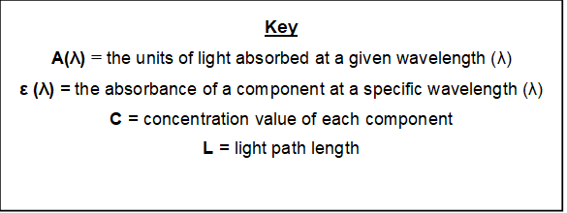**

Absorbance is measured at various wavelengths and the sum of all absorbing species is calculated. Measuring at multiple wavelengths allows the absorbance of the different haemoglobin species to be differentiated by solving simultaneous equations. The absorbance can then be used to calculate concentration of each species by rearranging the Beer-Lambert equation shown above.

This method may be subject to interference from other light absorbing materials (e.g. cardio green, methylene blue and high levels of lipid or Liposyn). The analyser can detect these above a certain level and will prevent the display of incorrect results if these substances are present.

# Sample Requirements

* Whole blood should be taken in a blood gas syringe or capillary tube with dry, balanced heparin anticoagulant.
* If liquid heparin is used please be aware of the potential to dilute the sample.
* Syringes should be capped and thoroughly mixed after collection and again prior to sampling to prevent formation of small clots and ensure homogenous samples.
* Samples should be fully labelled and transported safely in a sample tray.
* Samples should be analysed within 15 minutes of collection. Samples can be stored on ice and measured within 30 minutes on **ice** and measure within 30 minutes.
* Measurement of blood bilirubin in patients undergoing phototherapy- Samples are light sensitive and MUST be protected from phototherapy light sources as these are specifically designed to degrade bilirubin and will falsely lower readings in both lab and POCT samples.
* Please note that the b123 blood gas analyser has **not** been validated for use on fluid samples. Refer to fluid protocol in section 10.4 for how to run fluid samples.
* Sample volumes:

|  |  |  |
| --- | --- | --- |
| **Activated/Installed Module** | **Typical sample volume (μL)** | **Volume limitation by the sample sensor (μL)** |
| BG – ISE – Hct – Glu - Lac | 102 | 211 |
| BG - ISE – Hct – Glu – Lac - COOX | 123 | 211 |
| COOX only | 44 | 87 |

# Tasks, Responsibilities and Authorisations

These procedures must only be carried out by staff members who have received face-to-face Cobas b123 blood gas analyser training with POCT or with a link trainer and completed competency paperwork. Access is given in Cobas IPOC and paperwork is stored in the X-drive>Biochemistry>POCT>Training Logs. Competency is recertified every 2 years.

# Equipment

The Cobas b123 POC system is a fully automated analyser for measurement of pH, blood gases, electrolytes, co-oximetry, bilirubin, glucose and lactate. Analysers are placed in the following locations (these are subject to temporary changes as required):

**York:** ICU Hot, ICU Amber, AMU, A&E Resus (x2), CCU, SCBU, Delivery, Ward 16, Ward 34, Theatres,

**Scarborough:** ITU, A&E 1st Assess, A&E Resus, CCU, SCBU, Rainbow, Delivery, Beech Ward, Lilac ward

In the event of a breakdown please contact the POCT team:

York 772 5890

Scarborough 771 2659

# Chemicals and Reagents

|  |  |  |
| --- | --- | --- |
|  | **COSHH Ref. No.** | **Classification & Specific Instructions** |
| **Fluid pack** | **See data sheet available from the POCT office** | **Preparation:** None  **Storage:** Room Temperature (15-25oC)  **Supplier:** Roche  Risk Statement & Control Measures  See PC/RA/YS-1  Hazard Identification & First Aid Measures  **Eye contact:** Flush eyes with water  **Skin contact:** Wash off with water  **Ingestion:** Seek Medical advice  **Inhalation:** remove victim to fresh air and seek medical advice if symptoms occur  Disposal - as per local guidelines for clinical/chemical waste in a hard container. |
| **cobas b 123 auto QC Pack** | **See data sheet available from the POCT office** | **Preparation:** None  **Storage:** 2-8oC before use, then room temperature (15-25oC) or up to 7 days prior to installing on the analyser  **Supplier:** Roche  Risk Statement See PC/RA/YS-1  Hazard Identification & First Aid Measures  **Eye contact:** Flush eyes with water if irritation occurs  **Skin contact:** Wash skin thoroughly with water if irritation occurs  **Ingestion:** Seek Medical advice  **Inhalation:** remove victim to fresh air and seek medical advice if symptoms occur  Disposal - as per local guidelines for clinical/chemical waste in a hard container. |

The reagents require no preparation.

A spare of each consumable is stored by each analyser so that end users can re-stock the analyser as required.

Stock consumables, spares and technical support is available from the point of care testing team (telephone number York ext. 772 5890 or Scarborough ext. 771 2659) in the first instance. Technical support will be given Monday – Friday, 9am-5pm staff permitting. Out of hours please contact the Biochemistry departments at either York or Scarborough.

Customer Services

Roche Diagnostics Limited

Charles Avenue

Burgess Hill

West Sussex

RH15 9RY

Tel 0808 100 80 60

|  |  |  |
| --- | --- | --- |
| **Item** | **Order number** | **Storage conditions** |
| Fluid pack (200 tests) | 05169992001 | Room Temperature |
| Fluid pack (400 tests) | 05170036001 | Room Temperature |
| Fluid pack (700 tests) | 05170052001 | Room Temperature |
| Cobas b123 Tri level Auto QC pack (24) | 05169933001 | Store Refrigerated at 2-8oC |
| Cobas b123 Sensor Cartridge BG/ISE/Glu/Lac\* (500 tests) | 05170478001 | Store Refrigerated at 2-8oC |

**GENERAL FIRST AID** 

The following first aid guidelines may be applied to all the substances detailed in this SOP.

Eyes: Irrigate thoroughly with water. At least 10 minutes is the recommended duration. Sterile saline is also available at the eye wash stations.

Lungs: Remove from exposure, rest and keep warm.

Skin: Wash substance off skin thoroughly with water. Remove contaminated clothing and wash before re-use.

Mouth: Wash out mouth thoroughly with water and give plenty of water to drink.

Remember – If at all concerned about the nature or severity of the problem, SEEK MEDICAL ADVICE.

# Risk Assessment (Environmental and Safety Controls)

BD16563_Staff carrying out this procedure should have read and understood the Local Rules or Health and Safety Manual applicable to their site which should be followed at all times during the procedure.

Full risk assessment, see PC/RA/YS-1

This SOP and the associated risk assessment(s) have considered all hazards and necessary precautions required to control any risks identified. Where appropriate this is detailed in the COSHH assessment and Risk Assessment. Any risk; where possible is mitigated and or monitored with health surveillance to ensure health and safety for all those affected by this procedure

# Calibration

The cobas b123 POC system is fully calibrated using three stable, aqueous solutions, which are in airtight bags inside the Fluid Pack. No additional calibrators are required.

All standard solutions used for calibration purposes are NIST traceable.

Automatic on-board calibration

Full system calibration every 24 hours (takes approx. 15 minutes)

2 Point (2P) calibration every 12 hours (i.e. as part of system calibration and 12 hours after this) (takes approx. 6 minutes)

1 Point (1P) calibration every 60 mins (takes approx. 3 minutes)

If a parameter fails its calibration the parameter(s) affected will not be available to select from main analyser screen.

To initiate re-calibration of the required parameter go to:

[Instrument] and select > ‘Calibration for Ready’.

This repeats any calibrations that have previously failed. Provided re-calibration is successful, the parameter will turn green on the calibration list and the analyser will enter ‘ready’ mode.

The system calibration and the 2P calibration are set up to occur 12 hours apart from each other at times that the unit should not be too busy. They are also set up to occur at different times to the adjacent gas machine (i.e. they should not occur at the same time on ICU and A&E or on AMU and CCU).

The following calibration has been set in Scarborough Hospital

|  |  |  |  |  |  |  |  |  |  |
| --- | --- | --- | --- | --- | --- | --- | --- | --- | --- |
|  | ED RESUS | ED 1st Assess | BEECH | CCU | ITU | DEL | SCBU | LILAC | RBW |
| SYSTEM calibration | 04:30 | 03:30 | 05:30 | 03:00 | 04:00 | 03:30 | 04:30 | 04:30 | 06:00 |
| 2PT calibration | 16:30 | 15:30 | 17:30 | 15:00 | 16:00 | 15:30 | 16:30 | 16:30 | 18:00 |
| 1PT calibration | Hour | Hour | Hour | Hour | Hour | Hour | Hour | Hour | Hour |

The following calibration schedule has been set in York Hospital

|  |  |  |  |  |  |  |  |  |  |
| --- | --- | --- | --- | --- | --- | --- | --- | --- | --- |
|  | ED RESUS | ED Resus (POCT) | ICU AMBER | ICU HOT | WARD 34 | AMU | SCBU | DELIVERY | CCU |
| SYSTEM calibration | 04:30 | 11:00 | 07:00 | 04:30 | 04:30 | 06:00 | 03:00 | 04:00 | 06:30 |
| 2PT calibration | 16:30 | 23:00 | 19:00 | 16:30 | 16:30 | 18:00 | 15:00 | 16:00 | 18:30 |
| 1PT calibration | Hourly | Hourly | Hourly | Hourly | Hourly | Hourly | Hourly | Hourly | Hourly |

|  |  |  |
| --- | --- | --- |
|  | THEATRES | WARD 16 |
| SYSTEM calibration | 06:30 | 09:00 |
| 2PT calibration | 18:30 | 21:00 |
| 1PT calibration | Hourly | Hourly |

The 1P occurs an hour after the end of the previous 1P calibration. For this reason, two gas machines may be performing a 1P calibration at the same time, however, as the 1P calibration only takes 3 minutes this shouldn’t affect the sample integrity.

Please see PC/INF/YS-43 / PC/INF/YS-42 for troubleshooting analytes that have failed a calibration.

# Quality Control

Roche Cobas b123 Auto QC Tri-Level for blood gas, ISE’s and CO + derivatives, are stored on board the analyser.

One spare QC pack is stored near the analyser.

All other stock is stored at 4 oC in fridge 29 in York Biochemistry, POCT fridge in Scarborough (first floor), or the fridge on Lloyd ward. Contact POCT team or the point of care coordinator if required. Quality control packs should be at room temperature (24hr – 7 days) prior to inserting on the analyser.

Two levels of QC are analysed each day, one every 12 hours

Times for Scarborough quality control samples:

|  |  |  |  |  |  |  |  |  |
| --- | --- | --- | --- | --- | --- | --- | --- | --- |
| ED RESUS | ED 1st Assess | BEECH | CCU | ITU | DELIVERY | SCBU | LILAC | RBW |
| 04:00 | 06:00 | 06:00 | 06:30 | 06:00 | 04:00 | 05:00 | 09:30 | 11:00 |
| 16:00 | 18:00 | 18:00 | 18:30 | 18:00 | 16:00 | 17:00 | 21:30 | 23:00 |

Times for York quality control samples

|  |  |  |  |  |  |  |  |  |  |  |
| --- | --- | --- | --- | --- | --- | --- | --- | --- | --- | --- |
| ED Resus | ED Resus (POCT) | ICU Amber | ICU Hot | Ward 34 | AMU | SCBU | Delivery | Theatres | Wd 16 | CCU |
| 08:30 | 11:00 | 07:30 | 05:00 | 06:45 | 06:00 | 06:00 | 08:00 | 10:00 | 11:30 | 10:00 |
| 20:30 | 23:00 | 19:30 | 17:00 | 18:45 | 18:00 | 18:00 | 20:00 | 22:00 | 23:30 | 22:00 |

To order additional QC, go to [workplace] > [QC measurement] and select the desired level from the material selection screen

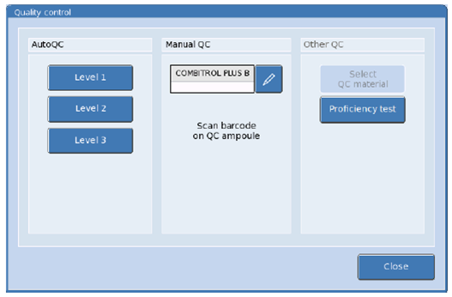

QC results are stored under

[Workplace] > [QC Database]

Please see PC/INF/YS-43 / PC/INF/YS-42 or details of how to troubleshoot when an analyte has failed a QC.

# External Quality Assurance (EQA)

All blood gas analysers are registered for the RIQAS blood gas analyser EQA scheme. Samples are received monthly and are analysed by a member of the POCT team. The results are reported back at the site specific POCT committee meetings

# Procedural Steps

## Taking a syringe sample

When taking the blood sample:

* Confirm patient ID (NHS number)
* If possible, obtain consent.
* A dry heparin plastic syringe should be used.
* The minimum depth of blood required when sampling from a syringe is 15mm (200ul of sample) required.
* **The sample should be labelled with a patient sticker**
* Once collected, carefully remove the needle from the syringe and expel any air in the tip of the syringe. Any air bubbles will render the sample unsuitable for analysis.
* Mix the sample gently mixed by rolling the syringe between your palms prior to analysis.

**Taking a capillary sample (Neonates)**

Neonate capillary sample can be taken using a standard Heal stab technique.

**Measurement of blood bilirubin in patients undergoing phototherapy**- Samples are light sensitive and **MUST** be protected from phototherapy light sources as these are specifically designed to degrade bilirubin and will falsely lower readings in both lab and POCT samples.

## Running samples

* Ensure the analyser is in Ready mode and that all the required parameters are green. If any required parameters are in red please refer to section 13 for simple troubleshooting, or Blood Gas Information Poster (PC-INF-sb123 / PC-INF-yb123).

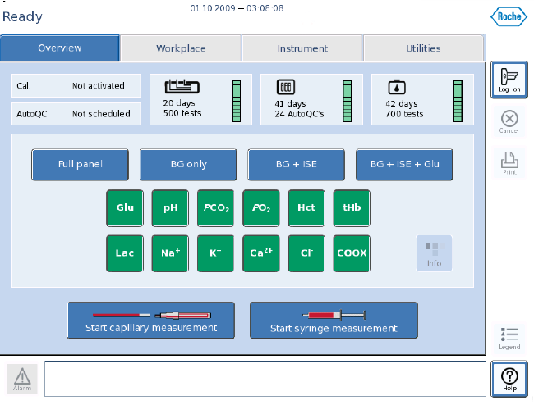

* Press [Log in] at the right hand side of the screen. Scan your operator ID barcode or enter your operator ID in **capital** letters by selecting the pencil.
* Enter your 6-number password. Press the return button and [OK].
* Press [Start Syringe Measurement] for gas syringes or [Start Capillary Measurement] for capillary samples.
* Securely attach the syringe or capillary to the fill port and select [yes] when asked if securely attached to begin sample aspiration. Do NOT attempt to hold the syringe or inject the sample into the machine.

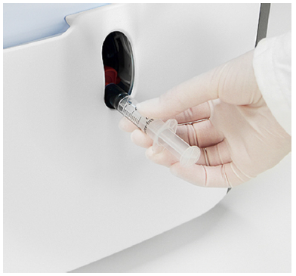Syringe measurement

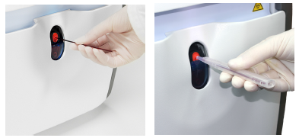Capillary measurement

* When prompted to ‘Remove the syringe’ or ‘Remove the capillary’ carefully pull out the sample and confirm removal by pressing [yes].
* This automatically commences sample measurement.
* **‘Patient Demographics and Input Values’** screen. Fields marked with an asterisk (\*) are compulsory and MUST be entered, to avoid the results being discarded: These fields are:
  + The Patient ID (NHS number where ever possible)
  + Surname
  + First name
  + DOB
  + Blood type (Venous, Arterial, Capillary)
  + Remark (Delivery Suites only)

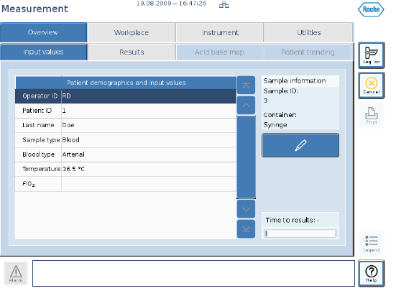

* To enter patient details:
  + Click on the patient ID field and press the pencil icon to display the keyboard and type in the patients’ **NHS number**
  + If the patient is already known to the system the rest of the patient details will appear automatically. If not please type in the **Last name and First name** manually using the pencil icon to display the keyboard. Then enter the **DOB** using the pencil icon and choosing the year first by pressing and holding the arrow key.

*If these are not provided the results will be discarded, if these are incorrect the results will NOT enter the patients’ electronic notes.*

* + Click on blood type field and choose venous, arterial or capillary.
* Results will appear on the screen when available. When analysis is complete the report will print automatically. The results will also appear in the patients’ electronic notes, provided correct identification has been provided.
* Once results have been printed, discard the sample in a suitable sharps bin.
* Please note:
  + A parameter which has failed a calibration or a QC (red square) will not give a result until the problem has been corrected.
  + If you press [Print] whilst measurements are still in progress, values for some analytes may be missing on the printout.

* + Results can be re-printed once measurement is complete by pressing [Workplace] > [Measuring Database]. Select the desired patient from the list and click [Print] on the right-hand side of the screen.
  + For very small samples (<123 μL), the sample is automatically analysed in ‘micro sample’ mode. This will perform Co-oximetry measurements (if 37μL of sample present), and Blood Gas Measurements (if >55μL sample present), but will return a message saying ‘Insufficient Volume’ for glucose, lactate and electrolyte measurements.

## Running a fluid sample

**Please note that the b123 blood gas analyser has not been validated for use on fluid samples.**

* Follow steps as above to run the sample
* At the patient demographics screen enter ‘FLUID’ as the **Patient ID** to prevent fluid results being filed as blood gas results in CPD
* This will bring up the details of the last fluid sample run on the analyser
* These **must be manually overwritten with patient details of the sample you are running**
* The printout will show correct patient details

# Reporting of Results

End users are responsible for verifying the validity and accurate transcription of their patients’ results. The clinician requesting the test and, if appropriate, the patient must also be informed of the result.

Please **do not** stick the print out into the patients’ notes as they fade with time, however, a photocopy or scan of the print out may be attached to the patients notes. Reference ranges and results that are unavailable due to sample integrity errors are displayed on the print out as such.

The following information should be reported in the patients’ notes:

* The clinician requesting the blood gas analysis
* The person performing the test
* The date and time of the test
* The results and their units
* All individuals to whom the results have been reported (eg. clinician, patient)

If the correct patient demographics were entered, all blood gas results will be available in the patients’ electronic records.

|  |  |
| --- | --- |
| **Parameter** | **Units reported in** |
| Gases (pO2 and pCO2) | kPa |
| ISE’s (sodium, potassium, chloride & ionised calcium) and MSS analytes (glucose and lactate) | mmol/L |
| Total haemoglobin (tHb) | g/dL |
| Haemoglobin derivatives | % of tHb |
| Bilirubin | µmol/L |

# Reference Intervals

|  |  |  |  |
| --- | --- | --- | --- |
| **Parameter** | **Lower reference limit** | **Upper reference limit** | **Source** |
| **PO2** | 11.07 kPa | 14.40 kPa | (1) Tietz 5th Ed 2012 |
| **PCO2** | 4.27 kPa | 6.00 kPa | (1) Tietz 5th Ed 2012 |
| **pH** | 7.350 | 7.450 | (1) Tietz 5th Ed 2012 |
| **Sodium** | 136 mmol/L | 145 mmol/L | (1) Tietz 5th Ed 2012 |
| **Potassium** | 3.50 mmol/L | 5.10 mmol/L | (1) Tietz 5th Ed 2012 |
| **Chloride** | 98.0 mmol/L | 107.0 mmol/L | (1) Tietz 5th Ed 2012 |
| **Ionised Calcium** | 1.150 mmol/L | 1.330 mmol/L | (1) Tietz 5th Ed 2012 |
| **tHb** | 115.0 g/L | 178.0 g/L | (2) Labor und Diagnose |
| **COHb** | 0% | 3% | (2) Labor und Diagnose |
| **O2Hb** | 94% | 98% | (2) Labor und Diagnose |
| **Met Hb** | 0% | 1.5% | (1) Tietz 5th Ed 2012 |
| **Hct** | 36% | 53% | (2) Labor und Diagnose |
| **Glucose** | 4.0 mmol/L | 5.3 mmol/L | Trust Hypoglycaemia Pathway  Diabetes UK |
| **Lactate** | 1.0 mmol/L | 2.0 mmol/L | Locally agreed |
| **Bilirubin (newborn)** | 51.27 µmol/L | 170.91 µmol/L |  |
| **Bilirubin (≤1yr)** | 68.36 µmol/L | 136.73 µmol/L |  |
| **Bilirubin (2nd day)** | 102.55 µmol/L | 170.91 µmol/L |  |

**Source of Reference Ranges**

1. Tietz Textbook of Clinical Chemistry and Molecular Diagnostics, 5th edition 2012
2. Lothar Thomas, Labor und Diagnose, 8. Auflage, p. 840

# Performance Characteristics

Intra-assay performance details for the analysers are published by Roche and are available in the Instructions for Use (in the POCT Cupboard, York or the POCT office in Scarborough).

The following table shows the inter-assay precision for all assays from the evaluation carried out prior to implementation:

|  |  |  |  |  |  |  |  |  |  |
| --- | --- | --- | --- | --- | --- | --- | --- | --- | --- |
|  | **QC 1 n=20** | | | **QC2 n=20** | | | **QC3 n=20** | | |
|  | **Mean** | **SD** | **CV(%)** | **Mean** | **SD** | **CV(%)** | **Mean** | **SD** | **CV(%)** |
| **PO2** | 8.578 | 0.297 | 3.46 | 13.89 | 0.278 | 2.0 | 19.67 | 0.61 | 3.08 |
| **PCO2** | 8.70 | 0.08 | 0.93 | 5.65 | 0.091 | 1.61 | 3.38 | 0.109 | 3.23 |
| **pH** | 7.14 | 0.01 | 0.14 | 7.39 | 0.006 | 0.09 | 7.54 | 0.006 | 0.08 |
| **Sodium** | 119 | 0.78 | 0.66 | 142 | 0.56 | 0.39 | 155 | 0.42 | 0.27 |
| **Potassium** | 3.0 | 0.024 | 0.8 | 4.7 | 0.047 | 0.01 | 7.1 | 0.043 | 0.91 |
| **Chloride** | 84 | 1.02 | 1.22 | 102 | 0.73 | 0.72 | 119 | 1.59 | 1.33 |
| **Ionised Calcium** | 1.74 | 0.009 | 0.53 | 1.24 | 0.009 | 0.72 | 0.687 | 0.009 | 1.39 |
| **tHb** | 73.2 | 0.93 | 1.26 | 114.1 | 1.30 | 1.14 | 196.5 | 2.86 | 1.45 |
| **COHb** | 22.8 | 0.16 | 0.71 | 11.1 | 0.24 | 2.14 | 3.51 | 0.14 | 4.03 |
| **O2Hb** | 47.4 | 0.35 | 0.75 | 74.3 | 0.55 | 0.74 | 91.8 | 0.89 | 0.98 |
| **Bilirubin** | 100.4 | 0.75 | 0.74 | 196.2 | 2.56 | 1.3 | 346.2 | 4.0 | 1.14 |
| **Glucose** | 6.12 | 0.151 | 2.48 | 2.45 | 0.083 | 3.38 | 23.6 | 0.52 | 2.19 |
| **Lactate** | 10.20 | 0.32 | 3.13 | 3.11 | 0.37 | 1.2 | 1.66 | 0.050 | 2.99 |

Measurement of uncertainty data is performed on an annual basis. (PC-SOP-UNCERT)

Uncertainty details available by contacting POCT.

**Assay detection limits** (published by Roche and available in the Instructions for Use)

|  |  |  |
| --- | --- | --- |
| **Parameter** | **Lower reportable range** | **Upper reportable range** |
| **PO2** | 1.33 kPa | 93.3 kPa |
| **PCO2** | 1.33 kPa | 20.0 kPa |
| **pH** | 6.5 | 8.0 |
| **Sodium** | 100 mmol/L | 200 mmol/L |
| **Potassium** | 1.0 mmol/L | 15 mmol/L |
| **Chloride** | 70 mmol/L | 150 mmol/L |
| **Ionised Calcium** | 0.1 mmol/L | 2.5 mmol/L |
| **tHb** | 40 g/L | 250 g/L |
| **COHb** | 0% | 70% |
| **O2Hb** | 30% | 100% |
| **Met Hb** | 0% | 70% |
| **Hct** | 10% | 75% |
| **Bilirubin** | 51.3 umol/L | 855 umol/L |
| **Glucose** | 1.0 mmol/L | 30.0 mmol/L |
| **Lactate** | 1.0 mmol/L | 20.0 mmol/L |

# Known Limitations and sources of intererence

Include, as appropriate:

**Preanalytical Factors**

* Compression bandage present at phlebotomy can change potassium by up to 20%.
* Pressure during phlebotomy can cause haemolysis.
* Heparin salts are the only permitted anticoagulants to be used. Other anticoagulants, such as EDTA, citrate, oxalates, fluorides and ammonia-containing anticoagulants have a significant effect on the blood pH value and other parameters.
* Air bubbles in whole blood sample will affect gas partial pressure and acid-base balance.
* Whole blood samples that are not well mixed prior to sampling will not have even distribution of red blood cells and plasma and will affect tHb, SO2 and Hct.
* Glucose measurements should ideally be performed on a fasting sample.
* Lactate samples should be collected from patients at rest.
* Bilirubin samples should be analysed immediately or protected from light to avoid degradation.
* Electrochemical measurements should only be carried out in fluids with a physiological ion background, pH and buffering capacity.

**Glucose and Lactate**

The cobas b123 POC system performs active interference correction when measuring glucose and lactate. An additional integrated sensor exists to correct for any interference from endogenous (e.g. Uric acid) or exogenous (e.g. acetylsalicylic acid) compounds.

To attain the highest possible degree of accuracy, the compensation sensor is calibrated to the biosensors as part of daily system calibration.

The effects of the most significant interferents were determined during development and can be found in the Instructions for Use, *Effect of the substances on BG, pH, ISE, Glu, Lac, Hct* (p. 193).

Drugs causing some degree of interference are summarised below:

* Glucose and Lactate: Acetylcysteine, Hydroxycarbamide
* Glucose Only: Potassium Thiocyanate, Sodium Bromide, Norepinephrine
* Lactate Only: Glycolic Acid, Uric Acid, Salicylic Acid

**Ions and Hct**

Drug Interferences are summarized in the section *Effect of the substances on BG, pH, ISE, Glu, Lac, Hct* (p. 193 of Instructions for Use).

Drugs causing some degree of interference are summarised below:

* Sodium - Benzalkonium Chloride and Dobutamine
* Chloride – Potassium Thiocyanate, Sodium Bromide, -Iodide, -Nitroprusside and -Perchlorate, Salicylic Acid
* Haematocrit – Sodium Chloride

**Haemoglobin Derivatives**

Drug Interferences are summarized in the section *Effect of the substances on tHb, SO2, Bilirubin, Hb derivatives* (p. 195 of Instructions for Use).

Drugs causing some degree of interference to haemoglobin derivative measurements (with variable effects on tHb, HHb, MetHb, COHb, O2Hb, SO2, and Bilirubin) are summarised below:

- Methylene Blue

- Evans Blue

- Patent Blue

- Hydroxycobalamin

- Cyanomethaemoglobin

- Sulfhaemoglobin

- Fluorescein

# Trouble shooting

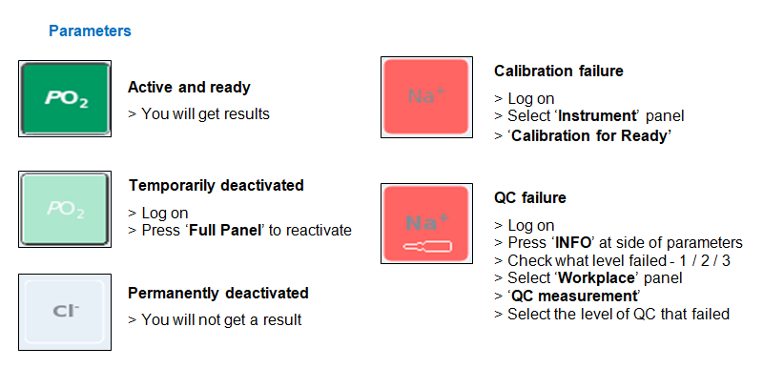

## 15.1 To change consumables

If the consumable is running low (), follow instructions to change before it is empty:

> Log on and go to ‘**Workplace**’ tab

> Choose correct reagent to **change** (middle column)

> Follow on screen instructions

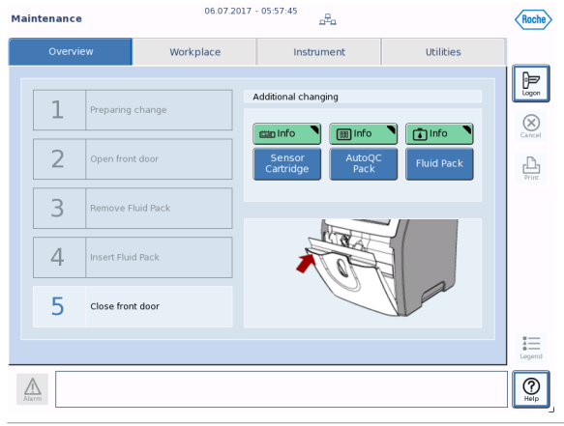

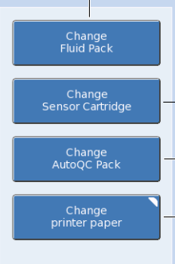

If the consumable has expired/emptied you will see a system stop on screen. Click the prompt to change the pack and follow onscreen instructions:

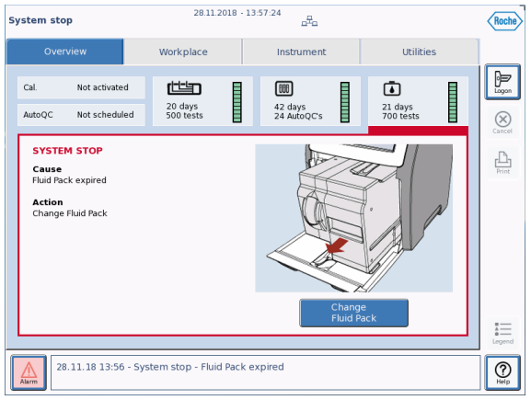

Fluid pack and sensor cartridge should be disposed of as per local clinical waste guidelines.

The AutoQC pack should be discarded in sharps waste.

# References

Instruction for use manual stored in POCT office at York and Scarborough

Technical training manual stored in POCT office at York and Scarborough

PC/VV/YS-16/17/18/19

COSHH data for products listed in the Chemicals are available from the POCT office on all sites