Clinical Assessment

Patient Name | DATE:  GI SURGEON:  PLASTIC SURGEON:  REFERRAL SOURCE:

1. Body Dimensions: | Weight (kg) |  | Height (m) |  | BMI (kg/m2)

Skin Assessment: |  | Anatomical Measurements (cm)
Normal | □ | Xi / SP
Scarring | □ | ASIS /ASIS
Ulceration | □ | Divarication (cm)
Redundant Skin | □ | Rectus Tone
Fistula | □ | Good | □
Stoma | □ | Poor | □

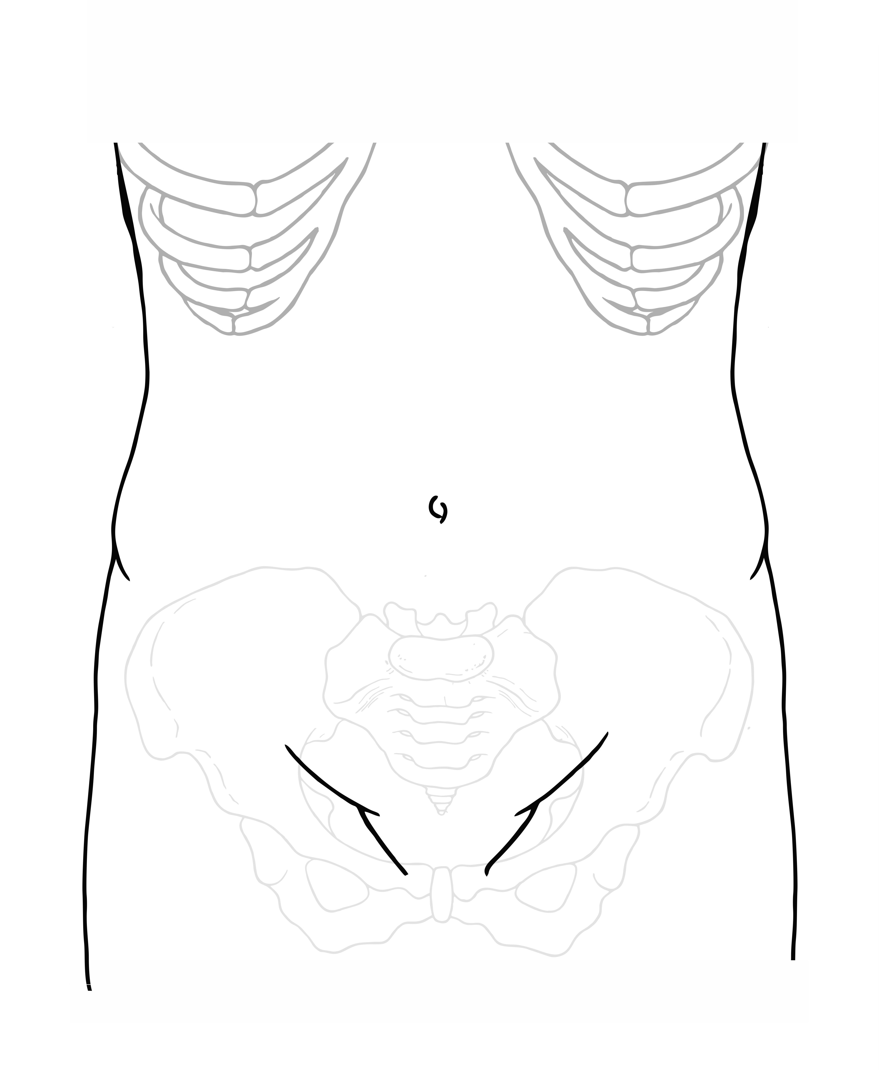 | Hernia (s): | Length (cm) | Width (cm)
 | 1
 | 2
 | 3
 | 4
 | 5
 | 6

M and L Zones for Incisional Hernia

Medial |  |  | Lateral
M1 | Subxiphoidal | xiphoid to 3 cm caudally | L1 | Subcostal | between costal margin  and a horizontal line 3 cm  above umbilicus
M2 | Epigastric | 3 cm below xiphoid to 3 cm  above umbilicus | L2 | Flank | lateral to rectal sheath  in area 3 cm above and  below umbilicus
M3 | Umbilical | 3 cm above to 3 cm below the  umbilicus | L3 | Iliac | between a horizontal line 3  cm below umbilicus and  the inguinal region
M4 | Infraumbilical | 3 cm below umbilicus to 3 cm above pubis | L4 | Lumbar | laterodorsal to anterior  axillary line
M5 | Suprapubic | pubic symphysis to 3 cm  cranially | L5

VHWG Classification:

Grade 1 |  | Grade 2 |  | Grade 3 |  | Grade 4
Low Risk |  | Comorbid |  | Potentially Contaminated |  | Infected
□ | Low Risk for complications | □ | Smoker | □ | Previous wound infection | □ | Infected Mesh
□ | No history of wound infection | □ | Obese | □ | Stoma Present | □ | Septic Dehiscence
 |  | □ | Diabetic | □ | Violation of G.I.T.
 |  | □ | Immunosuppressed
 |  | □ | COPD

Carolinas Equation for Determining Associated Risks (CeDar):

Current Risk of Complications (%)
Target Weight to Reduce Complications (kg)

Obesity Management Service Referral Criteria:

 |  | Yes |  | No | Unsure | Score
 |  | > 3yrs | < 3 yrs
BMI | ≥50 | Eligible
 | 45 – 49.9 | 5
 | 35 – 44.9 | 3
Pre-diabetes |  | 4 | 5 | 0
Type 2 diabetes |  | 4 | 5 | 0
Ischaemic heart disease |  | 3 | 5 | 0
Non-alcoholic fatty liver |  | 3 | 5 | 0
Stroke and cerebrovascular accident unspecified or  Transient cerebral ischaemia or  Cerebrovascular disease: |  | 3 | 5 | 0
Type 1 diabetes mellitus |  | 2 | 0 | 0
Obstructive Sleep Apnoea: |  | 2 | 0 | 0
Angina pectoris |  | 2 | 0 | 0
Generalised osteoarthritis - OA |  | 2 | 0 | 0
Diabetes mellitus arising in pregnancy: |  | 2 | 0 | 0
Gestational diabetes mellitus: |  | 2 | 0 | 0
Chronic obstructive pulmonary disease (COPD) or Asthma: |  | 2 | 0 | 0
Hypertensive disease: |  | 2 | 0 | 0
Cardiac dysrhythmias |  | 1 | 0 | 0
Rheumatoid Arthritis: |  | 1 | 0 | 0
Polycystic ovarian syndrome (PCOS) |  | 1 | 0 | 0
Acquired hypothyroidism |  | 1 | 0 | 0
Gastro-oesophageal reflux (GORD) |  | 1 | 0 | 0
Peptic ulcer NOS |  | 1 | 0 | 0
Significant back pain (on >2 analgesics, or under pain clinic) |  | 1 | 0 | 0
TOTAL ESTIMATED SCORE
Investigations:

 | Investigation | Results:
□ | HbA1c
□ | MRSA Screen
□ | Wound(s)
□ | Spirometry
□ | CPX | Anaerobic Threshold:
□ | Endoscopy | OGD:  Colonoscopy:
□ | CT Scan

Clinical Photographs:

□ | Photo Consent Form
□ | Photo Info Booklet

Booklets:

□ | Complex AWR
□ | Recovering from Major Abdominal Surgery
 | Getting You Fitter

Pre-Operative Management:

Optimisation:

□ | Weight | □ Tier 1:  □ Tier 2: Dietician Referral -> Sign Post  □ Tier 3: GP to Consider Referral  □ Tier 4: GP to Refer
□ | Exercise Regime | □ GP to Refer to Exercise Programme  □ Advice in Clinic
□ | Smoking Cessation | □ GP to Refer  □ Advice in Clinic
□ | Diabetic Management | □ HbA1c  □ Endocrine Referral
□ | Skin Care | □ Moisturise  □ Dermatology Referral
□ | Prehabilitation | □ Calf Exercises Advice  □ Breathing Exercises Advice  □ Leaflet given
□ | Abdominal Binder | □ Issued in Clinic  □ Orthotic Referral
□ | Pre-operative  Botulinum  Toxin | □ Pre-op Botulinum Toxin

Operative Plan:

Surgeon(s):

□ | General Surgeon | □ | Plastic Surgeon | □ | Other

Operative Duration:

Number of Operating Sessions
Estimated Time (hr)

Planned Incisions:

 | Stoppa Repair:
 | □ | Retro rectus | □ |  | Pre Peritoneal |  |  | □ |  | TAR
 | Component Separation:
 | Right |  |  | Left:
 | □ | Open |  | □ |  | Open
 | □ | Min Inv |  | □ |  | Min Inv
 | □ | None |  | □ |  | None
 | Revision of Soft Tissues:
 | □ | Yes |  | □ |  | No
 | Mesh:
 | □ | Synthetic |  | □ |  | Semi  synthetic | □ |  | Biological
 | Product:
 | Size:
Additional Procedures:
Bowel Prep:

COPY OF LETTER SENT TO PATIENT

Current Episode: | - Referred by  - Seen in clinic today by
Diagnosis:

Surgical History:
Hernia footprint: | - Width - cm  - Height - cm  - Covers M  - Covers L  - VWHG Classification of Grade
Smoker:
Diabetes:
BMI: | - Height -  - Weight -  - BMI -
CeDAR Calculation:
Target weight loss:
Plan:

Leaflets given: | - Consent for photography  - Getting fitter for surgery  - Complex abdominal wall hernia surgery  - Recovering from major abdominal surgery
Photography: | Sent to medical illustrations for photographs today
Dietitian referral: | Sent/Seen in clinic by
Prehabilitation clinic:
Website | https://www.yorkhospitals.nhs.uk/our-services/a-z-of-services/abdominal-wall-reconstruction/

To the patient:
This is a copy of a letter to health professionals which uses medical terms. A copy is sent to you as a reminder of what was discussed in the clinic, so you know what has been passed on. You may find it useful to keep copy letters and show them to other professionals when you meet them for the first time. Please feel free to discuss anything in this letter when you next come to clinic. You may also find further useful information at: https://www.yorkhospitals.nhs.uk/our-services/a-z-of-services/abdominal-wall-reconstruction/

