Blood Gas Analysis on the Abbott iSTAT Alinity

|  |  |
| --- | --- |
| Document Author/Reviewer | Jane Mason |
| Document Owner | Rachel Lampard |
| Approved By | Rachel Lampard |
| Review Interval | 2 years |

**Changes from last version of this document**

Update to new template

Update of references to documents

Addition of Chem 8+ cartridges

Table of Contents

[1 Purpose and Principle 3](#_Toc256000000)

[1.1 Purpose 3](#_Toc256000001)

[1.2 Principle 4](#_Toc256000002)

[2 Patient Preparation & Sample Requirements 5](#_Toc256000003)

[3 Tasks, Responsibilities and Authorisations 5](#_Toc256000004)

[4 Equipment 6](#_Toc256000006)

[5 Chemicals and Reagents 6](#_Toc256000007)

[6 Risk Assessment (Environmental and Safety Controls) 6](#_Toc256000008)

[7 Calibration 7](#_Toc256000009)

[8 Quality Control 7](#_Toc256000010)

[9 External Quality Assurance (EQA) 8](#_Toc256000011)

[10 Procedural Steps 9](#_Toc256000012)

[10.1 How to run a patient sample 9](#_Toc256000013)

[10.2 How to find previous patient results 10](#_Toc256000014)

[10.3 How to change Alinity printer paper 11](#_Toc256000015)

[11 Reporting of Results 11](#_Toc256000016)

[12 Reference Intervals 11](#_Toc256000017)

[13 Performance Characteristics 12](#_Toc256000019)

[14 Known Limitations 13](#_Toc256000020)

[15 Related Forms/Templates and Documents 13](#_Toc256000021)

[16 References 13](#_Toc256000022)

# Purpose and Principle

## Purpose

**Blood gas** analysis allows clinicians to assess whether a patient has an acid-base disorder, or whether these systems are working properly to keep pH in the correct range.

**pH:** for the evaluation of acid-base status. Low pH = acidosis (excess H+). High pH = alkalosis (not enough H+). pH needs to be maintained within a tight range as small changes in pH can have a significant effect on the function of the body’s enzymes and metabolic processes. This provides a starting point for further testing, such as examination of lung or kidney function.

**pCO2:** a waste product of metabolism excreted through the lungs which provides an idea of lung function. Poorly functioning lungs will cause pCO2 to rise.

A small amount of CO2 is usually dissolved in blood, releases H+ and becomes a weak acid. Too much CO2 can therefore cause an acidosis, and too little can cause alkalosis.

Measurement of pCO2 is particularly important for patients on mechanical / assisted ventilation, who need to be kept at an appropriate ventilation rate.

**pO2:** used for a general evaluation of oxygen uptake in the lungs. Oxygen is carried to tissues as oxyhaemoglobin in red blood cells. A small amount is dissolved in the plasma and is measured as *p*O2. Low *p*O2 indicates either poor perfusion across the alveolar walls or poor ventilation. If it is ventilation that is impaired, a raised CO2 and an acid-base disorder may also be seen.

**Metabolic and Respiratory Acid-Base Disorders**

Respiratory acidosis/alkalosis: Caused by poor lung function and increased pCO2. Respiratory component is assessed by measuring pCO2.

Metabolic acidosis/alkalosis: Disorders not caused by the lungs, but from an overproduction of acid in the body’s metabolic processes (e.g. lactic acidosis) or a failure of the kidney to maintain pH within the normal range by excreting H+ and reabsorbing bicarbonate (e.g. acute kidney injury). The metabolic component of a disorder is assessed by measuring bicarbonate.

Bicarbonate can also be used for calculations, which produce values called the ‘standard bicarbonate’ and ‘base excess’ (BE). These extra tools are also designed to help understand the metabolic component of a disorder.

In most disorders, changes in bicarbonate are balanced by changes in pCO2. This is known as compensation, but rarely manages to correct the underlying disorder.

Main causes include:

|  |  |  |
| --- | --- | --- |
|  | **Acidosis** | **Alkalosis** |
| **Metabolic** | Renal failure  Hypoxia and shock  Diabetic ketoacidosis  Diarrhoea | Prolonged vomiting  Potassium deficiency  Administering of bicarbonate |
| **Respiratory** | Chronic lung disease  Acute airways obstruction  Impaired movement of chest wall  Respiratory distress syndrome | Hyperventilation  Over ventilation on respirator  Congestive heart failure |

The typical changes are:

|  |  |  |  |  |  |
| --- | --- | --- | --- | --- | --- |
|  | | | **pH** | ***p*CO2** | **HCO3-** |
| **Acidosis** | **Metabolic** | Initial state  Compensation | ↓  N | N  (↓) | ↓  ↓ |
| **Respiratory** | Acute change  Compensation | ↓  N | ↑  ↑ | N  (↑↑) |
| **Alkalosis** | **Metabolic** | Acute state  Chronic state | ↑  ↑ | N  N or slightly (↑) | ↑  ↑↑ |
| **Respiratory** | Acute change  Compensation | ↑  N | ↓  ↓ | N or ↓  (↓↓) |

KEY

N = Normal ↑ = Primary change (↑) = Compensatory change

**Electrolytes**

**Sodium Concentration [Na+]:** A main extracellular ion used for the evaluation of the fluid and electrolyte balance. A raised [Na+] can be caused by kidney failure or major fluid loss. A low [Na+] can be caused by heart failure, liver disease and several medications.

**Potassium concentration [K+]:** The main intracellular ion. A raised [K+] can be caused by medications, kidney disease or release from cells (e.g., acidosis, cell lysis). A low [K+] can be caused by medications or nutritional deficiencies. Extreme changes in [K+] increased risk of heart attack or cardiac arrest (< 2.5 mmol/L or > 7 mmol/L).

**Ionised Calcium Concentration [Ca2+]:** Free, ionised calcium is directly measured in the blood (i.e., bioavailable, ‘active’ calcium which is not bound to albumin or other ions). Ionised calcium can be particularly useful in patients with low albumin, or who have other ions in the blood (e.g. citrate following liver transplantation or heavy blood transfusion). Low values can cause seizures and cardiac arrest, whereas high volumes cause nausea, constipation, and kidney stones.

**Haematocrit (Hct) and Hb calculation**

Hct can aid the determination and monitoring of normal and abnormal total red cell volume status including conditions such as anaemia, erythrocytosis and blood loss related to trauma and surgery, as well as blood’s ability to transport oxygen. Haemoglobin is calculated as follows: hemoglobin (g/dL) = hematocrit (% PCV) x 0.34 This assumes a normal MCHC.

**Lactate (Lac)**

Lactate is a metabolite produced by the breakdown of glucose. Under normal conditions, lactate is produced at a low level by skeletal muscles and red blood cells and cleared by the liver. However, lactate levels can increase rapidly when oxygen supplies are restricted, or liver function is impaired. Causes of lactic acidosis include sepsis, lung disease, trauma, exercise, and metabolic disorders.

## Principle

The iSTAT Alinity instrument is a portable analytical, *in vitro*, diagnostic device utilising single use iSTAT cartridges containing electrodes and sensors to perform quantitative testing on whole blood. The test cartridges are filled with two or three drops of blood and inserted into the instrument. The instrument carefully monitors and controls the test process, including running internal quality checks to ensure quality of the cartridge. The iSTAT Alinity uses micro-fabricated electrochemical sensors located in the iSTAT single-use disposable cartridges. The cartridges are able to measure blood gases and electrolytes. This is mainly achieved by the lungs (which excrete CO2), and kidneys (which excrete or reabsorb H+ and bicarbonate).

# Patient Preparation & Sample Requirements

* Samples should be capped to maintain anaerobic conditions and thoroughly mixed immediately after collection and again prior to sampling to prevent formation of small clots and ensure homogenous samples.
* Sample volume 65uL
* Venous or Arterial whole blood should be taken in a dry, balanced heparin blood gas syringe or capillary tube.
  + Fill cartridge within 10 minutes of collection.
* Venous samples can also be collected in a lithium heparin tube
  + Fill cartridge within 10 minutes of collection.
* Capillary whole blood should be taken in a balanced heparin capillary tube.
  + Fill cartridge immediately after collection.
* When using CG4+ cartridges for blood gas and Lactate the cartridge MUST be filled immediately.
* Samples should be fully labelled and transported safely in a sample tray.
* Filling cartridge directly from skin puncture is not recommended.
* Samples should be discarded as clinical waste following analysis

# Tasks, Responsibilities and Authorisations

* These procedures must only be carried out by staff members who have received face-to-face iSTAT Alinity blood gas analyser training with POCT or with a link trainer and completed competency paperwork. Access is given in AegisPOC and paperwork is stored in the X-drive>Biochemistry>POCT>Training Logs. Competency is recertified every 2 years.
* All tasks should be performed under supervision of trained, competent colleague until staff member has passed competency and feels competent to perform tasks alone.

|  |  |  |
| --- | --- | --- |
| **Tasks** | **Responsible** | **Authorised** |
| Patient testing | Clinical staff who have received POCT training as above | POCT staff trained |
| Maintenance tasks | POCT staff who have received training |  |

# 

# Equipment

* **G3+** cartridges: 3P7825 blood gas for respiratory team
* **EG7+** cartridges: 3P7625 blood gas and electrolyte
* **CG4+** cartridges: 3P8525 blood gas and lactate
* **CHEM8+** cartridges : 09P31-25ISE, Glu, Lactate, Create, Urea, Bicarb.
* iSTAT printer paper (6F17-11) is obtained from POCT.
* Abbott Tricontrol Level 1 (5P7101) and Level 3 (5P7301)

# Chemicals and Reagents

* All chemical requirements are contained within individual assay cartridges.
* Cartridges are sealed in individual pouches or portion packs.
* There are no published hazardous warnings associated with this procedure.
* Stock supplies of cartridges are stored at 2 to 8°C.
* Do not allow cartridges to freeze.
* Cartridges are stable until the expiry date on the box.
* Allow cartridge to come to room temperature for 5 minutes before use (an entire box of cartridges should stand at room temperature for one hour).
* Room temperature storage is printed in the cartridge pouch and cartridge box.

# Risk Assessment (Environmental and Safety Controls)

For full risk assessment please see: PC/RA/YS-12

BD16563_Staff carrying out this procedure should have read and understood the Local Rules or Health and Safety Manual applicable to their site which should be followed at all times during the procedure.

* All human samples must be treated as potentially BIO-HAZARDOUS.
* Approved Personal Protective Equipment (PPE) including laboratory coats, disposable gloves must be worn. Eye protection should also be considered and must be worn when directed within the procedure.

This SOP and the associated risk assessment(s) have considered all hazards and necessary precautions required to control any risks identified. Where appropriate this is detailed in the COSHH assessment and Risk Assessment. Any risk; where possible is mitigated and or monitored with health surveillance to ensure health and safety for all those affected by this procedure

# Calibration

The instrument houses the mechanical and electrical systems necessary to control fluid movement within the cartridge, control the temperature, measure barometric pressure, measure electrical signals generated by the sensors, and display and transmit results. The instrument’s functions are factory calibrated to specifications that are programmed into the instrument along with acceptability limits, which, when exceeded, cause the instrument to display quality check messages, or to display \*\*\* rather than results. The internal simulator functions as a signal-checking mechanism on every cartridge inserted.

A one-point calibration is automatically performed as part of the test cycle on each cartridge type, except coagulation and immunoassay cartridges. Operator intervention is not necessary. The calibrant solution is automatically released from its foil pack and positioned over the sensors. The calculation of the result is equivalent to reading the sample’s concentration from an adjusted calibration curve.

# Quality Control

1. The iSTAT Alinity System automatically runs quality checks of analyser and cartridge performance each time a sample is tested. The internal quality control will suppress results if these do not meet certain internal specifications.
2. The **monthly** Electronic Simulator Check is performed by POCT staff. It provides an independent check on the ability of the instrument to take accurate and sensitive measurement of voltage, current and resistance from the cartridge. To perform the Electronic Simulator:
   1. From the Home Screen touch **‘More Options’** or follow on screen prompts
   2. Touch **‘Quality Options’**
   3. Touch **‘Perform Electronic Simulator Test’**
   4. Scan your Operator ID
   5. Scan the small square barcode on the simulator
   6. Remove the blue cap then insert the simulator into the cartridge port with the green arrow facing upwards
   7. Simulator will run – **do not remove it until prompted to**
   8. On completion the screen will show **‘Electronic Simulator Result’** and **‘Pass’** or **‘Fail’** underneath
   9. If it has ‘**Pass’** message the indicator light will flash green – press **‘Home’** then remove the simulator and press **‘Home’** again
   10. In the case of **‘Fail’** please **repeat** the Electronic Simulator Check, then try a **different** Electronic simulator– if the failure is persistent report to Abbott

The Electronic Simulator Check should also be performed if the meter is dropped. It is also performed following the 6 monthly Software/CLEW updates which are uploaded by the POCT Team.

1. Liquid control solutions are used to verify the integrity of each batch of cartridges that are issued for use from POCT stock and are also analysed **monthly** on each meter. Liquid controls are:

* TriControl Level 1: 5P7101
* Tricontrol Level 3: 5P7301

Quality control results are compared automatically against the eVAS (electronic Value Assignment) file that is preloaded onto the meter by the POCT Team.

These are performed by POCT staff as follows:

* 1. Allow QC and cartridges to warm to room temperature
  2. From the Home Screen touch **‘More Options’** or follow on screen prompts
  3. Touch **‘Quality Options’**
  4. Touch ‘**Scheduled QC’** if running as part of monthly or ‘**Unscheduled QC’** if running outside of the monthly for batch acceptance.
  5. Scan your Operator ID
  6. Scan ‘**Fluid Lot’** barcode from the control vial.
  7. Scan ‘**Cartridge Pouch’** barcode
  8. When ‘Help’ screens are displayed the meter is ready for cartridge insertion.
  9. Shake the ampuole vigorously for 5 to 10 seconds to equilibrate the liquid and gas phases.
  10. Protecting your finger, break the glass of the ampuole across the score line carefully
  11. Fill the cartridge using a pastette to the blue arrow fill line and shut the cartridge closure until it clicks. Use ampuole within 10 minutes of opening.
  12. Insert into the cartridge port slowly and smoothly until it clicks into place – the indicator light will turn white, and the screen will change to ‘**Processing’** then **‘Analyzing’**
  13. Once complete, the indicator light should flash green that the QC has passed.
  14. If QC fails, the indicator should flash amber. Please re-run QC with fresh control and fresh cartridge or refer to senior for guidance.

# External Quality Assurance (EQA)

The meters are enrolled in monthly RIQAS blood gas EQA scheme as per accreditation guidelines. For EQA protocols please see PC/SOP/YS-2.

# New ABBOTT I-Stat for Sale - $299 item# 1122023 | BimedisProcedural Steps

## How to run a patient sample

Please ensure appropriate PPE for patient contact and handling blood samples. To analyse a patient sample:

1. Bring cartridge from fridge to **room temperature** (~5 mins for single cartridge)

sample

fill line

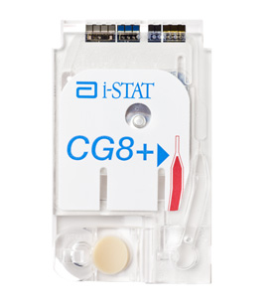

do not touch!

sample

well

1. Ensure to thoroughly **mix** dry heparinised blood gas syringe or capillary thoroughly **when sample is taken and prior to analysis**:

* mix by rolling between fingers or gentle inversion
* capped syringe analyse within **15 minutes**
* capillary analyse **immediately**
* label with patient ID

1. From the meter home screen press **‘Perform Patient Test’**
2. Scan your own **Operator ID**
3. Enter patient **NHS number or scan it from their wristband,** confirm patient full ID which should appear on screen. If patient does not have an NHS number please use the full Case (be aware that results without NHS number will not automatically transmit to CPD upon docking the meter. You may be prompted to enter patient age/sex if their ID is not recognised)
4. Scan long barcode on cartridge pouch
5. Select **‘Sample Type’** (venous/arterial/capillary) and press **‘Next’**
6. Guidance for taking a patient sample in balanced heparin syringe/capillary and filling the cartridge will appear on screen – press pause if you want to read through the instructions
7. Remove cartridge from pouch (avoiding touching sensors and calibrant pouch) and fill cartridge immediately:

* Lay cartridge on a flat surface
* Place Syringe/capillary at the sample well at an angle
* Dispense sample ensuring it travels into the well
* Keep dispensing until sample reaches the **Fill Mark Indicator**
* 3-4 large drops (65μl) should be enough to fill cartridge to the blue arrow. Please be careful not to over-/under-fill the cartridge, as this will generate an error.

1. **Shut cartridge closure clasp** firmly until it snaps into place securely.

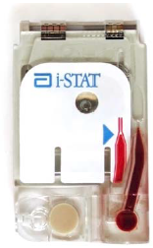

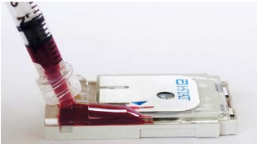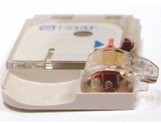

1. Insert into the cartridge port slowly and smoothly until it clicks into place – the indicator light will turn white and the screen will change to ‘**Processing’** then **‘Analyzing’.** The instrument must remain level during testing.
2. Once complete, the meter will alarm until you press **‘Silence’**
3. **Results** will be displayed on screen once test complete. Abnormal results will have high/low arrows on screen and indicator light turns **amber**
4. 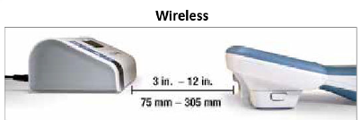To print, hold meter in front of printer and press ‘**Print’**
5. **Record** results in patient notes and escalate if appropriate.
6. Press the ‘**Home’** button in the bottom left corner of the Alinity screen and you will be prompted to remove the cartridge by gently pulling it out of the port.
7. Clean the meter with Clinell Wipes between each patient use by wiping the surfaces 3x times. Avoid forcing liquid into sensitive areas:

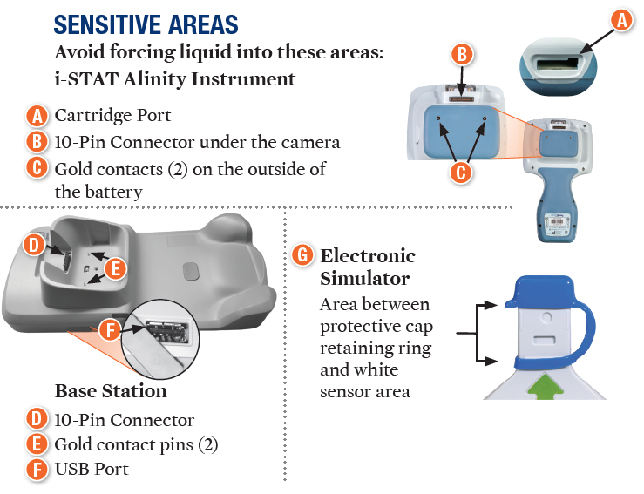

Clean the docking station and Electronic Simulator when/if required.

1. **Dock** meter after use
2. Ensure all used cartridges, samples and cleaning materials are disposed of as per infection prevention guidance in clinical waste.

## How to find previous patient results

1. From the instrument's **Home** screen, touch **More Options** > **Review Results** > **All Results**
2. Scan or Enter your own Operator ID.
3. Choose results by touching the checkbox in front of the result identifier then press **View**
4. There is also option to print selected results

## How to change Alinity printer paper

1. Lift printer lid by pulling the black window on the top of the device up
2. Replacement paper is placed into the paper holder with the curl of the paper facing upwards
3. When shutting the printer lid, leave a little paper overhanging to ensure it will print straight

# Reporting of Results

* Results will appear on screen.
* Abnormal results outside of reference limits will be displayed with up/down arrows and an amber indicator light
* Results can be printed by holding meter in front of printer and pressing ‘Print’
* Record results in patients notes and escalate as appropriate if abnormal.
* Results will be visible in patients electronic records once transmitted from the instrument.

# Reference Intervals

|  |  |  |  |  |
| --- | --- | --- | --- | --- |
| **Parameter** | **Lower reference limit** | **Upper reference limit** | **Reportable Range** | **Source** |
| **PO2** | 11.07 kPa | 14.40 kPa | 0.7-106.6 kPa | (1) Tietz 5th Ed 2012 |
| **PCO2** | 4.27 kPa | 6.00 kPa | 0.67-17.33 kPa | (1) Tietz 5th Ed 2012 |
| **pH** | 7.350 | 7.450 | 6.5-8.2 | (1) Tietz 5th Ed 2012 |
| **Sodium** | 136 mmol/L | 145 mmol/L | 100-180 mmol/L | (1) Tietz 5th Ed 2012 |
| **Potassium** | 3.50 mmol/L | 5.10 mmol/L | 2.0-9.0 mmol/L | (1) Tietz 5th Ed 2012 |
| **Chloride** | 98.0 mmol/L | 107.0 mmol/L |  | (1) Tietz 5th Ed 2012 |
| **Ionised Calcium** | 1.150 mmol/L | 1.330 mmol/L | 1.0-10.0 mmol/L | (1) Tietz 5th Ed 2012 |
| **tHb** | 115.0 g/L | 178.0 g/L | 51-255 g/L | (2) Labor und Diagnose |
| **Hct** | 36% | 53% | 15-75% | (2) Labor und Diagnose |
| **Lactate** | 1.0 mmol/L | 2.0 mmol/L | 0.3-20.0 mmol/L | Locally agreed |

# Performance Characteristics

A multiday precision study was performed by Abbott Point of Care with aqueous calibration verification materials in representative cartridges. Duplicates of each aqueous fluid were tested twice a day for 20 days.

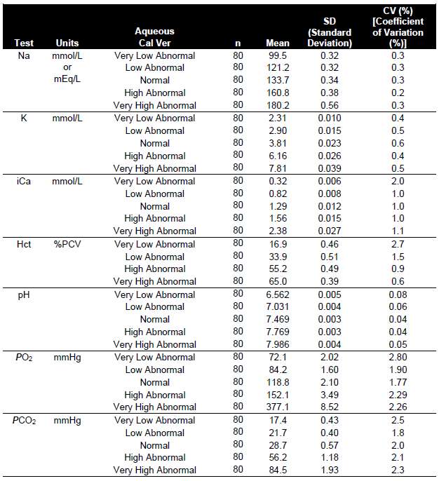





* Please see PC/VV/YS-13 for full verification (available on Q-Pulse or from POCT, laboratory medicine).

# Known Limitations

* Do not use cold cartridges- pO2 results may be falsely decreased if the cartridge is cold.
* Some suspected interferants listed include: Bromide, Glycolic Acid, Hydroxyurea, Acetylcysteine, Leflunomide, Magnesium Chloride, Nithiodote, Salicylate, Thiocyanate

# Related Forms/Templates and Documents

* PC/RA/YS-12
* PC/VV/YS-13

# References

* + iSTAT Alinity User Guide (Art: 746981-01 Rev. G)
  + iSTAT Alinity Quick reference Guide (Art: 731848-01 Rev. I)

**Source of Reference Ranges**

1. Tietz Textbook of Clinical Chemistry and Molecular Diagnostics, 5th edition 2012
2. Lothar Thomas, Labor und Diagnose, 8. Auflage, p. 840