POCT Link Trainer Guide – SureStep pregnancy test training

This document summarises the key points which should be covered by link trainers during training of pregnancy testing using the SureStep pregnancy test.

Purpose 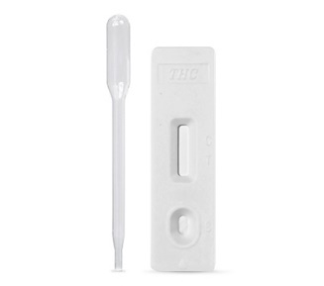 | - Human chorionic gonadotrophin (hCG) is a glycoprotein hormone, which is produced by the developing placenta shortly after conception.  - The SureStep test is a qualitative immunoassay, which detects the intact hCG molecule in urine.
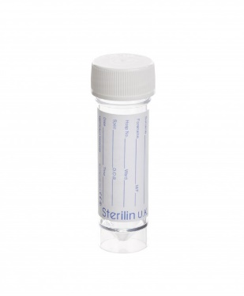  Sample requirements | - The urine sample must be collected into a clean dry plastic or glass container without preservatives. Label with the patient’s details.  - Specimens collected at any time of day may be used, but the first urine sample of the day usually contains the highest concentration of hCG.  - If the test is not to be done immediately the sample should be labelled with the patient’s full name, DOB and NHS number and stored at 2-8˚C for up to 48 hours.
EQA | - EQA samples should be tested on receipt, and the results returned to POCT on the form provided ASAP.
  Patient / sample preparation | - Gain positive patient identification and (when possible) consent.  - Wear the appropriate PPE.  - Collect a fresh urine sample in a clean container labelled with patient details.
Analysis | - Check the test expiry date.  - Fill in the audit sheet.  - Ensure the patient sample is at room temperature.  - Remove the pregnancy test strip and dropper from the foil wrapper and place on a flat surface. Label the strip with the patient’s name/NHS number.  - Using the dropper provided dispense three full drops of urine into the round sample well.  - After 3-4 minutes, read the result. DO NOT interpret the results after the 4-minute appropriate read time has passed.
Results | 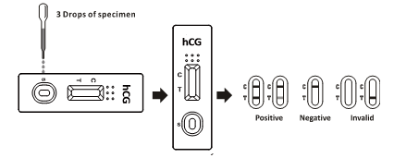  - To interpret the results please ensure that you are in good light.  - All results (including invalid results) must be recorded in the patients’ notes and on the audit sheet. Failure to do so will result in the test kits being withdrawn.
After testing | - Dispose of test strips following waste management guidance.
Stock | - Tests are supplied by POCT when a filled audit sheet is returned and tests are requested.
  Analyser issues | - Contact POCT:  - York (772)5890  - Scarborough (771)2659  - Bridlington (771) 3321
* DO NOT SHARE YOUR OPERATOR ID WITH ANYONE *
* IT IS A DISCIPLINARY OFFENCE *

