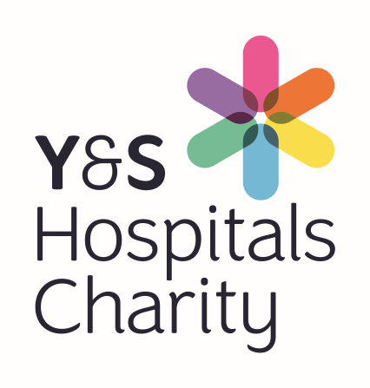
Ref no:

Reg. Charity 1054527

Charitable Funds - Request to Expend Form

Requestor Name:

Ward/Dept: Date of Request:

Fund Name: Fund No:
(Leave blank if unknown)
Please complete all areas of the form
Description/ Specification of Purchase  (Attach separate sheet if needed) : |  | Cost including VAT
Total Charitable Cost |  | £

Revenue Cost Implications (Maintenance / Training Etc.)

Give details:
Explain how patients will benefit:
Please complete the other side
The purchase of equipment above £1,000 has to go through MERG. Charitable fund authorisation should be received first before applying to MERG to ensure there is funding available.
MERG Approval Required? Y/N
If your application will benefit more than one ward, have all wards been consulted so they are aware of your funding application and they are supportive of your request?
Y/N
Are the League of Friends or Other Outside Bodies involved in the Purchase?

Y/N

If Yes, please attach a letter of funding confirmation from the Funding Body concerned

Requestor Authorisation  Name:  Signature:  Date: | Line Manager Authorisation  Name:  Signature:  Date:
Fund holder Authorisation Fund number:

As fund holder I have considered this request and confirm it meets the Charitable Expend Tests?
(Detailed in section 3.2 of Charity Expenditure Policy)

- The public perception test Y/N

- The patient benefit test Y/N

- The additionality test Y/N

Name:

Signature: Date:

Email the completed form to: Charity.finance@york.nhs.uk

Charitable Funds, Financial Services, Tribune House, Tribune Way, Clifton Moor, York, YO30 4RY

