Link Trainer Guide- Key points for POCT QUPID Pregnancy test kits
This document summarises the key points for use of the POCT QUPID Pregnancy test kits which should be covered by link trainers during training.
Before testing  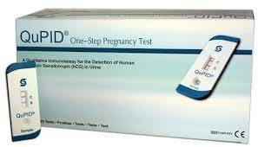 |  | - Check expiry date of cassettes, do not use out of date cassettes.  - Obtain consent from your patient.  - Ensure correct PPE is worn.  - HCG can be detected in urine 6 days post conception.  - Must only be carried out by staff who have received documented training on the use of the QPID Pregnancy test kits.
Sample requirement  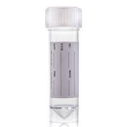√ | 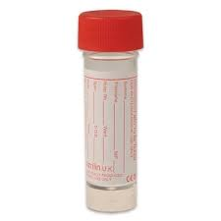x | - Sample must be taken into a clean/sterile, plain container.  - Sample should be labelled with patient details, including NHS Number.  - Samples are stable for 72hrs if stored at 2-8®C.  - Samples must be at room temp before analysis.
QC requirements |  | - QC is an internal visual line in the C area of the palette.
EQA samples |  | - EQA Samples are sent evert 2 months.  - It is every user’s responsibility to ensure the test is run and results returned to POCT.
Analysis |  | - Ensure 3 minutes is timed accurately.  - Ensure a good light source.  - A second person should confirm a result if the reader is unsure.  - A line MUST appear in the C area for a valid test.  - Any line in the T area is a Positive test.  - All tests MUST be recorded on an audit sheet.
Results and follow up testing |  | - All results should be recorded in patient notes, along with date/time/person performing the test.  - Equivocal tests should be confirmed with a serum sample sent to the laboratory.
After testing |  | - Dispose of test cassette in clinical waste.
QUPID Kit supply |  | - Kits are restocked by POCT on production of a completed audit sheet – NO AUDIT SHEET- NO TESTS!  - Contact POCT office:  - York (772)5890  - Scarborough (771)2659  - Bridlington (771) 3321

