Specimens that require testing at the Regional Cytogenetics Centre, Leeds
During routine Histology hours (Monday to Friday 8.30am-5pm excluding bank holidays), tissue specimens that are needed to be sent to Cytogenetics, can be sent to the Histology department, 3rd floor Laboratory Medicine preferably in an UNIVERSAL (available from specimen reception) filled with SALINE, +/-vial of maternal blood.

Specimens for Cytogenetics MUST NOT be sent in FORMALIN.
Cytogenetic specimens MUST be received with:
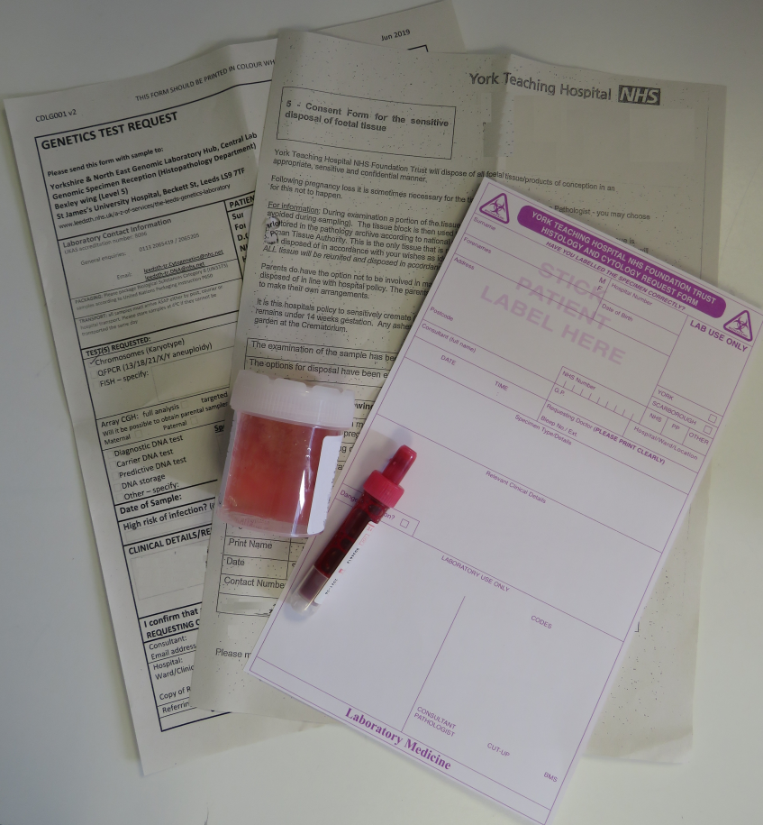

- Completed Cytogenetics form (available from the link below)
- For specimens that require routine Histology as well as genetic testing, for example, placenta/products of conception, a completed Histology request form is required (available from Specimen reception)
- If POC specimen, a completed sensitive disposal consent form (available from - http://staffroom.ydh.yha.com/clinical-Directorate-Information/master-clinical-document-library/laboratory-medicine/sensitive-disposal-of-products-of-conception-foetal-tissue-policy

If a specimen is collected out of hours (after 5pm over the weekend/bank holiday), please store in a local refrigerator (tissue specimen in SALINE AND blood vial), and transport to Histology at the earliest time the next working day (Cytogenetics are also closed out of routine hours).

Further information can be found at: https://www.leedsth.nhs.uk/a-z-of-services/the-leeds-genetics-laboratory/constitutional-genetics/constitutional-cytogenetics/tissue-samples/

