ICE Desktop Interoperability Guide for SystmOne

Version: | Version 1
Date of Issue: | 4th October 2016
Author: | David Worth
Review Date: | Next system or key contact change

Contents

Information Resources & Key Contacts 2
Configuring SystmOne for Electronic Requesting 3
Enabling Electronic Requesting in SystmOne 4
SystmOne Configuration for a Partner or Salaried GP with their own Prescription Pricing Authority (PPA) Code 5
Partner or Salaried GP working at a Second or Subsequent Practices 6
GP Locums 7
Practice Nurses 8
Practice Staff 9
Trouble Shooting Guide 10

Information Resources & Key Contacts

GMP Numbers: http://nww.hscic.gov.uk/ods/enquiries/searchonpcad/

GMC Numbers: http://www.gmc-uk.org/doctors/register/LRMP.asp

HSCIC Organisation Data Set Portal: http://odsportal.hscic.gov.uk/

Pathology IT Application Specialist: Eoin O’Cuinneagain
Laboratory Medicine
York Teaching Hospitals NHS FT
Wigginton Road
York
01904-724878
Email: eoin.ocuinneagain@york.nhs.uk

SNS Service Desk for Account SNS-AccessRequests@york.nhs.uk
Management & Queries

Configuring SystmOne for Electronic Requesting

To configure SystmOne for electronic requesting a practice user with the correct rights needs to:

1. Go into “SETUP”
2. Select “USERS & POLICY”
3. Select “STAFF & ORGANISATION SETUP
4. Click on the tab “EDI SETUP”
5. A dialogue box should appear called “Link to Pathology/Radiology Labs”
6. Look for Scarborough Pathology (Lab DTS Address “rccpm”) – don’t worry Scarborough and York are the same lab - we’re working on getting it change
7. Click Ok
8. Close down SystmOne (to be sure)
9. Restart and request

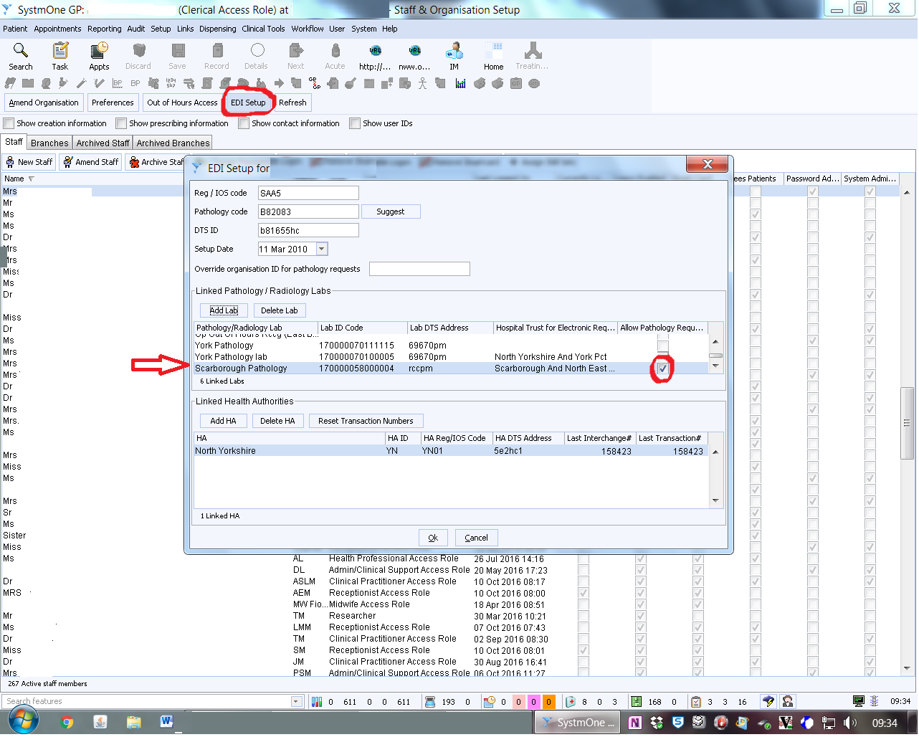

Enabling Electronic Requesting in SystmOne

To enable electronic requesting in SystmOne you will need to set up an icon on the USERS toolbar:

- right mouse click on toolbar
- configure toolbar
- highlight toolbar to amend
- select ‘amend tool bar’
- select ‘New Electronic Pathology/Radiology Request’
- double click to add function to toolbar (icon can be customised)
Icon for Requesting

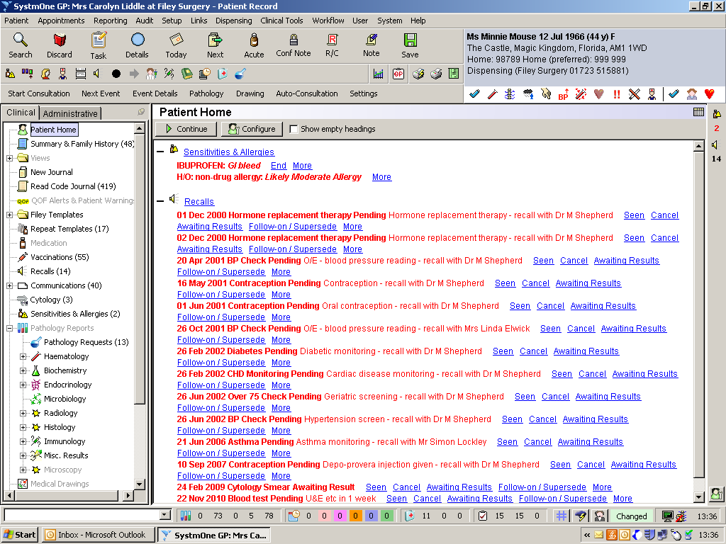

SystmOne Configuration for a Partner or Salaried GP with their own Prescription Pricing Authority (PPA) Code

First Practice

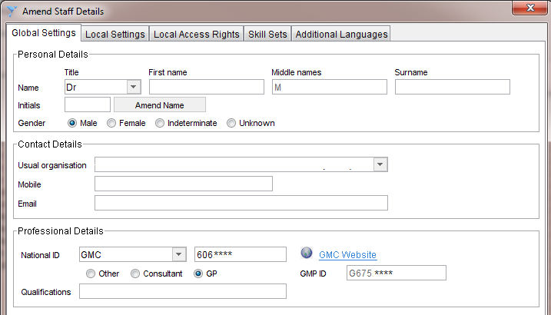

Note: for members of the practice team marked as a GP in the users set up the GMP ID is sent to ICE for system access.

SystmOne calculates the GMP ID internally including the prefixing of the number with a “G” and the calculation of the check digit at the end of the code.

You cannot use the same GMP at more than one location.

Partner or Salaried GP working at a Second or Subsequent Practices

Second and Subsequent Practices

If a member of the practice team already holds a post elsewhere, you cannot use the same GMP

A second PPA / GMP number must be used for the new location, this ensures reports go back to the correct location as this is the code is passed to ICE for system access.

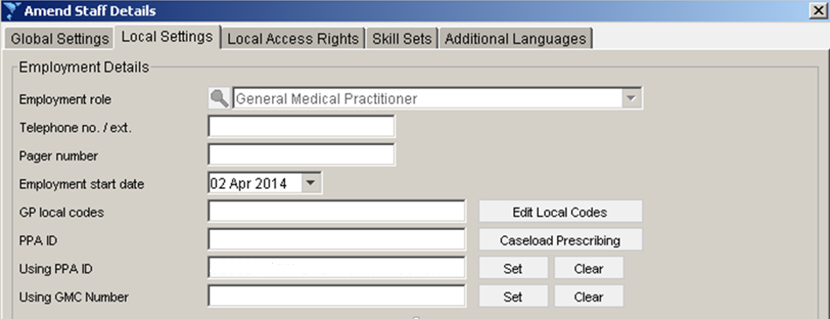

NB: Check the HSCIC web site for details or apply for a code stating that it is for use at a second site.

http://odsportal.hscic.gov.uk/

GP Locums

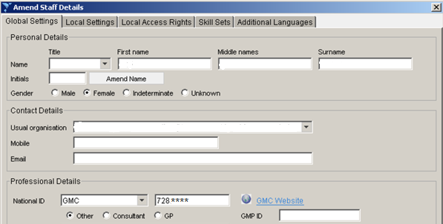

For GP Locums – do not mark as a GP on the Amend Staff Details, Global Settings Screen.

Select “Other”

When “Other” is selected SystmOne will pass the locums GMC number to ICE as the user name allowing the locum connect to ICE and, if the sites are configured, log into ICE from other ICE enabled instances of SystmOne.

If required a practice can configure a locum as a clinician provided the Locum details are not in use at another site. If in doubt, please contact Pathology IT. A spurious or pseudo national code can be negotiated if required.

Practice Nurses

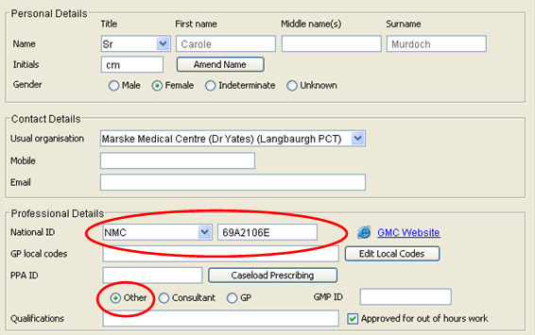

If the radio button is set to “Other” the Nursing and Midwifery Council Registration Number (PIN) and the national code for the site is sent to ICE as part of the authentication process.

If the practice wants reports to go back to the requesting nurse the nurse has to be set up as a GP.

Use with care. If the staff member in question is working out of one or more GP practices different codes must be used.

Practice Staff

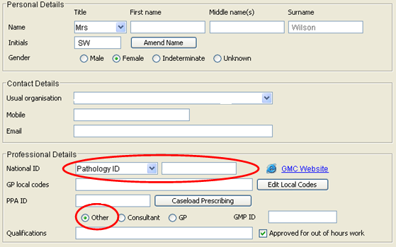

Set National ID to “Pathology ID”

Enter a unique code in the adjacent box.

- Admin Staff. Practice Code plus A1, A2, A3 etc.
- HCAs. Practice Code plus H1, H2, H3 etc.
- Phlebotomists. Practice Code plus P1, P2, P3 etc.

Set Radio Button to “Other”

The code in the box next to National ID will be transferred to ICE as the user login.

Locums and Registrars could be registered using this method if their registration codes are not available. For Locums Practice Code plus L1, L2 etc. Registrars Practice Code plus R1, R2 etc

If in doubt please contact SNS User Access: SNS-AccessRequests@york.nhs.uk

Trouble Shooting Guide

Yes
Set up user in locally. Follow the Trading Agreement process to inform the hospital of the new user
Retry once Hospital has confirmed user is configured on ICE
ICE URL:
https://nww.ice.yorkhospitals.nhs.uk/ICEDesktop/dotnet/icedesktop/interop/service_request.aspx

No
ICE user name set up locally
Test direct access to the web address for ICE
Requestor is unable to use ICE

Yes
Yes
Retry

No

Log Call with User Access or Hospital Service Desk

